**Exercise 1: Control Structures**

**Question 1.** Write a PL/SQL block that loops through all customers, checks their age, and if they are above 60, apply a 1% discount to their current loan interest rates.

**Code:**

DECLARE

    v_found BOOLEAN := FALSE;

BEGIN

    FOR c IN (SELECT CustomerID, DOB FROM Customers) LOOP

        IF MONTHS_BETWEEN(SYSDATE, c.DOB) / 12 > 60 THEN

            UPDATE Loans

            SET InterestRate = InterestRate - 1

            WHERE CustomerID = c.CustomerID;

            v_found := TRUE;

        END IF;

    END LOOP;

    IF NOT v_found THEN

        DBMS_OUTPUT.PUT_LINE('No customer above 60 years found.');

    END IF;

    COMMIT;

END;

/

**Output:**

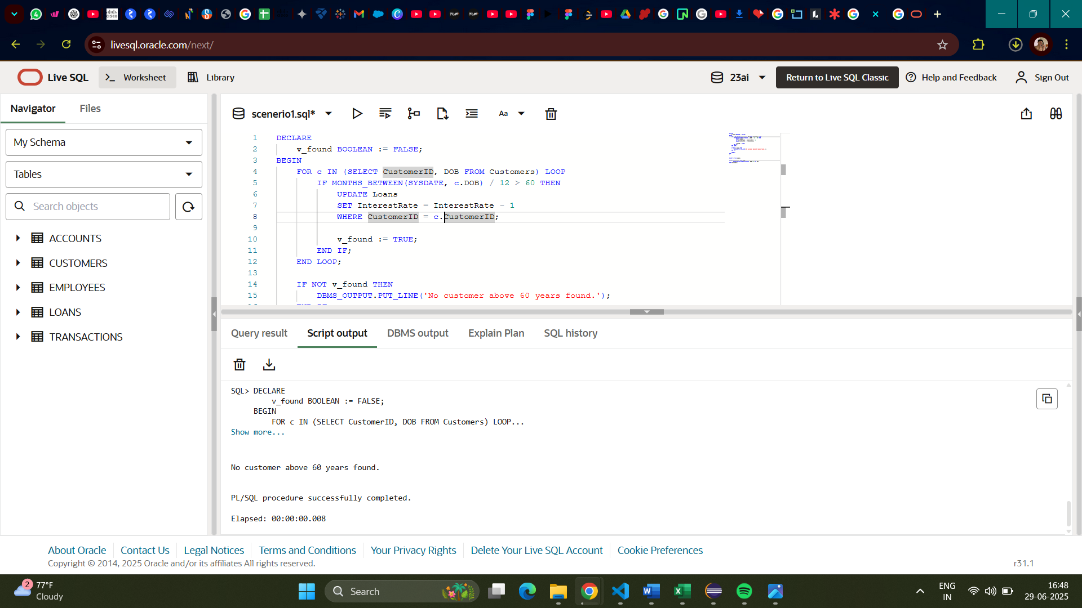

**Question 2.** Write a PL/SQL block that iterates through all customers and sets a flag IsVIP to TRUE for those with a balance over $10,000.

**Code:**

ALTER TABLE Customers ADD IsVIP VARCHAR2(5);

BEGIN

    FOR c IN (SELECT CustomerID, Balance FROM Customers) LOOP

        IF c.Balance > 10000 THEN

            UPDATE Customers

            SET IsVIP = 'TRUE'

            WHERE CustomerID = c.CustomerID;

        ELSE

            UPDATE Customers

            SET IsVIP = 'FALSE'

            WHERE CustomerID = c.CustomerID;

        END IF;

    END LOOP;

    COMMIT;

END;

/

SELECT CustomerID, Name, Balance, IsVIP

FROM Customers;

**Output:**

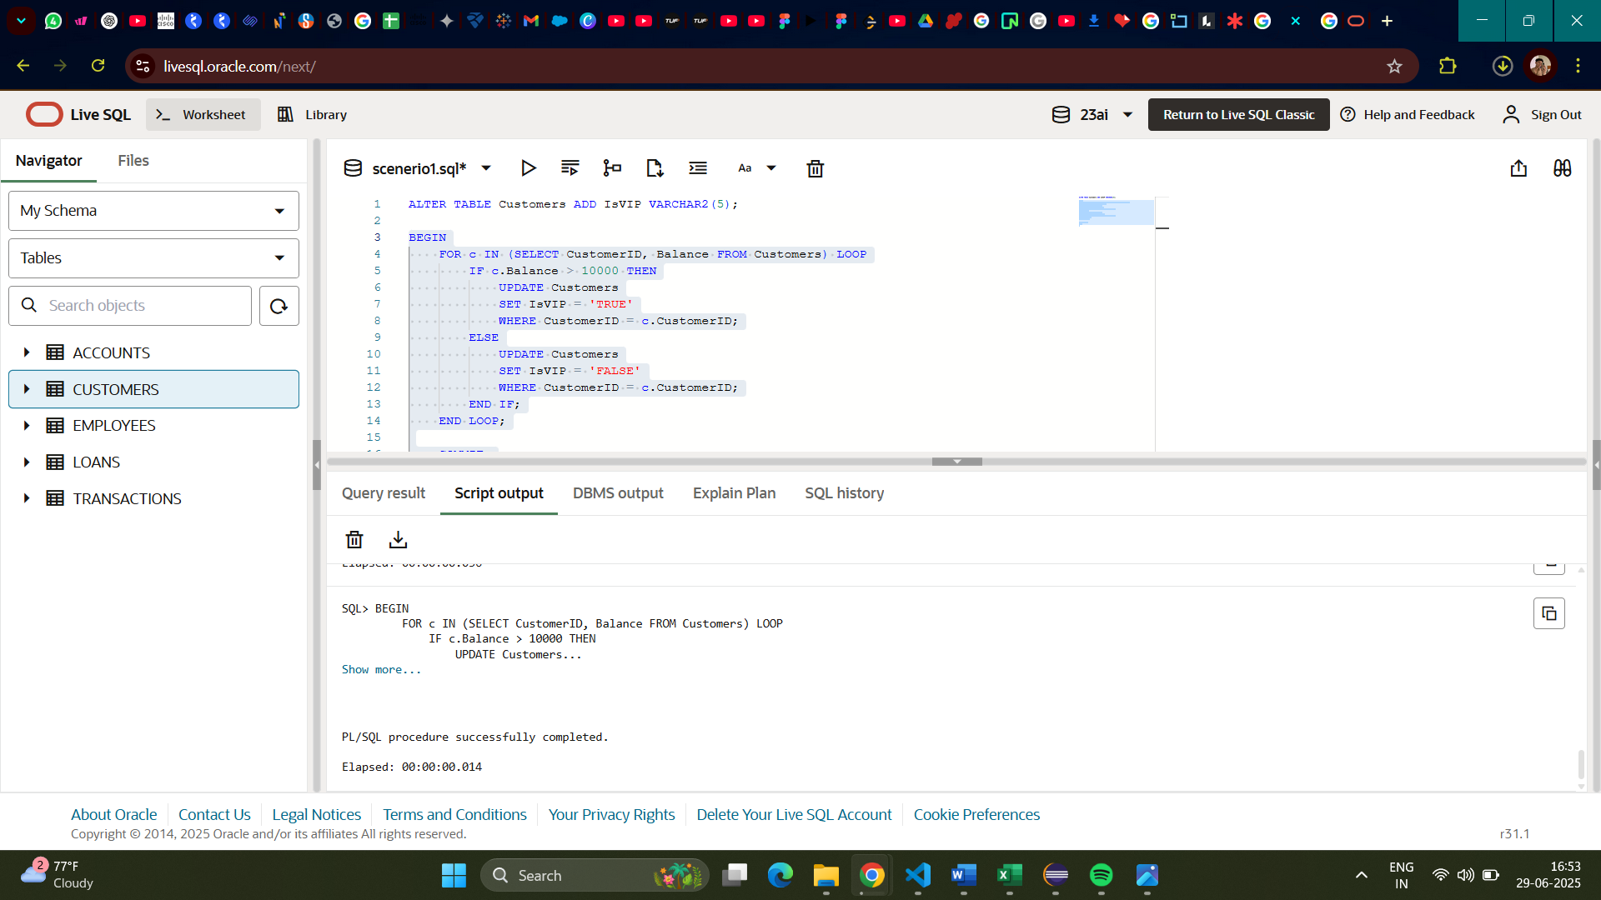

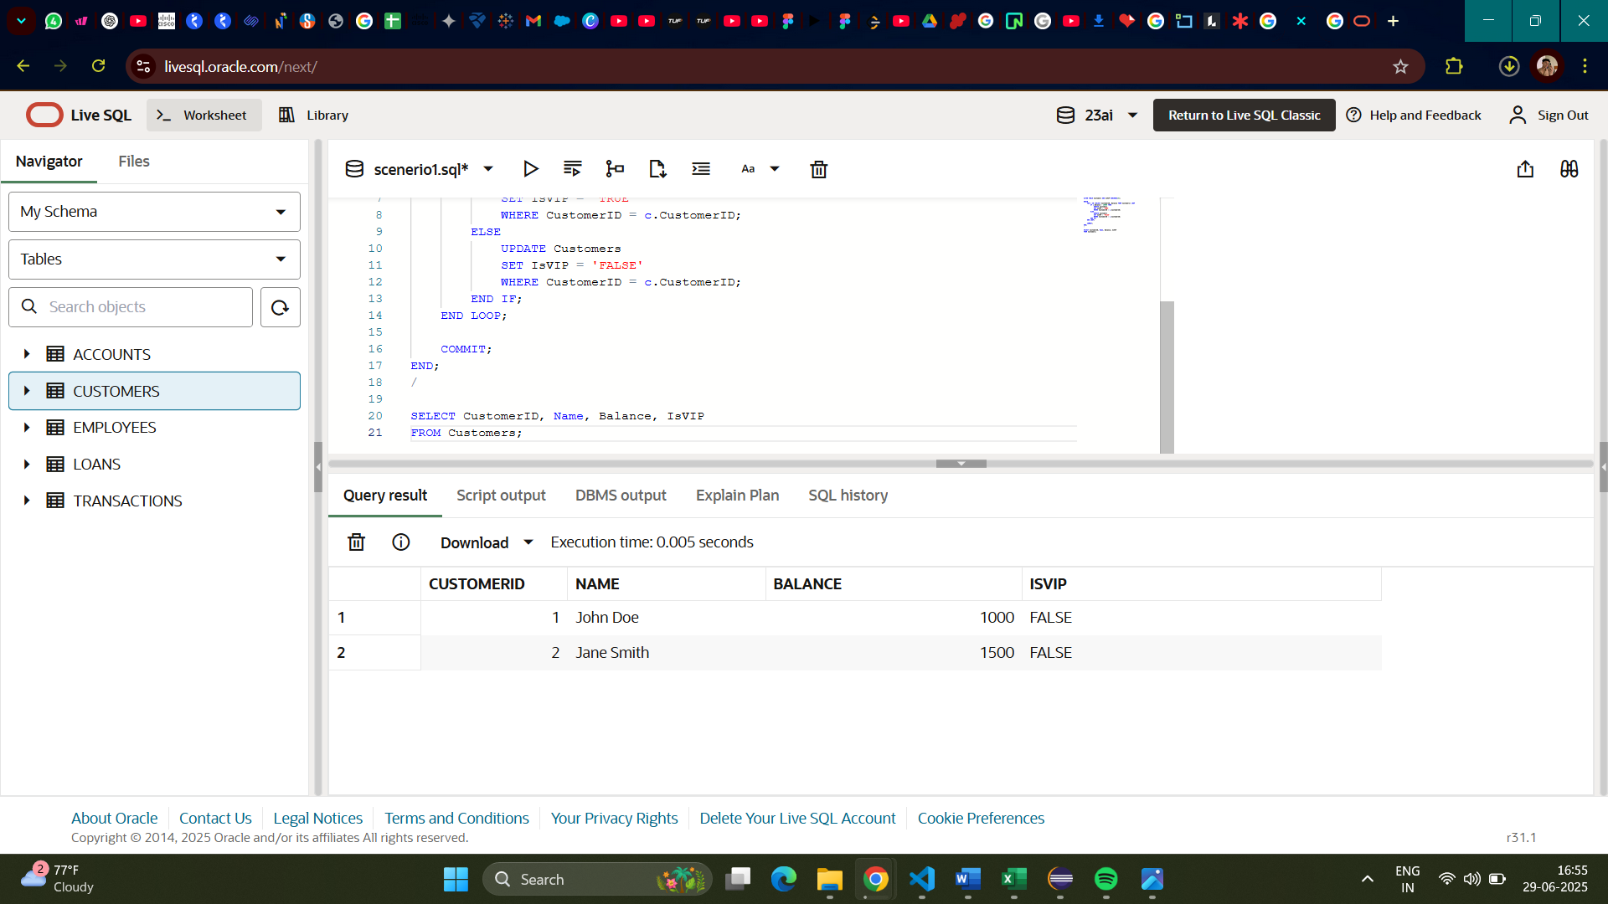

**Question 3.** Write a PL/SQL block that fetches all loans due in the next 30 days and prints a reminder message for each customer.

**Code:**

SET SERVEROUTPUT ON;

DECLARE

    v_found BOOLEAN := FALSE;

BEGIN

    FOR r IN (

        SELECT l.LoanID, c.Name, l.EndDate

        FROM Loans l

        JOIN Customers c ON l.CustomerID = c.CustomerID

        WHERE l.EndDate BETWEEN SYSDATE AND SYSDATE + 30

    ) LOOP

        DBMS_OUTPUT.PUT_LINE('Reminder: Loan ID ' || r.LoanID || ' for customer ' || r.Name ||

                             ' is due on ' || TO_CHAR(r.EndDate, 'YYYY-MM-DD'));

        v_found := TRUE;

    END LOOP;

    IF NOT v_found THEN

        DBMS_OUTPUT.PUT_LINE('No loans are due in the next 30 days.');

    END IF;

END;

/

SELECT * FROM Loans;

**Output:**

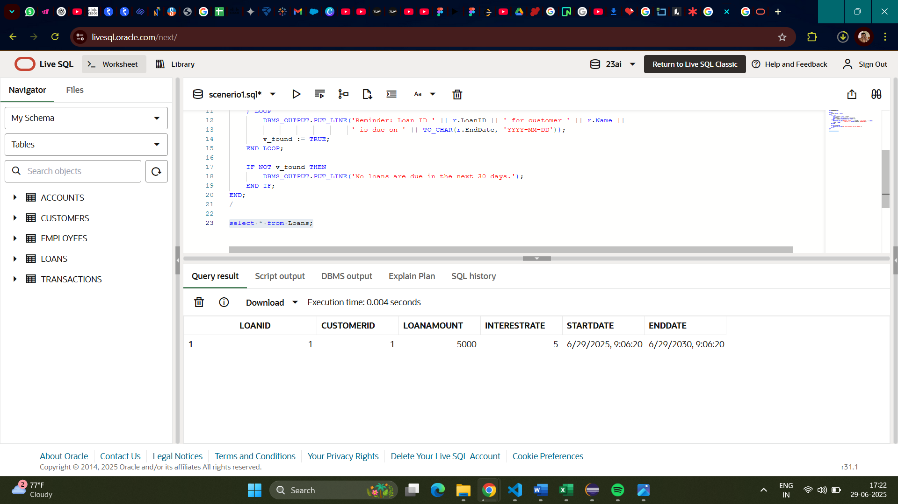

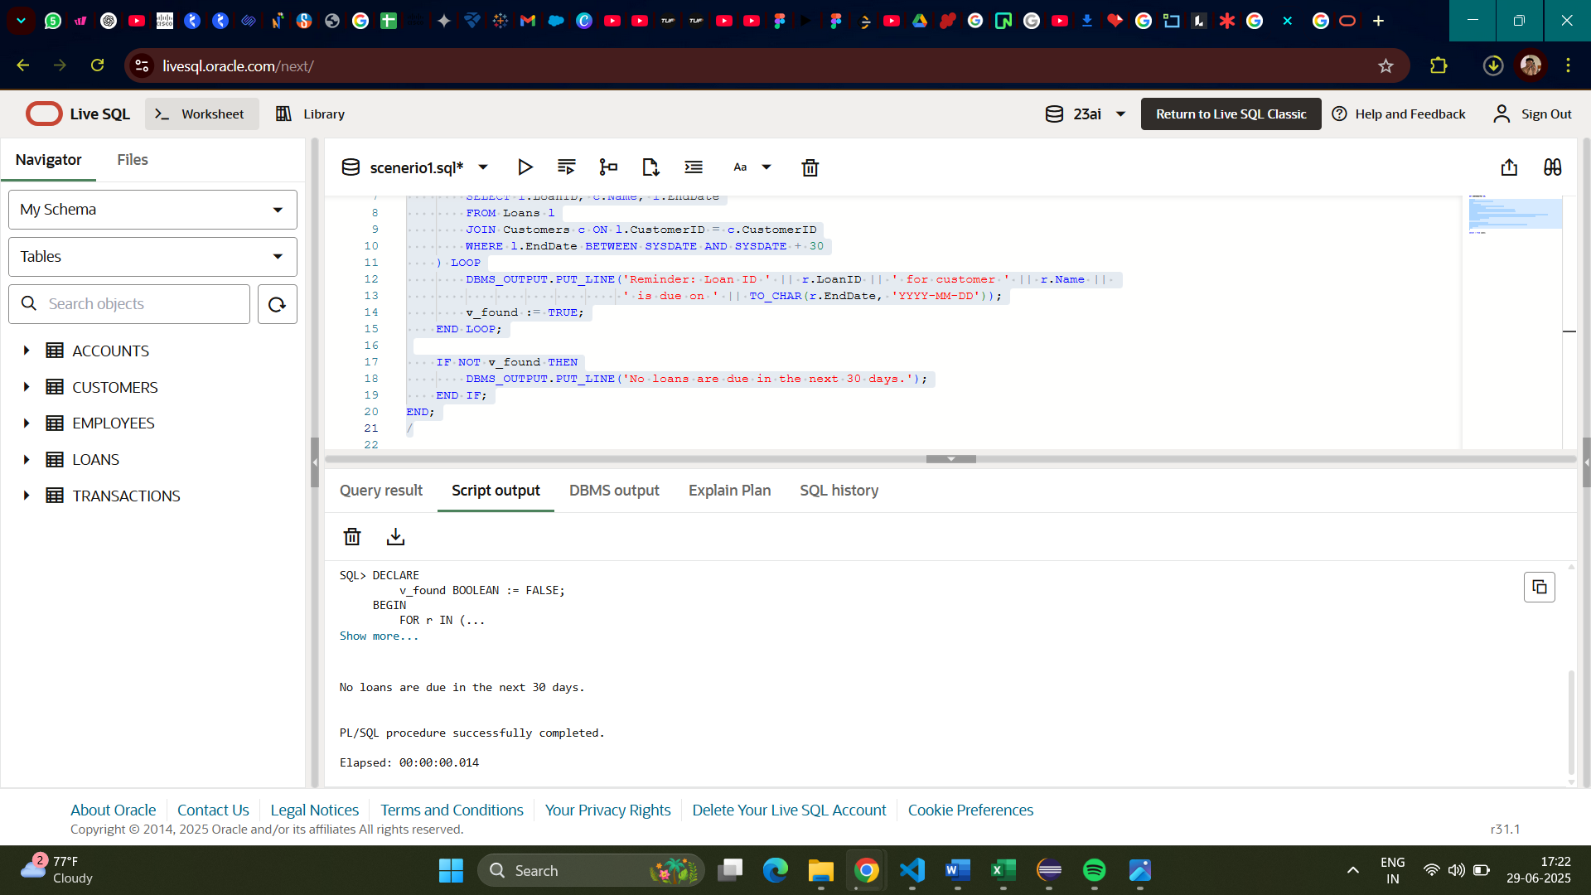

**Exercise 3: Stored Procedures**

**Question 1.** Write a stored procedure **ProcessMonthlyInterest** that calculates and updates the balance of all savings accounts by applying an interest rate of 1% to the current balance.

**Code:**

SET SERVEROUTPUT ON;

CREATE OR REPLACE PROCEDURE ProcessMonthlyInterest IS

BEGIN

    UPDATE Accounts

    SET Balance = Balance + (Balance * 0.01),

        LastModified = SYSDATE

    WHERE AccountType = 'Savings';

    COMMIT;

END;

/

BEGIN

    ProcessMonthlyInterest;

END;

/

SELECT AccountID, CustomerID, AccountType, Balance, LastModified

FROM Accounts

WHERE AccountType = 'Savings';

**Output:**

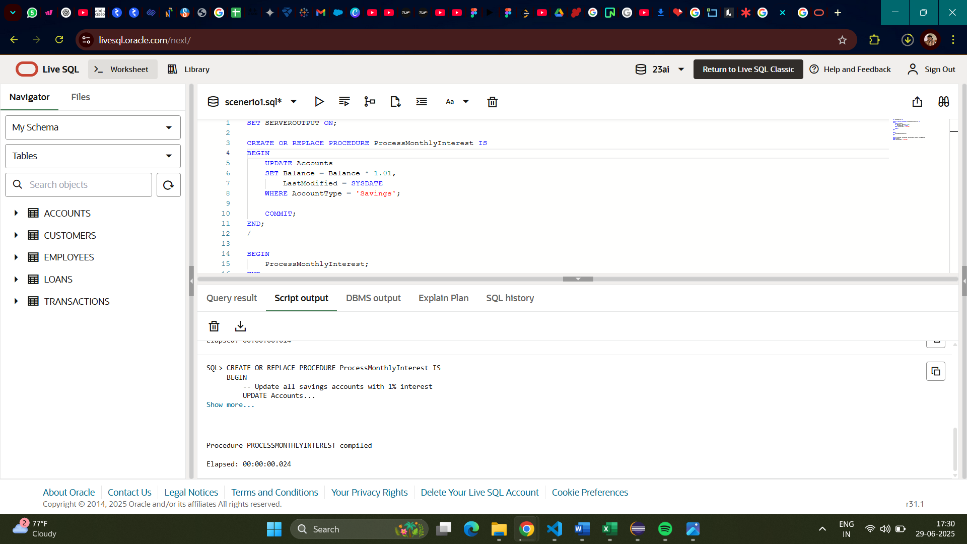

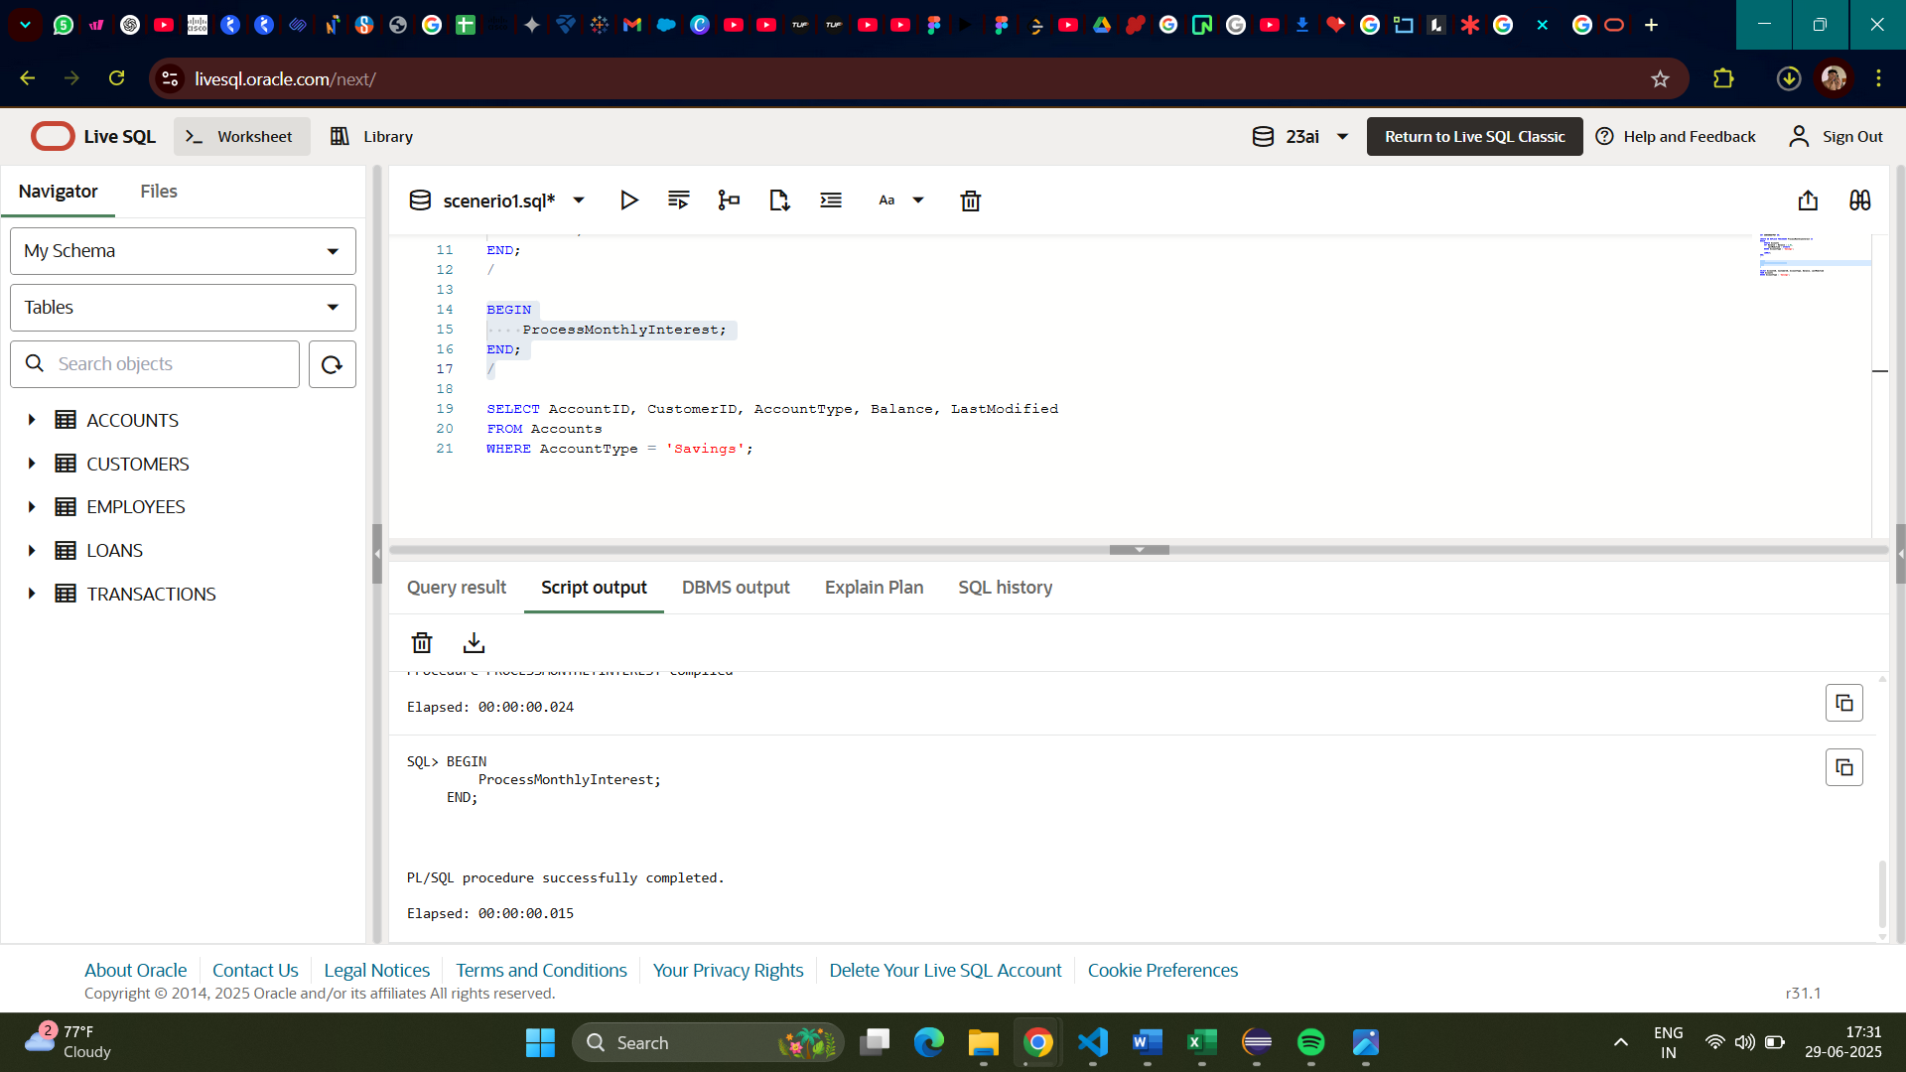

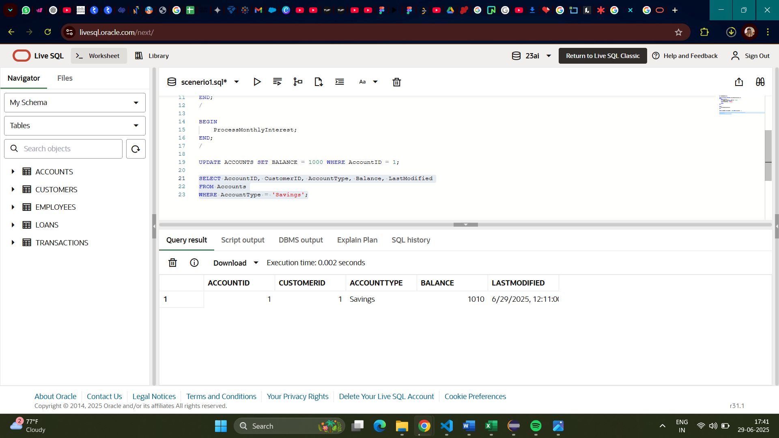

**Question2.** Write a stored procedure **UpdateEmployeeBonus** that updates the salary of employees in a given department by adding a bonus percentage passed as a parameter.

**Code:**SET SERVEROUTPUT ON;

CREATE OR REPLACE PROCEDURE UpdateEmployeeBonus (

    p_dept IN VARCHAR2,

    p_bonus_pct IN NUMBER

) IS

BEGIN

    UPDATE Employees

    SET Salary = Salary + (Salary * p_bonus_pct / 100)

    WHERE Department = p_dept;

    COMMIT;

END;

/

BEGIN

    UpdateEmployeeBonus('IT', 10);

END;

/

SELECT EmployeeID, Name, Department, Salary

FROM Employees

WHERE Department = 'IT';

**Output:**

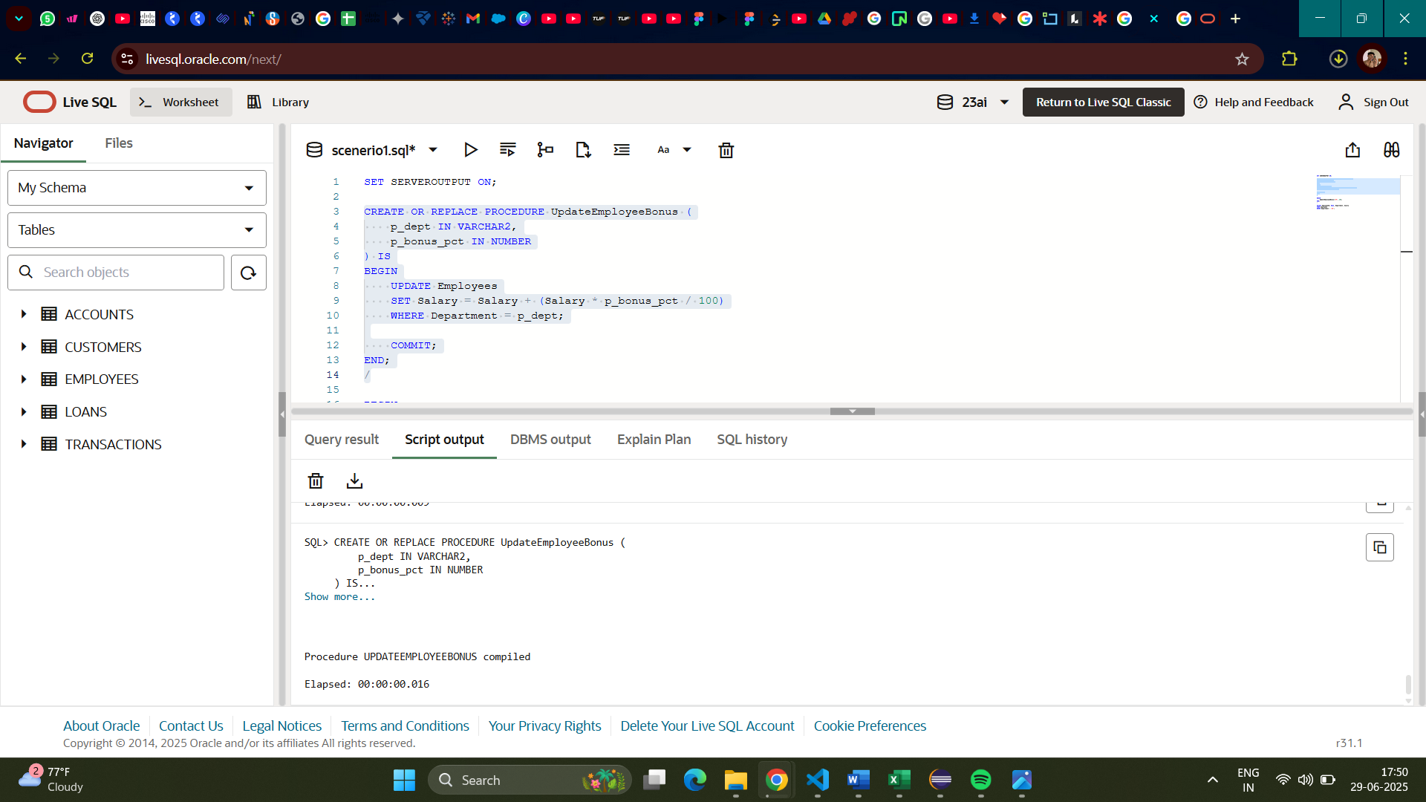

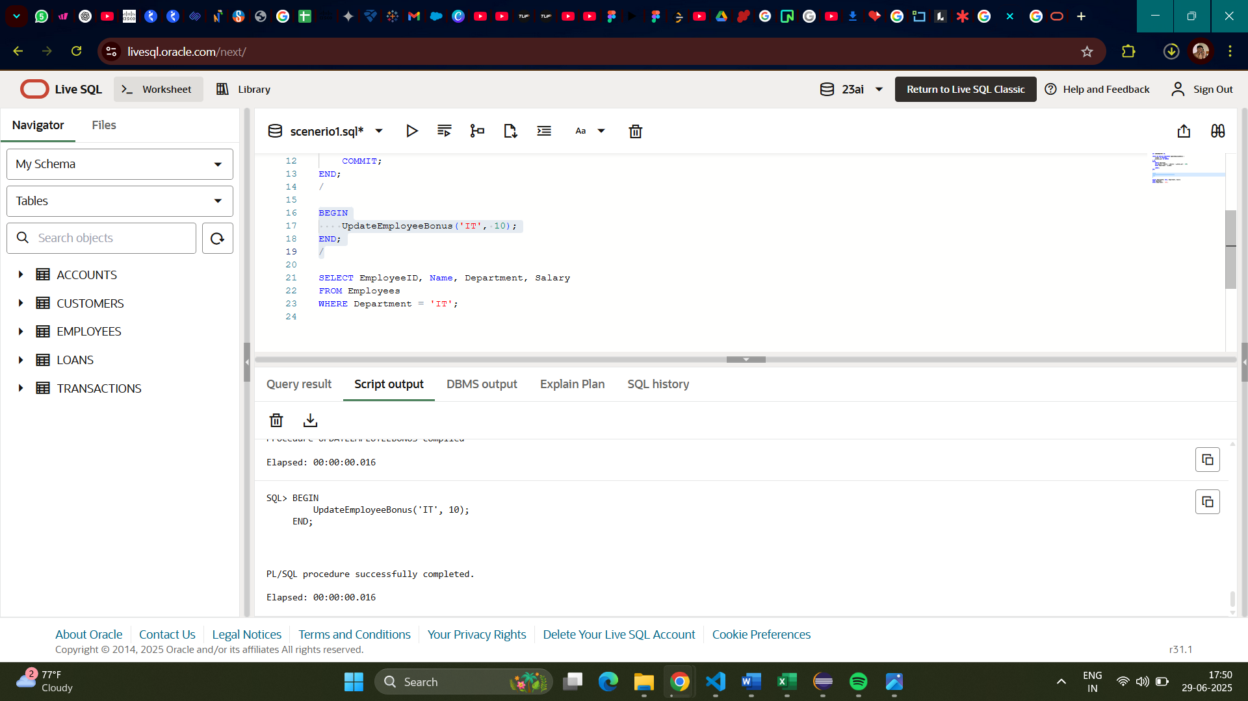

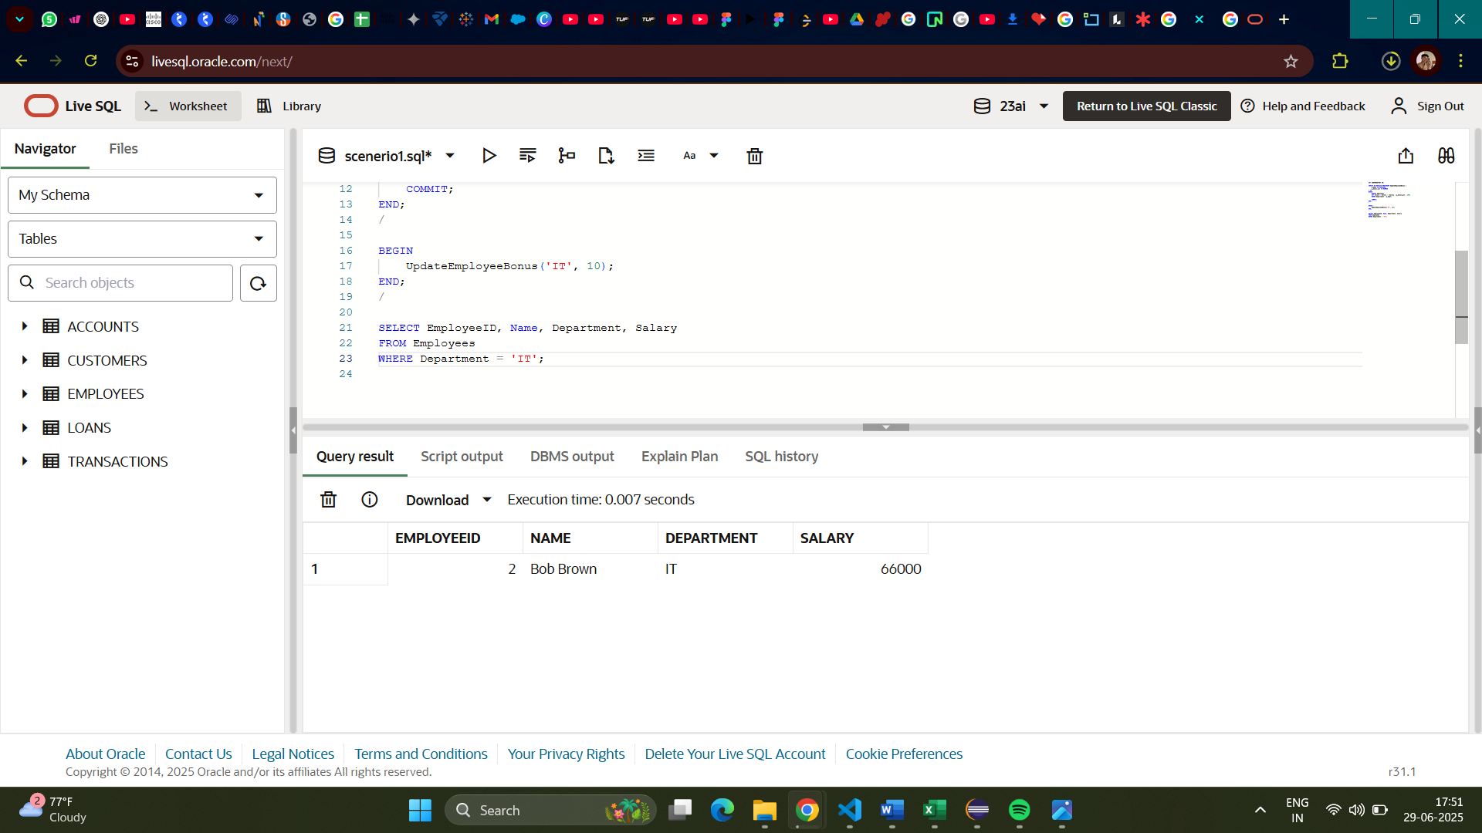

**Question 3.** Write a stored procedure **TransferFunds** that transfers a specified amount from one account to another, checking that the source account has sufficient balance before making the transfer.

**Code:**

SET SERVEROUTPUT ON;

CREATE OR REPLACE PROCEDURE TransferFunds (

    p_from_account IN NUMBER,

    p_to_account IN NUMBER,

    p_amount IN NUMBER

) IS

    v_balance NUMBER;

BEGIN

    SELECT Balance INTO v_balance

    FROM Accounts

    WHERE AccountID = p_from_account;

    IF v_balance < p_amount THEN

        RAISE_APPLICATION_ERROR(-20001, 'Insufficient funds in source account.');

    END IF;

    UPDATE Accounts

    SET Balance = Balance - p_amount,

        LastModified = SYSDATE

    WHERE AccountID = p_from_account;

    UPDATE Accounts

    SET Balance = Balance + p_amount,

        LastModified = SYSDATE

    WHERE AccountID = p_to_account;

    COMMIT;

    DBMS_OUTPUT.PUT_LINE('Transfer successful.');

END;

/

BEGIN

    TransferFunds(1, 2, 500);

END;

/

SELECT AccountID, CustomerID, AccountType, Balance

FROM Accounts

WHERE AccountID IN (1, 2);

**Output:**

