**Hands on 1**

**Create a Spring Web Project using Maven**   
  
**Code:**

pom.xml

<?xml version="1.0" encoding="UTF-8"?>

<project xmlns="http://maven.apache.org/POM/4.0.0" xmlns:xsi="http://www.w3.org/2001/XMLSchema-instance"

xsi:schemaLocation="http://maven.apache.org/POM/4.0.0 https://maven.apache.org/xsd/maven-4.0.0.xsd">

<modelVersion>4.0.0</modelVersion>

<parent>

<groupId>org.springframework.boot</groupId>

<artifactId>spring-boot-starter-parent</artifactId>

<version>3.5.3</version>

<relativePath/> <!-- lookup parent from repository -->

</parent>

<groupId>com.cognizant</groupId>

<artifactId>spring-learn</artifactId>

<version>0.0.1-SNAPSHOT</version>

<name>spring-learn</name>

<description>Demo project for Spring Rest</description>

<url/>

<licenses>

<license/>

</licenses>

<developers>

<developer/>

</developers>

<scm>

<connection/>

<developerConnection/>

<tag/>

<url/>

</scm>

<properties>

<java.version>21</java.version>

</properties>

<dependencies>

<dependency>

<groupId>org.springframework.boot</groupId>

<artifactId>spring-boot-starter</artifactId>

</dependency>

<dependency>

<groupId>org.springframework.boot</groupId>

<artifactId>spring-boot-starter-test</artifactId>

<scope>test</scope>

</dependency>

</dependencies>

<build>

<plugins>

<plugin>

<groupId>org.springframework.boot</groupId>

<artifactId>spring-boot-maven-plugin</artifactId>

</plugin>

</plugins>

</build>

</project>

SpringLearnApplication.java

package com.cognizant.spring_learn;

import org.springframework.boot.SpringApplication;

import org.springframework.boot.autoconfigure.SpringBootApplication;

import org.slf4j.Logger;

import org.slf4j.LoggerFactory;

*@SpringBootApplication*

public class SpringLearnApplication {

private static final Logger ***LOGGER*** = LoggerFactory.*getLogger*(SpringLearnApplication.class);

public static void main(String[] args) {

SpringApplication.*run*(SpringLearnApplication.class, args);

***LOGGER***.info("Inside main");

}

}

**Output:**

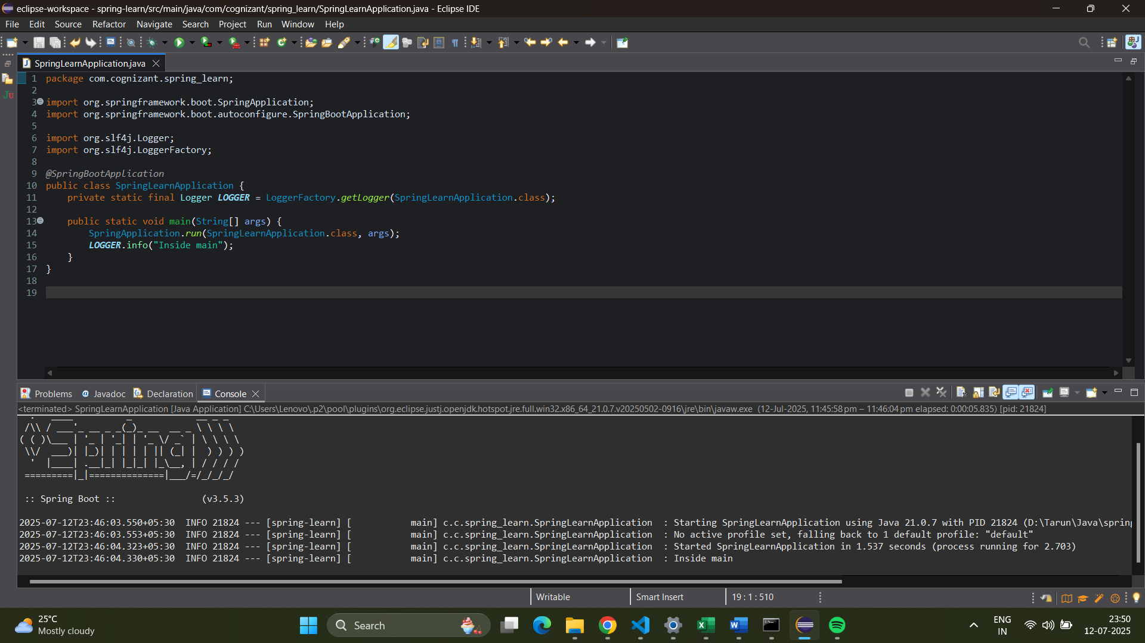

**Hands on 4**

**Spring Core – Load Country from Spring Configuration XML**

**Code:**

pom.xml

<?xml version="1.0" encoding="UTF-8"?>

<project xmlns="http://maven.apache.org/POM/4.0.0" xmlns:xsi="http://www.w3.org/2001/XMLSchema-instance"

xsi:schemaLocation="http://maven.apache.org/POM/4.0.0 https://maven.apache.org/xsd/maven-4.0.0.xsd">

<modelVersion>4.0.0</modelVersion>

<parent>

<groupId>org.springframework.boot</groupId>

<artifactId>spring-boot-starter-parent</artifactId>

<version>3.2.7</version>

<relativePath/>

</parent>

<groupId>com.cognizant</groupId>

<artifactId>spring-learn</artifactId>

<version>0.0.1-SNAPSHOT</version>

<name>spring-learn</name>

<description>Demo project for Spring Rest</description>

<properties>

<java.version>17</java.version>

</properties>

<dependencies>

<dependency>

<groupId>org.springframework.boot</groupId>

<artifactId>spring-boot-starter</artifactId>

<exclusions>

<exclusion>

<groupId>org.springframework.boot</groupId>

<artifactId>spring-boot-starter-logging</artifactId>

</exclusion>

</exclusions>

</dependency>

<dependency>

<groupId>org.slf4j</groupId>

<artifactId>slf4j-api</artifactId>

<version>2.0.13</version>

</dependency>

<dependency>

<groupId>ch.qos.logback</groupId>

<artifactId>logback-classic</artifactId>

<version>1.5.6</version>

</dependency>

<dependency>

<groupId>ch.qos.logback</groupId>

<artifactId>logback-core</artifactId>

<version>1.5.6</version>

</dependency>

<dependency>

<groupId>org.springframework</groupId>

<artifactId>spring-context</artifactId>

<version>6.1.9</version>

</dependency>

<dependency>

<groupId>org.springframework.boot</groupId>

<artifactId>spring-boot-starter-test</artifactId>

<scope>test</scope>

</dependency>

</dependencies>

<build>

<plugins>

<plugin>

<groupId>org.springframework.boot</groupId>

<artifactId>spring-boot-maven-plugin</artifactId>

</plugin>

</plugins>

</build>

</project>

Country.java

package com.cognizant.spring_learn;

import org.slf4j.Logger;

import org.slf4j.LoggerFactory;

public class Country {

private static final Logger ***LOGGER*** = LoggerFactory.*getLogger*(Country.class);

private String code;

private String name;

public Country() {

***LOGGER***.debug("Inside Country Constructor.");

}

public String getCode() {

***LOGGER***.debug("Inside getCode() method.");

return code;

}

public void setCode(String code) {

***LOGGER***.debug("Inside setCode() method. Setting code to: {}", code);

this.code = code;

}

public String getName() {

***LOGGER***.debug("Inside getName() method.");

return name;

}

public void setName(String name) {

***LOGGER***.debug("Inside setName() method. Setting name to: {}", name);

this.name = name;

}

*@Override*

public String toString() {

return "Country [code=" + code + ", name=" + name + "]";

}

}

SpringLearnApplication.java

package com.cognizant.spring_learn;

import org.slf4j.Logger;

import org.slf4j.LoggerFactory;

import org.springframework.context.ApplicationContext;

import org.springframework.context.support.ClassPathXmlApplicationContext;

public class SpringLearnApplication {

private static final Logger ***LOGGER*** = LoggerFactory.*getLogger*(SpringLearnApplication.class);

public static void main(String[] args) {

***LOGGER***.info("Starting SpringLearnApplication...");

*displayCountry*();

***LOGGER***.info("Finished SpringLearnApplication.");

}

public static void displayCountry() {

***LOGGER***.debug("Starting displayCountry() method.");

ApplicationContext context = new ClassPathXmlApplicationContext("country.xml");

Country country = (Country) context.getBean("country", Country.class);

***LOGGER***.debug("Country : {}", country.toString());

((ClassPathXmlApplicationContext) context).close();

***LOGGER***.debug("Finished displayCountry() method.");

}

}

logbacl.xml

<?xml version="1.0" encoding="UTF-8"?>

<configuration>

<appender name="STDOUT" class="ch.qos.logback.core.ConsoleAppender">

<encoder>

<pattern>%d{HH:mm:ss.SSS} [%thread] %-5level %logger{36} - %msg%n</pattern>

</encoder>

</appender>

<root level="DEBUG">

<appender-ref ref="STDOUT" />

</root>

<logger name="com.cognizant.springlearn" level="DEBUG" additivity="false">

<appender-ref ref="STDOUT" />

</logger>

</configuration>

**Output:**

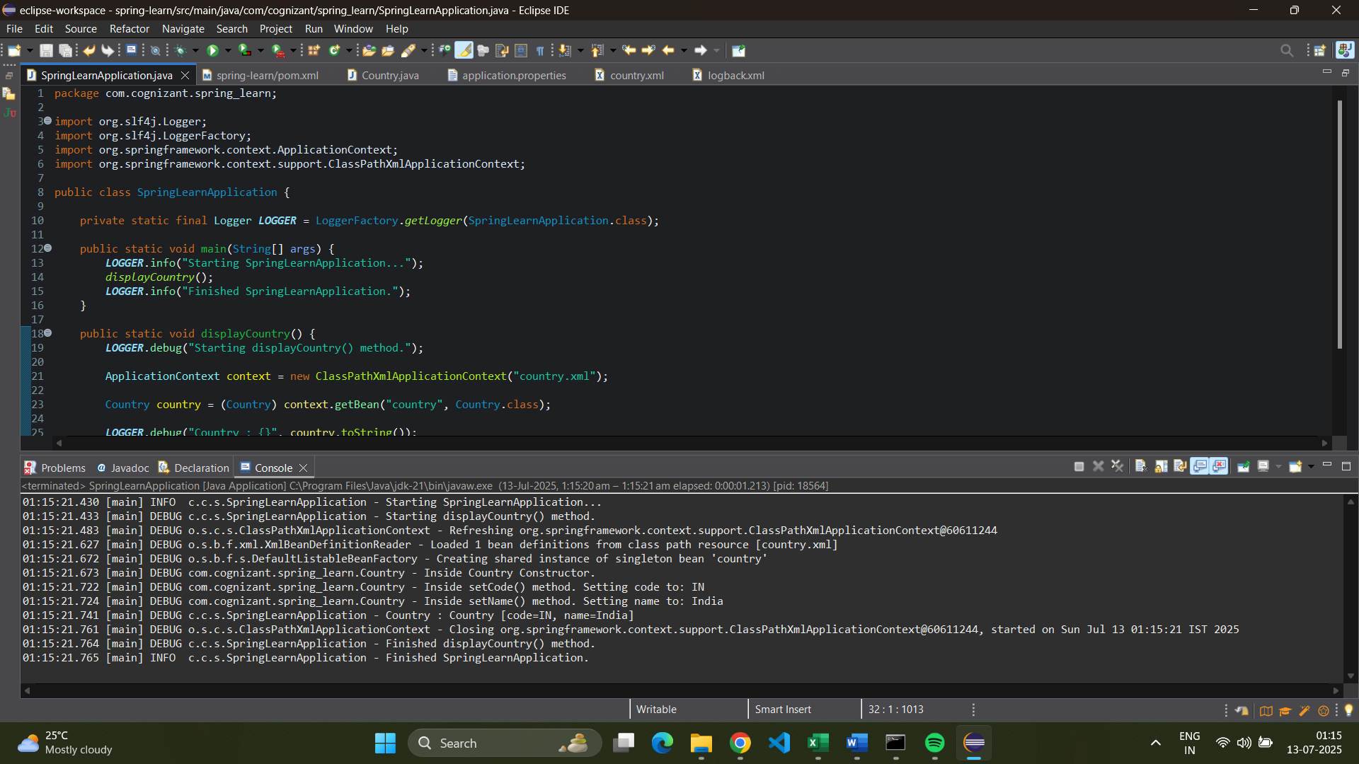

**Hands on**

**Hello World RESTful Web Service**

**Code:**

pom.xml

<?xml version="1.0" encoding="UTF-8"?>

<project xmlns="http://maven.apache.org/POM/4.0.0" xmlns:xsi="http://www.w3.org/2001/XMLSchema-instance"

xsi:schemaLocation="http://maven.apache.org/POM/4.0.0 https://maven.apache.org/xsd/maven-4.0.0.xsd">

<modelVersion>4.0.0</modelVersion>

<parent>

<groupId>org.springframework.boot</groupId>

<artifactId>spring-boot-starter-parent</artifactId>

<version>3.2.7</version>

<relativePath/>

</parent>

<groupId>com.cognizant</groupId>

<artifactId>spring-learn</artifactId>

<version>0.0.1-SNAPSHOT</version>

<name>spring-learn</name>

<description>Demo project for Spring Boot</description>

<properties>

<java.version>17</java.version>

</properties>

<dependencies>

<dependency>

<groupId>org.springframework.boot</groupId>

<artifactId>spring-boot-starter-web</artifactId>

</dependency>

<dependency>

<groupId>org.slf4j</groupId>

<artifactId>slf4j-api</artifactId>

<version>2.0.13</version>

</dependency>

<dependency>

<groupId>ch.qos.logback</groupId>

<artifactId>logback-classic</artifactId>

<version>1.5.6</version>

</dependency>

<dependency>

<groupId>ch.qos.logback</groupId>

<artifactId>logback-core</artifactId>

<version>1.5.6</version>

</dependency>

<dependency>

<groupId>org.springframework.boot</groupId>

<artifactId>spring-boot-starter-test</artifactId>

<scope>test</scope>

</dependency>

</dependencies>

<build>

<plugins>

<plugin>

<groupId>org.springframework.boot</groupId>

<artifactId>spring-boot-maven-plugin</artifactId>

</plugin>

</plugins>

</build>

</project>

HelloController.java

package com.cognizant.spring_learn.controller;

import org.slf4j.Logger;

import org.slf4j.LoggerFactory;

import org.springframework.web.bind.annotation.GetMapping;

import org.springframework.web.bind.annotation.RestController;

*@RestController*

public class HelloController {

private static final Logger ***LOGGER*** = LoggerFactory.*getLogger*(HelloController.class);

*@GetMapping*("/hello")

public String sayHello() {

***LOGGER***.info("START - sayHello() method");

String message = "Hello World!!";

***LOGGER***.info("END - sayHello() method");

return message;

}

}

SpringLearnApplication.java

package com.cognizant.spring_learn;

import org.slf4j.Logger;

import org.slf4j.LoggerFactory;

import org.springframework.boot.SpringApplication;

import org.springframework.boot.autoconfigure.SpringBootApplication;

import org.springframework.context.ApplicationContext;

import org.springframework.context.support.ClassPathXmlApplicationContext;

*@SpringBootApplication*

public class SpringLearnApplication {

private static final Logger ***LOGGER*** = LoggerFactory.*getLogger*(SpringLearnApplication.class);

public static void main(String[] args) {

***LOGGER***.info("Starting SpringLearnApplication as Spring Boot Web Application...");

SpringApplication.*run*(SpringLearnApplication.class, args);

***LOGGER***.info("SpringLearnApplication started.");

}

public static void displayCountry() {

***LOGGER***.debug("Starting displayCountry() method.");

ApplicationContext context = new ClassPathXmlApplicationContext("country.xml");

Country country = (Country) context.getBean("country", Country.class);

***LOGGER***.debug("Country : {}", country.toString());

((ClassPathXmlApplicationContext) context).close(); // Close the context

***LOGGER***.debug("Finished displayCountry() method.");

}

}

application.properties

spring.application.name=spring-learn

server.port=8083

**Output:**

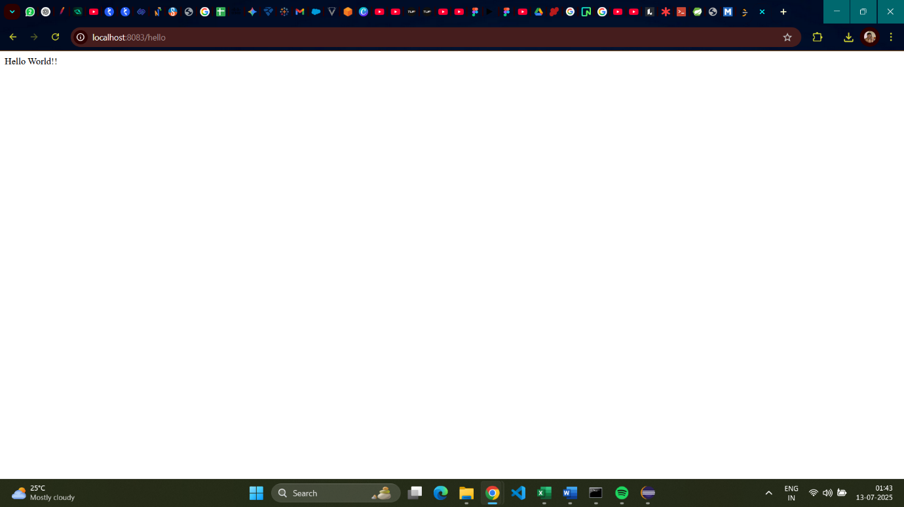

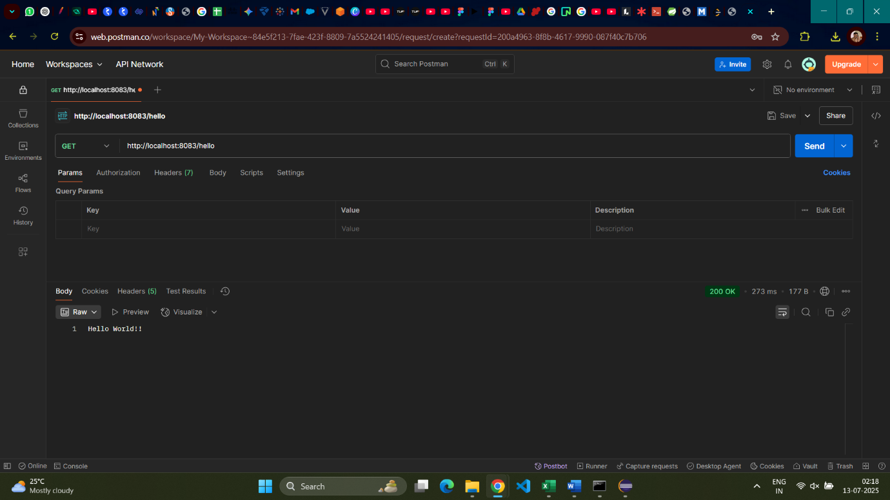

**Hands on**

**REST – Country Web Services**

**Code:**

pom.xml

<?xml version="1.0" encoding="UTF-8"?>

<project xmlns="http://maven.apache.org/POM/4.0.0" xmlns:xsi="http://www.w3.org/2001/XMLSchema-instance"

xsi:schemaLocation="http://maven.apache.org/POM/4.0.0 https://maven.apache.org/xsd/maven-4.0.0.xsd">

<modelVersion>4.0.0</modelVersion>

<parent>

<groupId>org.springframework.boot</groupId>

<artifactId>spring-boot-starter-parent</artifactId>

<version>3.2.7</version>

<relativePath/>

</parent>

<groupId>com.cognizant</groupId>

<artifactId>spring-learn</artifactId>

<version>0.0.1-SNAPSHOT</version>

<name>spring-learn</name>

<description>Demo project for Spring Boot</description>

<properties>

<java.version>17</java.version>

</properties>

<dependencies>

<dependency>

<groupId>org.springframework.boot</groupId>

<artifactId>spring-boot-starter-web</artifactId>

</dependency>

<dependency>

<groupId>org.slf4j</groupId>

<artifactId>slf4j-api</artifactId>

<version>2.0.13</version>

</dependency>

<dependency>

<groupId>ch.qos.logback</groupId>

<artifactId>logback-classic</artifactId>

<version>1.5.6</version>

</dependency>

<dependency>

<groupId>ch.qos.logback</groupId>

<artifactId>logback-core</artifactId>

<version>1.5.6</version>

</dependency>

<dependency>

<groupId>org.springframework.boot</groupId>

<artifactId>spring-boot-starter-test</artifactId>

<scope>test</scope>

</dependency>

</dependencies>

<build>

<plugins>

<plugin>

<groupId>org.springframework.boot</groupId>

<artifactId>spring-boot-maven-plugin</artifactId>

</plugin>

</plugins>

</build>

</project>

Country.java

package com.cognizant.spring_learn;

import org.slf4j.Logger;

import org.slf4j.LoggerFactory;

public class Country {

private static final Logger ***LOGGER*** = LoggerFactory.*getLogger*(Country.class);

private String code;

private String name;

public Country() {

***LOGGER***.debug("Inside Country Constructor.");

}

public String getCode() {

***LOGGER***.debug("Inside getCode() method.");

return code;

}

public void setCode(String code) {

***LOGGER***.debug("Inside setCode() method. Setting code to: {}", code);

this.code = code;

}

public String getName() {

***LOGGER***.debug("Inside getName() method.");

return name;

}

public void setName(String name) {

***LOGGER***.debug("Inside setName() method. Setting name to: {}", name);

this.name = name;

}

*@Override*

public String toString() {

return "Country [code=" + code + ", name=" + name + "]";

}

}

CountryController.java

package com.cognizant.spring_learn.controller;

import com.cognizant.spring_learn.Country;

import org.slf4j.Logger;

import org.slf4j.LoggerFactory;

import org.springframework.context.ApplicationContext;

import org.springframework.context.support.ClassPathXmlApplicationContext;

import org.springframework.web.bind.annotation.RequestMapping;

import org.springframework.web.bind.annotation.RestController;

*@RestController*

public class CountryController {

private static final Logger ***LOGGER*** = LoggerFactory.*getLogger*(CountryController.class);

*@RequestMapping*("/country")

public Country getCountryIndia() {

***LOGGER***.info("START - getCountryIndia() method");

ApplicationContext context = new ClassPathXmlApplicationContext("country.xml");

Country country = (Country) context.getBean("country", Country.class);

((ClassPathXmlApplicationContext) context).close();

***LOGGER***.info("END - getCountryIndia() method");

return country;

}

}

SpringLearnApplication.java

package com.cognizant.spring_learn;

import org.slf4j.Logger;

import org.slf4j.LoggerFactory;

import org.springframework.boot.SpringApplication;

import org.springframework.boot.autoconfigure.SpringBootApplication;

import org.springframework.context.ApplicationContext;

import org.springframework.context.support.ClassPathXmlApplicationContext;

*@SpringBootApplication*

public class SpringLearnApplication {

private static final Logger ***LOGGER*** = LoggerFactory.*getLogger*(SpringLearnApplication.class);

public static void main(String[] args) {

***LOGGER***.info("Starting SpringLearnApplication as Spring Boot Web Application...");

SpringApplication.*run*(SpringLearnApplication.class, args);

***LOGGER***.info("SpringLearnApplication started.");

}

public static void displayCountry() {

***LOGGER***.debug("Starting displayCountry() method.");

ApplicationContext context = new ClassPathXmlApplicationContext("country.xml");

Country country = (Country) context.getBean("country", Country.class);

***LOGGER***.debug("Country : {}", country.toString());

((ClassPathXmlApplicationContext) context).close(); // Close the context

***LOGGER***.debug("Finished displayCountry() method.");

}

}

country.xml

<?xml version="1.0" encoding="UTF-8"?>

<beans xmlns="http://www.springframework.org/schema/beans"

xmlns:xsi="http://www.w3.org/2001/XMLSchema-instance"

xsi:schemaLocation="http://www.springframework.org/schema/beans

http://www.springframework.org/schema/beans/spring-beans.xsd">

<bean id="country" class="com.cognizant.spring_learn.Country">

<property name="code" value="IN" />

<property name="name" value="India" />

</bean>

</beans>

application.properties

spring.application.name=spring-learn

server.port=8083

logback.xml

<?xml version="1.0" encoding="UTF-8"?>

<configuration>

<appender name="STDOUT" class="ch.qos.logback.core.ConsoleAppender">

<encoder>

<pattern>%d{HH:mm:ss.SSS} [%thread] %-5level %logger{36} - %msg%n</pattern>

</encoder>

</appender>

<root level="DEBUG">

<appender-ref ref="STDOUT" />

</root>

<logger name="com.cognizant.springlearn" level="DEBUG" additivity="false">

<appender-ref ref="STDOUT" />

</logger>

</configuration>

**Output:**

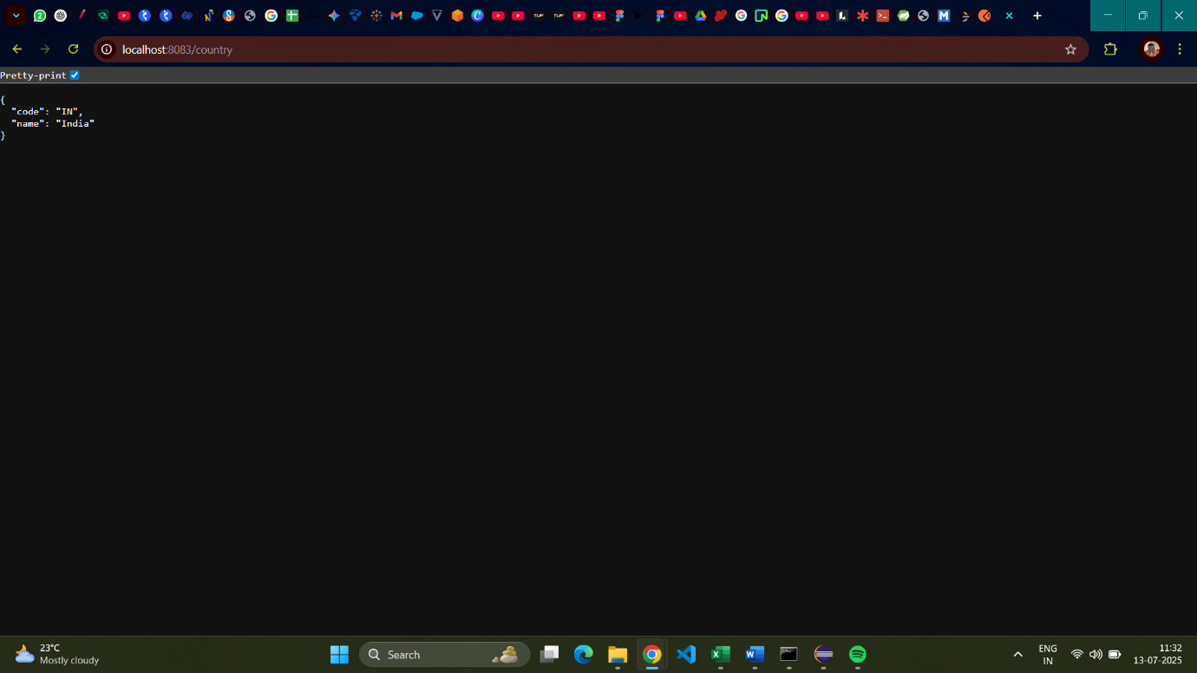

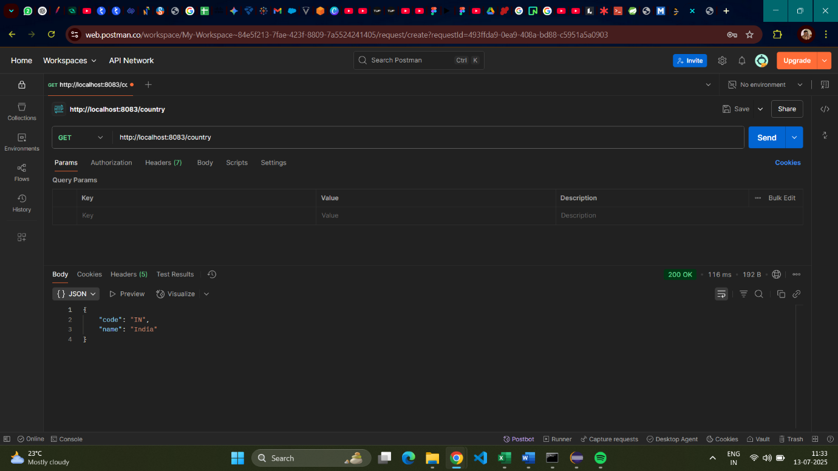

**Hands on**

**REST – Get country based on country code**

**Code:**

pom.xml

<?xml version="1.0" encoding="UTF-8"?>

<project xmlns="http://maven.apache.org/POM/4.0.0" xmlns:xsi="http://www.w3.org/2001/XMLSchema-instance"

xsi:schemaLocation="http://maven.apache.org/POM/4.0.0 https://maven.apache.org/xsd/maven-4.0.0.xsd">

<modelVersion>4.0.0</modelVersion>

<parent>

<groupId>org.springframework.boot</groupId>

<artifactId>spring-boot-starter-parent</artifactId>

<version>3.2.7</version>

<relativePath/>

</parent>

<groupId>com.cognizant</groupId>

<artifactId>spring-learn</artifactId>

<version>0.0.1-SNAPSHOT</version>

<name>spring-learn</name>

<description>Demo project for Spring Rest</description>

<properties>

<java.version>17</java.version>

</properties>

<dependencies>

<dependency>

<groupId>org.springframework.boot</groupId>

<artifactId>spring-boot-starter-web</artifactId>

</dependency>

<dependency>

<groupId>org.slf4j</groupId>

<artifactId>slf4j-api</artifactId>

<version>2.0.13</version>

</dependency>

<dependency>

<groupId>ch.qos.logback</groupId>

<artifactId>logback-classic</artifactId>

<version>1.5.6</version>

</dependency>

<dependency>

<groupId>ch.qos.logback</groupId>

<artifactId>logback-core</artifactId>

<version>1.5.6</version>

</dependency>

<dependency>

<groupId>org.springframework.boot</groupId>

<artifactId>spring-boot-starter-test</artifactId>

<scope>test</scope>

</dependency>

</dependencies>

<build>

<plugins>

<plugin>

<groupId>org.springframework.boot</groupId>

<artifactId>spring-boot-maven-plugin</artifactId>

</plugin>

</plugins>

</build>

</project>

CountryService.java

package com.cognizant.spring_learn.service;

import com.cognizant.spring_learn.Country;

import com.cognizant.spring_learn.service.exception.CountryNotFoundException;

import org.slf4j.Logger;

import org.slf4j.LoggerFactory;

import org.springframework.context.ApplicationContext;

import org.springframework.context.support.ClassPathXmlApplicationContext;

import org.springframework.stereotype.Service;

import java.util.List;

import java.util.Optional;

*@Service*

public class CountryService {

private static final Logger ***LOGGER*** = LoggerFactory.*getLogger*(CountryService.class);

private List<Country> countries;

public CountryService() {

***LOGGER***.info("START - CountryService Constructor");

ApplicationContext context = new ClassPathXmlApplicationContext("country.xml");

this.countries = (List<Country>) context.getBean("countryList");

((ClassPathXmlApplicationContext) context).close();

***LOGGER***.info("END - CountryService Constructor");

}

public Country getCountry(String code) throws CountryNotFoundException {

***LOGGER***.info("START - getCountry() service method with code: {}", code);

Optional<Country> foundCountry = countries.stream()

.filter(country -> country.getCode().equalsIgnoreCase(code))

.findFirst();

if (foundCountry.isPresent()) {

***LOGGER***.info("END - getCountry() service method, found country: {}", foundCountry.get());

return foundCountry.get();

} else {

***LOGGER***.error("Country with code '{}' not found.", code);

throw new CountryNotFoundException("Country with code '" + code + "' not found.");

}

}

}

CountryController.java

package com.cognizant.spring_learn.controller;

import com.cognizant.spring_learn.Country;

import com.cognizant.spring_learn.service.CountryService;

import org.slf4j.Logger;

import org.slf4j.LoggerFactory;

import org.springframework.beans.factory.annotation.Autowired;

import org.springframework.context.ApplicationContext;

import org.springframework.context.support.ClassPathXmlApplicationContext;

import org.springframework.web.bind.annotation.GetMapping;

import org.springframework.web.bind.annotation.PathVariable;

import org.springframework.web.bind.annotation.RequestMapping;

import org.springframework.web.bind.annotation.RestController;

*@RestController*

public class CountryController {

private static final Logger ***LOGGER*** = LoggerFactory.*getLogger*(CountryController.class);

*@Autowired*

private CountryService countryService;

*@RequestMapping*("/country")

public Country getCountryIndia() {

***LOGGER***.info("START - getCountryIndia() method");

ApplicationContext context = new ClassPathXmlApplicationContext("country.xml");

Country country = (Country) context.getBean("inCountry", Country.class);

((ClassPathXmlApplicationContext) context).close();

***LOGGER***.info("END - getCountryIndia() method");

return country;

}

*@GetMapping*("/countries/{code}")

public Country getCountry(*@PathVariable*("code") String code) {

***LOGGER***.info("START - getCountry() controller method with code: {}", code);

Country country = countryService.getCountry(code);

***LOGGER***.info("END - getCountry() controller method, returning: {}", country);

return country;

}

}

Country.java

package com.cognizant.spring_learn;

import org.slf4j.Logger;

import org.slf4j.LoggerFactory;

public class Country {

private static final Logger ***LOGGER*** = LoggerFactory.*getLogger*(Country.class);

private String code;

private String name;

public Country() {

***LOGGER***.debug("Inside Country Constructor.");

}

public String getCode() {

***LOGGER***.debug("Inside getCode() method.");

return code;

}

public void setCode(String code) {

***LOGGER***.debug("Inside setCode() method. Setting code to: {}", code);

this.code = code;

}

public String getName() {

***LOGGER***.debug("Inside getName() method.");

return name;

}

public void setName(String name) {

***LOGGER***.debug("Inside setName() method. Setting name to: {}", name);

this.name = name;

}

*@Override*

public String toString() {

return "Country [code=" + code + ", name=" + name + "]";

}

}

SpringLearnApplication.java

package com.cognizant.spring_learn;

import org.slf4j.Logger;

import org.slf4j.LoggerFactory;

import org.springframework.boot.SpringApplication;

import org.springframework.boot.autoconfigure.SpringBootApplication;

import org.springframework.context.ApplicationContext;

import org.springframework.context.support.ClassPathXmlApplicationContext;

*@SpringBootApplication*

public class SpringLearnApplication {

private static final Logger ***LOGGER*** = LoggerFactory.*getLogger*(SpringLearnApplication.class);

public static void main(String[] args) {

***LOGGER***.info("Starting SpringLearnApplication as Spring Boot Web Application...");

SpringApplication.*run*(SpringLearnApplication.class, args);

***LOGGER***.info("SpringLearnApplication started.");

}

public static void displayCountry() {

***LOGGER***.debug("Starting displayCountry() method.");

ApplicationContext context = new ClassPathXmlApplicationContext("country.xml");

Country country = (Country) context.getBean("country", Country.class);

***LOGGER***.debug("Country : {}", country.toString());

((ClassPathXmlApplicationContext) context).close(); // Close the context

***LOGGER***.debug("Finished displayCountry() method.");

}

}

CountryNotFoundException.java

package com.cognizant.spring_learn.service.exception;

import org.springframework.http.HttpStatus;

import org.springframework.web.bind.annotation.ResponseStatus;

*@ResponseStatus*(*HttpStatus*.***NOT_FOUND***)

public class CountryNotFoundException extends RuntimeException {

public CountryNotFoundException(String message) {

super(message);

}

}

application.properties

spring.application.name=spring-learn

server.port=8083

country.xml

<?xml version="1.0" encoding="UTF-8"?>

<beans xmlns="http://www.springframework.org/schema/beans"

xmlns:xsi="http://www.w3.org/2001/XMLSchema-instance"

xmlns:context="http://www.springframework.org/schema/context"

xsi:schemaLocation="http://www.springframework.org/schema/beans

http://www.springframework.org/schema/beans/spring-beans.xsd

http://www.springframework.org/schema/context

http://www.springframework.org/schema/context/spring-context.xsd">

<context:annotation-config/>

<bean id="inCountry" class="com.cognizant.spring_learn.Country">

<property name="code" value="IN"/>

<property name="name" value="India"/>

</bean>

<bean id="usCountry" class="com.cognizant.spring_learn.Country">

<property name="code" value="US"/>

<property name="name" value="United States"/>

</bean>

<bean id="auCountry" class="com.cognizant.spring_learn.Country">

<property name="code" value="AU"/>

<property name="name" value="Australia"/>

</bean>

<bean id="countryList" class="java.util.ArrayList">

<constructor-arg>

<list>

<ref bean="inCountry"/>

<ref bean="usCountry"/>

<ref bean="auCountry"/>

</list>

</constructor-arg>

</bean>

</beans>

logback.xml

<?xml version="1.0" encoding="UTF-8"?>

<configuration>

<appender name="STDOUT" class="ch.qos.logback.core.ConsoleAppender">

<encoder>

<pattern>%d{HH:mm:ss.SSS} [%thread] %-5level %logger{36} - %msg%n</pattern>

</encoder>

</appender>

<root level="DEBUG">

<appender-ref ref="STDOUT" />

</root>

<logger name="com.cognizant.springlearn" level="DEBUG" additivity="false">

<appender-ref ref="STDOUT" />

</logger>

</configuration>

**Output:**

