**Hands on  
Creating Microservices for account and loan**

1. Account Microservice

**Code:**

pom.xml

<?xml version="1.0" encoding="UTF-8"?>

<project xmlns="http://maven.apache.org/POM/4.0.0" xmlns:xsi="http://www.w3.org/2001/XMLSchema-instance"

xsi:schemaLocation="http://maven.apache.org/POM/4.0.0 https://maven.apache.org/xsd/maven-4.0.0.xsd">

<modelVersion>4.0.0</modelVersion>

<parent>

<groupId>org.springframework.boot</groupId>

<artifactId>spring-boot-starter-parent</artifactId>

<version>3.5.3</version>

<relativePath/> <!-- lookup parent from repository -->

</parent>

<groupId>com.cognizant</groupId>

<artifactId>account</artifactId>

<version>0.0.1-SNAPSHOT</version>

<name>account</name>

<description>Account Microservice</description>

<url/>

<licenses>

<license/>

</licenses>

<developers>

<developer/>

</developers>

<scm>

<connection/>

<developerConnection/>

<tag/>

<url/>

</scm>

<properties>

<java.version>21</java.version>

</properties>

<dependencies>

<dependency>

<groupId>org.springframework.boot</groupId>

<artifactId>spring-boot-starter-web</artifactId>

</dependency>

<dependency>

<groupId>org.springframework.boot</groupId>

<artifactId>spring-boot-devtools</artifactId>

<scope>runtime</scope>

<optional>true</optional>

</dependency>

<dependency>

<groupId>org.springframework.boot</groupId>

<artifactId>spring-boot-starter-test</artifactId>

<scope>test</scope>

</dependency>

</dependencies>

<build>

<plugins>

<plugin>

<groupId>org.springframework.boot</groupId>

<artifactId>spring-boot-maven-plugin</artifactId>

</plugin>

</plugins>

</build>

</project>

AccountController.java

package com.cognizant.account.controller;

import org.slf4j.Logger;

import org.slf4j.LoggerFactory;

import org.springframework.web.bind.annotation.GetMapping;

import org.springframework.web.bind.annotation.PathVariable;

import org.springframework.web.bind.annotation.RestController;

import java.util.HashMap;

import java.util.Map;

*@RestController*

public class AccountController {

private static final Logger ***LOGGER*** = LoggerFactory.*getLogger*(AccountController.class);

*@GetMapping*("/accounts/{number}")

public Map<String, Object> getAccountDetails(*@PathVariable* String number) {

***LOGGER***.info("START - getAccountDetails() for account number: {}", number);

Map<String, Object> accountDetails = new HashMap<>();

accountDetails.put("number", number);

accountDetails.put("type", "savings");

accountDetails.put("balance", 234343);

***LOGGER***.info("END - getAccountDetails(), returning: {}", accountDetails);

return accountDetails;

}

}

AccountApplication.java

package com.cognizant.account;

import org.springframework.boot.SpringApplication;

import org.springframework.boot.autoconfigure.SpringBootApplication;

*@SpringBootApplication*

public class AccountApplication {

public static void main(String[] args) {

SpringApplication.*run*(AccountApplication.class, args);

}

}

application.properties

spring.application.name=loan

**Output:**

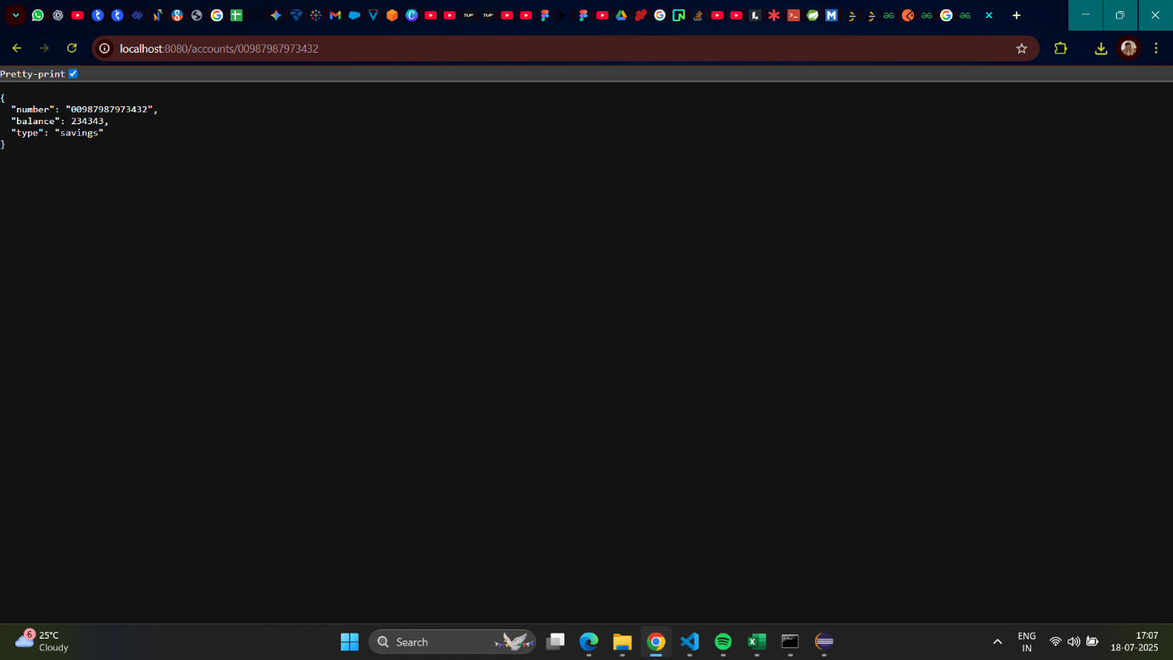

2. Loan Microservice

**Code:**

pom.xml

<?xml version="1.0" encoding="UTF-8"?>

<project xmlns="http://maven.apache.org/POM/4.0.0" xmlns:xsi="http://www.w3.org/2001/XMLSchema-instance"

xsi:schemaLocation="http://maven.apache.org/POM/4.0.0 https://maven.apache.org/xsd/maven-4.0.0.xsd">

<modelVersion>4.0.0</modelVersion>

<parent>

<groupId>org.springframework.boot</groupId>

<artifactId>spring-boot-starter-parent</artifactId>

<version>3.5.3</version>

<relativePath/> <!-- lookup parent from repository -->

</parent>

<groupId>com.cognizant</groupId>

<artifactId>loan</artifactId>

<version>0.0.1-SNAPSHOT</version>

<name>loan</name>

<description>Loan Microservice</description>

<url/>

<licenses>

<license/>

</licenses>

<developers>

<developer/>

</developers>

<scm>

<connection/>

<developerConnection/>

<tag/>

<url/>

</scm>

<properties>

<java.version>21</java.version>

</properties>

<dependencies>

<dependency>

<groupId>org.springframework.boot</groupId>

<artifactId>spring-boot-starter-web</artifactId>

</dependency>

<dependency>

<groupId>org.springframework.boot</groupId>

<artifactId>spring-boot-devtools</artifactId>

<scope>runtime</scope>

<optional>true</optional>

</dependency>

<dependency>

<groupId>org.springframework.boot</groupId>

<artifactId>spring-boot-starter-test</artifactId>

<scope>test</scope>

</dependency>

</dependencies>

<build>

<plugins>

<plugin>

<groupId>org.springframework.boot</groupId>

<artifactId>spring-boot-maven-plugin</artifactId>

</plugin>

</plugins>

</build>

</project>

LoanController.java

package com.cognizant.loan.controller;

import org.slf4j.Logger;

import org.slf4j.LoggerFactory;

import org.springframework.web.bind.annotation.GetMapping;

import org.springframework.web.bind.annotation.PathVariable;

import org.springframework.web.bind.annotation.RestController;

import java.util.HashMap;

import java.util.Map;

*@RestController*

public class LoanController {

private static final Logger ***LOGGER*** = LoggerFactory.*getLogger*(LoanController.class);

*@GetMapping*("/loans/{number}")

public Map<String, Object> getLoanDetails(*@PathVariable* String number) {

***LOGGER***.info("START - getLoanDetails() for loan number: {}", number);

Map<String, Object> loanDetails = new HashMap<>();

loanDetails.put("number", number);

loanDetails.put("type", "car");

loanDetails.put("loan", 400000);

loanDetails.put("emi", 3258);

loanDetails.put("tenure", 18);

***LOGGER***.info("END - getLoanDetails(), returning: {}", loanDetails);

return loanDetails;

}

}

LoanApplication.java

package com.cognizant.loan;

import org.springframework.boot.SpringApplication;

import org.springframework.boot.autoconfigure.SpringBootApplication;

*@SpringBootApplication*

public class LoanApplication {

public static void main(String[] args) {

SpringApplication.*run*(LoanApplication.class, args);

}

}

application.properties

spring.application.name=loan

server.port=8081

**Output:**

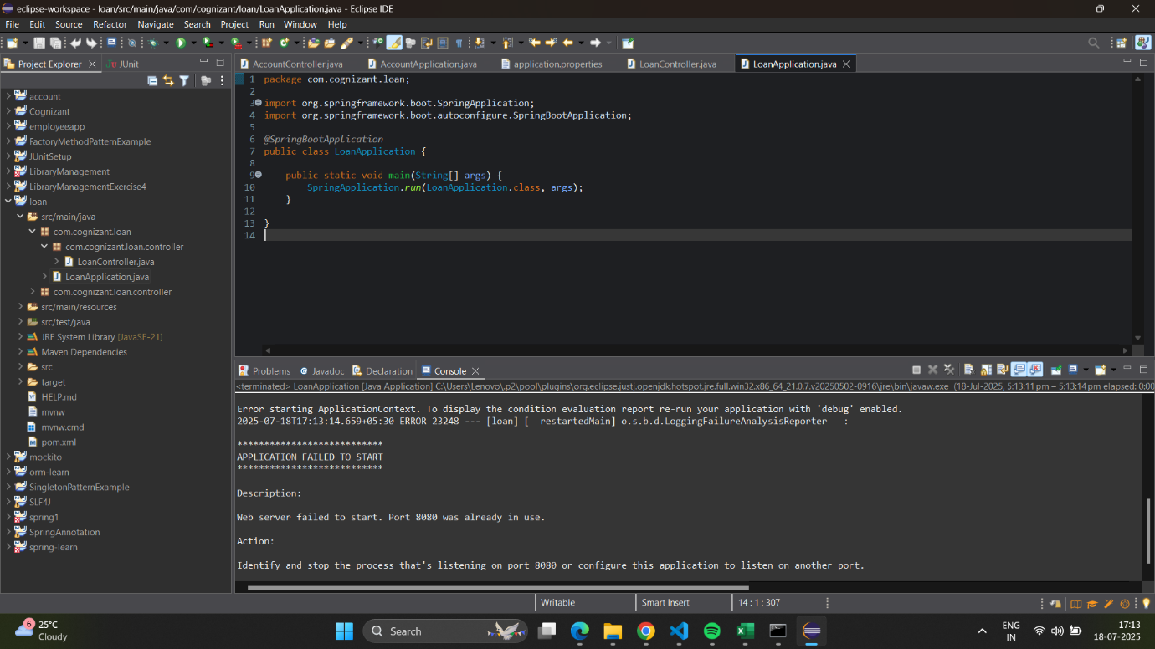

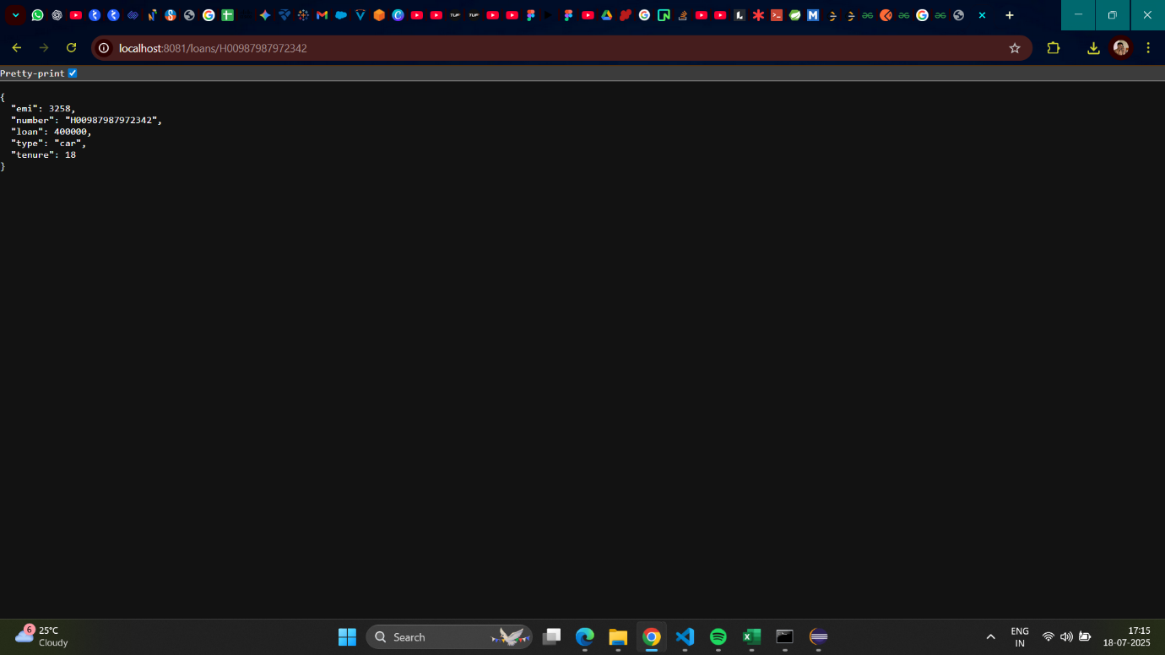

**Hands on  
Create Eureka Discovery Server and register microservices**

Part 1. Create and Launch Eureka Discovery Server

**Code:**

pom.xml

<?xml version="1.0" encoding="UTF-8"?>

<project xmlns="http://maven.apache.org/POM/4.0.0" xmlns:xsi="http://www.w3.org/2001/XMLSchema-instance"

xsi:schemaLocation="http://maven.apache.org/POM/4.0.0 https://maven.apache.org/xsd/maven-4.0.0.xsd">

<modelVersion>4.0.0</modelVersion>

<parent>

<groupId>org.springframework.boot</groupId>

<artifactId>spring-boot-starter-parent</artifactId>

<version>3.2.7</version>

<relativePath/> <!-- lookup parent from repository -->

</parent>

<groupId>com.cognizant</groupId>

<artifactId>eureka-discovery-server</artifactId>

<version>0.0.1-SNAPSHOT</version>

<name>eureka-discovery-server</name>

<description>Eureka Discovery Server for Microservices</description>

<properties>

<java.version>17</java.version>

<spring-cloud.version>2023.0.2</spring-cloud.version>

</properties>

<dependencies>

<dependency>

<groupId>org.springframework.cloud</groupId>

<artifactId>spring-cloud-starter-netflix-eureka-server</artifactId>

</dependency>

<dependency>

<groupId>org.springframework.boot</groupId>

<artifactId>spring-boot-starter-test</artifactId>

<scope>test</scope>

</dependency>

</dependencies>

<dependencyManagement>

<dependencies>

<dependency>

<groupId>org.springframework.cloud</groupId>

<artifactId>spring-cloud-dependencies</artifactId>

<version>${spring-cloud.version}</version>

<type>pom</type>

<scope>import</scope>

</dependency>

</dependencies>

</dependencyManagement>

<build>

<plugins>

<plugin>

<groupId>org.springframework.boot</groupId>

<artifactId>spring-boot-maven-plugin</artifactId>

</plugin>

</plugins>

</build>

</project>

EurekaDiscoveryServerApplication.java

package com.example.eureka_discovery_server;

import org.springframework.boot.SpringApplication;

import org.springframework.boot.autoconfigure.SpringBootApplication;

import org.springframework.cloud.netflix.eureka.server.EnableEurekaServer;

*@SpringBootApplication*

*@EnableEurekaServer*

public class EurekaDiscoveryServerApplication {

public static void main(String[] args) {

SpringApplication.*run*(EurekaDiscoveryServerApplication.class, args);

}

}

application.properties

spring.application.name=eureka-discovery-server

server.port=8761

eureka.client.register-with-eureka=false

eureka.client.fetch-registry=false

logging.level.com.netflix.eureka=OFF

logging.level.com.netflix.discovery=OFF

eureka.client.serviceUrl.defaultZone=http://localhost:8761/eureka/

**Output:**

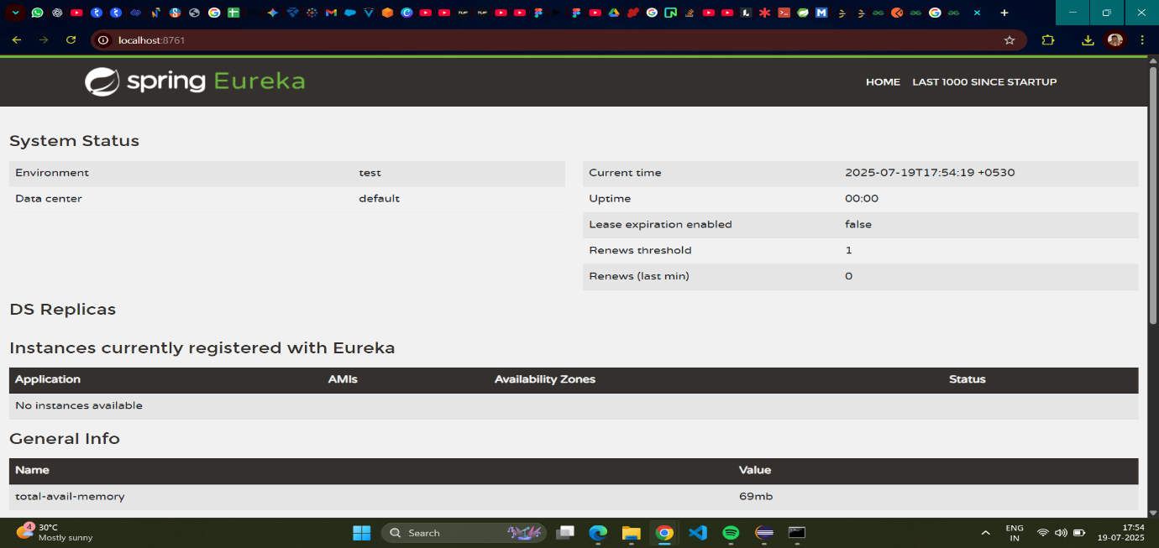

Part 2. Register Account Microservice with Eureka

**Code:**

pom.xml

<?xml version="1.0" encoding="UTF-8"?>

<project xmlns="http://maven.apache.org/POM/4.0.0" xmlns:xsi="http://www.w3.org/2001/XMLSchema-instance"

xsi:schemaLocation="http://maven.apache.org/POM/4.0.0 https://maven.apache.org/xsd/maven-4.0.0.xsd">

<modelVersion>4.0.0</modelVersion>

<parent>

<groupId>org.springframework.boot</groupId>

<artifactId>spring-boot-starter-parent</artifactId>

<version>3.2.7</version>

<relativePath/>

</parent>

<groupId>com.cognizant</groupId>

<artifactId>account</artifactId>

<version>0.0.1-SNAPSHOT</version>

<name>account</name>

<description>Account Microservice</description>

<properties>

<java.version>17</java.version>

<spring-cloud.version>2023.0.2</spring-cloud.version>

</properties>

<dependencies>

<dependency>

<groupId>org.springframework.boot</groupId>

<artifactId>spring-boot-starter-web</artifactId>

</dependency>

<dependency>

<groupId>org.springframework.boot</groupId>

<artifactId>spring-boot-devtools</artifactId>

<scope>runtime</scope>

<optional>true</optional>

</dependency>

<dependency>

<groupId>org.springframework.cloud</groupId>

<artifactId>spring-cloud-starter-netflix-eureka-client</artifactId>

</dependency>

<dependency>

<groupId>org.springframework.boot</groupId>

<artifactId>spring-boot-starter-test</artifactId>

<scope>test</scope>

</dependency>

</dependencies>

<dependencyManagement>

<dependencies>

<dependency>

<groupId>org.springframework.cloud</groupId>

<artifactId>spring-cloud-dependencies</artifactId>

<version>${spring-cloud.version}</version>

<type>pom</type>

<scope>import</scope>

</dependency>

</dependencies>

</dependencyManagement>

<build>

<plugins>

<plugin>

<groupId>org.springframework.boot</groupId>

<artifactId>spring-boot-maven-plugin</artifactId>

</plugin>

</plugins>

</build>

</project>

AccountApplication.java

package com.cognizant.account;

import org.springframework.boot.SpringApplication;

import org.springframework.boot.autoconfigure.SpringBootApplication;

import org.springframework.cloud.client.discovery.EnableDiscoveryClient;

*@SpringBootApplication*

*@EnableDiscoveryClient*

public class AccountApplication {

public static void main(String[] args) {

SpringApplication.*run*(AccountApplication.class, args);

}

}

application.properties

spring.application.name=account

server.port=8080

eureka.client.serviceUrl.defaultZone=http://localhost:8761/eureka/

**Output:**

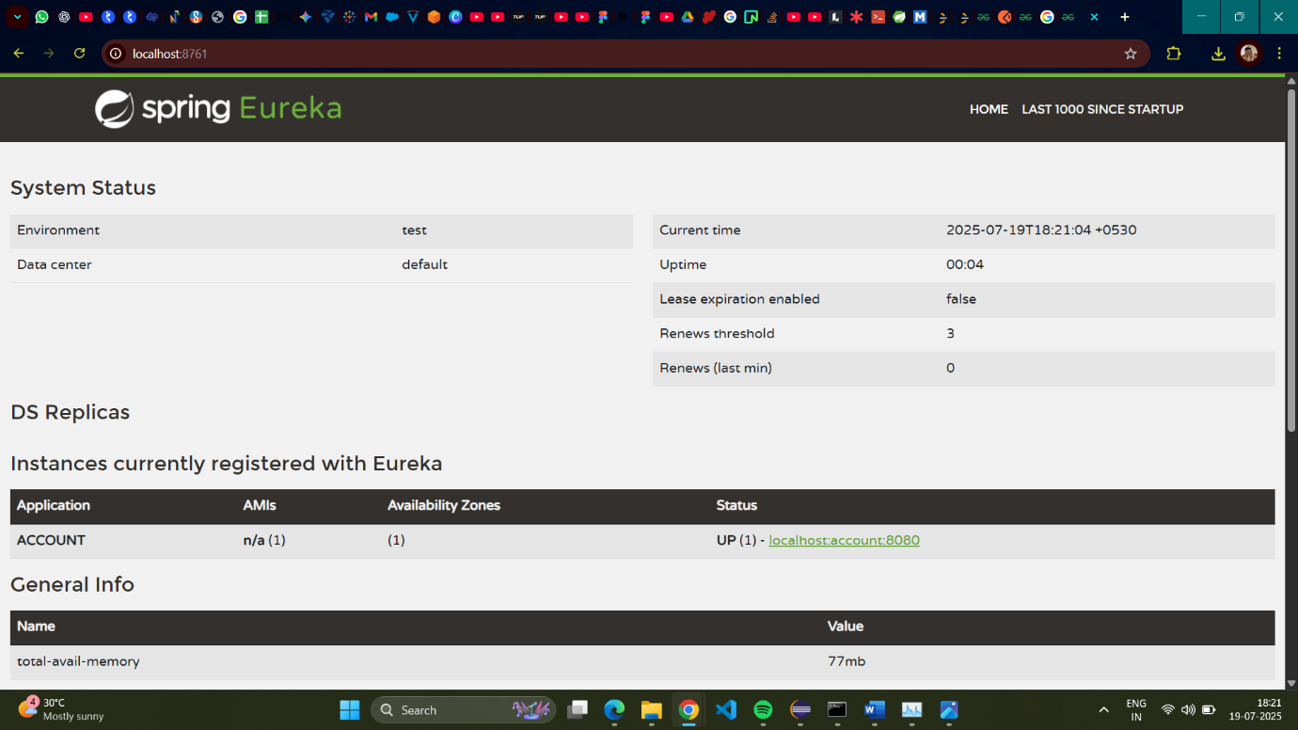

Part 3. Register Loan Microservice with Eureka

**Code:**

pom.xml

<?xml version="1.0" encoding="UTF-8"?>

<project xmlns="http://maven.apache.org/POM/4.0.0" xmlns:xsi="http://www.w3.org/2001/XMLSchema-instance"

xsi:schemaLocation="http://maven.apache.org/POM/4.0.0 https://maven.apache.org/xsd/maven-4.0.0.xsd">

<modelVersion>4.0.0</modelVersion>

<parent>

<groupId>org.springframework.boot</groupId>

<artifactId>spring-boot-starter-parent</artifactId>

<version>3.2.7</version>

<relativePath/> <!-- lookup parent from repository -->

</parent>

<groupId>com.cognizant</groupId>

<artifactId>loan</artifactId>

<version>0.0.1-SNAPSHOT</version>

<name>loan</name>

<description>Loan Microservice</description>

<properties>

<java.version>17</java.version>

<spring-cloud.version>2023.0.2</spring-cloud.version>

</properties>

<dependencies>

<dependency>

<groupId>org.springframework.boot</groupId>

<artifactId>spring-boot-starter-web</artifactId>

</dependency>

<dependency>

<groupId>org.springframework.boot</groupId>

<artifactId>spring-boot-devtools</artifactId>

<scope>runtime</scope>

<optional>true</optional>

</dependency>

<dependency>

<groupId>org.springframework.cloud</groupId>

<artifactId>spring-cloud-starter-netflix-eureka-client</artifactId>

</dependency>

<dependency>

<groupId>org.springframework.boot</groupId>

<artifactId>spring-boot-starter-test</artifactId>

<scope>test</scope>

</dependency>

</dependencies>

<dependencyManagement>

<dependencies>

<dependency>

<groupId>org.springframework.cloud</groupId>

<artifactId>spring-cloud-dependencies</artifactId>

<version>${spring-cloud.version}</version>

<type>pom</type>

<scope>import</scope>

</dependency>

</dependencies>

</dependencyManagement>

<build>

<plugins>

<plugin>

<groupId>org.springframework.boot</groupId>

<artifactId>spring-boot-maven-plugin</artifactId>

</plugin>

</plugins>

</build>

</project>

LoanApplication.java

package com.cognizant.loan;

import org.springframework.boot.SpringApplication;

import org.springframework.boot.autoconfigure.SpringBootApplication;

import org.springframework.cloud.client.discovery.EnableDiscoveryClient;

*@SpringBootApplication*

*@EnableDiscoveryClient*

public class LoanApplication {

public static void main(String[] args) {

SpringApplication.*run*(LoanApplication.class, args);

}

}

application.properties

spring.application.name=loan-service

server.port=8087

eureka.client.serviceUrl.defaultZone=http://localhost:8761/eureka/

**Output:**

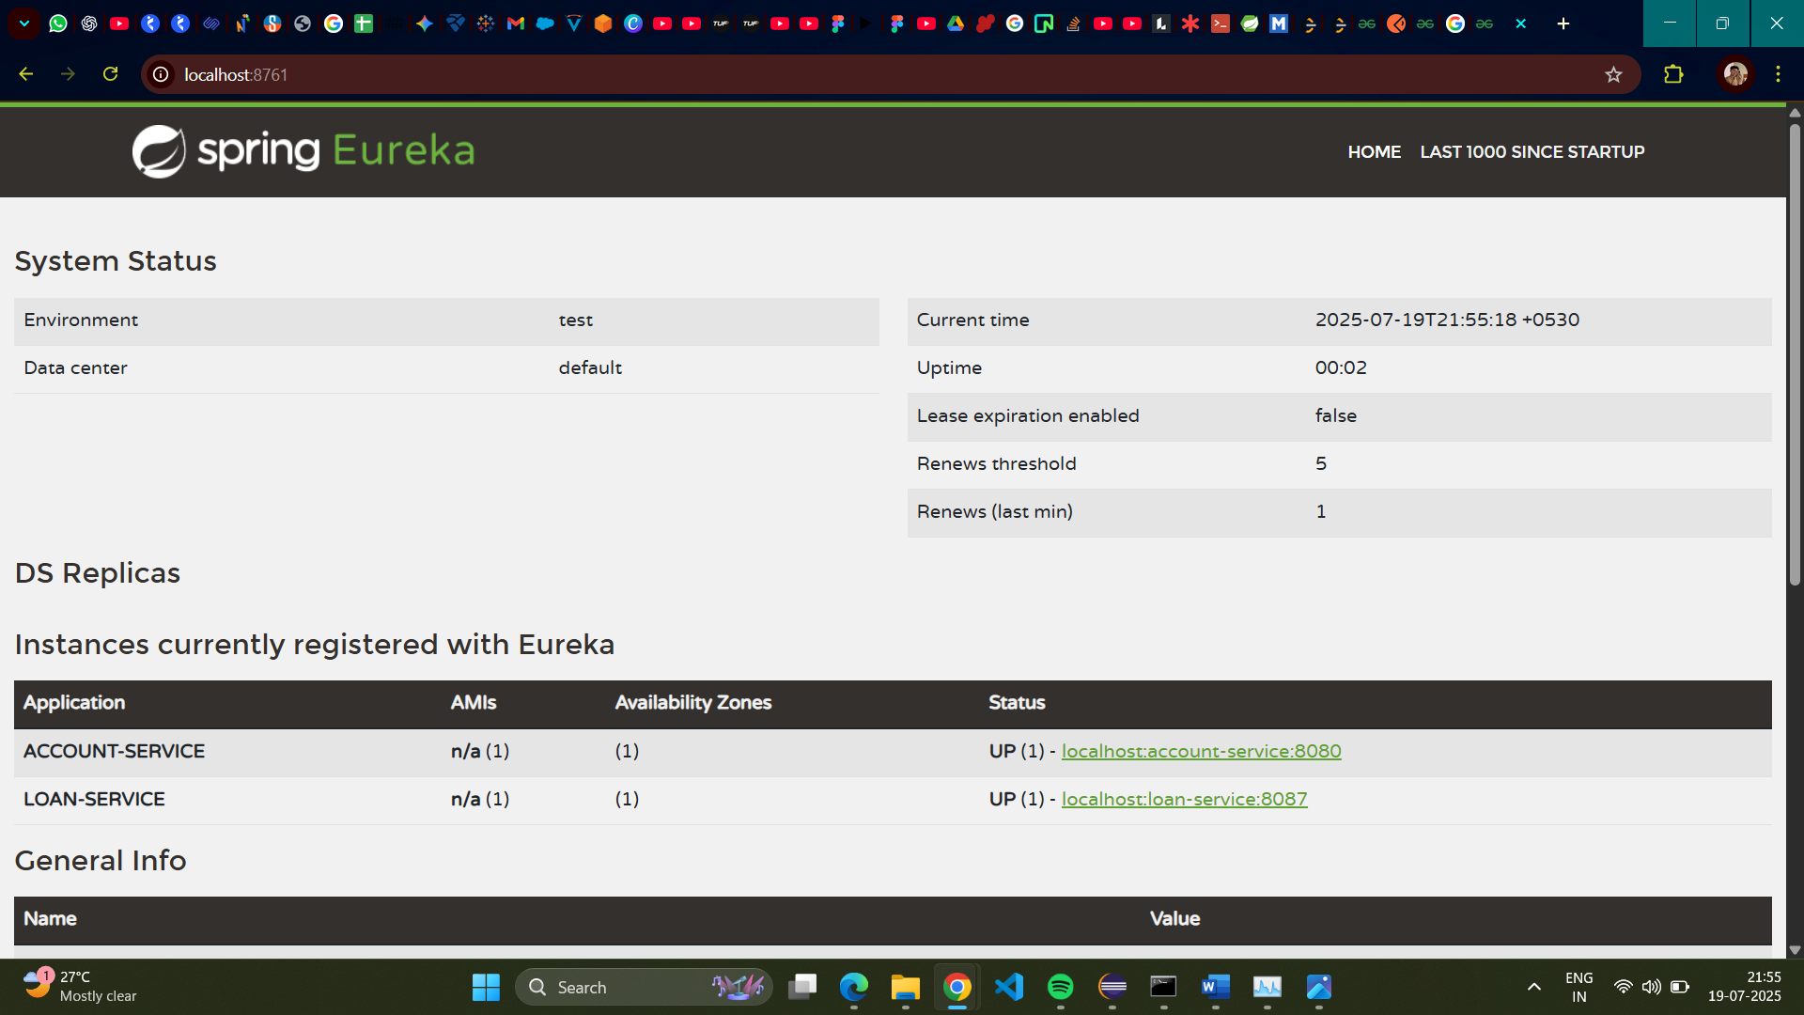

Part 4. Create Greet Microservice (for API Gateway Testing)

**Code:**

pom.xml

<?xml version="1.0" encoding="UTF-8"?>

<project xmlns="http://maven.apache.org/POM/4.0.0" xmlns:xsi="http://www.w3.org/2001/XMLSchema-instance"

xsi:schemaLocation="http://maven.apache.org/POM/4.0.0 https://maven.apache.org/xsd/maven-4.0.0.xsd">

<modelVersion>4.0.0</modelVersion>

<parent>

<groupId>org.springframework.boot</groupId>

<artifactId>spring-boot-starter-parent</artifactId>

<version>3.2.7</version>

<relativePath/> </parent>

<groupId>com.cognizant</groupId>

<artifactId>greet-service</artifactId>

<version>0.0.1-SNAPSHOT</version>

<name>greet-service</name>

<description>Demo project for Spring Boot Greet Service</description>

<properties>

<java.version>17</java.version>

<spring-cloud.version>2023.0.2</spring-cloud.version>

</properties>

<dependencies>

<dependency>

<groupId>org.springframework.boot</groupId>

<artifactId>spring-boot-starter-web</artifactId>

</dependency>

<dependency>

<groupId>org.springframework.boot</groupId>

<artifactId>spring-boot-devtools</artifactId>

<scope>runtime</scope>

<optional>true</optional>

</dependency>

<dependency>

<groupId>org.springframework.cloud</groupId>

<artifactId>spring-cloud-starter-netflix-eureka-client</artifactId>

</dependency>

<dependency>

<groupId>org.springframework.boot</groupId>

<artifactId>spring-boot-starter-test</artifactId>

<scope>test</scope>

</dependency>

</dependencies>

<dependencyManagement>

<dependencies>

<dependency>

<groupId>org.springframework.cloud</groupId>

<artifactId>spring-cloud-dependencies</artifactId>

<version>${spring-cloud.version}</version>

<type>pom</type>

<scope>import</scope>

</dependency>

</dependencies>

</dependencyManagement>

<build>

<plugins>

<plugin>

<groupId>org.springframework.boot</groupId>

<artifactId>spring-boot-maven-plugin</artifactId>

</plugin>

</plugins>

</build>

</project>

GreetController.java

package com.example.greet_service.controller;

import org.slf4j.Logger;

import org.slf4j.LoggerFactory;

import org.springframework.web.bind.annotation.GetMapping;

import org.springframework.web.bind.annotation.RestController;

*@RestController*

public class GreetController {

private static final Logger ***LOGGER*** = LoggerFactory.*getLogger*(GreetController.class);

*@GetMapping*("/greet")

public String greet() {

***LOGGER***.info("START - greet() method");

String message = "Hello World!!";

***LOGGER***.info("END - greet() method, returning: {}", message);

return message;

}

}

GreetServiceApplication.java

package com.example.greet_service;

import org.springframework.boot.SpringApplication;

import org.springframework.boot.autoconfigure.SpringBootApplication;

import org.springframework.cloud.client.discovery.EnableDiscoveryClient;

*@SpringBootApplication*

*@EnableDiscoveryClient*

public class GreetServiceApplication {

public static void main(String[] args) {

SpringApplication.*run*(GreetServiceApplication.class, args);

}

}

application.properties

server.port=8082

spring.application.name=greet-service

eureka.client.serviceUrl.defaultZone=http://localhost:8761/eureka/

**Output:**

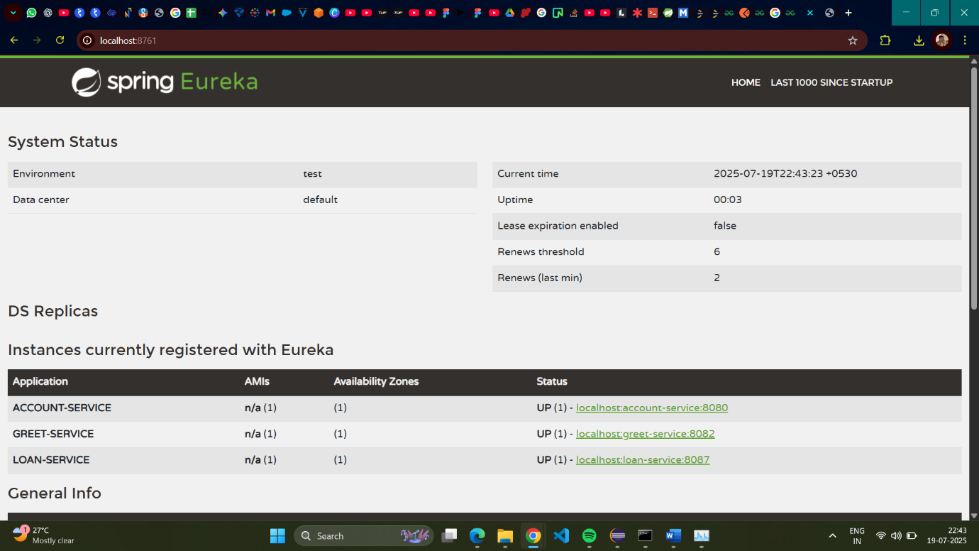

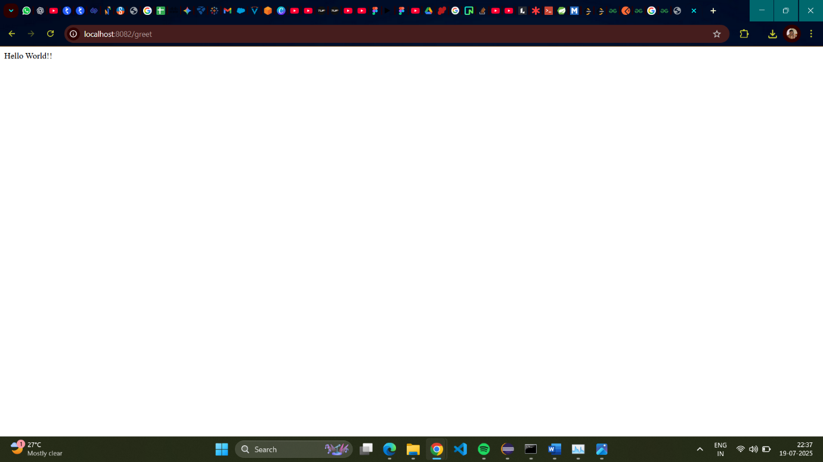

Part 5. Create Spring Cloud API Gateway

**Code:**

pom.xml

<?xml version="1.0" encoding="UTF-8"?>

<project xmlns="http://maven.apache.org/POM/4.0.0" xmlns:xsi="http://www.w3.org/2001/XMLSchema-instance"

xsi:schemaLocation="http://maven.apache.org/POM/4.0.0 https://maven.apache.org/xsd/maven-4.0.0.xsd">

<modelVersion>4.0.0</modelVersion>

<parent>

<groupId>org.springframework.boot</groupId>

<artifactId>spring-boot-starter-parent</artifactId>

<version>3.2.7</version>

<relativePath/> <!-- lookup parent from repository -->

</parent>

<groupId>com.cognizant</groupId>

<artifactId>api-gateway</artifactId>

<version>0.0.1-SNAPSHOT</version>

<name>api-gateway</name>

<description>Spring Cloud API Gateway</description>

<properties>

<java.version>17</java.version>

<spring-cloud.version>2023.0.2</spring-cloud.version>

</properties>

<dependencies>

<dependency>

<groupId>org.springframework.cloud</groupId>

<artifactId>spring-cloud-starter-gateway</artifactId>

</dependency>

<dependency>

<groupId>org.springframework.cloud</groupId>

<artifactId>spring-cloud-starter-netflix-eureka-client</artifactId>

</dependency>

<dependency>

<groupId>org.springframework.boot</groupId>

<artifactId>spring-boot-devtools</artifactId>

<scope>runtime</scope>

<optional>true</optional>

</dependency>

<dependency>

<groupId>org.springframework.boot</groupId>

<artifactId>spring-boot-starter-test</artifactId>

<scope>test</scope>

</dependency>

</dependencies>

<dependencyManagement>

<dependencies>

<dependency>

<groupId>org.springframework.cloud</groupId>

<artifactId>spring-cloud-dependencies</artifactId>

<version>${spring-cloud.version}</version>

<type>pom</type>

<scope>import</scope>

</dependency>

</dependencies>

</dependencyManagement>

<build>

<plugins>

<plugin>

<groupId>org.springframework.boot</groupId>

<artifactId>spring-boot-maven-plugin</artifactId>

</plugin>

</plugins>

</build>

</project>

ApiGatewayApplication.java

package com.example.api_gateway;

import org.springframework.boot.SpringApplication;

import org.springframework.boot.autoconfigure.SpringBootApplication;

import org.springframework.cloud.client.discovery.EnableDiscoveryClient;

import org.springframework.cloud.gateway.route.RouteLocator;

import org.springframework.cloud.gateway.route.builder.RouteLocatorBuilder;

import org.springframework.context.annotation.Bean;

*@SpringBootApplication*

*@EnableDiscoveryClient*

public class ApiGatewayApplication {

public static void main(String[] args) {

SpringApplication.*run*(ApiGatewayApplication.class, args);

}

*@Bean*

public RouteLocator customRouteLocator(RouteLocatorBuilder builder) {

return builder.routes()

.route(r -> r.path("/greet-service/**")

.filters(f -> f.rewritePath("/greet-service/(?<remaining>.*)", "/${remaining}"))

.uri("lb://GREET-SERVICE"))

.build();

}

}

LogFilter.java

package com.example.api_gateway.filter;

import org.slf4j.Logger;

import org.slf4j.LoggerFactory;

import org.springframework.cloud.gateway.filter.GatewayFilterChain;

import org.springframework.cloud.gateway.filter.GlobalFilter;

import org.springframework.core.Ordered;

import org.springframework.stereotype.Component;

import org.springframework.web.server.ServerWebExchange;

import reactor.core.publisher.Mono;

*@Component*

public class LogFilter implements GlobalFilter, Ordered {

private static final Logger ***LOGGER*** = LoggerFactory.*getLogger*(LogFilter.class);

*@Override*

public Mono<Void> filter(ServerWebExchange exchange, GatewayFilterChain chain) {

***LOGGER***.info("Global Pre-Filter executed: Path = {}, Method = {}",

exchange.getRequest().getPath(), exchange.getRequest().getMethod());

return chain.filter(exchange).then(Mono.*fromRunnable*(() -> {

***LOGGER***.info("Global Post-Filter executed: Status = {}", exchange.getResponse().getStatusCode());

}));

}

*@Override*

public int getOrder() {

return -1;

}

}

application.properties

server.port=9090

spring.application.name=api-gateway

eureka.client.serviceUrl.defaultZone=http://localhost:8761/eureka/

**Output:**

