**Hands on 9**

Create a React Application named “cricketapp”.

**Code:**

App.js

import React from 'react';

import { ListofPlayers } from './components/ListofPlayers';

import { Scorebelow70 } from './components/Scorebelow70';

import { players } from './playersData';

import { OddPlayers } from './components/OddPlayers';

import { EvenPlayers } from './components/EvenPlayers';

import { ListofIndianPlayers, IndianPlayers } from './components/ListofIndianPlayers';

function App() {

  const flag = false;

  const IndianTeamNames = [

    "Sachin1", "Dhoni2", "Virat3", "Rohit4", "Yuvraj5", "Raina6"

  ];

  if (flag === true) {

    return (

      <div>

        <h1>List of Players</h1>

        <*ListofPlayers* *players*={players} />

        <hr />

        <h1>List of Players having Scores Less than 70</h1>

        <*Scorebelow70* *players*={players} />

      </div>

    );

  } else {

    return (

      <div>

        <h1>Indian Team</h1>

          <h2>Odd Players</h2>

          <*OddPlayers* *players*={IndianTeamNames} />

          <hr />

          <h2>Even Players</h2>

          <*EvenPlayers* *players*={IndianTeamNames} />

          <hr />

          <h1>List of Indian Players Merged:</h1>

          <*ListofIndianPlayers* *IndianPlayers*={IndianPlayers} />

      </div>

    );

  }

}

export default App;

playersData.js

export const players = [

    { id: 1, name: "Jack", score: 50 },

    { id: 2, name: "Michael", score: 70 },

    { id: 3, name: "John", score: 40 },

    { id: 4, name: "Ann", score: 61 },

    { id: 5, name: "Elisabeth", score: 61 },

    { id: 6, name: "Sachin", score: 95 },

    { id: 7, name: "Dhoni", score: 100 },

    { id: 8, name: "Virat", score: 84 },

    { id: 9, name: "Jadeja", score: 64 },

    { id: 10, name: "Raina", score: 75 },

    { id: 11, name: "Rohit", score: 80 }

];

ListofPlayers.jsx

import React from 'react';

export const ListofPlayers = ({ *players* }) => {

    return (

        <div>

            <ul>

                {*players*.map(*item* => (

                    <li *key*={*item*.id}>

                        Mr. {*item*.name} <span>{*item*.score}</span>

                    </li>

                ))}

            </ul>

        </div>

    );

};

ListofIndianPlayers.jsx

import React from 'react';

const T20Players = ['First Player', 'Second Player', 'Third Player'];

const RanjiTrophyPlayers = ['Fourth Player', 'Fifth Player', 'Sixth Player'];

export const IndianPlayers = [...T20Players, ...RanjiTrophyPlayers];

export const ListofIndianPlayers = ({ *IndianPlayers* }) => {

    return (

        <div>

            <ul>

                {*IndianPlayers*.map((*player*, *index*) => (

                    <li *key*={*index*}>Mr. {*player*}</li>

                ))}

            </ul>

        </div>

    );

};

Scorebelow70.jsx

import React from 'react';

export const Scorebelow70 = ({ *players* }) => {

    const playersBelow70 = *players*.filter(*item* => *item*.score <= 70);

    return (

        <div>

            <ul>

                {playersBelow70.map(*item* => (

                    <li *key*={*item*.id}>

                        Mr. {*item*.name} <span>{*item*.score}</span>

                    </li>

                ))}

            </ul>

        </div>

    );

};

EvenPlayers.jsx

import React from 'react';

export function EvenPlayers({ *players* }) {

    const [, second, , fourth, , sixth] = *players*;

    return (

        <div>

            <ul>

                <li>Second : {second}</li>

                <li>Fourth : {fourth}</li>

                <li>Sixth : {sixth}</li>

            </ul>

        </div>

    );

}

OddPlayers.jsx

import React from 'react';

export function OddPlayers({ *players* }) {

    const [first, , third, , fifth] = *players*;

    return (

        <div>

            <ul>

                <li>First : {first}</li>

                <li>Third : {third}</li>

                <li>Fifth : {fifth}</li>

            </ul>

        </div>

    );

}

**Output:**

When flag = true

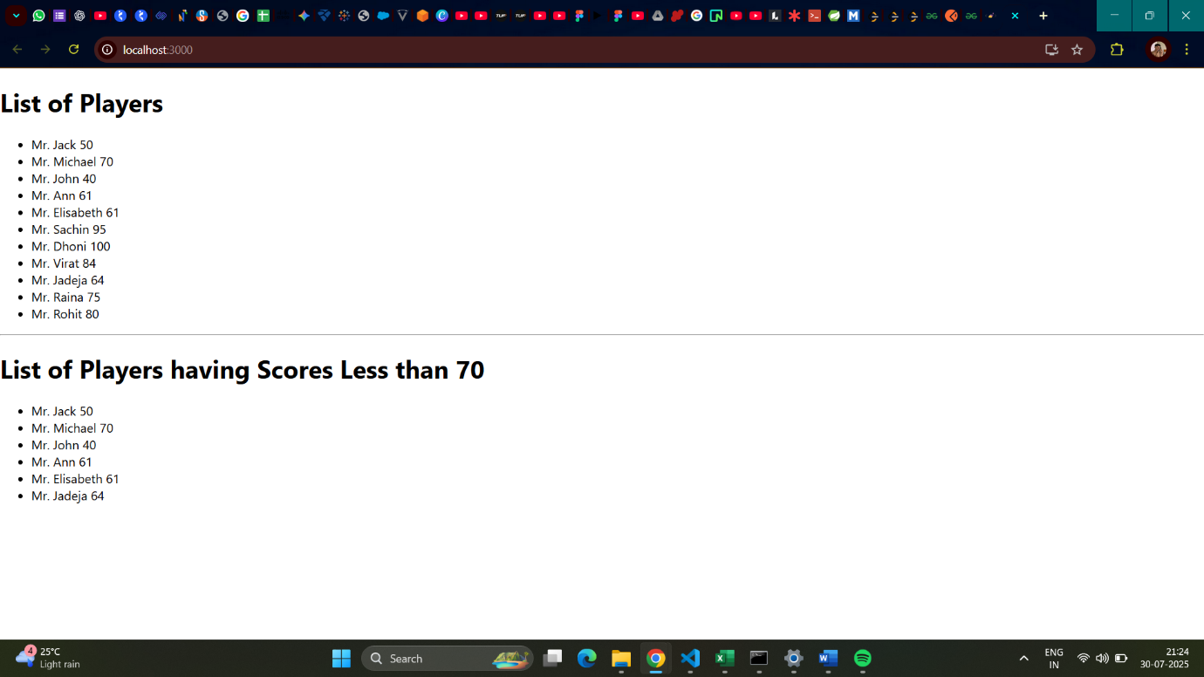

When flag = false

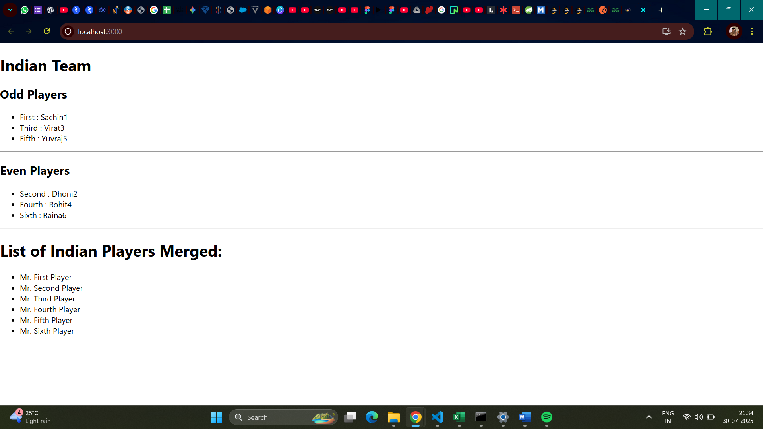

**Hands on 10**

Create a React Application named “officespacerentalapp” which uses React JSX to create elements, attributes and renders DOM to display the page.

**Code:**

App.js

import React from 'react';

import './App.css';

const OFFICE_IMAGE_URL = 'https://officebanao.com/wp-content/uploads/2024/06/office-with-lot-desks-computers.jpg';

const pageHeading = "Office Space";

const jsxatt = <img *src*={OFFICE_IMAGE_URL} *width*="25%" *height*="25%" *alt*="Office Space" />;

const ItemName = {

  Name: "DBS",

  Rent: 50000,

  Address: "Chennai"

};

const officeItems = [

  { id: 1, name: "Tech Hub Co.", rent: 75000, address: "Bangalore" },

  { id: 2, name: "Innovate Space", rent: 45000, address: "Hyderabad" },

  { id: 3, name: "City Towers", rent: 60000, address: "Mumbai" },

  { id: 4, name: "Green Offices", rent: 59999, address: "Delhi" },

  { id: 5, name: "Skyline Suite", rent: 82000, address: "Pune" }

];

function App() {

  const getRentStyle = (*rent*) => {

    return {

      color: *rent* <= 60000 ? 'red' : 'green',

      fontWeight: 'bold'

    };

  };

  return (

    <div *className*="App">

      <h1>{pageHeading}, at Affordable Range</h1>

      {jsxatt}

      <h1>Name: {ItemName.Name}</h1>

      <h3 *style*={getRentStyle(ItemName.Rent)}>

        Rent: Rs. {ItemName.Rent}

      </h3>

      <h3>Address: {ItemName.Address}</h3>

      <hr *style*={{ margin: '30px 0' }} />

      <h2>More Office Spaces:</h2>

      {officeItems.map(*office* => (

        <div *key*={*office*.id} *style*={{ marginBottom: '20px', border: '1px solid #ccc', padding: '15px', borderRadius: '8px' }}>

          <h3>Name: {*office*.name}</h3>

          <h3 *style*={getRentStyle(*office*.rent)}>

            Rent: Rs. {*office*.rent}

          </h3>

          <h3>Address: {*office*.address}</h3>

        </div>

      ))}

    </div>

  );

}

export default App;

**Output:**

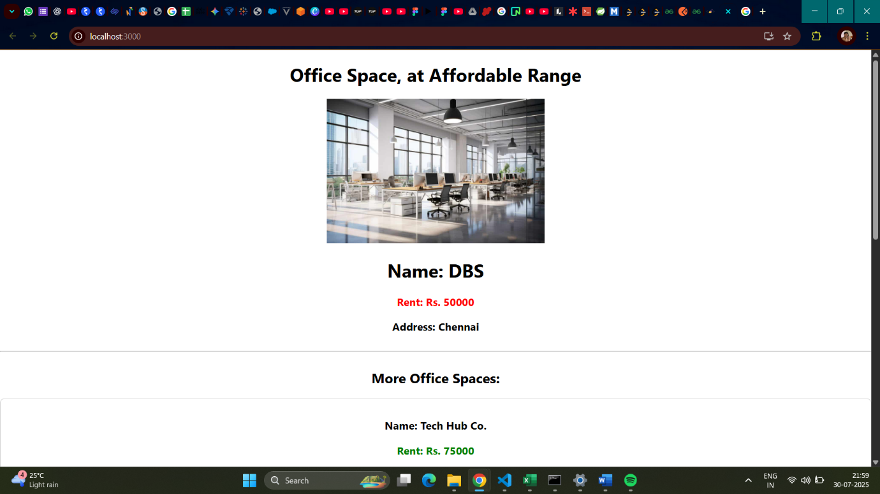

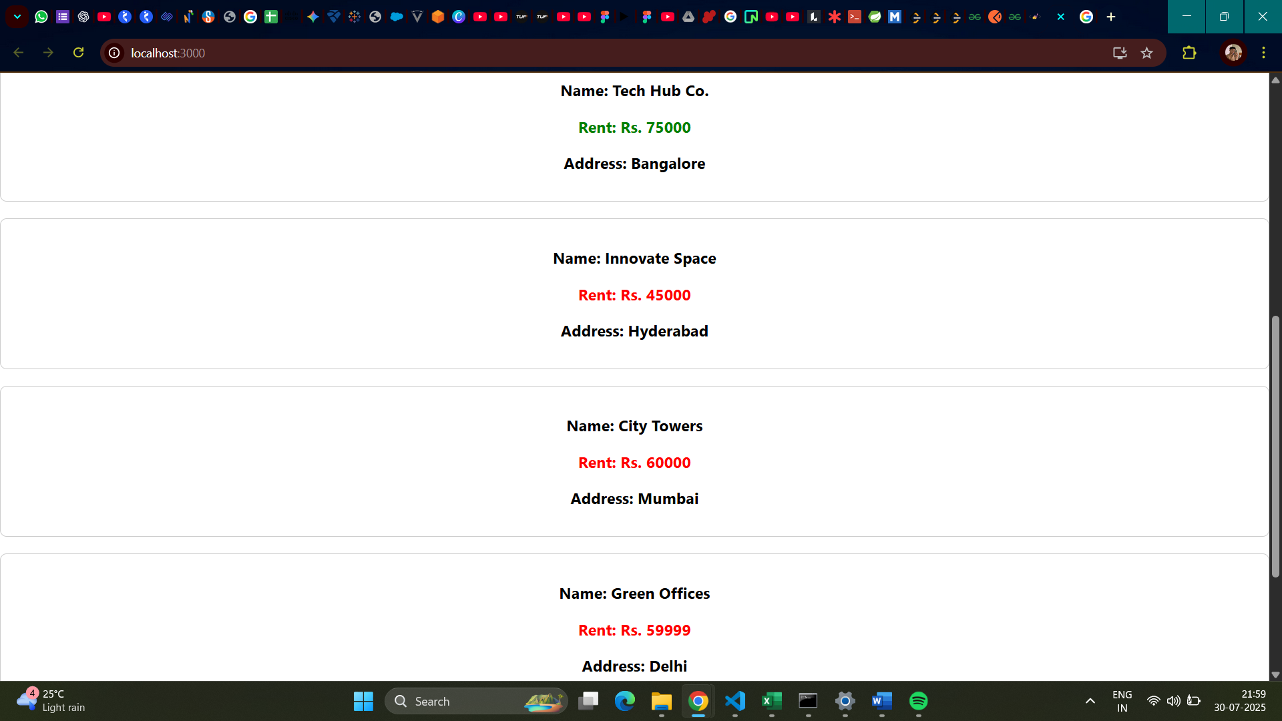

**Hands on 11**

Create a React Application “eventexamplesapp” to handle various events of the form elements in HTML.

Create a “CurrencyConvertor” component which will convert the Indian Rupees to Euro when the Convert button is clicked.

**Code:**

App.js

import React, { useState } from 'react';

import './App.css';

function App() {

  const [count, setCount] = useState(0);

  const [amount, setAmount] = useState('');

  const [currency, setCurrency] = useState('');

  const incrementCounter = () => {

    setCount(*prevCount* => *prevCount* + 1);

  };

  const sayHello = () => {

    alert("Hello! Member1");

  };

  const handleIncrementClick = () => {

    incrementCounter();

    sayHello();

  };

  const decrementCounter = () => {

    setCount(*prevCount* => *prevCount* - 1);

  };

  const sayWelcome = (*message*) => {

    alert(*message*);

  };

  const handleClickMe = (*event*) => {

    console.log("Synthetic Event:", *event*);

    console.log("Event type:", *event*.type);

    alert("I was clicked");

  };

  const handleAmountChange = (*e*) => {

    setAmount(*e*.target.value);

  };

  const handleCurrencyChange = (*e*) => {

    setCurrency(*e*.target.value);

  };

  const handleSubmit = (*e*) => {

*e*.preventDefault();

    const euroRate = 0.0099;

    const convertedAmount = parseFloat(amount) * euroRate;

    if (!isNaN(convertedAmount)) {

      alert(`Converting to Euro Amount is ${convertedAmount.toFixed(2)}`);

    } else {

      alert("Please enter a valid amount.");

    }

  };

  return (

    <div *className*="App">

      <h1>Counter: {count}</h1>

      <div *className*="button-group">

          <button *onClick*={handleIncrementClick}>Increment</button>

          <button *onClick*={decrementCounter}>Decrement</button>

          <button *onClick*={() => sayWelcome("Welcome")}>Say Welcome</button>

          <button *onClick*={handleClickMe}>Click on me</button>

      </div>

      <h1 *style*={{ color: 'green', marginTop: '40px' }}>Currency Convertor!!!</h1>

      <form *onSubmit*={handleSubmit} *className*="currency-form">

        <div *className*="form-group">

          <label *htmlFor*="amount">Amount:</label>

          <input

*type*="number"

*id*="amount"

*value*={amount}

*onChange*={handleAmountChange}

*placeholder*="Enter amount in INR"

          />

        </div>

        <div *className*="form-group">

          <label *htmlFor*="currency">Currency:</label>

          <input

*type*="text"

*id*="currency"

*value*={currency}

*onChange*={handleCurrencyChange}

*placeholder*="e.g., Euro"

          />

        </div>

        <button *type*="submit">Submit</button>

      </form>

    </div>

  );

}

export default App;

App.css

*.App* {

  font-family: Arial, sans-serif;

  padding: 20px;

}

*.button-group* button {

  margin: 5px;

  padding: 10px 15px;

  font-size: 16px;

  cursor: pointer;

  border: 1px solid #ccc;

  border-radius: 5px;

  background-color: #f0f0f0;

}

*.button-group* button*:hover* {

  background-color: #e0e0e0;

}

*.currency-form* {

  display: flex;

  flex-direction: column;

  align-items: center;

  gap: 15px;

  margin-top: 20px;

  padding: 20px;

  border: 1px solid #eee;

  border-radius: 8px;

  max-width: 400px;

  box-shadow: 0 2px 5px rgba(0,0,0,0.1);

}

*.currency-form* *.form-group* {

  display: flex;

  flex-direction: column;

  align-items: flex-start;

  width: 100%;

}

*.currency-form* label {

  margin-bottom: 5px;

  font-weight: bold;

}

*.currency-form* input {

  width: 100%;

  padding: 8px;

  border: 1px solid #ccc;

  border-radius: 4px;

  font-size: 16px;

}

*.currency-form* button[*type*="submit"] {

  padding: 10px 20px;

  font-size: 18px;

  background-color: #007bff;

  color: white;

  border: none;

  border-radius: 5px;

  cursor: pointer;

}

*.currency-form* button[*type*="submit"]*:hover* {

  background-color: #0056b3;

}

**Output:**

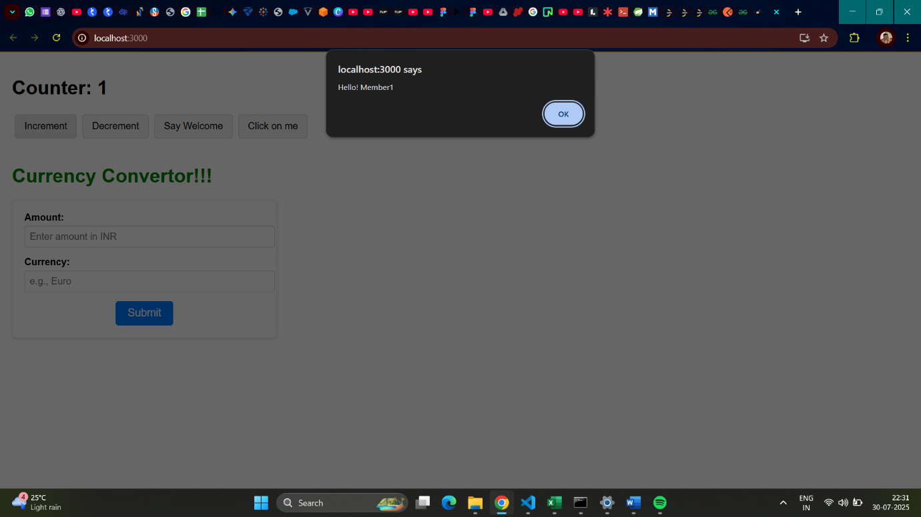

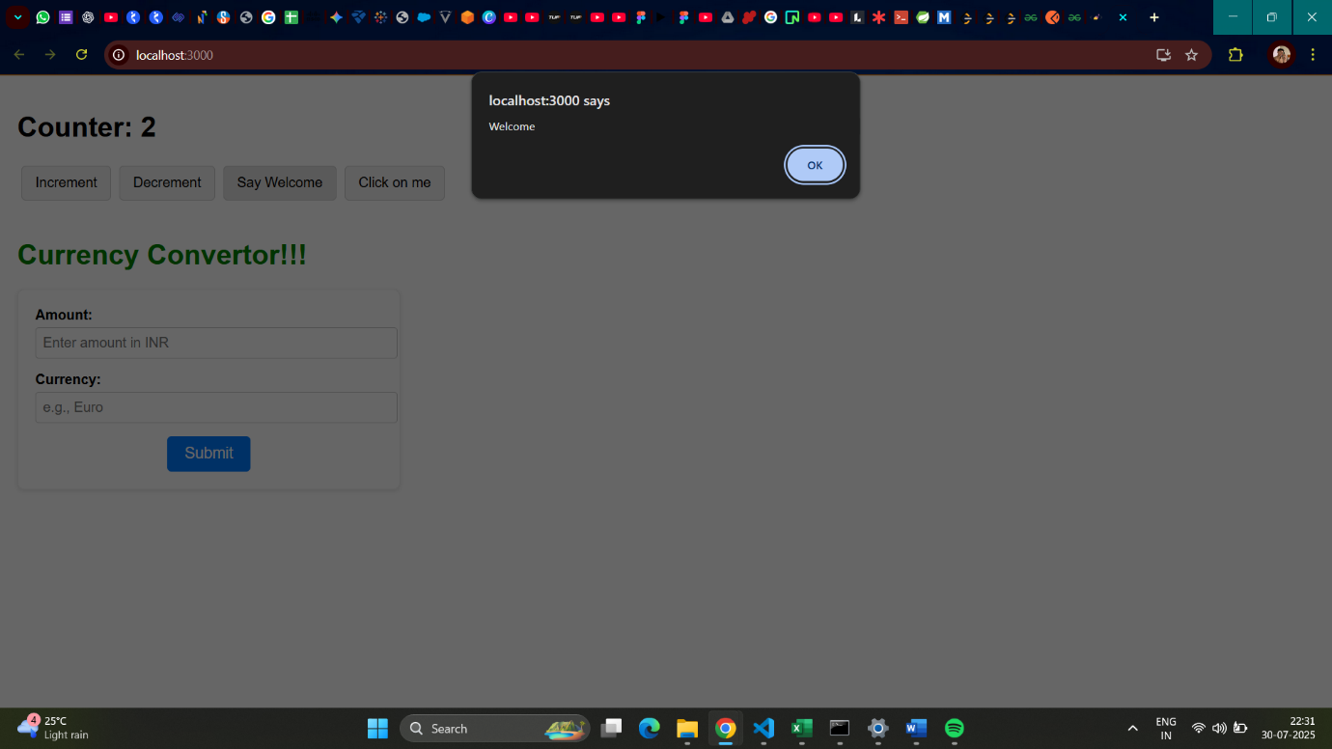

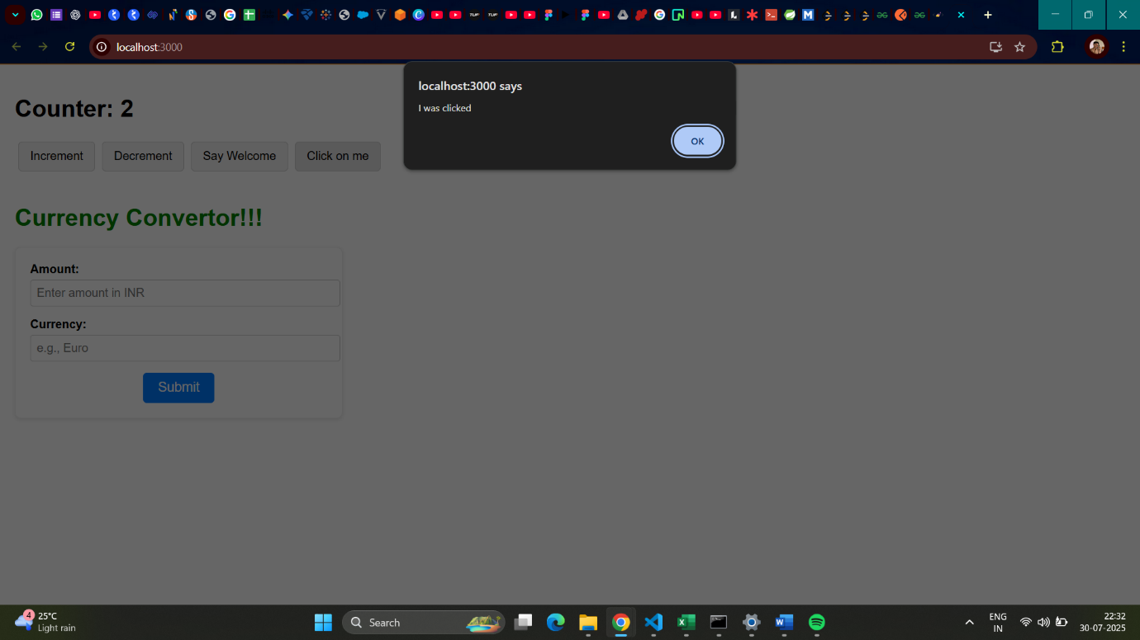

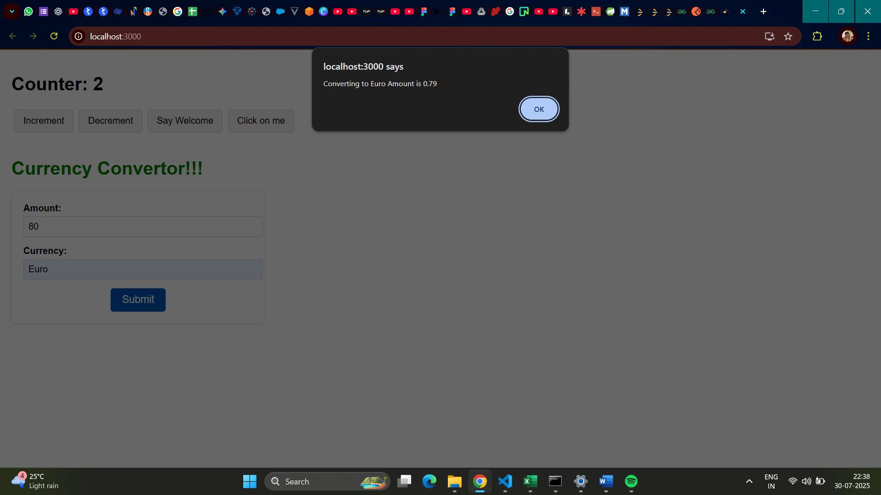

**Hands on 12**

Create a React Application named “ticketbookingapp” where the guest user can browse the page where the flight details are displayed whereas the logged in user only can book tickets.

**Code:**

LoginButton.jsx

import React from 'react';

function LoginButton(*props*) {

  return (

    <button *onClick*={*props*.onClick}>

      Login

    </button>

  );

}

export default LoginButton;

LogoutButton.jsx

import React from 'react';

function LogoutButton(*props*) {

  return (

    <button *onClick*={*props*.onClick}>

      Logout

    </button>

  );

}

export default LogoutButton;

UserGreeting.jsx

import React from 'react';

function UserGreeting() {

  return <h1>Welcome back</h1>;

}

export default UserGreeting;

GuestGreeting.jsx

import React from 'react';

function GuestGreeting() {

  return <h1>Please sign up.</h1>;

}

export default GuestGreeting;

Greeting.jsx

import React from 'react';

import UserGreeting from './UserGreeting';

import GuestGreeting from './GuestGreeting';

function Greeting(*props*) {

  const isLoggedIn = *props*.isLoggedIn;

  if (isLoggedIn) {

    return <*UserGreeting* />;

  }

  return <*GuestGreeting* />;

}

export default Greeting;

App.js

import React, { useState } from 'react';

import Greeting from './components/Greeting';

import LoginButton from './components/LoginButton';

import LogoutButton from './components/LogoutButton';

import './App.css';

function App() {

  const [isLoggedIn, setIsLoggedIn] = useState(false);

  const handleLoginClick = () => {

    setIsLoggedIn(true);

  };

  const handleLogoutClick = () => {

    setIsLoggedIn(false);

  };

  let button;

  if (isLoggedIn) {

    button = <*LogoutButton* *onClick*={handleLogoutClick} />;

  } else {

    button = <*LoginButton* *onClick*={handleLoginClick} />;

  }

  return (

    <div *className*="App">

      <*Greeting* *isLoggedIn*={isLoggedIn} />

      {button}

    </div>

  );

}

export default App;

App.css

*.App* {

  font-family: Arial, sans-serif;

  text-align: center;

  padding: 50px;

  display: flex;

  flex-direction: column;

  justify-content: center;

  align-items: center;

}

h1 {

  margin-bottom: 20px;

}

button {

  padding: 10px 20px;

  font-size: 16px;

  margin-top: 20px;

  cursor: pointer;

  border: 1px solid #ccc;

  border-radius: 5px;

  background-color: #f0f0f0;

}

button*:hover* {

  background-color: #e0e0e0;

}

**Output:**

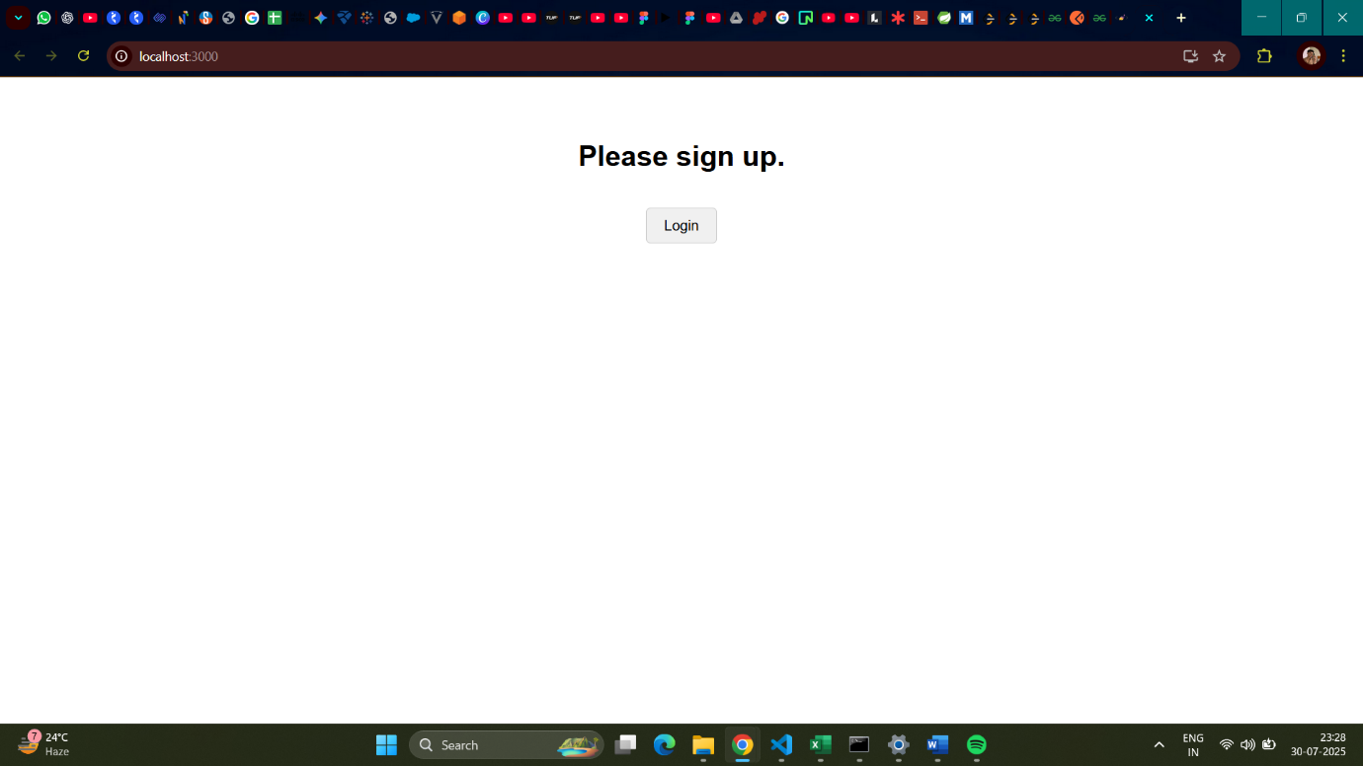

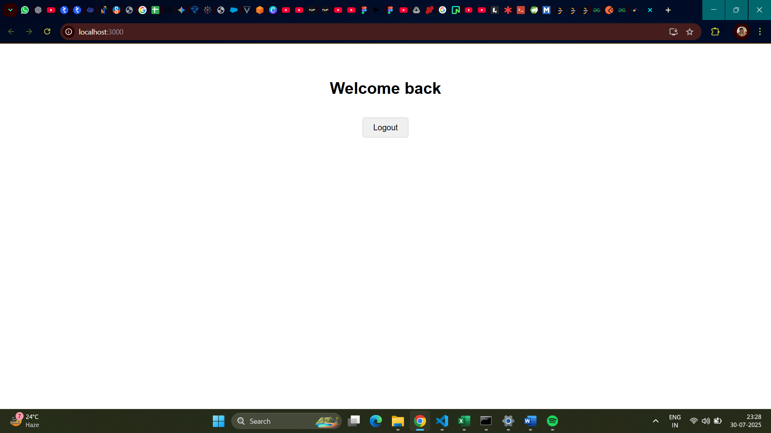

**Hands on 13**

Create a React App named “bloggerapp” in with 3 components.

1. Book Details

2. Blog Details

3. Course Details

**Code:**

booksData.js

export const books = [

    { id: 101, bname: 'Master React', price: 670 },

    { id: 102, bname: 'Deep Dive into Angular 11', price: 800 },

    { id: 103, bname: 'Mongo Essentials', price: 450 },

];

blogsData.js

export const blogs = [

    { id: 201, title: 'React Learning', author: 'Stephen Biz', content: 'Welcome to learning React!' },

    { id: 202, title: 'Installation', author: 'Schewzdenier', content: 'You can install React from npm.' },

    { id: 203, title: 'Component Life Cycle', author: 'Jane Doe', content: 'Understanding component lifecycle methods.' },

];

coursesData.jsx

export const courses = [

    { id: 301, name: 'Angular', date: '4/5/2021' },

    { id: 302, name: 'React', date: '6/3/2020' },

    { id: 303, name: 'Vue.js', date: '1/15/2022' },

];

BookDetails.jsx

import React from 'react';

const BookItem = ({ *book* }) => (

    <div>

        <h3>{*book*.bname}</h3>

        <h4>{*book*.price}</h4>

    </div>

);

const BookDetails = ({ *books* }) => {

    const bookdet = (

        <ul>

            {*books*.map(*book* => (

                <li *key*={*book*.id}>

                    <*BookItem* *book*={*book*} />

                </li>

            ))}

        </ul>

    );

    return (

        <div *className*="book-details">

            <h1>Book Details</h1>

            {bookdet}

        </div>

    );

};

export default BookDetails;

BlogDetails.jsx

import React from 'react';

const BlogItem = ({ *blog* }) => (

    <div>

        <h3>{*blog*.title}</h3>

        <h4>{*blog*.author}</h4>

        <p>{*blog*.content}</p>

    </div>

);

const BlogDetails = ({ *blogs* }) => {

    const content = (

        <ul>

            {*blogs*.map(*blog* => (

                <li *key*={*blog*.id}>

                    <*BlogItem* *blog*={*blog*} />

                </li>

            ))}

        </ul>

    );

    return (

        <div *className*="blog-details">

            <h1>Blog Details</h1>

            {content}

        </div>

    );

};

export default BlogDetails;

CourseDetails.jsx

import React from 'react';

const CourseItem = ({ *course* }) => (

    <div>

        <h3>{*course*.name}</h3>

        <h4>{*course*.date}</h4>

    </div>

);

const CourseDetails = ({ *courses* }) => {

    const coursedet = (

        <ul>

            {*courses*.map(*course* => (

                <li *key*={*course*.id}>

                    <*CourseItem* *course*={*course*} />

                </li>

            ))}

        </ul>

    );

    return (

        <div *className*="course-details">

            <h1>Course Details</h1>

            {coursedet}

        </div>

    );

};

export default CourseDetails;

ConditionalRenderer.jsx

import React from 'react';

const ConditionalRenderer = ({ *showType* }) => {

    let renderedContent;

    if (*showType* === 'books') {

        renderedContent = <p>Showing Books via if/else</p>;

    } else if (*showType* === 'blogs') {

        renderedContent = <p>Showing Blogs via if/else</p>;

    } else if (*showType* === 'courses') {

        renderedContent = <p>Showing Courses via if/else</p>;

    } else {

        renderedContent = <p>No specific type selected (if/else)</p>;

    }

    const showMessage = *showType* === 'all';

    const isSpecialCase = *showType* === 'special';

    return (

        <div *style*={{ border: '1px dashed #666', padding: '15px', margin: '20px 0' }}>

            <h2>Conditional Rendering Examples</h2>

            <h3>1. If/Else (Element Variable)</h3>

            {renderedContent}

            <h3>2. Logical && Operator</h3>

            {showMessage && <p>This message appears when 'all' is selected (Logical &&)</p>}

            <h3>3. Ternary Operator</h3>

            {isSpecialCase ? (

                <p>This is a special case (Ternary True)</p>

            ) : (

                <p>This is a normal case (Ternary False)</p>

            )}

            <h3>4. Preventing Component Rendering (returning null)</h3>

            {*showType* === 'none' ? null : <p>This component renders unless 'none' is selected</p>}

        </div>

    );

};

export default ConditionalRenderer;

App.js

import React, { useState } from 'react';

import BookDetails from './components/BookDetails';

import BlogDetails from './components/BlogDetails';

import CourseDetails from './components/CourseDetails';

import ConditionalRenderer from './components/ConditionalRenderer';

import { books } from './data/booksData';

import { blogs } from './data/blogsData';

import { courses } from './data/coursesData';

import './App.css';

function App() {

  const [activeSection, setActiveSection] = useState('all');

  return (

    <div *className*="App">

      <h1>Blogger App Content</h1>

      <div *className*="controls">

        <button *onClick*={() => setActiveSection('books')}>Show Books</button>

        <button *onClick*={() => setActiveSection('blogs')}>Show Blogs</button>

        <button *onClick*={() => setActiveSection('courses')}>Show Courses</button>

        <button *onClick*={() => setActiveSection('all')}>Show All Conditional</button>

        <button *onClick*={() => setActiveSection('special')}>Show Special Conditional</button>

        <button *onClick*={() => setActiveSection('none')}>Hide Conditional</button>

      </div>

      <div *className*="content-layout">

        <div *className*="section st2">

          <*CourseDetails* *courses*={courses} />

        </div>

        <div *className*="section v1">

          <*BookDetails* *books*={books} />

        </div>

        <div *className*="section mystyle1">

          <*BlogDetails* *blogs*={blogs} />

        </div>

      </div>

      <*ConditionalRenderer* *showType*={activeSection} />

      {activeSection === 'all' && (

                <p *style*={{ marginTop: '20px', fontWeight: 'bold' }}>

                    You are viewing all conditional rendering examples.

                </p>

            )}

    </div>

  );

}

export default App;

App.css

body {

  margin: 0;

  font-family: Arial, sans-serif;

  padding: 20px;

  background-color: #f4f4f4;

}

*.App* {

  text-align: center;

  max-width: 1200px;

  margin: 0 auto;

  padding: 20px;

  background-color: #fff;

  box-shadow: 0 0 10px rgba(0, 0, 0, 0.1);

  border-radius: 8px;

}

h1 {

  color: #333;

  margin-bottom: 5px;

}

h2 {

    color: #555;

    margin-top: 5px;

    margin-bottom: 5px;

}

h3 {

    color: #444;

    font-size: 1.2em;

    margin-bottom: 5px;

}

h4 {

    color: #666;

    font-size: 1em;

    margin-bottom: 10px;

}

ul {

  list-style: none;

  padding: 0;

  margin: 0;

}

li {

  margin-bottom: 5px;

  padding: 5px;

  border-bottom: 1px dashed #eee;

}

li*:last-child* {

  border-bottom: none;

}

*.controls* button {

  margin: 5px;

  padding: 10px 15px;

  font-size: 16px;

  cursor: pointer;

  border: 1px solid #007bff;

  border-radius: 5px;

  background-color: #007bff;

  color: white;

  transition: background-color 0.3s ease;

}

*.controls* button*:hover* {

  background-color: #0056b3;

}

*.content-layout* {

  display: flex;

  justify-content: space-around;

  align-items: flex-start;

  flex-wrap: wrap;

  margin-top: 20px;

}

*.section* {

  flex: 1;

  min-width: 280px;

  margin: 10px;

  padding: 20px;

  border: 1px solid #ddd;

  border-radius: 8px;

  background-color: #f9f9f9;

  box-shadow: 0 2px 5px rgba(0,0,0,0.05);

}

*.content-layout* *.section* + *.section* {

  border-left: 2px solid #28a745;

}

**Output:**

