Hydris AI — Basin Intelligence & Water Risk
DataCraft’26 · Problem Statement 1 · Project Report
PROBLEM STATEMENT
Companies with factories worldwide cannot easily answer: “How water-risky is each of my sites, why, and how will that change?” Our goal: take a factory location, automatically resolve its watershed, and return a multi-risk profile (scarcity, flood, drought, groundwater) for today and 2030/2050 scenarios, with an explanation of what drives every score — aligned with the Positive Water Impact (PWI) framework of Availability, Quality and Accessibility.
DATASET DESCRIPTION
- Core source: WRI Aqueduct 4.0 (CC-BY 4.0) via Google Earth Engine — baseline_annual (13 indicators, e.g. baseline water stress, drought, riverine/coastal flood, groundwater decline) and future_annual (optimistic/BAU/pessimistic × 2030/50/80), at HydroBASINS level-6 basin resolution.
- Driver datasets (all probed live in GEE before use): CHIRPS daily rainfall (30 yr), MODIS MOD16 evapotranspiration & MOD13Q1 NDVI, NASA GLDAS soil moisture/runoff, GRACE groundwater storage, SMAP soil saturation, HydroSHEDS flow/elevation, HYSOGs250m soil groups, ESA WorldCover, SoilGrids, JRC GHSL built-up; plus Nominatim geocoding and NewsAPI clippings.
- Pilot set: 5 factories on 4 continents (Chennai, Tiruppur, Fresno, Hamburg, Riyadh) × 3 driver engines = 15 driver profiles; any point on Earth can be added live.
- Preprocessing: Aqueduct –9999 → null (excluded, weights renormalized, never set to 0); +9999 kept as arid-mask; annual series built with a batched, gap-safe yearly() helper (handles MODIS pre-2000 and GRACE 2017–18 gaps); unit scaling; severities normalized to 0–1; GEE polygons repaired (GeometryCollection → Polygon) and simplified for the map.
METHODOLOGY
- 1. Basin resolution & headline scores: point-in-polygon lookup in Aqueduct returns 13 indicators, mapped to three PWI dimensions (Availability = scarcity composite 0.36·bws + 0.36·bwd + 0.18·iav + 0.10·sev, flood, drought, groundwater; Quality = ucw, cep, rri; Accessibility = mean(udw, usa)). Future scenarios use WRI projections.
- 2. Driver engines (the “why”): Drought D = 0.35·Meteorological (gamma-fit SPI, SPEI-lite) + 0.30·Agricultural (soil moisture, NDVI) + 0.35·Hydrological (runoff, GRACE). Groundwater G = 0.35·extraction pressure + 0.30·aquifer decline (GRACE trend) + 0.20·recharge weakness. Flood = rain .25 + SCS-CN runoff .25 + catchment .20 + soil saturation .15 + urbanization .15 (Hazard × Exposure × Vulnerability). Output: hazard 0–5 plus attribution % per driver.
- 3. Validated AI layer: Groq Llama 3.3 70B (temperature 0) writes plain-language narratives and tags news sentiment; a numeral validator checks every number against the computed JSON, retries, then falls back to a deterministic template.
- 4. Product: FastAPI backend + Supabase cache + React/MapLibre dark map with PWI ring gauges, 13 indicator bars, 2030/2050 toggle, custom weights and add-a-factory.
RESULTS & INSIGHTS
- Distinct risk fingerprints: the driver engines separate sites that WRI’s single overall score lumps together. Chennai is flood-led (3.57/5, rainfall-driven), Fresno groundwater-led (3.97/5, extraction + GRACE decline), Riyadh groundwater-led (3.26/5).  - Surfaced hidden risk: Hamburg is “Low” overall (0.75/5) yet its drought hazard is 2.98/5 — a signal the overall score hides.  - Explainability: attribution sums to 100% for every site × risk (15/15); top drivers vary by site (SPEI, SCS-CN runoff, GRACE storage, extraction pressure).  - Physical plausibility: Chennai curve number ≈ 85–92 (urban); Fresno GRACE decline flagged high — consistent with known hydrology (validation gates 0, 1a–1c passed).  - Honesty metrics: 0 leaked –9999 values; missing data shown as “n/d” (Chennai groundwater, Riyadh drought), never 0; LLM text rejected if any number is absent from the computed JSON.  - Performance: cached profile ~100 ms; live driver run 2–47 s per risk on pilots (1–2 min for a brand-new site). | 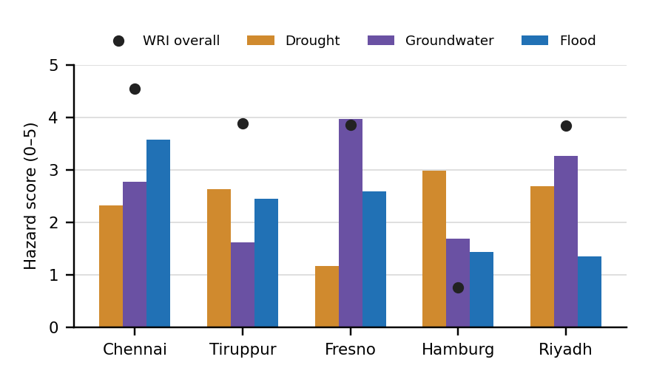  Fig. 1 — Driver-engine hazard vs. WRI overall score, 5 pilot sites
NOVELTY
- Scores that explain themselves: each WRI score is paired with a satellite-computed driver breakdown, turning a number into an action (e.g. which share of flood risk comes from rainfall vs. impervious runoff).
- Honesty layer by design: every driver carries a source ID and confidence tag (computed / proxy / regional / no-data); GRACE always labeled regional; flood/drought/groundwater badged “not projected by WRI” instead of faked futures.
- Hallucination-proof AI: mechanical numeral validation of LLM output — AI explains, it never invents data.
- Global, zero-storage, resilient: computes on demand in Earth Engine for any coordinate; Supabase → bundled demo → live-compute fallback keeps the product working even if GEE is down.

