SOFTWARE ENGINEERING PROJECT REPORT
Hydris AI
Basin Intelligence & Water Risk Platform
Tarun Vaibhav V 24BCE5078
Bipasha V 24BCE5346

Project Report
An AI-first water-stewardship platform aligned with the Positive Water Impact (PWI) framework: factory locations → watershed resolution → multi-risk profile (scarcity, flood, drought, groundwater) today and under 2030/2050 scenarios, with satellite-computed, explainable drivers behind every score.
Scope covered: Basin intelligence & water risk (core) · PWI quantification engine · Evidence & disclosure agent · Intervention intelligence engine · Stewardship Copilot

Contents
1. Executive Summary 2
2. Problem Statement 2
3. Dataset Description 3
4. Methodology 5
5. Results & Insights 8
6. Novelty 11
7. Limitations and Honest Caveats 11

1. Executive Summary
Hydris AI answers a question every multi-site manufacturer faces: how water-risky is each of my factories, why, and how will that change? A user enters (or picks on a map) any factory location on Earth. The system resolves the site’s watershed in Google Earth Engine, returns the 13 WRI Aqueduct 4.0 risk indicators mapped onto the three PWI dimensions (Availability, Quality, Accessibility), projects water stress to 2030/2050 under three scenarios, and — the core differentiator — runs three satellite-driven engines (drought, groundwater, flood) that decompose each hazard into its measurable drivers with an attribution percentage, dataset ID and confidence tag.
On top of that diagnostic core, the repository extends the platform with a PWI quantification engine (3×3 matrix, 52-question self-assessment, certification), an intervention “digital twin” that simulates and optimises mitigation portfolios, an evidence & disclosure agent that maps factory documents to CDP Water Security questions, and a retrieval-augmented Stewardship Copilot. Every LLM output is mechanically constrained so that AI explains the numbers but never invents them.
Table 1. Project at a glance.
Indicator | Value | Source in repository
Pilot factories / continents | 5 sites / 4 continents | data/pilot_basins.geojson
Driver profiles computed | 15 (5 sites × 3 risks) | data/drivers_demo.json
Attribution completeness | 15 / 15 profiles sum to 100% | drivers.composite()
Satellite/GIS datasets probed live | 13 GEE collections | backend/drivers.py → DS()
API routes (FastAPI) | 34 routes: site, drivers, PWI, intervention, evidence, orgs | backend/main.py
Offline test suite | 23 passed, 4 live tests skipped (need credentials) | backend/tests/test_contract.py
Copilot knowledge base | 1,205 chunks from 7 PDFs + 19-sheet workbook | backend/build/chunks.json

2. Problem Statement
To build the AI-first water stewardship platform, aligned with the Positive Water Impact (PWI) framework. AI is expected to be used throughout the build for reasoning, drafting, matching and automation.

2.1 Basin Intelligence and Water Risk
The core problem requires: enter factory locations → automatically resolve each site’s watershed → return a multi-risk profile (scarcity, flood, drought, groundwater) for today and under 2030/2050 scenarios, with an explanation of what drives each score. The required deliverables are:
- an interactive site map with basin boundaries;
- current and future risk scores per site;
- an explanation of the drivers behind each score, computed from data rather than invented.

2.2 Guiding principle: the honesty layer
The whole system follows seven honesty rules documented in the README, so that missing or uncertain data is shown as such rather than hidden:
- Aqueduct’s -9999 no-data becomes null everywhere; missing values are excluded and weights renormalised — never coerced to 0.
- Every driver carries a source (dataset ID) and a confidence tag: computed / proxy / regional / no-data.
- Attribution % is always “estimated contribution to the modelled score”, never physical cause.
- GRACE (~300 km resolution) is always tagged regional, never sold as site-scale.
- LLM narratives are mechanically validated: every number must exist in the computed JSON; otherwise retry, then a deterministic template.
- Dataset IDs are probed live in GEE before use — nothing is assumed from memory.
- WRI projects only stress/depletion/variability, so flood/drought/groundwater are badged “baseline (not projected by WRI)” instead of faking projections.

3. Dataset Description

3.1 Primary source — WRI Aqueduct 4.0
Headline risk comes from WRI Aqueduct 4.0 (CC-BY 4.0), accessed in Google Earth Engine as WRI/Aqueduct_Water_Risk/V4/baseline_annual (13 indicators at HydroBASINS level-6 basin resolution) and future_annual (fields {opt|bau|pes}{30|50|80}_{ws|wd|iv|sv}_x_s). A point-in-polygon lookup returns the containing basin, so no heavy raster storage is needed. Each indicator provides raw value, score (0–5), category and label.
Table 2. The 13 Aqueduct indicators used by engine.py and their PWI mapping.
Group | Indicators (code) | PWI dimension
Quantity (qan) | Baseline water stress (bws), depletion (bwd), interannual variability (iav), seasonal variability (sev), groundwater table decline (gtd), drought risk (drr), riverine flood (rfr), coastal flood (cfr) | Availability
Quality (qal) | Untreated connected wastewater (ucw), coastal eutrophication potential (cep) | Quality
Regulatory & reputational (rrr) | Unimproved drinking water (udw), unimproved sanitation (usa), regulatory & reputational risk (rri) | Accessibility (udw, usa); Quality (rri)

3.2 Satellite and GIS driver datasets
The three driver engines use the following Earth Engine collections. Each ID is probed live at start-up (with fall-back IDs); a missing dataset degrades only its own driver to no-data.
Table 3. Earth Engine datasets used by backend/drivers.py.
Dataset (GEE ID) | Variable | Used for
UCSB-CHG/CHIRPS/DAILY | 30-yr daily rainfall | SPI (gamma), design storm, recharge
MODIS/061/MOD16A2GF | Potential evapotranspiration | SPEI-lite (P − PET)
MODIS/061/MOD13Q1 | NDVI | Vegetation (agricultural) drought
NASA/GLDAS/V021/NOAH/G025/T3H | Soil moisture, runoff | Agricultural & hydrological drought
NASA/GRACE/MASS_GRIDS_V04/MASCON_CRI | Water-storage anomaly | Storage drought, aquifer-decline trend (regional)
NASA/SMAP/SPL4SMGP/008 | Surface soil moisture | Flood soil saturation
WWF/HydroSHEDS/15ACC, 15CONDEM | Flow accumulation, elevation | Flood catchment factor
HiHydroSoil v2 HSG 250 m | Hydrologic soil group | SCS curve number
ESA/WorldCover/v200 | 10 m land cover | Curve number, infiltration
projects/soilgrids-isric/sand_mean | Sand fraction | Recharge index
COPERNICUS/DEM/GLO30 | 30 m elevation / slope | Recharge index
JRC/GHSL/P2023A/GHS_BUILT_S | Built-up surface | Urbanisation (exposure proxy)

Supporting services: OpenStreetMap Nominatim (geocoding/reverse-geocoding), NewsAPI (local news clippings), the World Bank Open Data API (live country-level water & WASH context for the PWI engine, fetched and never stored) and HydroSHEDS level-9 sub-basins for the map overlay.

3.3 Pilot sites
Five representative factories on four continents were chosen to cover contrasting risk regimes: monsoon-coastal (Chennai), inland textile cluster (Tiruppur), irrigated aquifer-stressed valley (Fresno), temperate low-stress (Hamburg) and hyper-arid (Riyadh).
Table 4. Pilot factory set (pilot_basins.geojson; coordinates rounded to 2 dp).
ID | Site | Lat, Lng | Basin (pfaf_id) | WRI overall | Category
S1 | Chennai plant (IN) | 13.08, 80.27 | 453750 | 4.54 | Extremely High
S2 | Tiruppur textile (IN) | 11.11, 77.34 | 453803 | 3.88 | High
S3 | Fresno plant (US-CA) | 36.74, −119.79 | 774429 | 3.86 | High
S4 | Hamburg plant (DE) | 53.55, 9.99 | 232810 | 0.75 | Low
S5 | Riyadh plant (SA) | 24.71, 46.68 | 297818 | 3.83 | High

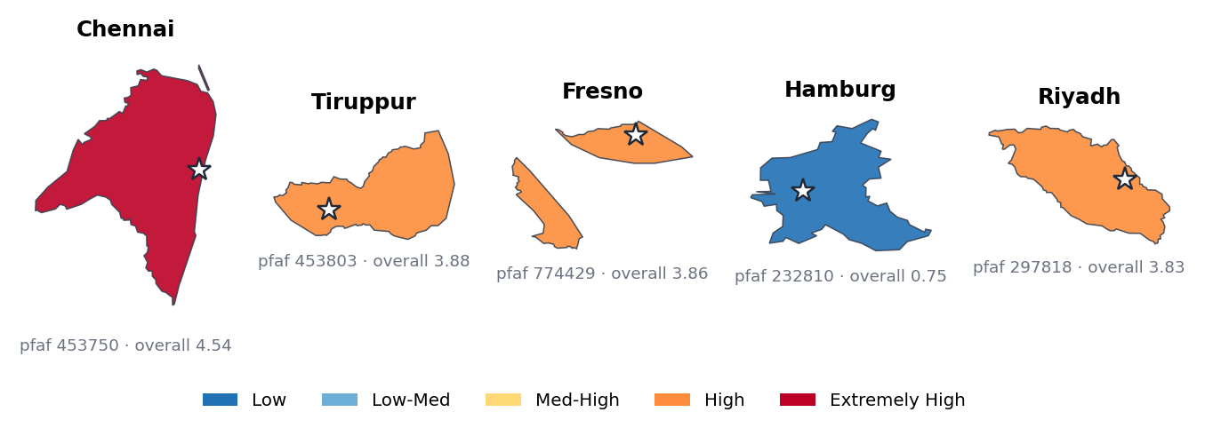
Figure 1. Pilot basin polygons (HydroBASINS level-6, simplified) coloured by WRI overall score; star = factory location.

3.4 Resource pack and knowledge corpus
- Water Stewardship Module workbook (22 sheets) — UI/UX spec (S-01/S-02 screens, design tokens), PRD, PWI 4-Step framework, Baseline & Targets, 52-question Self-Assessment, PWI Dashboard, CDP Report Generator and basin sample data.
- Open Water Data Catalog — 38 open datasets (composite risk, hydrography, floods, groundwater, drought, climate, water use, quality, WASH, land/soil, population, dams, stewardship frameworks) with licences.
- Driver-formula toolkits — drought and groundwater formula/GEE PDFs and a flood driving-factors document, which define the engine formulas.
- Stewardship Copilot corpus — 7 reference PDFs (AWS Standard v3.0 + Guidance, VWBA 2.0, WQBA guidebook, CII Compendium of Best Practices, industrial and integrated water-management texts) plus a 19-sheet portfolio workbook, chunked (1,100 chars, 150 overlap) into a FAISS index.
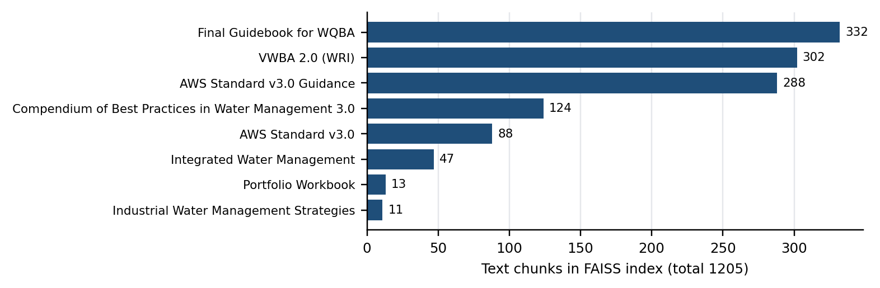
Figure 2. Composition of the Copilot’s retrieval index (backend/build/chunks.json).

3.5 Pre-processing steps
- No-data cleaning: -9999 → null for raw, score, category and label fields; +9999 (arid mask) is kept as a real score.
- Renormalisation: weighted means skip missing components and divide by the sum of available weights.
- Gap-safe time series: a batched yearly() helper makes one getInfo() round-trip per driver and uses lazy ee.Algorithms.If guards for years before a dataset starts (MOD16 < 2000) and mission gaps (GRACE 2017–18); unit scaling is applied client-side.
- Standardisation: series converted to z-scores or gamma-fit SPI, then mapped to 0–1 severities (e.g. sev = clip(0.5 − z/4, 0, 1)).
- Geometry repair: GEE simplify() can degrade Polygons into GeometryCollections of LineStrings, which map fill layers skip silently; both seed.normalize_geometry() (Python) and normalizeGeometry() (TypeScript) rebuild them.
- Caching: computed profiles, futures, PWI dimensions and driver JSON are upserted into Supabase so repeat reads take ~100 ms.

3.6 Data model
Table 5. Supabase schema (supabase/*.sql). RLS: anonymous read, service-role write.
Table | Key | Contents
sites | id | name, lat, lng, pfaf_id, org_id
risk_cache | pfaf_id | 13-indicator profile, future scenarios, PWI dimensions
driver_cache | (site_id, risk) | full driver-engine JSON incl. attribution + confidence
basins | pfaf_id | simplified polygon + cleaned Aqueduct properties
organizations, user_profiles | uuid | multi-tenant orgs and admin/viewer roles
evidence_documents / claims / reports | uuid / site_id | uploaded evidence, verified claims with grades, CDP roll-up

4. Methodology

4.1 System architecture
The frontend reads Supabase first, falls back to bundled demo JSON if Supabase is unreachable, and calls the FastAPI compute service only for uncached computation. If Earth Engine is down, every seeded site still works fully.
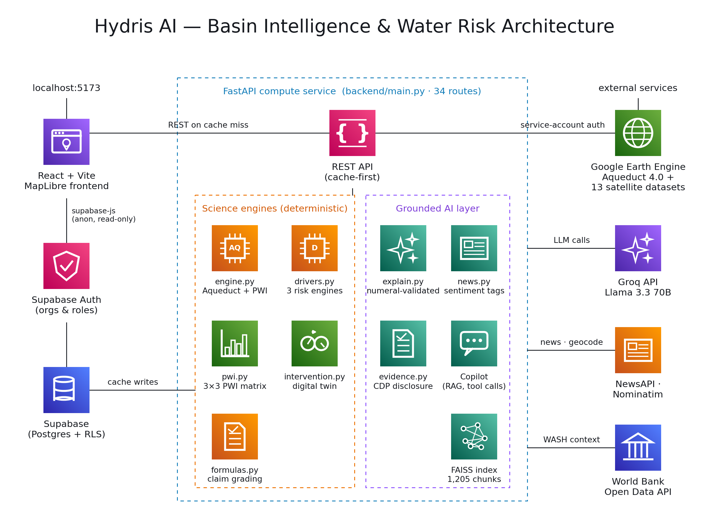
Figure 3. System architecture: React frontend, Supabase, the FastAPI compute service (science engines + grounded AI layer) and external services.

4.2 Headline engine and PWI mapping
The Aqueduct engine (engine.py, ported 1:1 from the Colab notebook that passed Gate 0) fetches the containing basin and derives the PWI dimensions:
Scarcity = 0.36·bws + 0.36·bwd + 0.18·iav + 0.10·sev (renormalised over available terms)
- Availability = mean(scarcity, max(rfr, cfr), drr, gtd)
- Quality = mean(ucw, cep, rri) (country regulatory ety is not in the GEE table → noted as a data gap)
- Accessibility = mean(udw, usa)
Scores are classified as Low (0–1), Low-Medium (1–2), Medium-High (2–3), High (3–4) and Extremely High (4–5). Users can re-weight the 13 indicators on a base-2 scale (0, 0.25, 0.5, 1, 2, 4); partial weight dictionaries are overrides, so exclusion requires an explicit 0. Future scores are read for 2030/2050/2080 × optimistic/BAU/pessimistic.

4.3 Driver engines — the “why” behind each score
Table 6. Driver-engine formulas (backend/drivers.py = notebooks/hydris_drivers.ipynb).
Engine | Formula | Drivers and method
Drought | D = 0.35·M + 0.30·A + 0.35·H (split evenly inside pillars) | M: gamma-fit SPI (z fallback) on CHIRPS 3-month + SPEI-lite z(P − PET); A: GLDAS soil moisture + MODIS NDVI; H: GLDAS runoff + GRACE storage (regional)
Groundwater | G = 0.35·EP + 0.30·AD + 0.20·RW (+0.15·QD excluded) | EP extraction-pressure proxy from Aqueduct gtd + bwd; AD GRACE linear-fit trend; RW = 1 − recharge index (CHIRPS × sand × slope × WorldCover infiltration); QD has no global raster → excluded
Flood | rain .25 + runoff .25 + catchment .20 + soil-sat .15 + urban .15 | Design storm = mean + 1σ of annual 1-day maxima; SCS-CN runoff; HydroSHEDS flow accumulation + relative elevation; SMAP saturation; GHSL built-up; framed as Hazard × Exposure × Vulnerability

Flood runoff uses the NRCS TR-55 curve-number method with hydrologic soil group and land cover:
S = 25400 / CN − 254 Q = (P − 0.2S)² / (P + 0.8S)
All engines share one composite. Only drivers with a severity participate; weights are renormalised and each driver’s attribution is its share of the weighted sum:
hazard₀₋₁ = Σ(sᵢ·wᵢ) / Σwᵢ hazard₀₋₅ = 5·hazard₀₋₁ attributionᵢ = 100·sᵢwᵢ / Σ sⱼwⱼ
Every factor is individually try/except-isolated, so a server-side GEE failure turns that factor into no-data with the error recorded instead of crashing the engine.

4.4 Grounded AI layer
Narratives are produced by Groq (Llama 3.3 70B, temperature 0) under a system prompt that forbids arithmetic and requires quoting only numbers that appear verbatim in the JSON. A numeral validator then extracts every number in the reply and checks it against the set of numbers in the driver JSON. On failure the call is retried (up to 3 times); if it still fails, or no API key is present, a deterministic template is built directly from the JSON. The response states which engine produced it (groq or template).
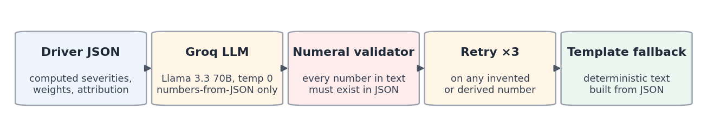
Figure 4. No-hallucination pipeline for LLM narratives (backend/explain.py).
- News signals: NewsAPI clippings for the site’s highest-scoring risk, reverse-geocoded to the locality; one Groq JSON call tags sentiment and government action, with a keyword fallback. Headlines and URLs are always verbatim from NewsAPI.
- Stewardship Copilot: Groq function-calling over structured tools (rank_sites, rank_projects_by_impact, off_track_projects, get_site, get_project, read-only SQL) plus semantic search over the FAISS index (sentence-transformer embeddings, top-5). A citation contract requires every fact to cite a sheet or page and to label values as Sourced or Illustrative.

4.5 PWI Quantification Engine
The PWI engine implements the official methodology transcribed from the Water Stewardship Module workbook: a 3×3 matrix of pillars (P1 Site, P2 Sub-Basin, P3 Basin) × dimensions (Availability, Quality, Access), scored from a 52-question self-assessment (each question 0–3 with an evidence flag).
Table 7. PWI engine formulas (backend/pwi.py).
Output | Formula
Cell (dimension) score | Σ question scores / (3 × n questions) × 100
Pillar score | Availability×0.4 + Quality×0.3 + Access×0.3
Site PWI | (P1 + P2 + P3) / 3
Portfolio PWI | mean of site PWI scores
Confidence | mean(evidence: Yes 100 / Partial 70 / No 50) − Σ penalties from 10 cross-validation (XV) rules
Quantitative path | Availability = replenishment / withdrawal; Quality = treated / generated wastewater; Access = share of ILO WASH ratios met

Table 8. Certification decision matrix.
PWI score | Confidence | Certification result
≥ 100% | ≥ 75% | SELF-CERTIFIED — Positive Water Impact achieved (valid 3 yr)
80–99% | ≥ 75% | CONDITIONAL — partial desk audit (valid 1 yr)
60–79% | ≥ 50% | IN PROGRESS — external audit needed
< 60% | any | NOT ACHIEVED — revised plan required
any | < 50% | LOW CONFIDENCE — fix data quality first

Targets use the 20/40/40 split (20% of replenishment at Site, 40% Sub-Basin, 40% Basin). Every emitted number is a traced object carrying value, unit, formula, source, assumptions and confidence. An LLM planner (pwi_recommend.py) proposes interventions per gap, with expected gains clamped to the actual gap and a template fallback.

4.6 Intervention Intelligence Engine (digital twin)
This module turns the diagnosis into prescriptions. A catalogue of 8 interventions (rainwater harvesting, wastewater recycling, leak repair, process optimisation, managed aquifer recharge, green cover, stormwater detention, soil-moisture conservation) specifies which drivers each one moves and by how much, with a saturating response to intensity. The counterfactual reuses drivers.composite() verbatim, so simulated and baseline scores come from identical maths. An optimiser exhaustively searches portfolios against a goal (max risk reduction, best ROI, risk budget, max water). Effect coefficients are stamped planning-estimate, and confidence propagates by weakest link. No LLM touches any number on this path.

4.7 Evidence & Disclosure Agent
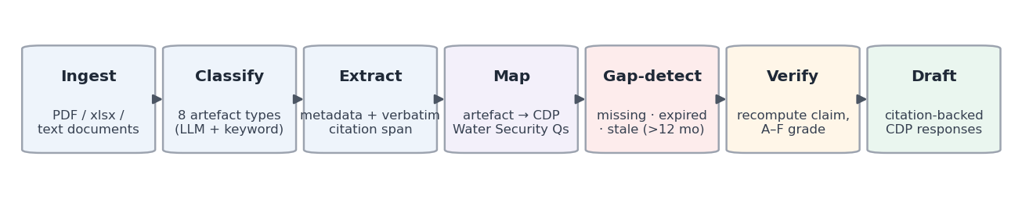
Figure 5. Evidence pipeline (backend/evidence.py + formulas.py).
Documents are classified into eight artefact types, mapped to eight CDP Water Security questions (W1.2, W1.2b, W1.4, W5.1, W5.1a, W6.1, W8.1, W9.1) and checked for gaps (missing, expired permit, stale > 12 months). Intervention claims are recomputed from nine audited formulas (e.g. rainwater = catchment × rainfall × runoff coefficient, with CHIRPS rainfall from GEE) and graded by deviation:
Table 9. Claim grading bands; grade is capped by formula soundness (sound → A, calibration/oversimplified → B, weak → C).
Deviation | ≤ 10% | ≤ 20% | ≤ 35% | ≤ 50% | > 50%
Grade | A | B | C | D | F

Claim confidence = 0.35·document quality + 0.25·engineering validation + 0.20·external-data match + 0.10·image verification + 0.10·historical consistency. When the LLM is unavailable, the output explicitly reports degraded mode instead of silently failing claims.

4.8 Product layer
- Map (S-01): full-bleed dark MapLibre map (Carto Dark Matter), search, 7-layer selector, legend, basemap toggle, add-site button (form or map-pick) and a level-9 sub-basin overlay.
- Risk card (S-02): overall score in a 48 px mono font, three PWI ring gauges, flood/shortage chips, 13 mini-bars (null shown as “n/d”) and “Why drought / groundwater / flood?” panels with attribution bars and narrative.
- Other views: Portfolio register (ranked, sortable, CSV import/export, 2050 column), PWI assessment, Evidence, Digital Twin (What-If Lab) and Copilot; Supabase login with organisations and roles.
- Accessibility: WRI ordinal palette #2171B5 → #BD0026 validated for colour-vision deficiency (worst pair ΔE 18.4); colour is never shown without a text label.

5. Results & Insights

5.1 Headline risk across the pilot basins
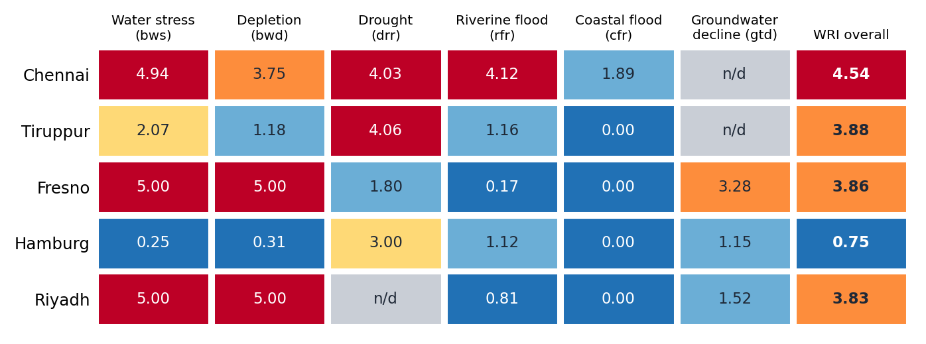
Figure 6. Aqueduct indicator scores for the five pilot basins; grey = no-data (null, never 0).
- Chennai is the riskiest site (overall 4.54, Extremely High), with extreme water stress (4.94), drought (4.03) and riverine flood (4.12).
- Fresno and Riyadh saturate water stress and depletion at 5.00; Riyadh’s drought indicator is no-data (arid basin) and Chennai/Tiruppur groundwater decline is no-data — shown as “n/d”, exactly as the honesty layer requires.
- Hamburg is Low overall (0.75) with no indicator above 3.

5.2 Driver-engine hazards vs. the WRI overall score
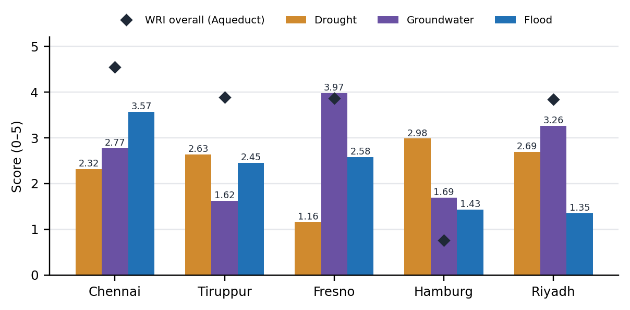
Figure 7. Satellite driver-engine hazard (0–5) per risk vs. the WRI overall score.
- Distinct risk fingerprints: Chennai is flood-led (3.57), Fresno groundwater-led (3.97) and Riyadh groundwater-led (3.26). Sites with nearly identical WRI overall scores (Tiruppur 3.88, Fresno 3.86, Riyadh 3.83) have completely different dominant hazards, and therefore need different interventions.
- Hidden risk surfaced: Hamburg is Low overall (0.75) but its drought-driver hazard is 2.98 — the highest drought value in the pilot set — a signal a single composite score conceals.
- Physical plausibility: Chennai’s computed curve number is 87 (urban, HSG-D) with a 116.7 mm design storm, inside the 85–92 range expected by Gate 1c; Fresno’s GRACE trend is −1.58 cm/yr, giving the highest aquifer-decline severity (0.894), consistent with its known groundwater overdraft and Gate 1b.

5.3 Explainability — what drives each score
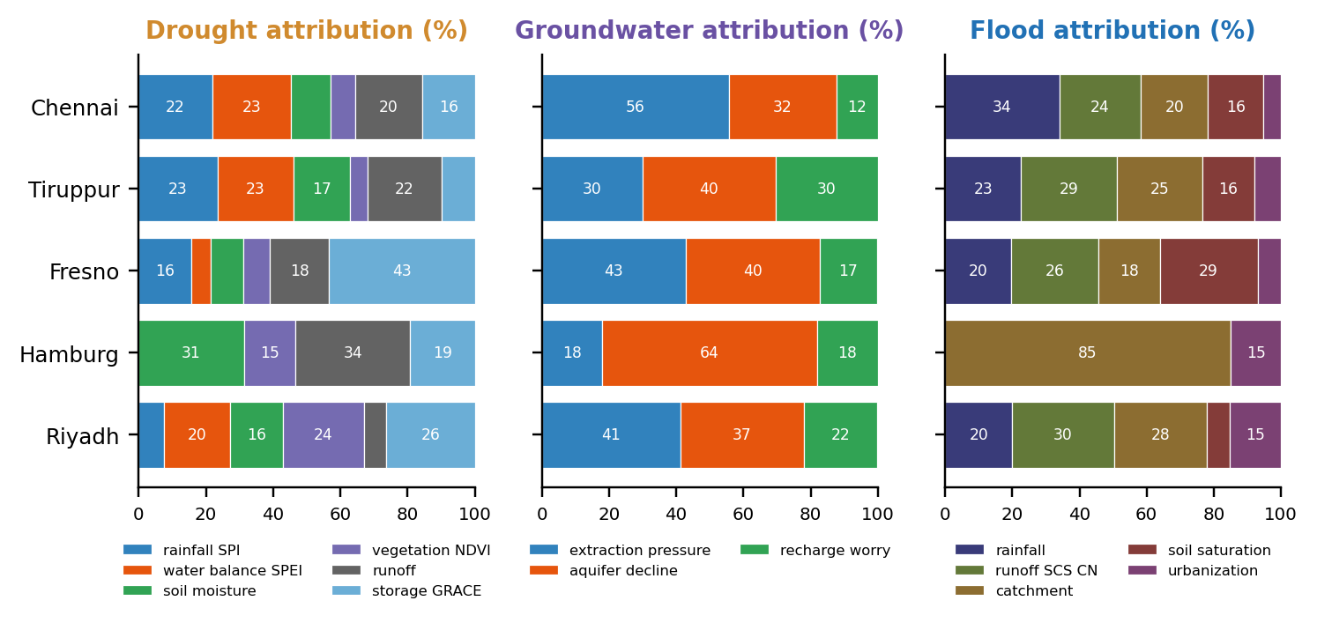
Figure 8. Estimated contribution of each driver to the modelled hazard (%), per site and risk.
All 15 profiles sum to 100%. Top drivers differ by place: water-balance SPEI (23.4%) and rainfall SPI (21.9%) for Chennai drought, GRACE storage for Fresno drought (43%), aquifer decline for Hamburg groundwater (64%), rainfall for Chennai flood (34%). Hamburg’s flood attribution is 85% catchment because rainfall and SCS runoff were no-data there; they were excluded and weights renormalised rather than set to zero — visible, not hidden.

5.4 Honesty, confidence and performance
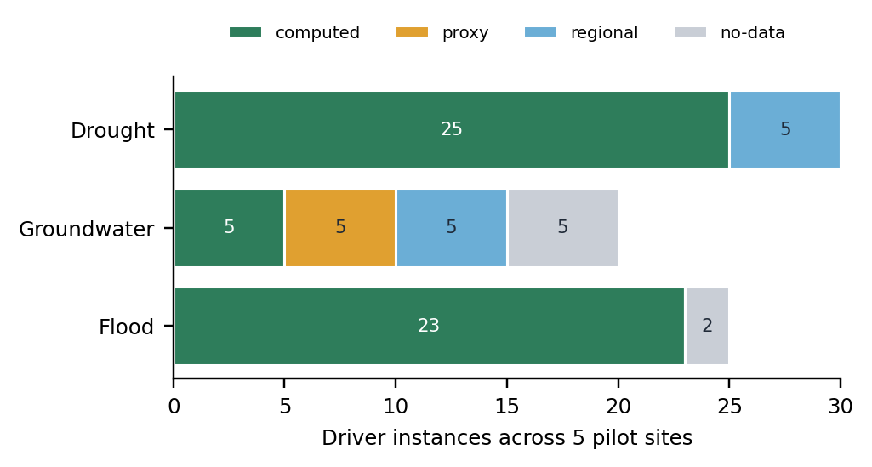  Figure 9. Confidence tags across all 75 driver instances. | 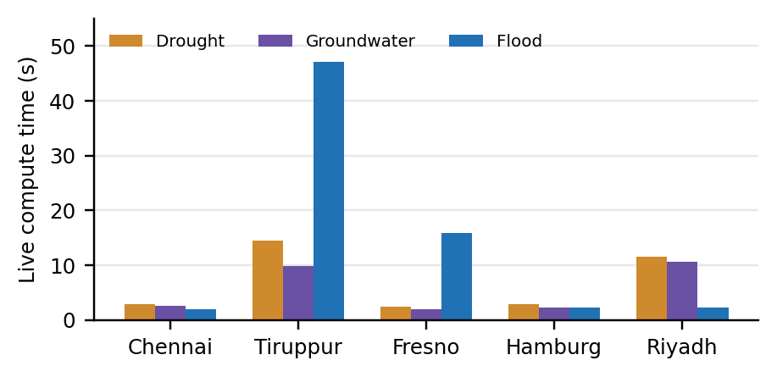  Figure 10. Live compute time per site and risk (runtime_s).

- Drought: 25 computed, 5 regional (GRACE). Flood: 23 computed, 2 no-data (Hamburg). Groundwater is the least certain engine: 5 computed, 5 proxy, 5 regional, 5 no-data (groundwater-quality factor QD, which has no global raster).
- Running the intervention engine’s confidence report on Chennai gives weight-weighted evidence quality of 91.2% (drought), 56.0% (groundwater) and 100% (flood); 82.4% overall.
- Zero -9999 leaks: the engine cleans raw, score, category and label fields (a leaking gtd.cat=-9999 was found and fixed).
Live runs on the pilots took 1.9–47.1 s per risk; the slowest was Tiruppur flood (47.1 s). The README notes 1–2 min for a brand-new site. Cached reads from Supabase take ~100 ms, which is why caching and precomputed pilots exist.

5.5 PWI engine — worked example (ASSUMED-DEMO data)
The PWI engine was run on the labelled worked example in pwi_demo.py. Every input there is synthetic and stamped ASSUMED-DEMO, so the numbers illustrate the method, not a real factory.
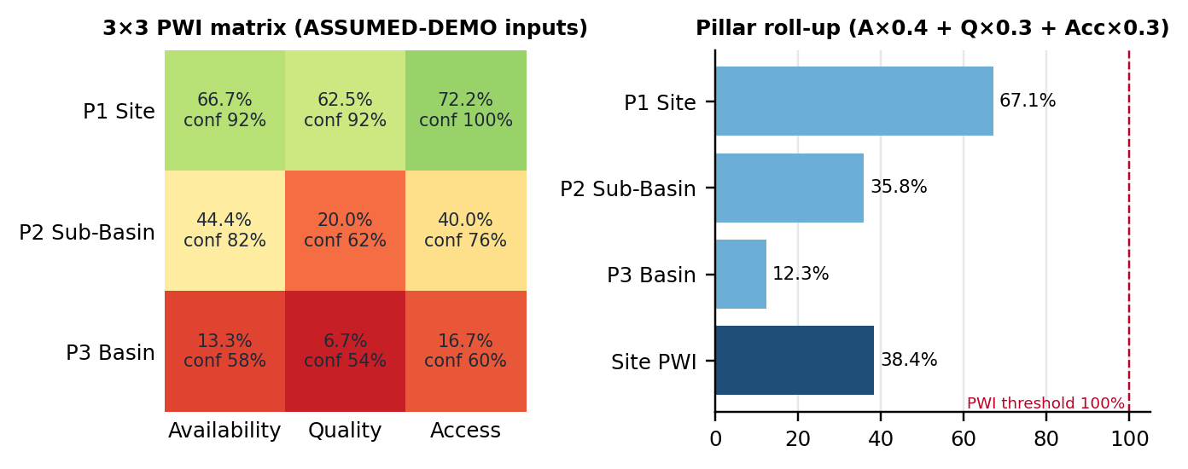
Figure 11. PWI 3×3 matrix with per-cell confidence, and the pillar roll-up.
- The site pillar is mature (67.1%) while sub-basin (35.8%) and basin (12.3%) engagement is early, giving a site PWI of 38.4% against the 100% threshold.
- The quantitative path gives Availability 40% (208,000 m³/yr replenished of 520,000 m³/yr withdrawn), Quality 95% (285,000 of 300,000 m³ treated) and Access 100% (all ILO WASH ratios met).
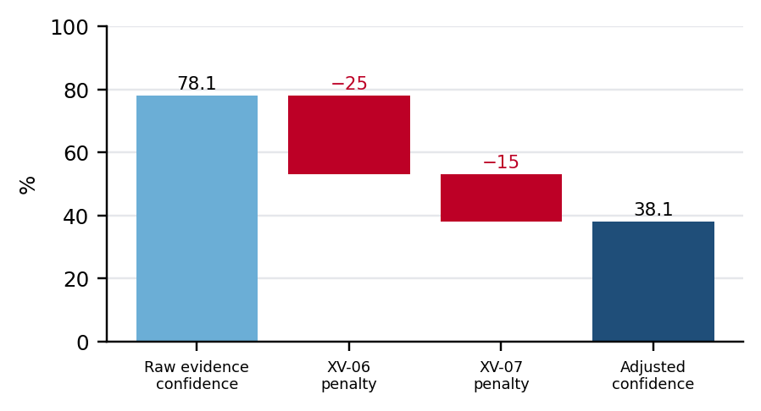
Figure 12. Confidence adjustment: two cross-validation rules fire (XV-06 NBS verification needs monitoring, XV-07 household WASH needs assessment first).
Because adjusted confidence falls to 38.1% (< 50%), the certification matrix returns “LOW CONFIDENCE: fix data quality”. The engine refuses to certify weak evidence even though some pillars score well. Gap analysis ranks the largest gaps at the basin pillar (Quality gap 93.3 points) and recommends phased interventions.

5.6 Intervention optimisation — Chennai
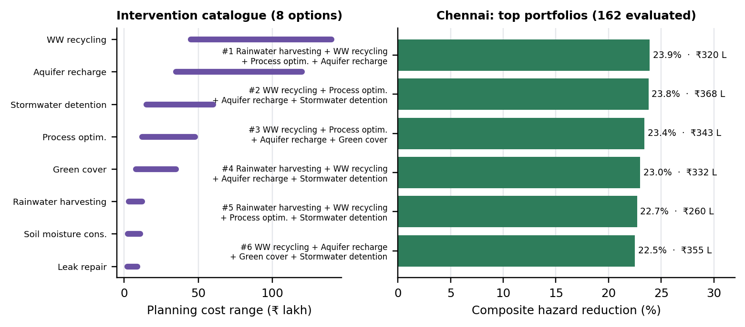
Figure 13. Intervention cost ranges and the best portfolios found for Chennai (planning estimates).
The optimiser evaluated 162 portfolios on Chennai’s cached drivers. The best (rainwater harvesting + wastewater recycling + process optimisation + managed aquifer recharge, planning cost ₹320 lakh) lowers the combined hazard from 2.887 to 2.197 (−23.9%). The top six portfolios sit within 1.4 points of one another while their costs range from ₹260 lakh to ₹368 lakh, so the optimiser also surfaces a cheaper near-equivalent (#5: 22.7% for ₹260 lakh). All values are labelled planning estimates.

5.7 Evidence agent
On its seven synthetic sample documents, the pipeline mapped evidence to all 8 CDP questions (100% coverage) and flagged one gap: the discharge permit expired on 2024-12-31. The run was offline without an LLM key, so extraction used the keyword fallback. The output reported this as degraded mode, and claims whose parameters could not be extracted were marked “insufficient inputs” (the weak wetland formula was capped at grade C) rather than fabricated. This is the intended behaviour, not the full-capability result.

5.8 Testing and validation gates
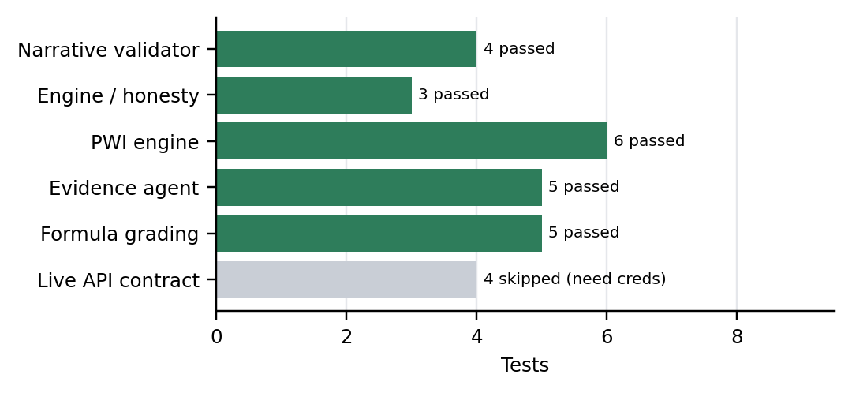
Figure 14. Automated test results (pytest, run offline for this report).
The notebook gates documented in the README all passed: Gate 0 (PWI dimensions on 5 sites, badges match WRI, zero -9999 leaks), Gates 1a/1b/1c (drought, groundwater and flood engines) and Gate 2 (API + tests). In the offline run for this report, 23 tests passed, covering the no-hallucination validator, null handling, PWI formulas and certification, evidence mapping and claim grading. The 4 live contract tests are skipped without GEE/Supabase credentials.

6. Novelty
- Scores that explain themselves. Commercial tools report a basin score; Hydris pairs every WRI score with a satellite-computed decomposition (attribution %, dataset, confidence) that points directly at an action.
- An honesty layer as architecture. Null-not-zero with renormalisation, confidence tags on every driver, regional labels for GRACE, and “not projected by WRI” badges run through the engine, API, database and UI.
- Hallucination-proof AI by construction. The LLM is the interface to the science, not its source: a mechanical numeral validator, retries and a deterministic fallback guarantee grounded narratives; the intervention maths uses no LLM at all.
- Diagnosis → prescription in one model. The digital twin re-runs the exact same composite on modified severities, so simulated risk reductions are consistent with baseline scores, and confidence propagates by weakest link.
- Methodology fidelity. The PWI 3×3 matrix, 52-question instrument, XV rules and certification tiers are transcribed from the provided workbook, and every number is traced to its formula and source.
- Global, zero-storage and resilient. Any coordinate on Earth is computed on demand in Earth Engine with live dataset probing; the Supabase → bundled demo → live compute chain keeps the demo working even if GEE fails.
- Evidence verification, not just collection. Disclosure claims are independently recomputed with GEE rainfall and graded A–F, capped by audited formula soundness.

7. Limitations and Honest Caveats
- Risk scores exist at Aqueduct basin resolution; level-9 sub-basin polygons refine shape, not score.
- Groundwater extraction pressure is a labelled proxy; the quality factor (QD) is excluded because no global groundwater-chemistry raster exists.
- GRACE is regional (~300 km); SMAP reads only the top ~5 cm of soil.
- The first driver computation for a new site takes 1–2 minutes; pilots are precached.
- The /reweight custom score uses an equal-weight base (like Aqueduct’s own custom tool), so it differs from WRI’s default weighting — this is captioned in the UI.
- The NewsAPI free tier works only from localhost; deployed news needs a paid tier or precached clippings.
- The PWI and evidence demonstrations use labelled ASSUMED/SYNTHETIC inputs; real factory data (Section A + 52 answers) is required for real certification. The WRC Top-100 basin list and JMP/AQUASTAT wiring are open gaps.
- Secrets were committed to git history at one point; they were removed from tracking and SECURITY.md lists the key rotation and history purge still required.

