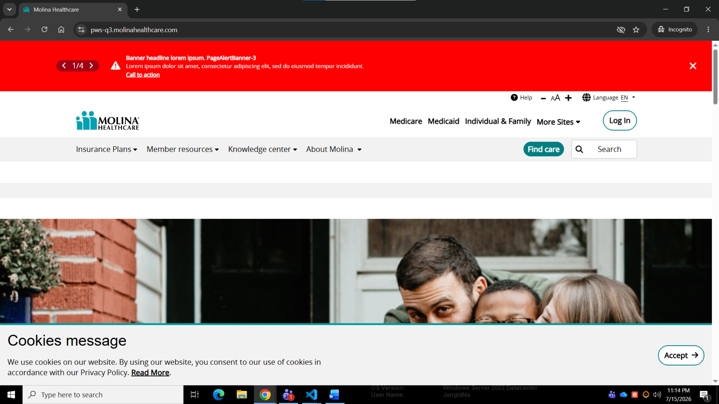

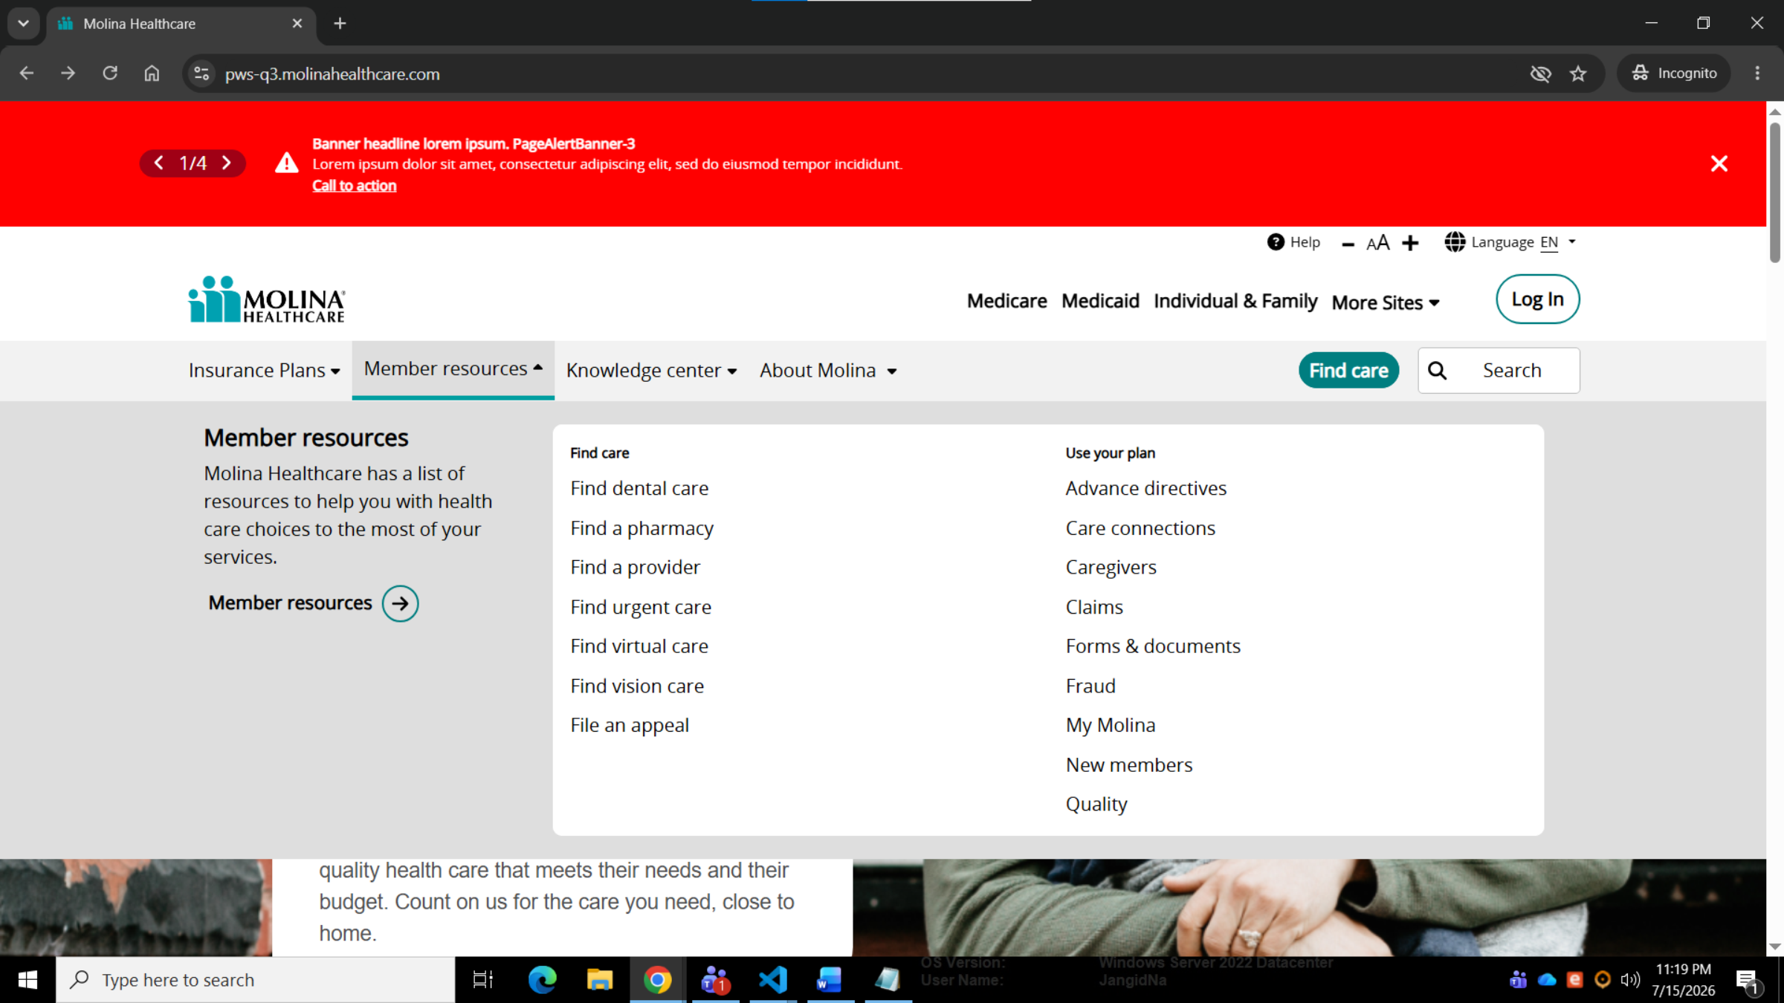

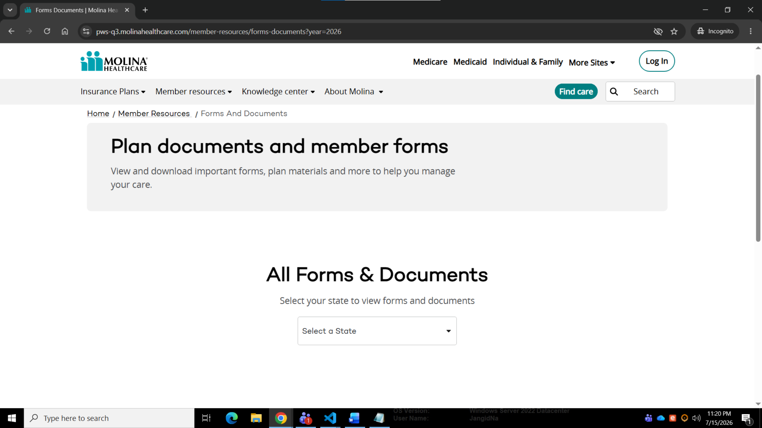

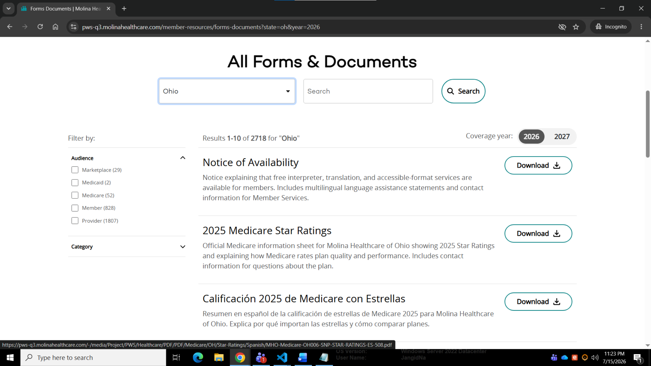
url : https://pws-q3.molinahealthcare.com/member-resources/forms-documents?state=oh&year=2026

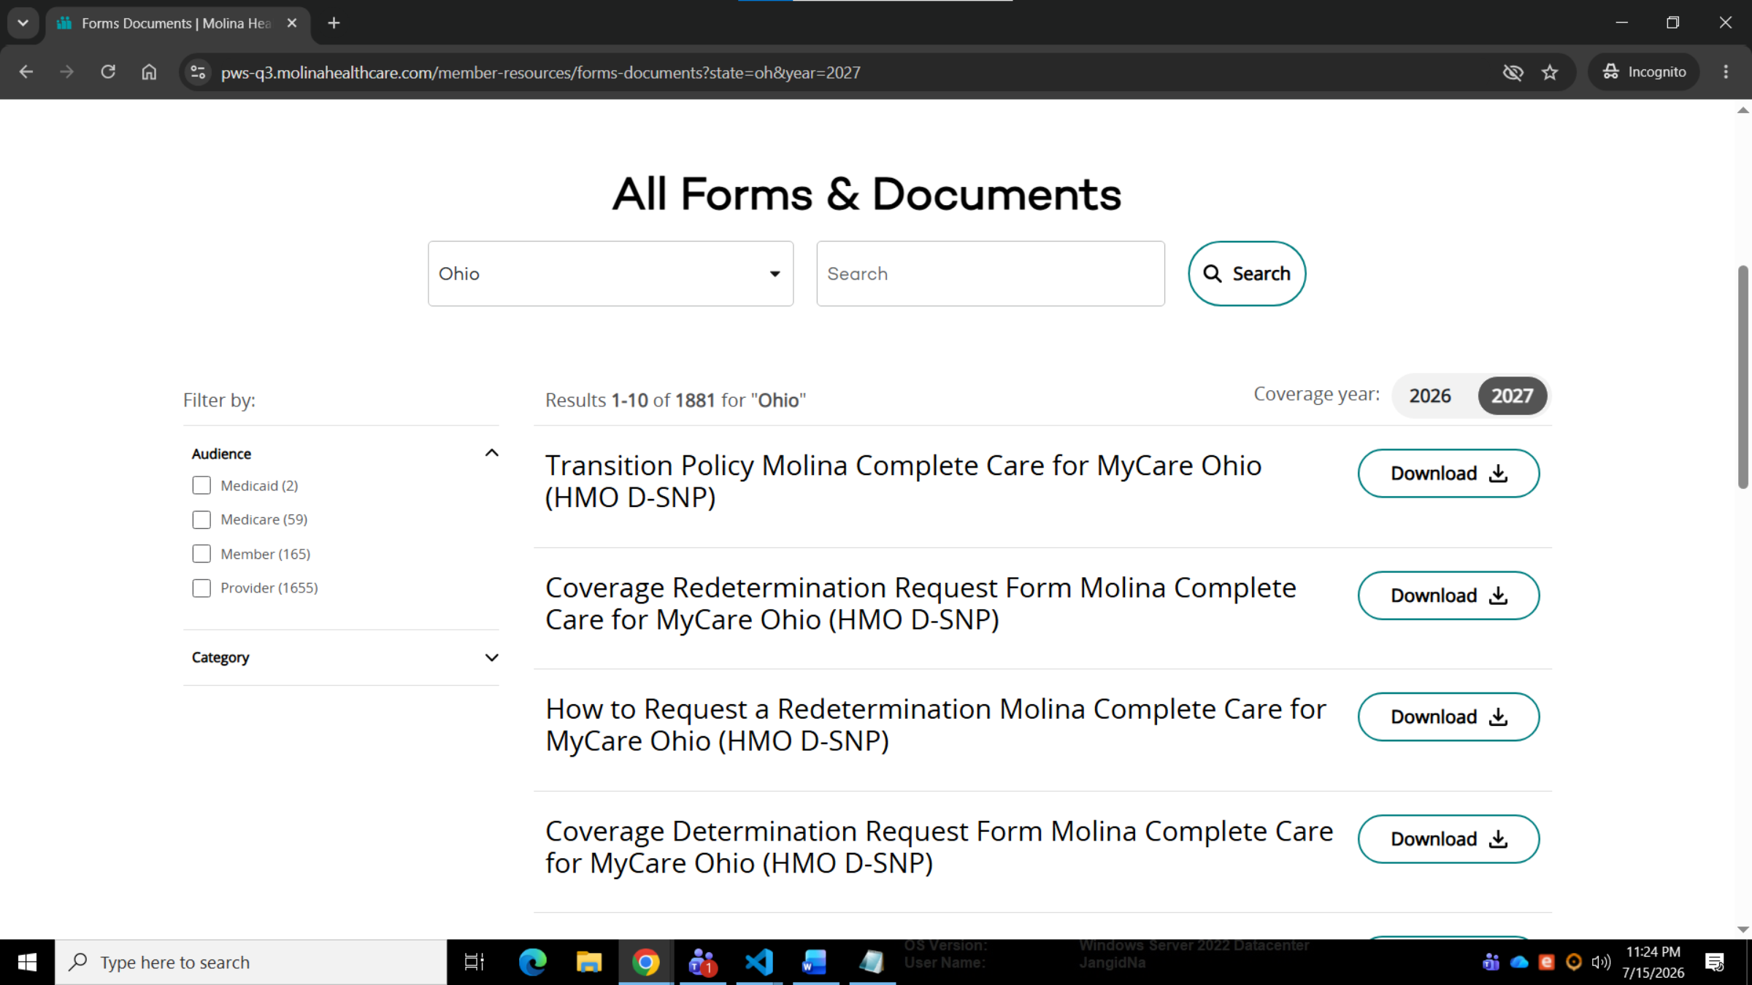
URL : https://pws-q3.molinahealthcare.com/member-resources/forms-documents?state=oh&year=2027

