**LAB PROGRAM 1 (INSURANCE DATABASE) Name: Tarun Sri Ram**

**USN: 1BM19CS171**

**Queries:**

|  |
| --- |
| Create database insurance; |
|  | use insurance; |
|  |  |
|  | create table person( |
|  | driver_id varchar(10), |
|  | name varchar(20), |
|  | address varchar(30), |
|  | primary key(driver_id) |
|  | ); |
|  |  |
|  | desc person; |
|  |  |
|  | create table car( |
|  | reg_num varchar(10), |
|  | model varchar(10), |
|  | year int, |
|  | primary key(reg_num) |
|  | ); |
|  |  |
|  | desc car; |
|  |  |
|  | create table accident( |
|  | report_num int, |
|  | accident_date date, |
|  | location varchar(20), |
|  | primary key(report_num) |
|  | ); |
|  |  |
|  | create table owns( |
|  | driver_id varchar(10), |
|  | reg_num varchar(10), |
|  | primary key(driver_id,reg_num), |
|  | foreign key(driver_id) references person(driver_id), |
|  | foreign key(reg_num) references car(reg_num) |
|  | ); |
|  |  |
|  | desc owns; |
|  |  |
|  | create table participated( |
|  | driver_id varchar(10), |
|  | reg_num varchar(10), |
|  | report_num int, |
|  | damage_amount int, |
|  | primary key(driver_id,reg_num,report_num), |
|  | foreign key(driver_id) references person(driver_id), |
|  | foreign key(reg_num) references car(reg_num), |
|  | foreign key(report_num) references accident(report_num) |
|  | ); |
|  |  |
|  | desc participated; |
|  |  |
|  | insert into person values('A01','Richard',' Srinivas Nagar'); |
|  | insert into person values('A02','Pradeep','Rajajinagar'); |
|  | insert into person values('A03','Smith','Ashoknagar'); |
|  | insert into person values('A04','Venu','N.R.Colony'); |
|  | insert into person values('A05','John','Hanumanth Nagar'); |
|  |  |
|  | commit; |
|  |  |
|  | select * from person; |
|  |  |
|  | insert into car values('KA031181','Lancer',1957); |
|  | insert into car values('KA041702','Audi',2005); |
|  | insert into car values('KA043408','Honda',2008); |
|  | insert into car values('KA052250','Indica',1990); |
|  | insert into car values('KA095477','Toyota',1998); |
|  |  |
|  | commit; |
|  |  |
|  | select * from car; |
|  |  |
|  |  |
|  | insert into accident values(11,'2001-01-03','Mysore Road'); |
|  | insert into accident values(12,'2021-01-03','Southend Circle'); |
|  | insert into accident values(13,'2020-03-03',' Bulltemple Road'); |
|  | insert into accident values(14,' 2017-02-08',' Mysore Road'); |
|  | insert into accident values(15,'2004-03-05','Kanakpura Road'); |
|  | commit; |
|  |  |
|  | select * from accident; |
|  |  |
|  | insert into owns values ('A01','KA052250'); |
|  | insert into owns values ('A02','KA043408'); |
|  | insert into owns values ('A03','KA031181'); |
|  | insert into owns values ('A04','KA095477'); |
|  | insert into owns values ('A05','KA041702'); |
|  | commit; |
|  |  |
|  | select * from owns; |
|  |  |
|  | insert into participated values ('A01','KA052250',11, 25000); |
|  | insert into participated values ('A02','KA043408',12, 50000); |
|  | insert into participated values ('A03','KA031181',13, 25000); |
|  | insert into participated values ('A04','KA095477',14, 3000); |
|  | insert into participated values ('A05','KA041702',15, 5000); |
|  | commit; |
|  |  |
|  | select * from participated; |
|  |  |
|  | update participated |
|  | set damage_amount = 2500 |
|  | where reg_num='KA031111'; |
|  |  |
|  | select * from participated; |
|  |  |
|  | insert into accident values(101,'2020-12-01','Xavier Road'); |
|  | insert into participated values('A01','KA031111',101, 1001); |
|  | commit; |
|  | select * from accident; |
|  | select * from participated; |
|  |  |
|  | insert into car values('KA01010', 'Accord', 2002); |
|  | insert into owns values('A02', 'KA01010'); |
|  | insert into accident values(200, '2008-12-01', 'Pinto Road'); |
|  | insert into participated values('A02', 'KA01010', 200, 500); |
|  | commit; |
|  |  |
|  | select * from car; |
|  | select * from owns; |
|  | select * from accident; |
|  | select * from participated; |
|  |  |
|  | select count(*) from accident where year(accident_date)=2008; |
|  | select count(*) from participated where reg_num in ( select reg_num from car where model="Accord"); |

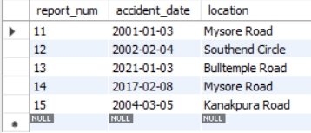

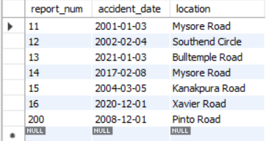

Accident Table

Accident Final Table

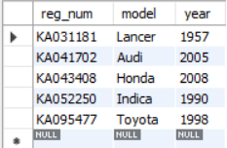

Car Table

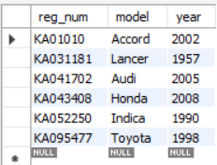

Car Final Table

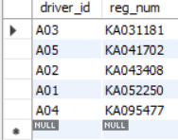

Owns Table

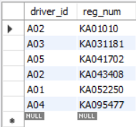

Owns Final Table

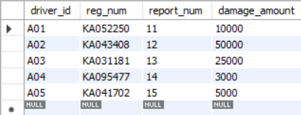

Participated Table

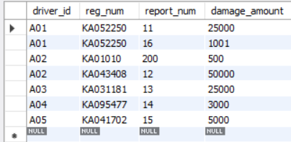

Participated Table Final

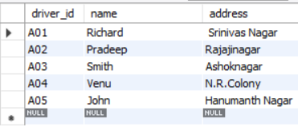

Person Table

**LAB PROGRAM 2 (BANK DATABASE) Name : Tarun Sri Ram**

**USN:1BM19CS171**

**Queries:**

|  |
| --- |
| create database bank; |
|  | use bank; |
|  |  |
|  | create table branch ( |
|  | branch_name varchar(25), |
|  | branch_city varchar(15), |
|  | assets int, |
|  | primary key (branch_name) |
|  | ); |
|  |  |
|  | create table bank_account ( |
|  | accno int, |
|  | branch_name varchar(25), |
|  | balance int, |
|  | primary key (accno), |
|  | foreign key (branch_name) references branch(branch_name) |
|  | ); |
|  |  |
|  | create table bank_customer ( |
|  | customer_name varchar(10), |
|  | customer_street varchar(25), |
|  | customer_city varchar(15), |
|  | primary key (customer_name) |
|  | ); |
|  |  |
|  | create table depositer ( |
|  | customer_name varchar(10), |
|  | accno int, |
|  | primary key(customer_name, accno), |
|  | foreign key (customer_name) references bank_customer(customer_name), |
|  | foreign key (accno) references bank_account(accno) |
|  | ); |
|  |  |
|  | create table loan ( |
|  | loan_number int, |
|  | branch_name varchar(25), |
|  | amount int, |
|  | primary key (loan_number), |
|  | foreign key (branch_name) references branch(branch_name) |
|  | ); |
|  |  |
|  | insert into branch values('SBI_Chamrajpet', 'Bangalore', 50000); |
|  | insert into branch values('SBI_ResidencyRoad', 'Bangalore', 10000); |
|  | insert into branch values('SBI_ShivajiRoad', 'Bombay', 20000); |
|  | insert into branch values('SBI_ParliamentRoad', 'Delhi', 10000); |
|  | insert into branch values('SBI_Jantarmantar', 'Delhi', 20000); |
|  | commit; |
|  |  |
|  | insert into bank_account values(1, 'SBI_Chamrajpet', 2000); |
|  | insert into bank_account values(2, 'SBI_ResidencyRoad', 5000); |
|  | insert into bank_account values(3, 'SBI_ShivajiRoad', 6000); |
|  | insert into bank_account values(4, 'SBI_ParliamentRoad', 9000); |
|  | insert into bank_account values(5, 'SBI_Jantarmantar', 8000); |
|  | insert into bank_account values(6, 'SBI_ShivajiRoad', 4000); |
|  | insert into bank_account values(8, 'SBI_ResidencyRoad', 4000); |
|  | insert into bank_account values(9, 'SBI_ParliamentRoad', 3000); |
|  | insert into bank_account values(10, 'SBI_ResidencyRoad', 5000); |
|  | insert into bank_account values(11, 'SBI_Jantarmantar', 2000); |
|  | commit; |
|  |  |
|  | insert into bank_customer values ('Avinash', 'Bull_Temple_Road', 'Bangalore'); |
|  | insert into bank_customer values ('Dinesh', 'Bannergatta_Road', 'Bangalore'); |
|  | insert into bank_customer values ('Mohan', 'National_College_Road', 'Bangalore'); |
|  | insert into bank_customer values ('Nikhil', 'Akbar_Road', 'Delhi'); |
|  | insert into bank_customer values ('Ravi', 'Prithviraj_Road', 'Delhi'); |
|  | commit; |
|  |  |
|  | insert into depositer values('Avinash', 1); |
|  | insert into depositer values('Dinesh', 2); |
|  | insert into depositer values('Nikhil', 4); |
|  | insert into depositer values('Ravi', 5); |
|  | insert into depositer values('Avinash', 8); |
|  | insert into depositer values('Nikhil', 9); |
|  | insert into depositer values('Dinesh', 10); |
|  | insert into depositer values('Nikhil', 11); |
|  | commit; |
|  |  |
|  | insert into loan values(1, 'SBI_Chamrajpet', 1000); |
|  | insert into loan values(2, 'SBI_ResidencyRoad', 2000); |
|  | insert into loan values(3, 'SBI_ShivajiRoad', 3000); |
|  | insert into loan values(4, 'SBI_ParliamentRoad', 4000); |
|  | insert into loan values(5, 'SBI_Jantarmantar', 5000); |
|  | commit; |
|  |  |
|  |
|  |
|  |
|  |
|  |
|  |

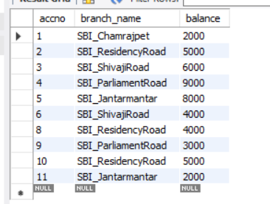

Bank Account Table

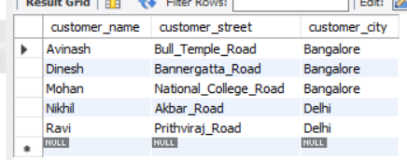

Bank Customer Table

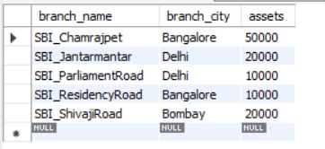

Branch Table

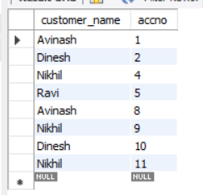

Depositor Table

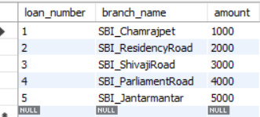

Loan Table

**Query 3 :**

use bank;

select distinct c.customer_name

from bank_customer c,bank_account b

where exists(select d.customer_name,count(d.customer_name)

from depositer d,bank_account ba

where ba.accno = d.accno and

c.customer_name = d.customer_name and ba.branch_name = 'SBI_ResidencyRoad'

group by d.customer_name having count(d.customer_name)>=2);

**Output:**

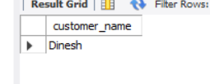

**Query 4:**

use bank;

select d.customer_name from depositer d,branch b,bank_account a

where b.branch_name=a.branch_name

AND a.accno=d.accno

and branch_city='Delhi'

group by d.customer_name

HAVING COUNT(distinct b.branch_name)=(

SELECT COUNT(branch_name)

FROM branch

WHERE branch_city='Delhi');

**Output:**

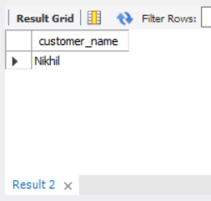

**Query 5:**

delete from bank_account

where branch_name in

(select branch_name from branch where branch_city = 'Bombay');

select * from bank_account;

**Output:**

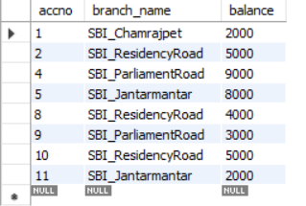

**NAME-TASMIYA FATHIMA**

**PROGRAM 3-( SUPPLIER DATABASE)**

Consider the following schema:

SUPPLIERS(sid: integer, sname: string, address: string)

PARTS(pid: integer, pname: string, color: string)

CATALOG(sid: integer, pid: integer, cost: real)

The Catalog relation lists the prices charged for parts by Suppliers.

create database Supplier;

use Supplier;

create table catalog(sid int,pid int,cost int);

desc catalog;

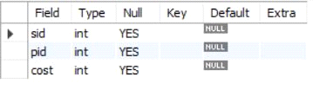

create table supplier(sid int,sname varchar(20),city varchar(15),primary key (sid));

desc supplier;

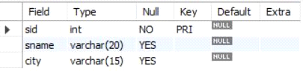

create table parts(pid int,pname varchar(15),color varchar(10),primary key (pid));

desc parts;

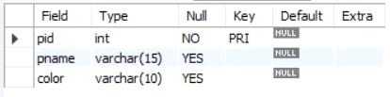

insert into supplier values(10001, 'Acme Widget','Bengaluru');

insert into supplier values(10002,'Johns','Kolkata');

insert into supplier values(10003, 'Vimal','Mumbai');

insert into supplier values(10004, 'Reliance','Delhi');

insert into supplier values(10005, 'Mahindra','Mumbai');

select * from supplier;

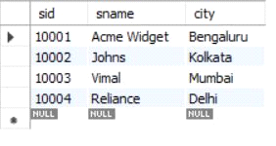

insert into parts values(20001, 'Book','Red');

insert into parts values(20002, 'Pen','Red');

insert into parts values(20003, 'Pencil','Green');

insert into parts values(20004, 'Mobile','Green');

insert into parts values(20005, 'Charger','Black');

select * from parts;

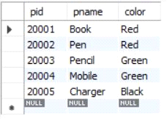

insert into catalog values(10001, '20001','10');

insert into catalog values(10001, '20002','10');

insert into catalog values(10001, '20003','30');

insert into catalog values(10001, '20004','10');

insert into catalog values(10001, '20005','10');

insert into catalog values(10002, '20001','10');

insert into catalog values(10002, '20002','20');

insert into catalog values(10003, '20003','30');

insert into catalog values(10004, '20003','40');

select * from catalog;

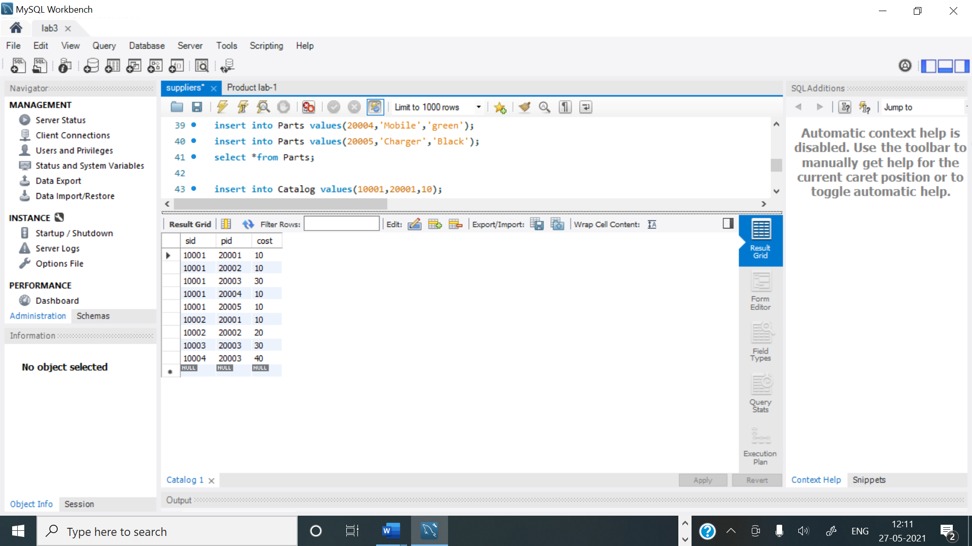

**1.Find the pnames of parts for which there is some supplier.**

select distinct p.pname from parts p, catalog c where p.pid = c.pid;

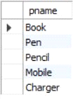

**2.Find the snames of suppliers who supply every part.**

select s.sname from supplier s

where not exists (select p.pid from parts p where not exists

(select c.sid from catalog c where c.sid = s.sid and c.pid = p.pid));



**3.Find the snames of suppliers who supply every red part.**

select s.sname from supplier s where not exists

(select p.pid from parts p where p.color = 'Red' and

(not exists (select c.sid from catalog c where c.sid = s.sid and c.pid = p.pid)));

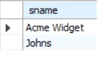

**4.Find the pnames of parts supplied by Acme Widget Suppliers and by no one else.**

select p.pname from parts p , catalog c, supplier s

where p.pid = c.pid and c.sid = s.sid and s.sname = 'Acme Widget'

and not exists

(select * from catalog c1, supplier s1 where

p.pid = c1.pid and c1.sid = s1.sid and s1.sname <> 'Acme Widget');

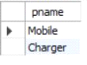

**5.Find the sids of suppliers who charge more for some part than the average cost of that part (averaged over all the suppliers who supply that part).**

select distinct c.sid from catalog c

where c.cost > ( select avg (c1.cost)

from catalog c1

where c1.pid = c.pid );

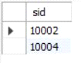

**6.For each part, find the sname of the supplier who charges the most for that part.**

select p.pid, s.sname

from parts p, supplier s, catalog c

where c.pid = p.pid

and c.sid = s.sid

and c.cost = (select MAX(c1.cost)

from catalog c1

where c1.pid = p.pid);

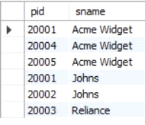

**LAB PROGRAM 4 (STUDENT FACULTY DATABASE) Name: Tarun Sriram D**

**USN: 1BM19CS171**

**Queries:**

|  |
| --- |
|  |
| CREATE DATABASE student_faculty; |
|  | USE student_faculty; |
|  | CREATE TABLE student( |
|  | snum INT, |
|  | sname VARCHAR(10), |
|  | major VARCHAR(2), |
|  | lvl VARCHAR(2), |
|  | age INT, primary key(snum)); |
|  |  |
|  | CREATE TABLE faculty( |
|  | fid INT,fname VARCHAR(20), |
|  | deptid INT, |
|  | PRIMARY KEY(fid)); |
|  |  |
|  | CREATE TABLE class( |
|  | cname VARCHAR(20), |
|  | metts_at TIMESTAMP, |
|  | room VARCHAR(10), |
|  | fid INT, |
|  | PRIMARY KEY(cname), |
|  | FOREIGN KEY(fid) REFERENCES faculty(fid)); |
|  |  |
|  | CREATE TABLE enrolled( |
|  | snum INT, |
|  | cname VARCHAR(20), |
|  | PRIMARY KEY(snum,cname), |
|  | FOREIGN KEY(snum) REFERENCES student(snum), |
|  | FOREIGN KEY(cname) REFERENCES class(cname)); |
|  |  |
|  | INSERT INTO STUDENT VALUES(1, 'jhon', 'CS', 'Sr', 19); |
|  | INSERT INTO STUDENT VALUES(2, 'Smith', 'CS', 'Jr', 20); |
|  | INSERT INTO STUDENT VALUES(3 , 'Jacob', 'CV', 'Sr', 20); |
|  | INSERT INTO STUDENT VALUES(4, 'Tom ', 'CS', 'Jr', 20); |
|  | INSERT INTO STUDENT VALUES(5, 'Rahul', 'CS', 'Jr', 20); |
|  | INSERT INTO STUDENT VALUES(6, 'Rita', 'CS', 'Sr', 21); |
|  |  |
|  | INSERT INTO FACULTY VALUES(11, 'Harish', 1000); |
|  | INSERT INTO FACULTY VALUES(12, 'MV', 1000); |
|  | INSERT INTO FACULTY VALUES(13 , 'Mira', 1001); |
|  | INSERT INTO FACULTY VALUES(14, 'Shiva', 1002); |
|  | INSERT INTO FACULTY VALUES(15, 'Nupur', 1000); |
|  |  |
|  | insert into class values('class1', '12/11/15 10:15:16', 'R1', 14); |
|  | insert into class values('class10', '12/11/15 10:15:16', 'R128', 14); |
|  | insert into class values('class2', '12/11/15 10:15:20', 'R2', 12); |
|  | insert into class values('class3', '12/11/15 10:15:25', 'R3', 11); |
|  | insert into class values('class4', '12/11/15 20:15:20', 'R4', 14); |
|  | insert into class values('class5', '12/11/15 20:15:20', 'R3', 15); |
|  | insert into class values('class6', '12/11/15 13:20:20', 'R2', 14); |
|  | insert into class values('class7', '12/11/15 10:10:10', 'R3', 14); |
|  |  |
|  | insert into enrolled values(1, 'class1'); |
|  | insert into enrolled values(2, 'class1'); |
|  | insert into enrolled values(3, 'class3'); |
|  | insert into enrolled values(4, 'class3'); |
|  | insert into enrolled values(5, 'class4'); |
|  | insert into enrolled values(1, 'class5'); |
|  | insert into enrolled values(2, 'class5'); |
|  | insert into enrolled values(3, 'class5'); |
|  | insert into enrolled values(4, 'class5'); |
|  | insert into enrolled values(5, 'class5'); |
|  |  |

**Class Table:**

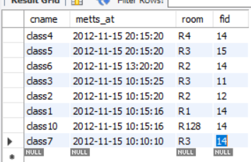

**Enrolled Table:**

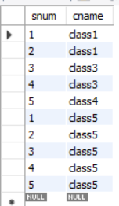

**Faculty Table:**

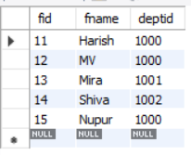

**Student Table:**

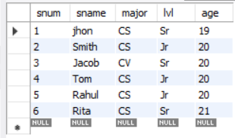

**ADDITIONAL QUERIES**

**Query 1:**

SELECT DISTINCT S.Sname

FROM Student S, Class C, Enrolled E, Faculty F

WHERE S.snum = E.snum AND E.cname = C.cname AND C.fid = F.fid AND

F.fname = 'Harish' AND S.lvl = 'Jr';

**Output:**

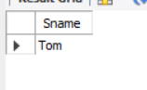

**Query 2:**

SELECT DISTINCT cname

FROM class

WHERE room='R128'

OR

cname IN (SELECT e.cname FROM enrolled e GROUP BY e.cname HAVING COUNT(*)>=5);

**Output:**

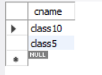

**Query 3:**

SELECT DISTINCT S.sname

FROM Student S

WHERE S.snum IN (SELECT E1.snum

FROM Enrolled E1, Enrolled E2, Class C1, Class C2

WHERE E1.snum = E2.snum AND E1.cname <> E2.cname

AND E1.cname = C1.cname

AND E2.cname = C2.cname AND C1.metts_at = C2.metts_at);

**Output:**

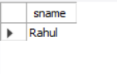

**Query 4:**

SELECT f.fname,f.fid

FROM faculty f

WHERE f.fid in ( SELECT fid FROM class

GROUP BY fid HAVING COUNT(*)=(SELECT COUNT(DISTINCT room) FROM class) );

**Output:**

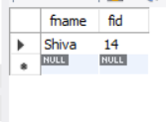

**Query 5:**

SELECT DISTINCT F.fname

FROM Faculty F

WHERE 5 > (SELECT COUNT(E.snum)

FROM Class C, Enrolled E

WHERE C.cname = E.cname

AND C.fid = F.fid);

**Output:**

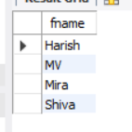

**Query 6:**

SELECT DISTINCT S.sname

FROM Student S

WHERE S.snum NOT IN (SELECT E.snum

FROM Enrolled E );

**Output:**

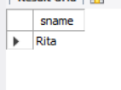

**Query 7:**

SELECT S.age, S.lvl

FROM STUDENT S

GROUP BY S.age, S.lvl

HAVING S.lvl IN(SELECT S1.lvl

FROM STUDENT S1

WHERE S1.age=S.age

GROUP BY S1.age, S1.lvl

HAVING COUNT(*) >= ALL (SELECT COUNT(*)

FROM STUDENT S2

WHERE S1.age=S2.age

GROUP BY S2.lvl, S2.age))

ORDER BY S.age;

**Output:**

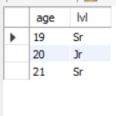

**LAB PROGRAM 5 (FLIGHT DATABASE) Name: Tarun Sriram D**

**USN: 1BM19CS171**

**Queries:**

|  |
| --- |
|  |
| create database flightdb; |
|  | use flightdb; |
|  |  |
|  | create table flights( |
|  | flno int, |
|  | fromplace varchar(15), |
|  | toplace varchar(15), |
|  | distance int, |
|  | departs datetime, |
|  | arrives datetime, |
|  | price int, |
|  | primary key (flno) |
|  | ); |
|  | desc flights; |
|  | create table aircraft( |
|  | aid int, |
|  | aname varchar(15), |
|  | cruisingrange int, |
|  | primary key (aid) |
|  | ); |
|  | desc aircraft; |
|  | create table employees ( |
|  | eid int, |
|  | ename varchar(15), |
|  | salary int, |
|  | primary key (eid) |
|  | ); |
|  | desc employees; |
|  | create table certified ( |
|  | eid int, |
|  | aid int, |
|  | foreign key (eid) references employees(eid), |
|  | foreign key (aid) references aircraft(aid) |
|  | ); |
|  | desc certified; |
|  | insert into flights values(101, 'Bangalore', 'Delhi', 2500, '2005-05-13 07:15:31', '2005-05-13 18:15:31', 5000); |
|  | insert into flights values(102, 'Bangalore', 'Lucknow', 3000, '2013-05-05 07:15:31', '2013-05-05 11:15:31', 6000); |
|  | insert into flights values(103, 'Lucknow', 'Delhi', 500, '2013-05-05 12:15:31', '2013-05-05 17:15:31', 3000); |
|  | insert into flights values(107, 'Bangalore', 'Frankfurt', 8000, '2013-05-05 07:15:31', '2013-05-05 22:15:31', 60000); |
|  | insert into flights values(104, 'Bangalore', 'Frankfurt', 8500, '2013-05-05 07:15:31', '2013-05-05 23:15:31', 75000); |
|  | insert into flights values(105, 'Kolkata', 'Delhi', 3400, '2013-05-05 07:15:31', '2013-05-05 09:15:31', 7000); |
|  | insert into flights values(106, 'Bangalore', 'Kolkata', 1000, '2013-05-05 01:15:30', '2013-05-05 09:20:30', 10000); |
|  | insert into flights values(108, 'Lucknow', 'Kolkata', 1000, '2013-05-05 11:30:30', '2013-05-05 15:20:30', 10000); |
|  |  |
|  | commit; |
|  |  |
|  | select * from flights; |
|  |  |
|  | insert into aircraft values(101, '747', 3000); |
|  | insert into aircraft values(102, 'Boeing', 900); |
|  | insert into aircraft values(103, '647', 800); |
|  | insert into aircraft values(104, 'Dreamliner', 10000); |
|  | insert into aircraft values(105, 'Boeing', 3500); |
|  | insert into aircraft values(106, '707', 1500); |
|  | insert into aircraft values(107, 'Dream', 120000); |
|  | insert into aircraft values(108, '707', 760); |
|  | insert into aircraft values(109, '747', 1000); |
|  | commit; |
|  |  |
|  | select * from aircraft; |
|  |  |
|  | insert into employees values(701, 'A', 50000); |
|  | insert into employees values(702, 'B', 100000); |
|  | insert into employees values(703, 'C', 150000); |
|  | insert into employees values(704, 'D', 90000); |
|  | insert into employees values(705, 'E', 40000); |
|  | insert into employees values(706, 'F', 60000); |
|  | insert into employees values(707, 'G', 90000); |
|  | commit; |
|  |  |
|  | select * from employees; |
|  |  |
|  | insert into certified values(701, 101); |
|  | insert into certified values(701, 102); |
|  | insert into certified values(701, 106); |
|  | insert into certified values(701, 105); |
|  |  |
|  | insert into certified values(702, 104); |
|  | insert into certified values(703, 104); |
|  | insert into certified values(704, 104); |
|  |  |
|  | insert into certified values(702, 107); |
|  | insert into certified values(703, 107); |
|  | insert into certified values(704, 107); |
|  |  |
|  | insert into certified values(702, 101); |
|  | insert into certified values(702, 108); |
|  | insert into certified values(701, 109); |
|  | commit; |
|  | select * from certified; |
|  |  |

**Aircraft Table :**

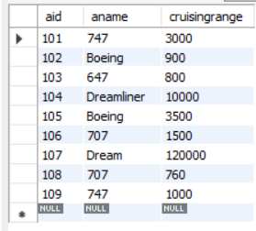

**Employees Table:**

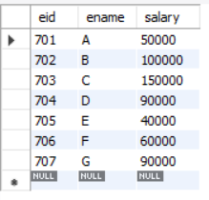

**Certified Table :**

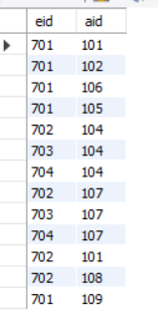

**Flights Table:**

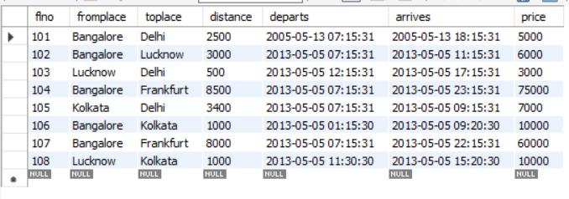

**ADDITIONAL QUERIES**

**Query 1:**

select distinct a.aname from aircraft a where a.aid in (

select c.aid from certified c, employees e where

c.eid = e.eid and not exists(

select * from employees e1 where e1.eid=e.eid and e1.salary<80000

)

);

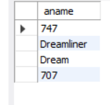**Result:**

**Query 2:**

select max(a.cruisingrange), c.eid from certified c, aircraft a where c.aid = a.aid group by c.eid having count(c.eid)>3;

**Result:**

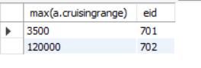

**Query 3:**

select ename from employees where salary <(

select min(price) from flights where fromplace='Bangalore' and toplace='Frankfurt');

**Result:**

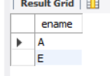

**Query 4:**

select avg(e.salary), c.aid from certified c, employees e where c.aid in(

select aid from aircraft where cruisingrange>1000) and e.eid = c.eid group by c.aid;

**Result:**

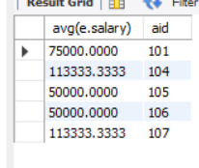

**Query 5:**

select ename from employees where eid in(

select eid from certified where aid in(

select aid from aircraft where aname = 'Boeing'));

**Result:**

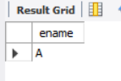

**Query 6:**

select aname from aircraft where cruisingrange > any (select distance from flights where fromplace='Bangalore' and toplace='Delhi');

**Result:**

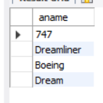

**Query 7:**

SELECT F.flno, F.departs

FROM flights F

WHERE F.flno IN ( ( SELECT F0.flno

FROM flights F0

WHERE F0.fromplace = 'Bangalore' AND F0.toplace = 'Kolkata'

AND extract(hour from F0.arrives) < 18 )

UNION

( SELECT F0.flno

FROM flights F0, flights F1

WHERE F0.fromplace = 'Bangalore' AND F0.toplace <> 'Kolkata'

AND F0.toplace = F1.fromplace AND F1.toplace = 'Kolkata'

AND F1.departs > F0.arrives

AND extract(hour from F1.arrives) < 18)

UNION

( SELECT F0.flno

FROM flights F0, flights F1, flights F2

WHERE F0.fromplace = 'Bangalore'

AND F0.toplace = F1.fromplace

AND F1.toplace = F2.fromplace

AND F2.toplace = 'Kolkata'

AND F0.toplace <> 'Kolkata'

AND F1.toplace <> 'Kolkata'

AND F1.departs > F0.arrives

AND F2.departs > F1.arrives

AND extract(hour from F2.arrives) < 18));

**Result:**

