**LIBRARY MANAGEMENT SYSTEM**

-Tarun Kumar Gupta(IMT2020061)

1. USE CASE DIAGRAM

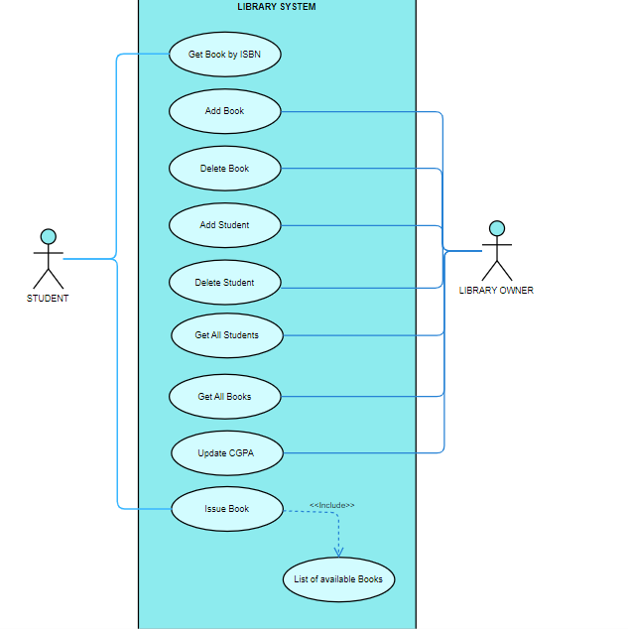

1. UML Diagram

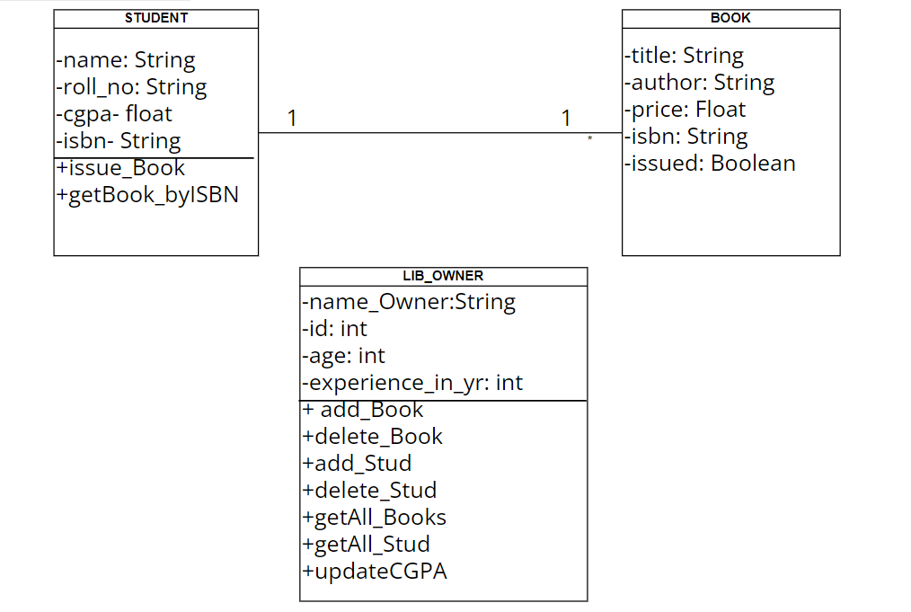

1. OR MAPPING

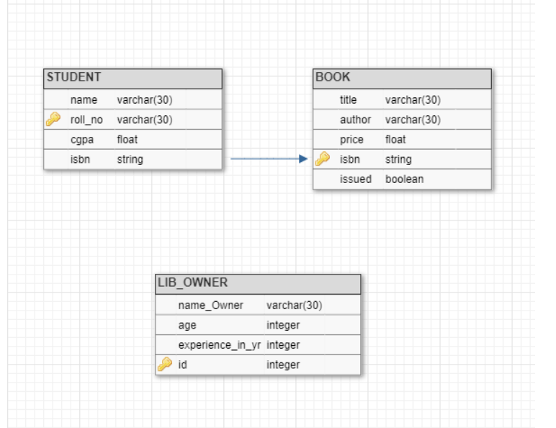

iv) Output Screenshots

1. Welcome page:

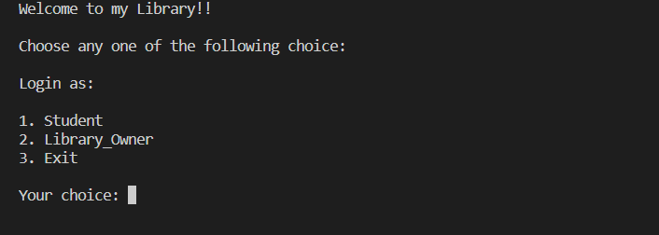

1. Student login page:

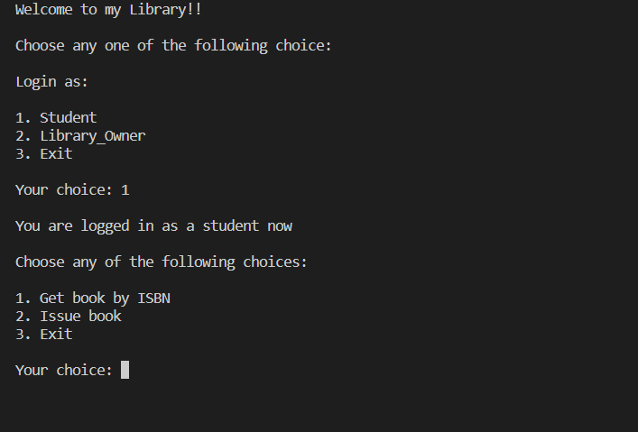

1. Get book by ISBN:

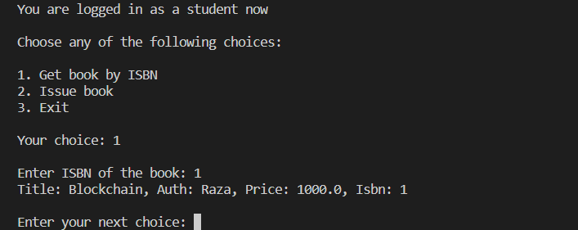

1. Issue book:

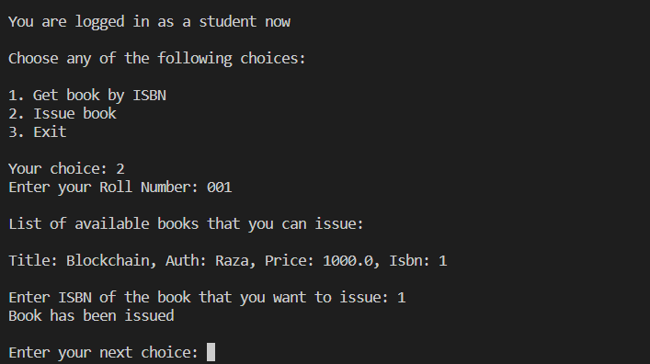

1. Owner login page:

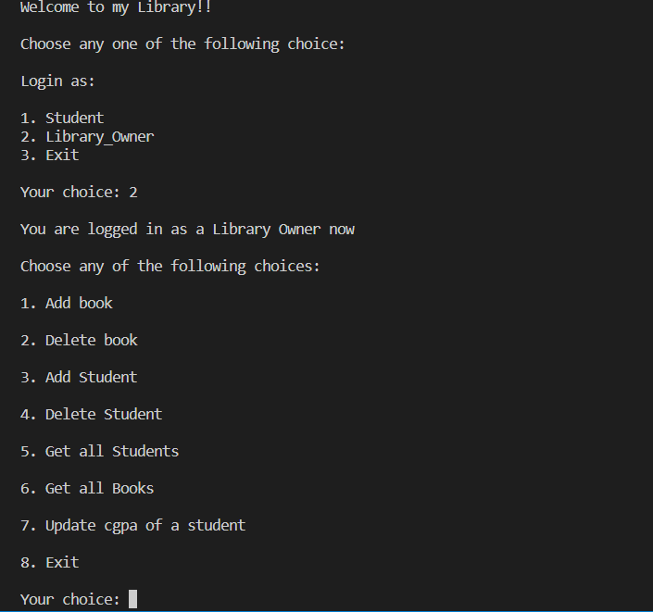

1. Add book:

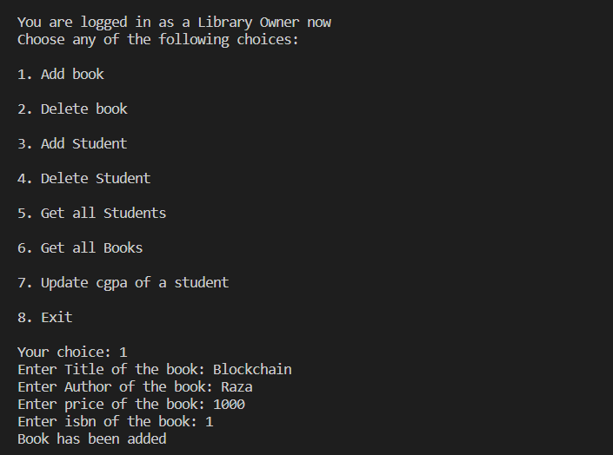

1. Delete book:

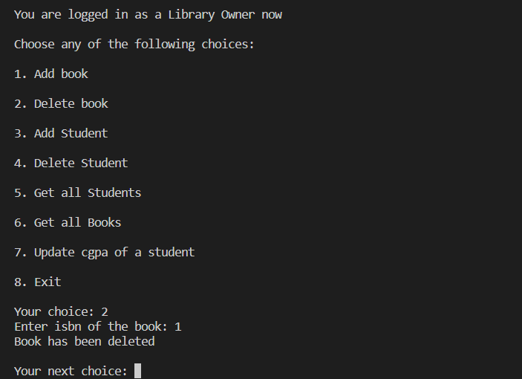

1. Add Student:

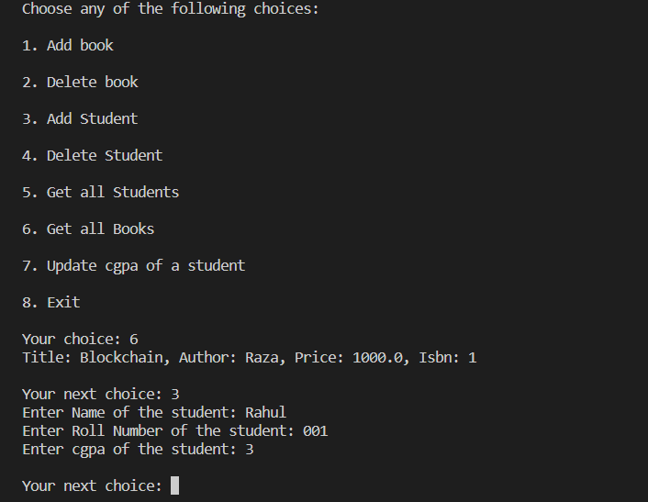

1. Delete Student:

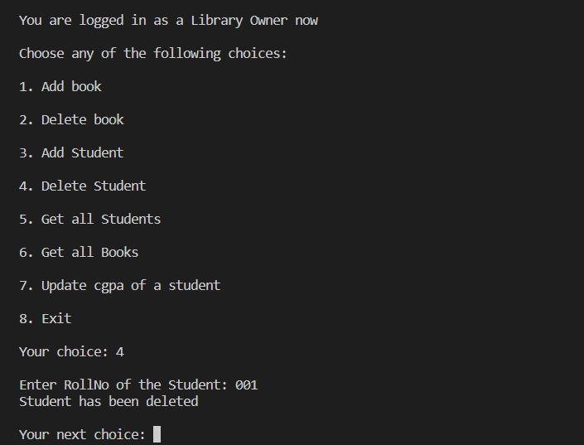

1. Get all Students:

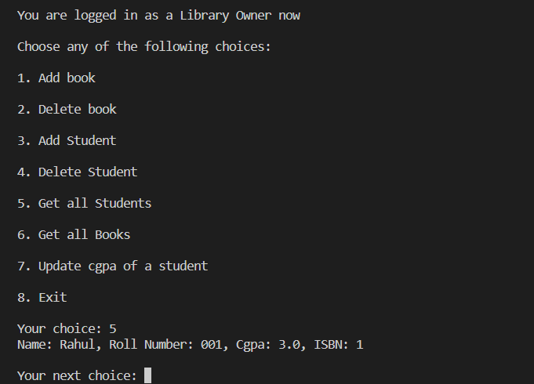

1. Get all Books:

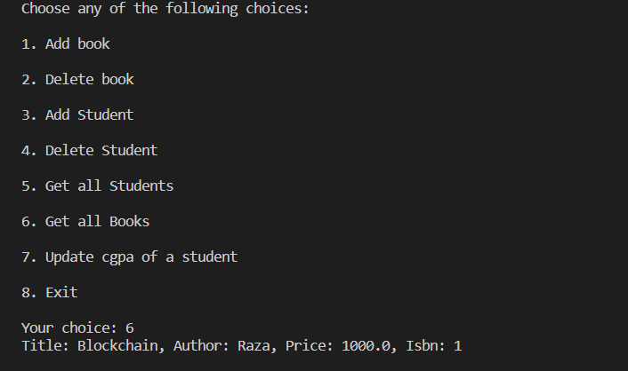

1. Update CGPA of Student and showing the updated CGPA:

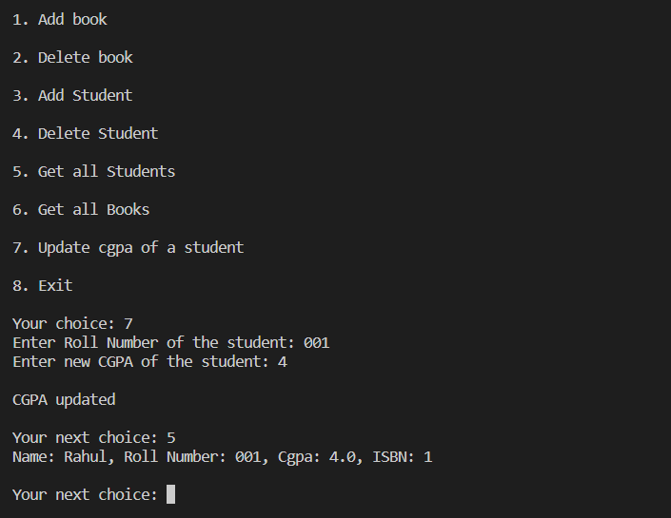

1. Notes and Instructions to run the code:
2. In your mysql command prompt run these commands:
3. source creatLib.sql
4. source alterLib.sql
5. source addData.sql
6. Come out of your mysql command prompt.
7. Run the command export CLASSPATH=’$path’ where $path is the path of mysql-connector-java-8.0.18.jar file in your system. For eg. export CLASSPATH='/home/iiitb/Desktop/session 10/mysql-connector-java-8.0.18.jar:.'
8. In IMT2020061_MainMenu.java change the username and password to your credentials of mysql command prompt.
9. Then run javac IMT2020061_MainMenu.java
10. Then run java IMT2020061_MainMenu

NOTES: In mysql command prompt, you can run source dropLib.sql to delete the database.