M S Ramaiah Institute of Technology
(Autonomous Institute, Affiliated to VTU)
Department of Information Science & Engineering
Term: 16th JAN to 10th MAY 2013 Subject: Computer Networks-II Sub Code: IS601
CIE Test No: II Semester: VI Section: A, B, &C Credits: 4:0:0 Max Marks: 30 Time Allotted: 1 hr
Instructions to Candidates:
Mobile phones are banned
PART A is compulsory; Answer any 05 from Part B

PART-A (Compulsory Question15Marks)

- Illustrating the procedure for encryption in Simplified Data Encryption Standard for the string 10100010 using the key 0111111101, show all the intermediate results.
Consider:
IP={2,6,3,1,4,8,5,7}
S1=
0123
2013
3010
2103

S0=
1032
3210
0213
3132

IP⁻¹={4,1,3,5,7,2,8,6}
P10={3,5,2,7,4,10,1,9,8,6}
P8={6,3,7,4,8,5,10,9}
P4={2,4,3,1}

PART-B (ANY 03*05M each)

- What is the drawback of priority queuing and discuss how to overcome this drawback.
- Illustrate the inverse domain configuration in DNS to read the IP address 132.34.45.121
- Explain different types of attacks on encrypted messages.
- Give relationship between security services and mechanisms.

M S Ramaiah Institute of Technology
(Autonomous Institute, Affiliated to VTU)
Department of Information Science & Engineering
Term: 16th JAN to 10th MAY 2013 Subject: Computer Networks-II Sub Code: IS601
CIE Test No: II Semester: VI Section: A, B, &C Credits: 4:0:0 Max Marks: 30 Time Allotted: 1 hr
Instructions to Candidates:
Mobile phones are banned
PART A is compulsory; Answer any 05 from Part B

PART-A (Compulsory Question15Marks)

- Illustrating the procedure for decryption in Simplified Data Encryption Standard for the string 10100010 using the key 0111111101, show the intermediate results for the following steps (Key generation need to be demonstrated): IP, Fk (1st function), SW
Consider:
IP={2,6,3,1,4,8,5,7}
S1=
0123
2013
3010
2103

S0=
1032
3210
0213
3132

IP⁻¹={4,1,3,5,7,2,8,6}
P10={3,5,2,7,4,10,1,9,8,6}
P8={6,3,7,4,8,5,10,9}
P4={2,4,3,1}

PART-B (ANY 03*05M each)

- What is the drawback of priority queuing and discuss how to overcome this drawback.
- Illustrate the inverse domain configuration in DNS to read the IP address 132.34.45.121
- Explain different types of attacks on encrypted messages.
- Give relationship between security services and mechanisms.

M S Ramaiah Institute of Technology
(Autonomous Institute, Affiliated to VTU)
Department of Information Science & Engineering
Term: 16th JAN to 10th MAY 2013 Subject: Computer Networks-II Sub Code: IS601
CIE Test No: II Semester: VI Section: A, B, &C Credits: 4:0:0 Max Marks: 30 Time Allotted: 1 hr
Instructions Given to Candidates:
Mobile phones are banned
PART A is compulsory; Answer any 05 from Part B

SCHEME FOR EVALUATION

PART-A (Compulsory Question15Marks)

- IP: 01011111 3M
FK: 10100001 (SK1: 01011111) 5M + 5M
SW: 00011010 2M

PART-B (ANY 03*05M each)

- Drawback of priority queue: Starvation 02M
Solution: explaining weighted fair queuing: 03M

- inverse domain configuration in DNS to read the IP address 132.34.45.121 05M

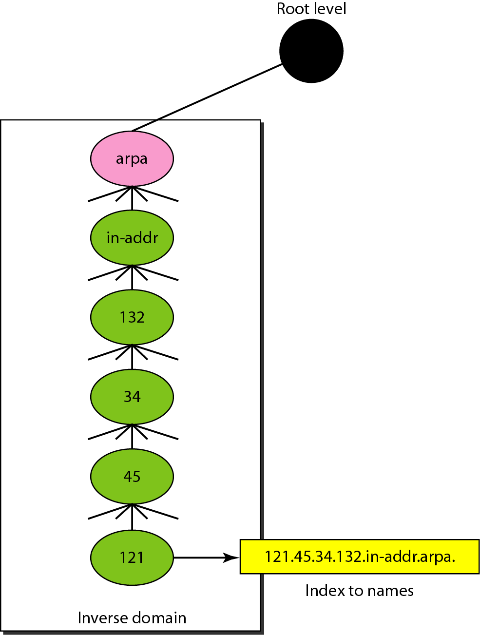

- Different types of attacks on encrypted messages:
Ciphertext only, Known Plaintext, Chosen plaintext, Chosen cipher text, chosen text. (05*01M each)

- Relationship between security services and mechanisms: 05M
