CIE: Internal Assessment Details

Internal Assessment Question Paper – 1
M S Ramaiah Institute of Technology
(Autonomous Institute, Affiliated to VTU)

Department of Information Science and Engineering
Programme: B. E. in Information Science and Engineering
Term: | 16.01.2014 to 10.05.2014 | Course Code: | IS601
Course: | Computer Networks II | Semester: | VI
CIE: | Test – I | Max Marks: | 30
Date: | 26.02.2014 | Time: | 9.15-10.15
Portions for Test: Lecture Nos. from 1 to 15 as per lesson plan circulated to students at the beginning of the semester
Instructions to Candidates: Answer any three questions.
Note: Mobiles and Programmable Calculators are strictly prohibited.
S. No. | Question | Marks | Bloom’s Level #
Part – I
1. | Why do OSPF messages propagate faster than RIP messages? Calculate the minimum cost from Source node A to all other nodes for the following graph using Dijkstra’s Algorithm.  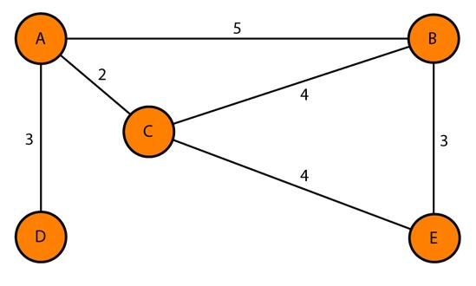 | 10 | R  U  E
2. | Briefly describe the relationship between 3 phases of TCP congestion policy. List and explain the policies that can prevent congestion. | 10 | R  U
3. | With a neat diagram, explain the user datagram format. List 5 uses of UDP Protocol. | 10 | R  U
4. | Illustrate the difference between RPF and RPB. Explain the process of tree formation using Core-Based Tree Protocol. | 10 | U  A
#R – Remember; U – Understand; A – Analyze; E - Evaluate

Course Outcomes meant to be assessed by the first IA Test: CO1, CO2

