M S RAMAIAH INSTITUTE OF TECHNOLOGY
(Autonomous Institute, affiliated to VTU)
DEPARTMENT OF INFORMATION SCIENCE & ENGINEERING

Term: | 28.01.2015 to 16.05.2015 | Course Code: | IS611/IS601
Course: | Computer Networks | Semester: | 6 – A, B & C
CIE: | Test – II | Max Marks: | 30
Date: | 06.04.2015 | Time: | 9.15AM – 10.15AM
Portions for Test: Lecture Nos. from 15 to 29, 48 to 51 as per lesson plan.
Instructions to Candidates: Answer any three questions.
Note: Mobiles and Programmable Calculators are strictly prohibited.
S. No. | Question | Marks | Bloom’s Level # | COs
1. | List the steps of the updating phase in distance vector routing protocol. Briefly describe the classification of BGP path attributes. | 4+6 | R | CO2
2. | Give the flow chart for Dijkstra algorithm. Using the same give the routing table for node E in the network configuration (check overleaf for the diagram) by illustrating the formation of shortest path tree.  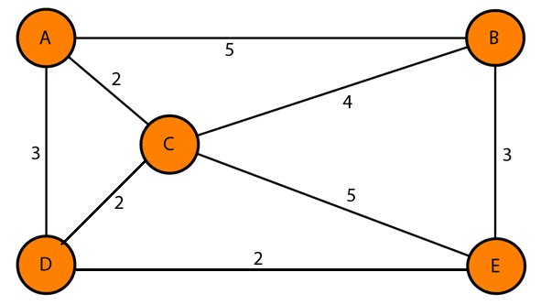 | 4+6 | R, Ap | CO2
3. | - Illustrate with a neat diagram how RPM is more efficient than RPF and RPB. Does RPF and RPB create a shortest path tree? Explain.  - List four uses of UDP protocol. | 6+2  2 | R, U, An | CO3
4. | - How are options negotiated in TELNET?  - In electronic mail, what is MIME? Briefly explain its header with diagram? | 4  6 | R, U | CO5
#R – Remember; U – Understand; Ap – Apply; An – Analyze;

