***Experiment - 1***

***Aim:-***

***Case - Study*** on the architecture of 8051uC chip

***THEORY*:**

Introduction: The Intel MCS-51 (commonly referred to as 8051) is a Harvard architecture, single chip microcontroller (µC) series which was developed by Intel in 1980 for use in embedded systems. Intel's original versions were popular in the 1980s and early 1990s. While Intel no longer manufactures the MCS-51, binary compatible derivatives remain popular today. Intel's original MCS-51 family was developed using NMOS technology, but later versions, identified by a letter C in their name (e.g., 80C51) used CMOS technology and consumed less power than their NMOS predecessors. This made them more suitable for battery-powered devices



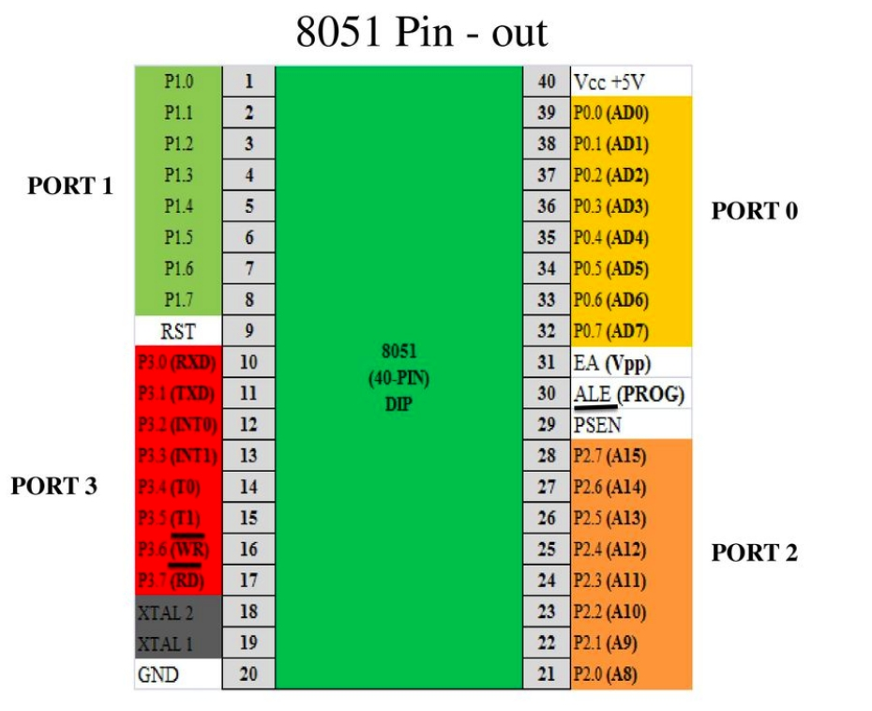

**Block Diagram : -**

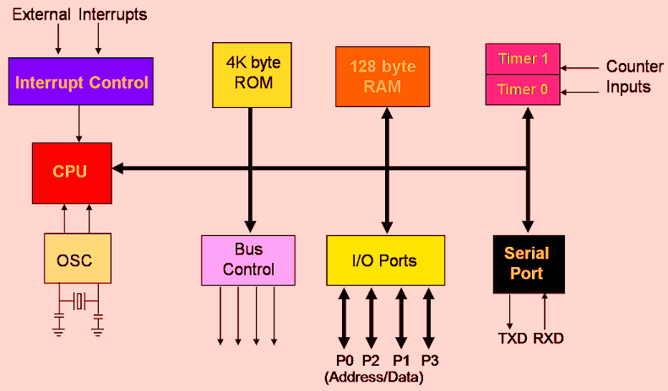

**Features Of 8051uC chip :-**

* 4KB bytes on-chip program memory (ROM)
* 128 bytes on-chip data memory (RAM)
* Four register banks
* 128 user defined software flags
* 8-bit bidirectional data bus
* 16-bit unidirectional address bus
* 32 general purpose registers each of 8-bit
* 16 bit Timers (usually 2, but may have more or less)
* Three internal and two external Interrupts
* Four 8-bit ports,(short model have two 8-bit ports)
* 16-bit program counter and data pointer
* 8051 may also have a number of special features such as UARTs, ADC, Op-amp, etc.

**Conclusion :-**

**In this session we studied what is 8051uC microcontroller?,**

**Its architecture and its detail pin structure.**