***Experiment - 10***

***Aim:-***

Interface a LCD and ultrasonic sensor with the **ARDUINO** in **Proteus** and WAP in IDE to simulate the circuit

***Components:-***

1. ***Proteus***
2. ***ARDUINO***
3. ***Ultrasonic Sensor***
4. ***ARDUINO IDE***
5. ***LCD***

*PROTEUS: - The Proteus Design Suite is a proprietary software tool suite used primarily for electronic design*

*automation. The software is used mainly by electronic design engineers and technicians to create*

*schematics and electronic prints for manufacturing printed circuit boards.*

*Arduino UNO : The Arduino UNO is an open-source micro0controller board based on the Microchip*

*ATmega328P micro0controller and developed by Arduino.cc. The board is equipped with sets of digital and*

*analog input/output (I/O) pins that may be interfaced to various expansion boards (shields) and other*

*circuits.*

*ARDUINO IDE:-The Arduino Integrated Development Environment is a cross-platform application that is*

*written in functions from C and C++. It is used to write and upload programs to Arduino compatible-boards.*

*Ultrasonic Sensor:- Ultrasonic sensor is the electronic device which is used to measure the distance of a target object by emitting ultra sonic waves and convert the signals into electric signals.*

***CODE:-***

*#include <LiquidCrystal.h>*

*LiquidCrystal lcd(13, 12, 11, 10, 9, 8);*

*const int trigPin = 5;*

*const int echoPin = 4;*

*void setup()*

*{*

*lcd.begin(20, 4);*

*lcd.setCursor(0, 0);*

*lcd.print("Ultrasonic distance");*

*lcd.setCursor(0, 1);*

*lcd.print("System at SU LAB");*

*delay(1000);*

*Serial.begin(9600);*

*}*

*void loop()*

*{*

*long duration, inches, cm;//variable where the the reflection time of the ultrasound is stored*

*pinMode(trigPin, OUTPUT);*

*digitalWrite(trigPin, LOW);//Clears the trigPin*

*delayMicroseconds(2);*

*digitalWrite(trigPin, HIGH);*

*delayMicroseconds(10);*

*digitalWrite(trigPin, LOW);*

*pinMode(echoPin, INPUT);*

*duration = pulseIn(echoPin, HIGH);*

*inches = microsecondsToInches(duration);*

*cm = microsecondsToCentimeters(duration);*

*lcd.clear();*

*lcd.setCursor(0, 2);*

*lcd.print(inches);*

*lcd.setCursor(4, 2);*

*lcd.print("in, ");*

*lcd.setCursor(8, 2);*

*lcd.print(cm);*

*lcd.setCursor(12, 2);*

*lcd.print("cm");*

*Serial.print("in, ");*

*Serial.print(cm);*

*Serial.print("cm");*

*Serial.println("CM");*

*delay(200);*

*lcd.setCursor(0, 0);*

*lcd.print("Tarun");*

*delay(1000);*

*}*

*long microsecondsToInches(long microseconds)*

*{*

*return microseconds / 74 / 2;*

*}*

*long microsecondsToCentimeters(long microseconds)*

*{*

*return microseconds / 29 / 2;*

*}*

***Simulation Circuit:-***

***Stage 1 :-***

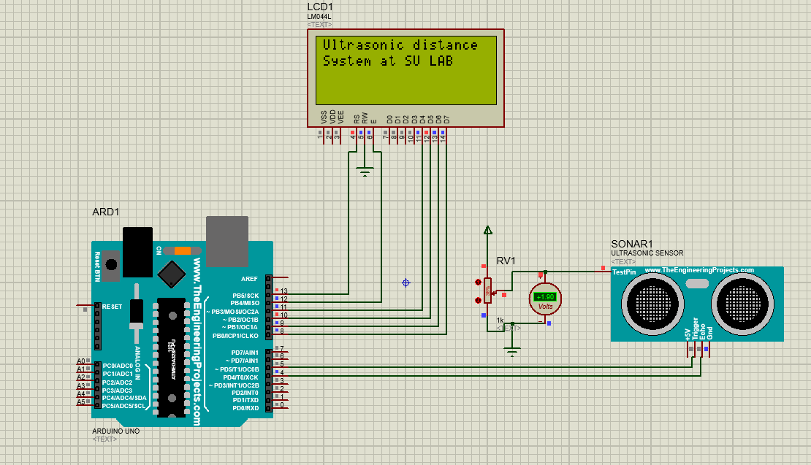

***Stage 2 :-***

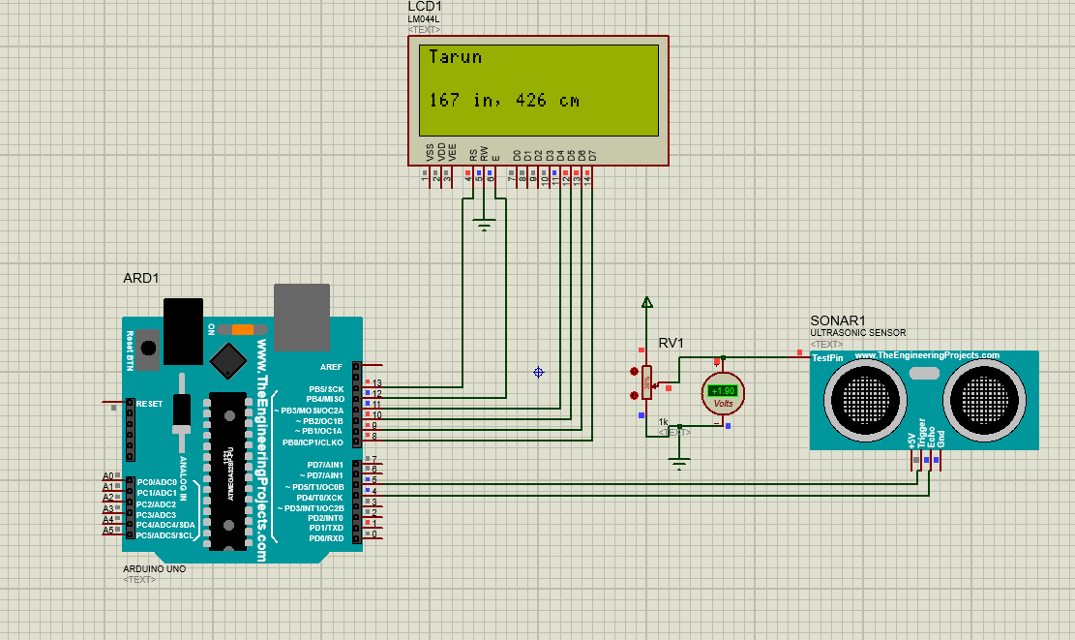

***Result:-***

The LCD was lit successfully.