***Experiment - 2***

***Aim:-***

Interface a LED with the micro-controller chip **ATMEGA-328P** in **Proteus** and WAP in IDE to simulate the circuit

***Components:-***

1. ***Proteus***
2. ***ATMEGA-328P***
3. ***LED***
4. ***ARDUINO IDE***

*PROTEUS: - The Proteus Design Suite is a proprietary software tool suite used primarily for electronic design*

*automation. The software is used mainly by electronic design engineers and technicians to create*

*schematics and electronic prints for manufacturing printed circuit boards.*

*ATMEGA-328P:-* The **ATmega328** is a single-chip **micro-controller** created by Atmel in the megaAVR family (later Microchip Technology acquired Atmel in 2016). It has a modified Harvard architecture 8-bit RISC processor core.

*ARDUINO IDE:-The Arduino Integrated Development Environment is a cross-platform application that is*

*written in functions from C and C++. It is used to write and upload programs to Arduino compatible-boards.*

***CODE:-***

*void setup() {*

*pinMode(12,OUTPUT); //to configure a specific pin to behave either as an input or an output*

*}*

*void loop() {*

*digitalWrite(12,HIGH); //write a HIGH or a LOW value to a digital pin*

*delay(500); //pauses the program for the given amount of time (in milliseconds)*

*digitalWrite(12,LOW);*

*delay(200);*

*}*

***Simulation Circuit:-***

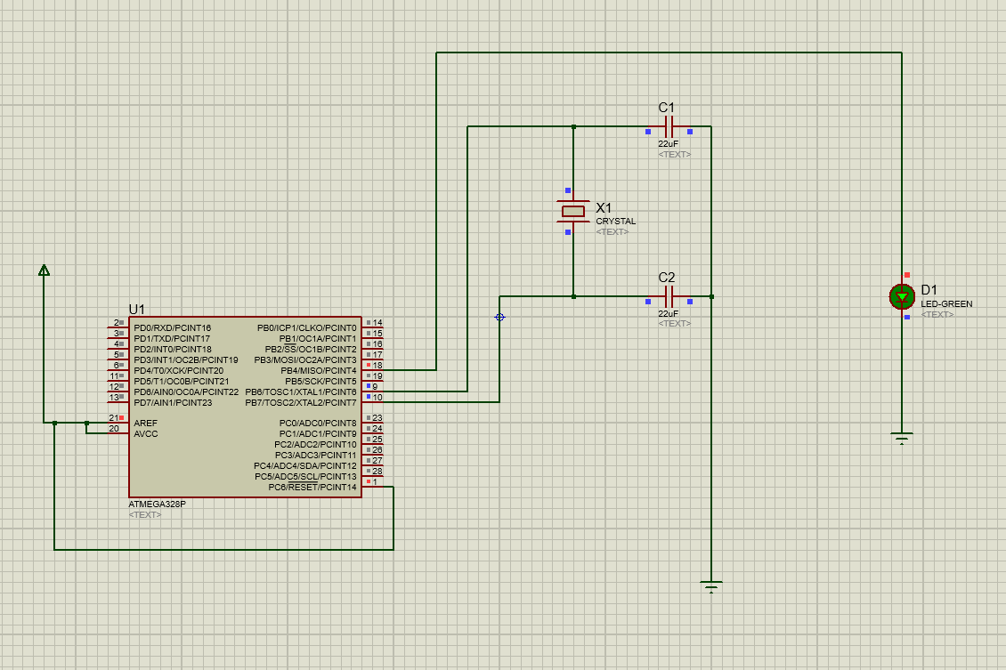

***Result:-***

The LED was lit successfully.