***Experiment - 4***

***Aim:-***

Interface a LCD with the micro-controller **ATMEGA_328P** in **Proteus** and WAP in IDE to simulate the circuit

***Components:-***

1. ***Proteus***
2. ***ATMEGA-328P***
3. ***LED***
4. ***ARDUINO IDE***

*PROTEUS: - The Proteus Design Suite is a proprietary software tool suite used primarily for electronic design*

*automation. The software is used mainly by electronic design engineers and technicians to create*

*schematics and electronic prints for manufacturing printed circuit boards.*

*ATMEGA-328P:-* The **ATmega328** is a single-chip **micro-controller** created by Atmel in the megaAVR family (later Microchip Technology acquired Atmel in 2016). It has a modified Harvard architecture 8-bit RISC processor core.

*ARDUINO IDE:-The Arduino Integrated Development Environment is a cross-platform application that is*

*written in functions from C and C++. It is used to write and upload programs to Arduino compatible-boards.*

***CODE:-***

*#include <LiquidCrystal.h>*

*LiquidCrystal lcd(13,12,11,10,9,8);*

*void setup() {*

*lcd.begin(16,2); // initialize the serial communication*

*To set bund rate*

*lcd.print("Tarun"); // to print the string in lcd*

*delay(1000);*

*lcd.clear(); // to clear the output of lcd*

*}*

*void loop() {*

*lcd.setCursor(0,1); // to set the position of string in lcd*

*lcd.print(“180BTCCSE018”);*

*delay(1000);*

*lcd.setCursor(4,2);*

*lcd.print(“BYE”);*

*delay(400);*

*}*

***Simulation Circuit:***

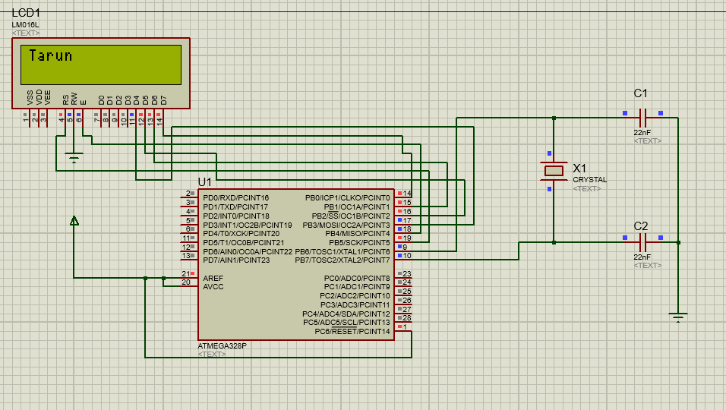

***Result:-***

The LCD was lit successfully.