***Experiment - 6***

***Aim:-***

Interface a LCD and LED with the **ARDUINO** in **Proteus** and WAP in IDE to simulate the circuit

***Components:-***

1. ***Proteus***
2. ***ARDUINO***
3. ***LED***
4. ***ARDUINO IDE***
5. ***LCD***

*PROTEUS: - The Proteus Design Suite is a proprietary software tool suite used primarily for electronic design*

*automation. The software is used mainly by electronic design engineers and technicians to create*

*schematics and electronic prints for manufacturing printed circuit boards.*

*Arduino UNO : The Arduino UNO is an open-source micro0controller board based on the Microchip*

*ATmega328P micro0controller and developed by Arduino.cc. The board is equipped with sets of digital and*

*analog input/output (I/O) pins that may be interfaced to various expansion boards (shields) and other*

*circuits.*

*ARDUINO IDE:-The Arduino Integrated Development Environment is a cross-platform application that is*

*written in functions from C and C++. It is used to write and upload programs to Arduino compatible-boards.*

***CODE:-***

*#include <LiquidCrystal.h>*

*LiquidCrystal lcd(13,12,11,10,9,8);*

*int push = 5;*

*int red_led = 3;*

*int blue_led = 2;*

*void setup() {*

*pinMode(push,INPUT); // assigning pin number ‘push’ as output pin in which ‘push’ is number of digital pin*

*pinMode(red_led,OUTPUT);*

*pinMode(blue_led,OUTPUT);*

*lcd.begin(16,2); // initialize the serial communication To set bund rate*

*lcd.setCursor(0,0); // to set the position of string in lcd*

*lcd.print("Tarun"); // to print the string in lcd*

*delay(2000);*

*}*

*void loop() {*

*int push_read = digitalRead(push);* // read the digital pin as 13 etc.

*if(push_read == HIGH){*

*lcd.clear();*

*lcd.setCursor(0,2);*

*lcd.print("Button Pressed");*

*digitalWrite(red_led,HIGH);* // turn ON the pin number x as HIGH or ON in which x is the number of digital pin

*digitalWrite(blue_led,LOW);*

*delay(30);*

*}*

*else{*

*lcd.clear();*

*lcd.setCursor(0,2);*

*lcd.print("Button not Pressed 029");*

*digitalWrite(red_led,LOW);*

*digitalWrite(blue_led,HIGH);*

*delay(30);*

*}*

*}*

***Simulation Circuit:-***

***Stage 1 :-***

When Name was displayed before the next operation in delay time.

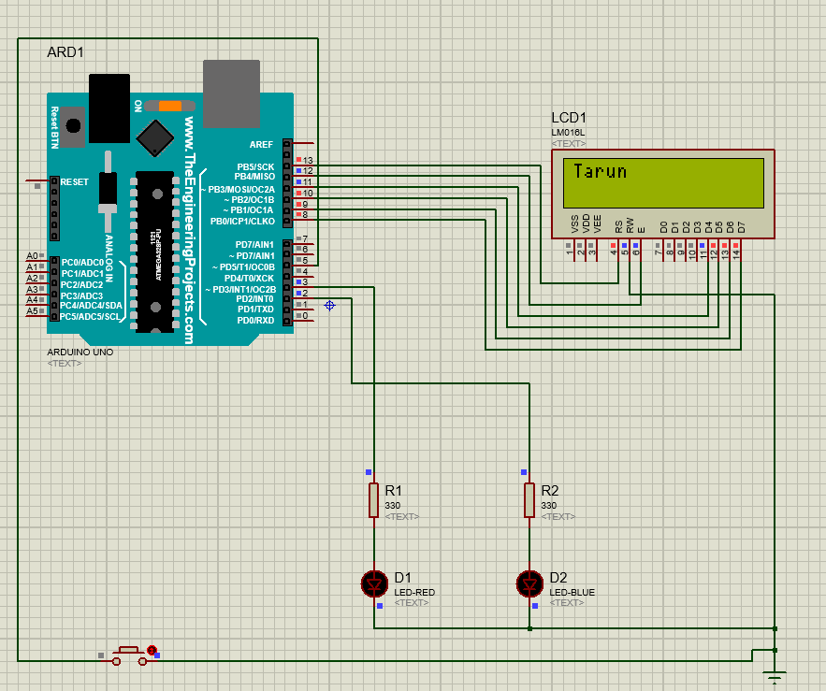

***Stage 2 :-***

When Button not press was displayed before tapping or pushing the push button.

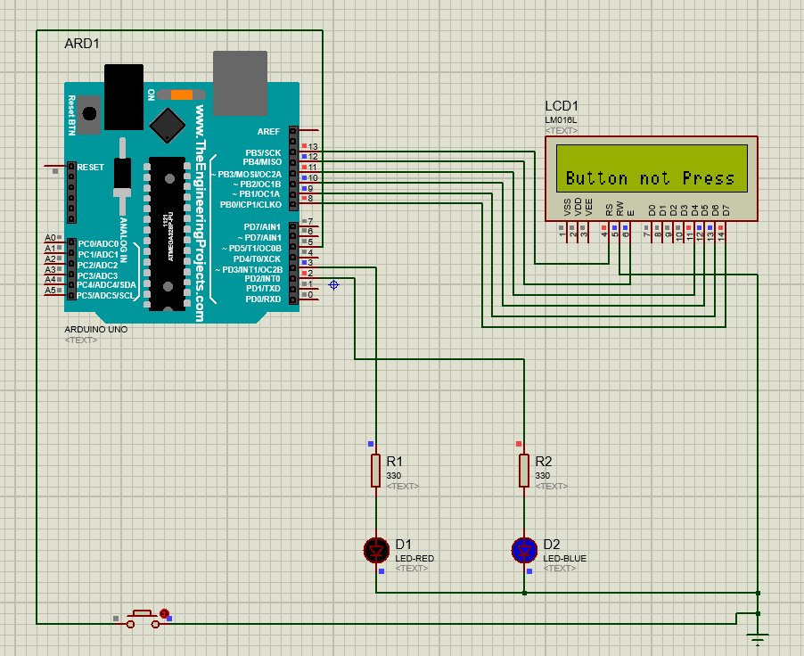

***Stage 3 :-***

When Button pressed was displayed after tapping or pushing the push button.

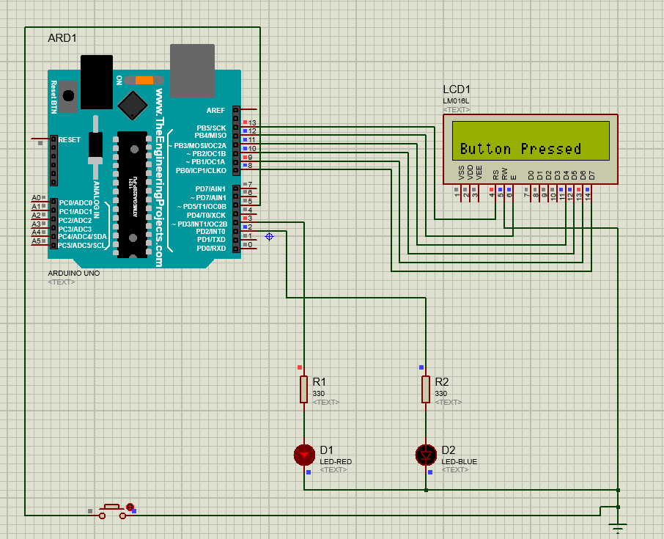

***Result:-***

The LCD was lit successfully.