***Experiment - 7***

***Aim:-***

Interface a LCD, LED and Flame sensor to detect fire with the **ARDUINO** in **Proteus** and WAP in IDE to simulate the circuit

***Components:-***

1. ***Proteus***
2. ***ARDUINO***
3. ***LED***
4. ***ARDUINO IDE***
5. ***LCD***
6. ***Flame Sensor***

*PROTEUS: - The Proteus Design Suite is a proprietary software tool suite used primarily for electronic design*

*automation. The software is used mainly by electronic design engineers and technicians to create*

*schematics and electronic prints for manufacturing printed circuit boards.*

*Arduino UNO : The Arduino UNO is an open-source micro0controller board based on the Microchip*

*ATmega328P micro0controller and developed by Arduino.cc. The board is equipped with sets of digital and*

*analog input/output (I/O) pins that may be interfaced to various expansion boards (shields) and other*

*circuits.*

*ARDUINO IDE:-The Arduino Integrated Development Environment is a cross-platform application that is*

*written in functions from C and C++. It is used to write and upload programs to Arduino compatible-boards.*

*Flame Sensor:- The flame sensor is a sensor which is designated to detect and respond to the flame or fire.*

***CODE:-***

*#include <LiquidCrystal.h>*

*LiquidCrystal lcd(13, 12, 11, 10, 9, 8);*

*int fire_sensor = 2;*

*int led_red = 7;*

*int led_blue = 6;*

*void setup() {*

*pinMode(fire_sensor, INPUT);*

*pinMode(led_red, OUTPUT);*

*pinMode(led_blue, OUTPUT);*

*lcd.begin(16, 2);*

*lcd.setCursor(0, 0);*

*lcd.print("Fire Alert!");*

*delay(1000);*

*}*

*void loop() {*

*int fire_sensor_read = digitalRead(fire_sensor);*

*if (fire_sensor_read == LOW) {*

*lcd.clear();*

*lcd.setCursor(0, 2);*

*lcd.print("Fire Tarun");*

*digitalWrite(led_red, HIGH);*

*digitalWrite(led_blue, LOW);*

*delay(500);*

*}*

*else {*

*lcd.clear();*

*lcd.setCursor(0, 2);*

*lcd.print("No Fire Tarun");*

*digitalWrite(led_red, LOW);*

*digitalWrite(led_blue, HIGH);*

*delay(500);*

*}*

***Simulation Circuit:-***

***Stage 1 :-***

When Fire Alert was displayed

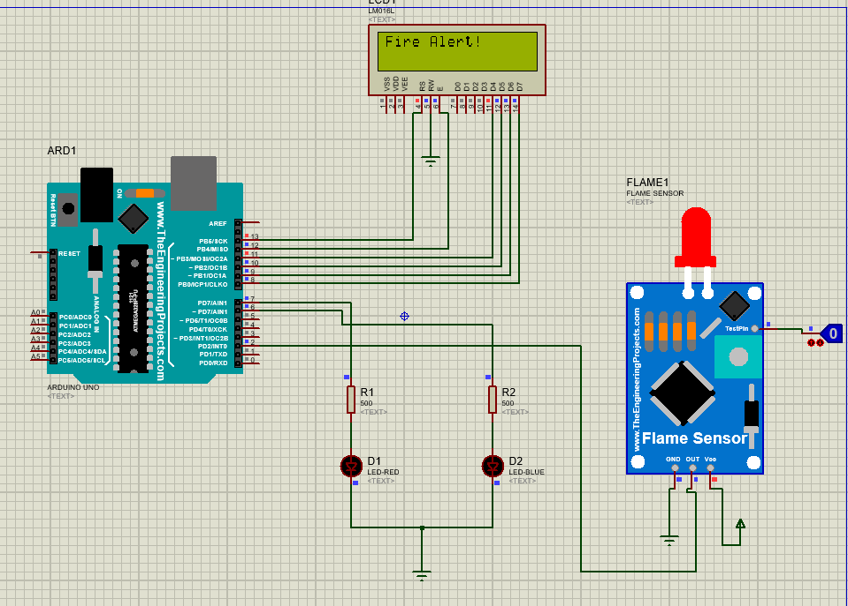

***Stage 2 :-***

When Fire alert with name is displayed

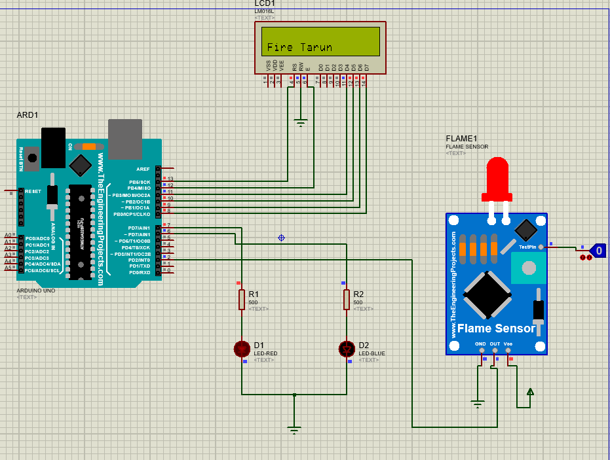

***Stage 3 :-***

When not Fire with name displayed

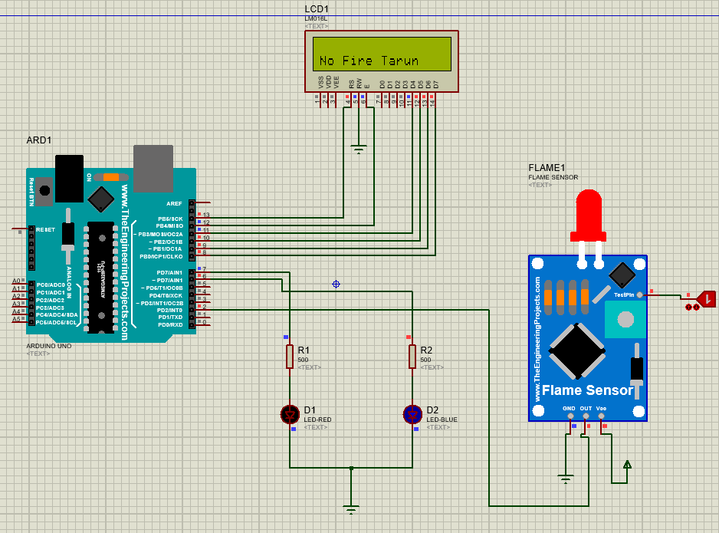

***Result:-***

The LCD was lit successfully.