***Experiment - 9***

***Aim:-***

Interface a LCD and gas sensor for alcohol detection with the **ARDUINO** in **Proteus** and WAP in IDE to simulate the circuit

***Components:-***

1. ***Proteus***
2. ***ARDUINO***
3. ***Gas sensor***
4. ***ARDUINO IDE***
5. ***LCD***
6. ***Buzzer***

*PROTEUS: - The Proteus Design Suite is a proprietary software tool suite used primarily for electronic design*

*automation. The software is used mainly by electronic design engineers and technicians to create*

*schematics and electronic prints for manufacturing printed circuit boards.*

*Arduino UNO : The Arduino UNO is an open-source micro0controller board based on the Microchip*

*ATmega328P micro0controller and developed by Arduino.cc. The board is equipped with sets of digital and*

*analog input/output (I/O) pins that may be interfaced to various expansion boards (shields) and other*

*circuits.*

*ARDUINO IDE:-The Arduino Integrated Development Environment is a cross-platform application that is*

*written in functions from C and C++. It is used to write and upload programs to Arduino compatible-boards.*

*Gas Sensor:- Gas sensor are the electronic device which is used to detect and identify different type of gasses.*

***CODE:-***

*#include <LiquidCrystal.h>*

*LiquidCrystal lcd(13, 12, 11, 10, 9, 8);*

*int alcohol_sensor = 2;*

*const int buzzer = 4;*

*void setup() {*

*pinMode(alcohol_sensor, INPUT);*

*pinMode(buzzer, OUTPUT);*

*lcd.begin(20, 4);*

*lcd.setCursor(0, 0);*

*lcd.print("Start");*

*delay(500);*

*lcd.setCursor(0, 1);*

*lcd.print("Alcohol Detector");*

*delay(500);*

*lcd.setCursor(0, 2);*

*lcd.print("Tarun");*

*delay(1000);*

*}*

*void loop() {*

*int alcohol_sensor_read = digitalRead(alcohol_sensor);*

*if (alcohol_sensor_read == LOW){*

*lcd.clear();*

*lcd.setCursor(0, 3);*

*lcd.print("Alcohol Detected");*

*tone(buzzer, 1000);*

*delay(300);*

*}*

*else{*

*lcd.clear();*

*lcd.setCursor(0,3);*

*lcd.print("Alcohol Not Detected");*

*noTone(buzzer);*

*delay(100);*

*}*

*}*

***Simulation Circuit:-***

***Stage 1 :-***

Starting of the detector

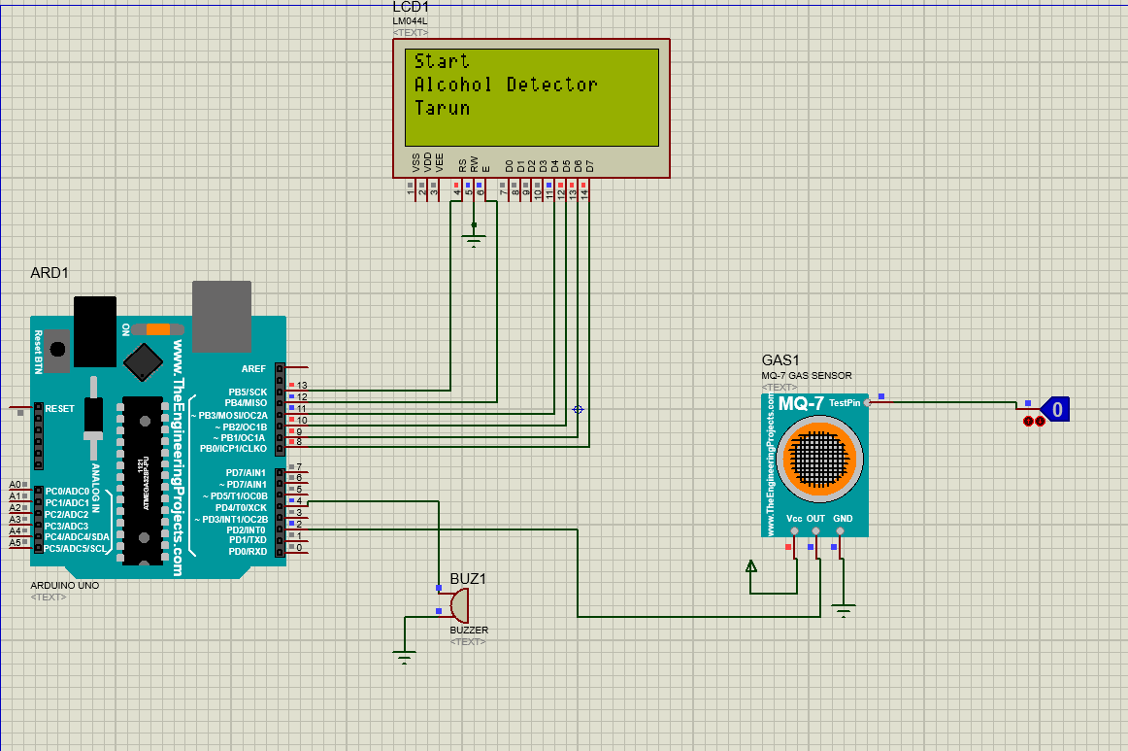

***Stage 2 :-***

Detection of alcohol and vice-versa

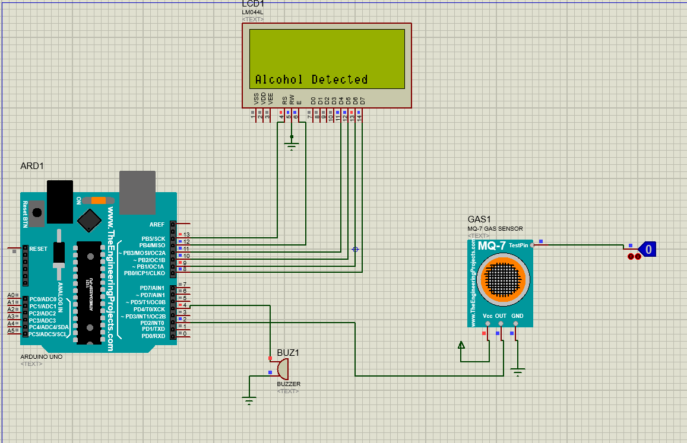

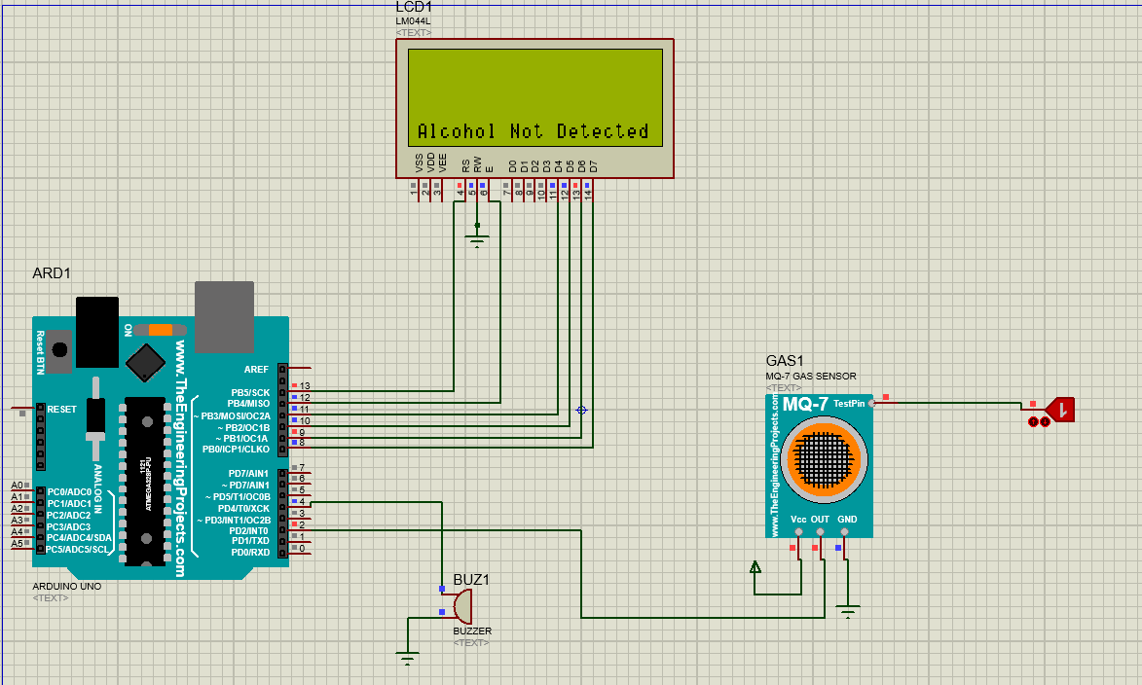

***Result:-***

The LCD was lit successfully.