Experiment - 8
Aim:-
Interface a LCD, LED and PIR sensor to detect motion with the ARDUINO in Proteus and WAP in IDE to simulate the circuit

Components:-
- Proteus
- ARDUINO
- LED
- ARDUINO IDE
- LCD
- PIR Sensor

PROTEUS: - The Proteus Design Suite is a proprietary software tool suite used primarily for electronic design
automation. The software is used mainly by electronic design engineers and technicians to create
schematics and electronic prints for manufacturing printed circuit boards.

Arduino UNO : The Arduino UNO is an open-source micro0controller board based on the Microchip
ATmega328P micro0controller and developed by Arduino.cc. The board is equipped with sets of digital and
analog input/output (I/O) pins that may be interfaced to various expansion boards (shields) and other
circuits.

ARDUINO IDE:-The Arduino Integrated Development Environment is a cross-platform application that is
written in functions from C and C++. It is used to write and upload programs to Arduino compatible-boards.

PIR Sensor:- The PIR sensor allow you to sense motion, almost always used to detect weather a human has moved in or out of the sensors range.

CODE:-

#include <LiquidCrystal.h>
LiquidCrystal lcd(13, 12, 11, 10, 9, 8);
int pir_sensor = 2;
int led_red = 7;
int led_green = 6;
void setup() {
pinMode(pir_sensor, INPUT);
pinMode(led_red, OUTPUT);
pinMode(led_green, OUTPUT);
lcd.begin(20, 4);
lcd.setCursor(0, 0);
lcd.print("Motion Detector");
delay(1000);
lcd.setCursor(0, 1);
lcd.print("Start");
delay(500);

}

void loop() {
int pir_sensor_read = digitalRead(pir_sensor);
if(pir_sensor_read == LOW){
lcd.clear();
lcd.setCursor(0, 2);
lcd.print("Motion! Tarun");
digitalWrite(led_red, HIGH);
digitalWrite(led_green, LOW);
delay(500);
lcd.setCursor(0, 3);
lcd.print("Tap Lache-LG");
delay(500);
}
else{
lcd.clear();
lcd.setCursor(0, 2);
lcd.print("No Motion! Tarun");
digitalWrite(led_red, LOW);
digitalWrite(led_green, HIGH);
delay(500);
lcd.setCursor(0, 3);
lcd.print("End");
delay(500);
}
}

Simulation Circuit:-

Stage 1 :-
When Motion Detector is displayed

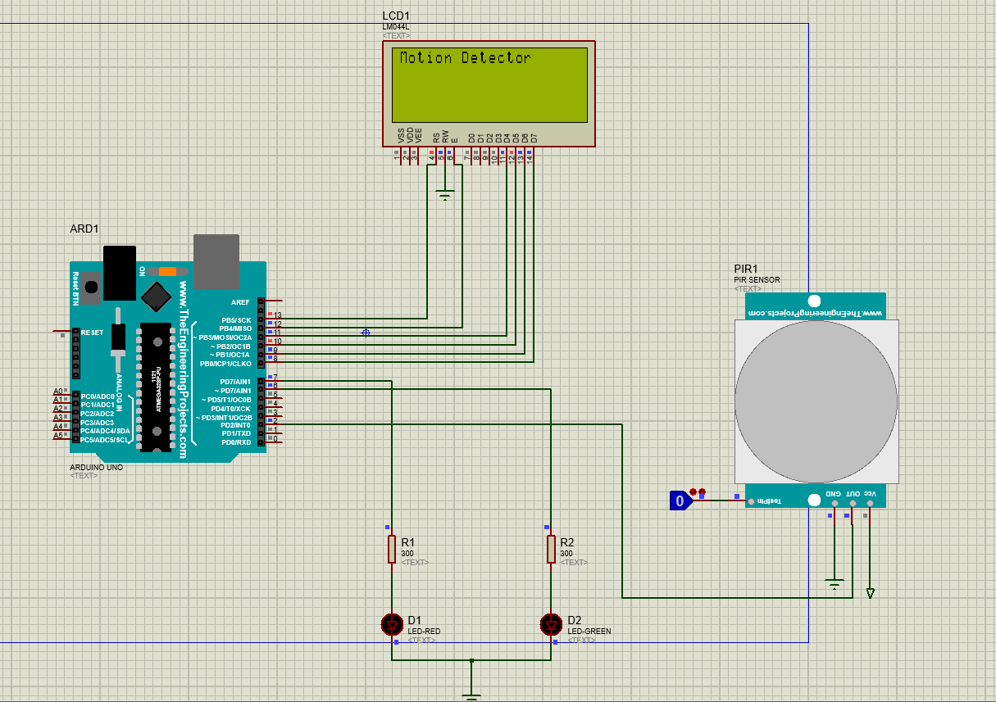

Stage 2 :-

When Motion with name is displayed

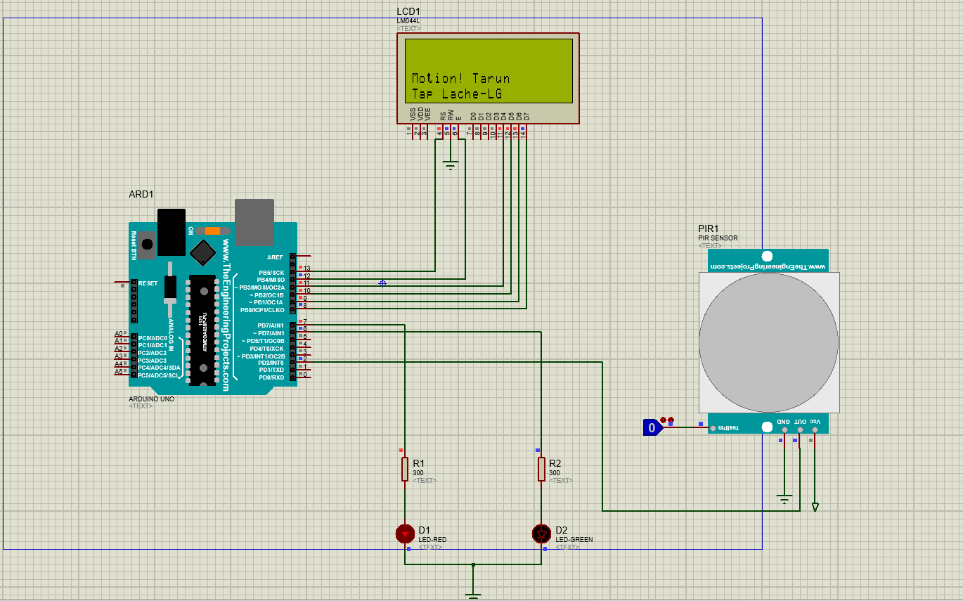

Result:-
The LCD was lit successfully.

