**Smart Mining Safety Monitoring System using IOT**

By Tarun Yadav

B.Tech CSE

180BTCCSE018

**Abstract -** The Internet of things (IOT) is the extension of Internet connectivity into physical devices and everyday objects. Embedded with electronics, Internet connectivity, and other forms of hardware; these devices can communicate and interact with others over the Internet, and they can be remotely monitored and controlled. In the mining industry, IOT is used as a means of achieving cost and productivity optimization, improving safety measures and developing their artificial intelligence needs.

**Objective -** Mining is one of the industries in which workers have to work under extreme conditions as per the requirement and hundreds of workers die from mining accidents and occupational diseases every year. In order to coordinate various tasks and ensure mining safety, there’s a dire need to install underground monitoring and control systems.

**Synopsis -**

* The ability to collect data in near real-time and analyze equipment and environmental data can completely transform the mining industry. Many mining companies have begun to partner with IOT experts and smart solutions providers to monitor operations and improve overall efficiency. Companies are deploying connected worker solutions and fundamentally transforming mining while improving worker safety.
* Worker safety has been one of the biggest issues in mining for a long time. Obvious risks of any mining operations include large pieces of equipment around often confined spaces, inability to monitor workers’ health, poor visibility and toxic gases that create hazardous environments. Wearables and gas detection sensors monitor the levels of flammable and toxic gas in an environment and alert workers or supervisors so that ventilation and airflow can be kept to optimal levels.
* IOT can play a significant role to ensure worker safety in far-flung locations and extreme environments. Wearables like a smart helmet, wrist band and smart vest can address potential health risks by constantly monitoring vital signs, cardiac activity and real-time location. This helps supervisors to anticipate and take precautionary steps to avoid potential threats.

**Literature Survey -**

* **Existing System -** Most of the system proposed right now is mainly working on the detection of the toxic gas and not focusing on the fact that if the person may get in contact with these gases need emergency treatment due to which the frequency of casualties due to fall damage and other factors are increasing day by day.
* **Introduced System -** Introduced system not only focusing on the toxic gas but also on the other risk like fall damage, worker real-time health monitoring and if some unusual event happen worker can have immediate help and take advantages of technology as much as we can to overcome from this situations.

**Circuit Diagram -**

**Hardware -**

1. Micro-controller Chip
2. Heartbeat Sensor
3. Motion Sensor(PIR)
4. Gas Sensor(MQ-9)
5. Red LED for alerting worker
6. Green LED for alerting worker
7. Buzzer for alerting worker
8. LCD for alerting monitoring person

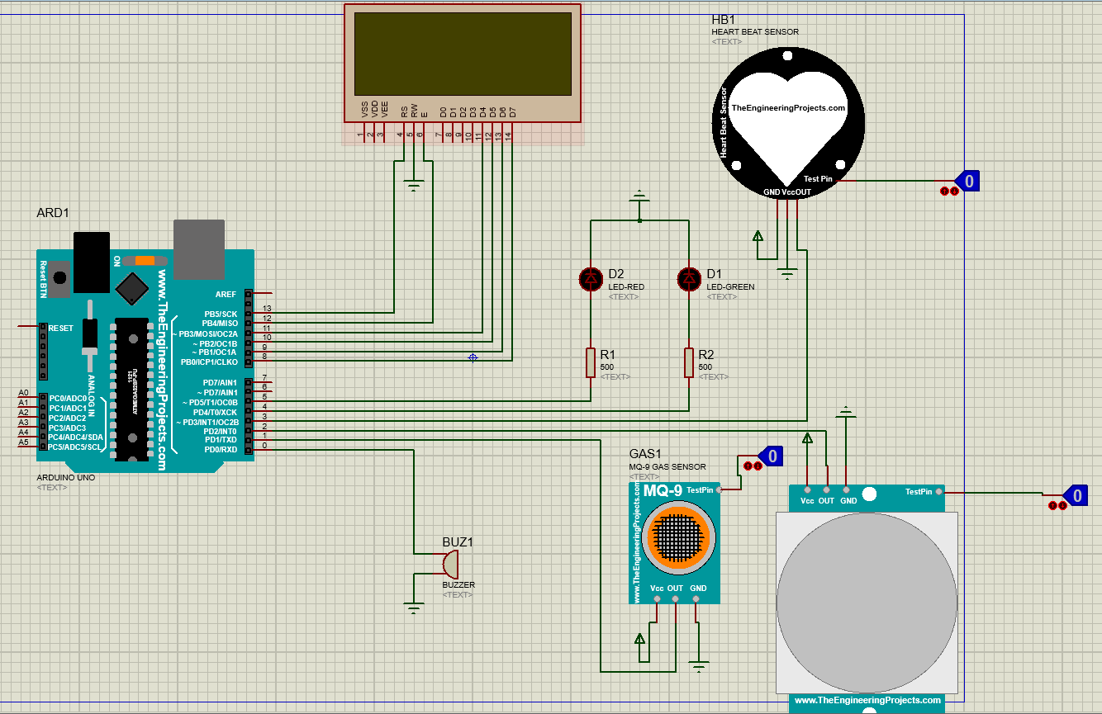

**Working -**

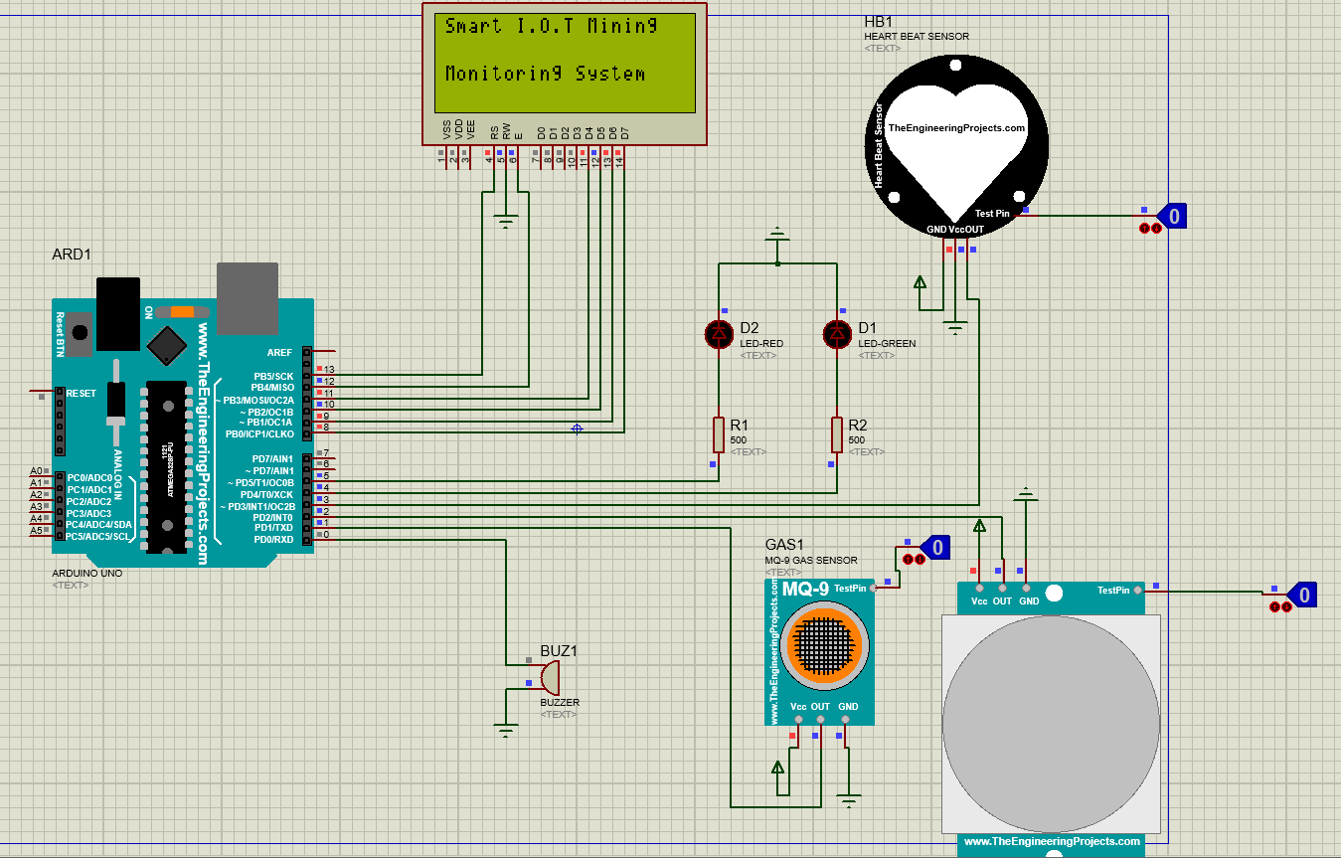

Micro-controller chip is used as an embedded system to control all the component in the circuit and give the desired output. Three sensor I.e MQ-9 (Gas sensor), PIR (Motion Sensor) and ECG (Heartbeat Sensor) for continuous monitoring of workers real time reading of surrounding toxic gas, motion and heartbeat with two led I.e Red and Green LED’s for alerting workers with a buzzer again for alerting worker and LCD (20X4) for person who is monitoring away from field.

Firstly Gas sensor (MQ-9) which is basically for sensing toxic gases in mining fields like CARBON MONO OXIDE and other flammable gases comes into action, if it found a toxic and flammable gasses around then Green LED changes to RED for danger and if some cases worker is failed to notice LED Buzzer comes into play to alert the worker from toxic and flammable gases as shown in below pictures:-

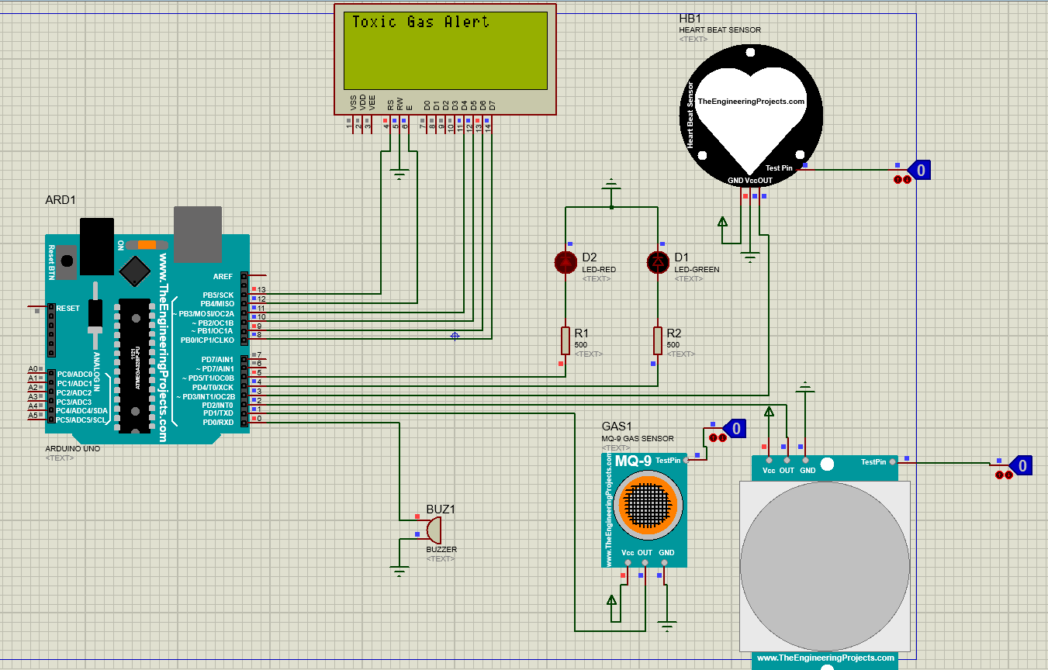

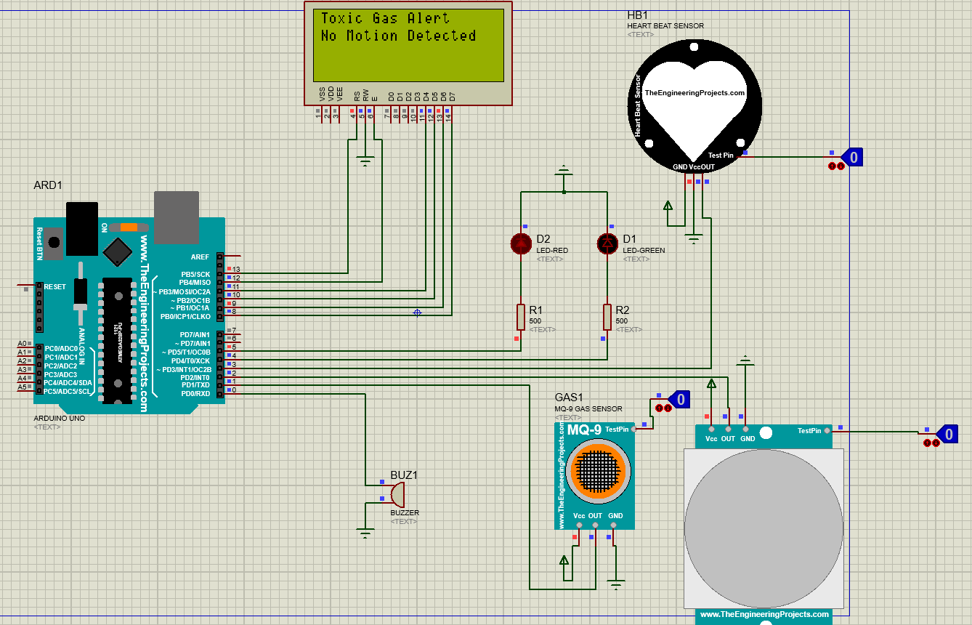

Secondly under some circumstances like falling of roof or wall in mining field the motion sensor is used to send the information of worker been unconscious for a long time along with the heartbeat sensor sending heartbeat reading to the person who is monitoring from away, if he found some abnormal reading he can send emergency help as soon as possible from outside as shown in below pictures:-

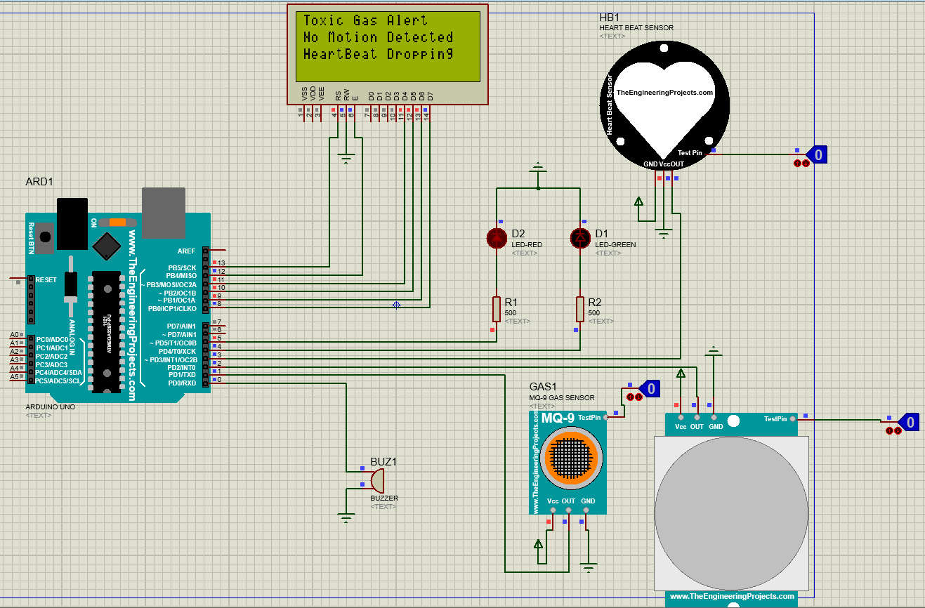

And lastly when everything is normal as usual Green LED is lighted and displayed Everything is fine as shown in picture below:-

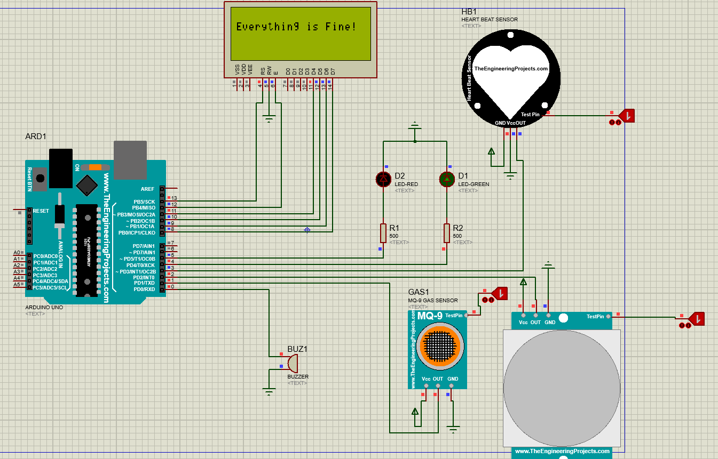

**Claims -** Using this safety monitoring system we can save a lots of casualties which used to happen in day to day life of a mining industry worker and save many life by taking advantage of technology we have right now.

We can send help at appropriate time so save the life of a worker if some disaster occur or if situation go out of control from him/her.

**References -**

* <https://www.infosysbpm.com/blogs/sourcing-procurement/Pages/iot-in-mining.aspx>
* <https://www.softwebsolutions.com/resources/industrial-iot-in-mining-industry.htm> l
* <https://www.softwebsolutions.com/resources/iot-in-mining-safety.html>
* <https://espace.curtin.edu.au/bitstream/handle/20.500.11937/70206/267607.pdf?sequence=2&i> sAllowed=y
* <https://innovate.myg>ov.in/wp-content/uploads/2018/10/mygov1540365102183318.pd f
* <https://www.ijrte.org/wp-content/uploads/papers/v8i2/B3762078219.pdf>
* <https://www.irjet.net/archives/V4/i3/IRJET-V4I3565.pdf>

**Conclusion -** A real time monitoring system is developed to provide clearer and more point to point perspective of the information about the worker inside. This system is displaying the parameters on the monitoring unit as well as it also alerting the miners inside; it will be helpful to all miners present inside the mine to save their life before any casualty occurs. Alarm triggers when sensor values crosses the threshold level.