**Smart Warehouse using CISCO Packet Tracer and IOT devices**

By Tarun Yadav

B.Tech CSE

180BTCCSE018

**Abstract -** The Internet of things (IOT) is the extension of Internet connectivity into physical devices and everyday objects. Embedded with electronics, Internet connectivity, and other forms of hardware; these devices can communicate and interact with others over the Internet, and they can be remotely monitored and controlled. In the mining industry, IOT is used as a means of achieving cost and productivity optimization, improving safety measures and developing their artificial intelligence needs.

**Objective -** Warehouse is the place in which is used by manufactures, importers, exporters, customs, transport business etc. to store their products. With the help of Smart Warehouse we can not only improve the safety of the the workers working inside the warehouse but also we can improve the security and quality of the product stored inside the warehouse.

**Synopsis -**

* The ability of the IOT devices and technology we can make the entire environment fully automatic which help in improving the safety of worker, security and quality of the product at the same time.
* Worker safety has been one of the biggest issues in every environment or in any industry. So with the help of the IOT devices such as Fire sensor for monitoring the fire help in making them fell safe.
* IOT can play a significant role to ensure worker safety in extreme environments as discussed above but appliances like smart lights. Smart ac, smart fan can help in improving the quality of life of the people. While devices like motion sensor, webcam and smart doors can help in increasing the security measures and smart ac with thermostat can help in maintaining the quality of product stored.

**Literature Survey -**

* **Existing System -** Most of the system proposed right now is mainly working separately and not fully automatic which increase the requirement of the money and labour for the same
* **Introduced System -** Introduced system not only focusing on making the safety of the worker and quality and security of the product with making everything fully automatic into consideration.

**Component Used -**

**Hardware -**

1. Micro-controller Chip
2. Fire Sensor
3. Motion Sensor
4. Webcam
5. Thermostat
6. Gateway

**Appliance -**

1. Smart Fan
2. Smart Lights
3. Smart Window
4. Smart AC
5. Smart Door

**Working -**

Complete Layout of the Smart Warehouse

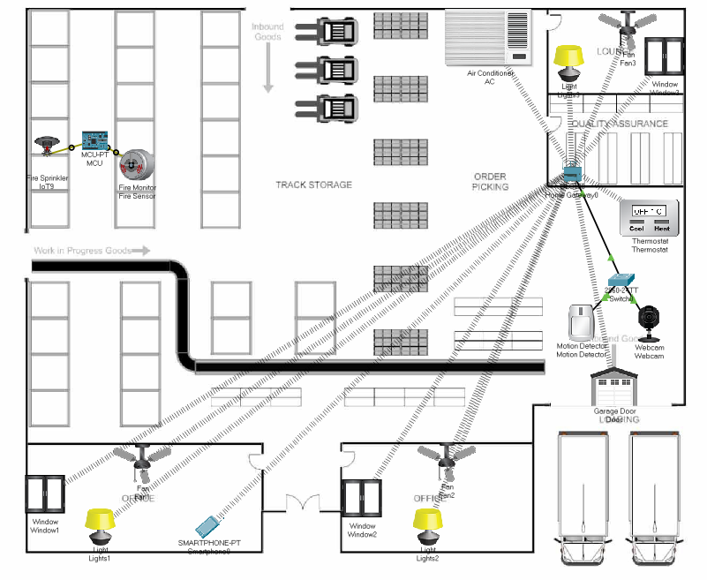

First functionality is the fire sense and fire extinguish system. Fire is sensed by fire sensor then it passed the signal to connected MCU and then MCU passed the signal to the sprinkler to extinguish the fire before any damage caused.

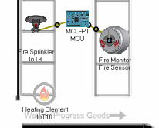

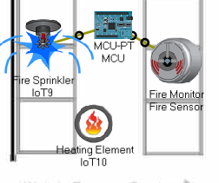

Second Functionality is to make quality of life better and easier by using of appliances such as smart fan, smart light and smart window which can be controlled by a smart phone which is connected to a gateway which control all the appliances.

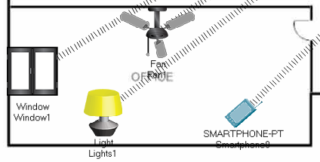

Third functionality is for improving the security measure by using motion sensor, webcam and a automatic smart door.Webcam start recording once motion sensor sense any motion around it and a smart door is connected with the same smart phone which is connected to same gateway discussed above to control the movement of door accordingly.

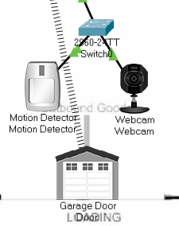

Fourth functionality is to maintain the quality of the product stored inside the warehouse by controlling the temperature inside the warehouse.A thermostat is used for monitoring the temperature continuously which is connected to a same gateway discussed above and a smart ac is also connected to it which is used to control the temperature accordingly.

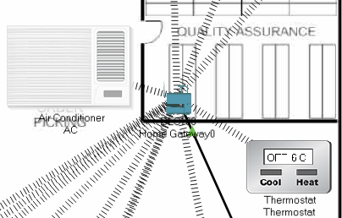

**References -**

* [h](https://www.infosysbpm.com/blogs/sourcing-procurement/Pages/iot-in-mining.aspx)ttps://www.google.com
* https://youtube/cisco-packet-tracer-labs.com

**Conclusion -** A real time Smart Warehouse using IOT system is developed using CISCO Packet Tracer to improve the safety of the worker working inside the warehouse and improve the quality and security of the product stored inside the warehouse.