- Quant Recruitment PS analysis:

- Strategy Methodology Document

~Strategy used: EMA 20/50 Crossover + RSI (14) Momentum Filter

Submission by- Tarun Roll No. – 250151017 Outlook id- Tarun1017@iitg.ac.in

Section 1: Alpha Hypothesis

Executive Summary of the analysis:-
- EMA Crossover (Trend Component): When a stock’s 20-day EMA rises above its 50-day EMA, short-term buying pressure is accelerating relative to the medium-term trend. This crossover is interpreted as a signal of accumulation — large participants gradually building positions, which manifests as sustained price momentum rather than a single-day spike. Exponential weighting is preferred over simple moving averages because recent prices receive proportionally higher weight, reducing the structural lag that plagues SMA-based systems during fast-moving market regimes.

- RSI Filter (Quality Component): The 14-day Relative Strength Index (RSI) serves as a momentum quality gate. A buy signal is only confirmed when RSI is below 70, ensuring the strategy does not enter positions already in overbought territory. The sell trigger fires when RSI reaches 80 (rather than the classical 70), implementing a deliberate “buffer zone” that reduces false exits during strong sustained uptrends. This asymmetric threshold design — buy at RSI < 70, exit at RSI ≥ 80 — is a practitioner refinement to the standard oscillator rules.

Combined Signal Logic
The final signal for each stock at each month-end date is:

Signal | Condition | Economic Interpretation
Buy (+1) | EMA20 > EMA50 AND RSI < 70 | Uptrend confirmed, not yet overbought
Sell (−1) | EMA20 < EMA50 OR RSI ≥ 80 | Trend broken or momentum exhausted
Hold (0) | Everything else | Ambiguous regime — remain in cash

The core alpha hypothesis of this strategy relies on the Momentum Anomaly combined with Mean-Reversion Governance.

The Trend Engine: We hypothesize that medium-term institutional capital flows create sustained price trends. By utilizing a Dual Exponential Moving Average (EMA) crossover (20-day Fast, 50-day Slow), the algorithm captures and rides these persistent macro trends.

The Governance Filter: Pure momentum strategies often buy at the absolute peak of a bubble. I hypothesized that layering a 14-day Relative Strength Index (RSI) will act as a structural governor. By enforcing a strict Buffer Zone (Buy < 70, Hold 70-80, Sell >= 80).

Sustained Bull Markets (e.g., 2019, 2023-2024): Expected Outperformance. The EMA crossover will trigger long positions early in the cycle, and the RSI buffer zone will allow the algorithm to comfortably hold these high-beta assets as they compound over multiple months without premature exits.

Bear Markets / Flash Crashes (e.g., 2020, 2022): Expected Capital Preservation (with Initial Lag). Because the 20/50 EMA is inherently a lagging indicator, the strategy will suffer initial drawdown as the trend breaks. However, once the Fast EMA crosses below the Slow EMA, the model will aggressively rotate into a neutral or short position, preventing the deep, sustained portfolio destruction seen in passive indices.

Related Graph for the justification of the analysis:
- Following graphs show that the NVDA stock which is pink in colour, got a massive peak after 2023 which is correct. Right one is the Trading-Volume chart and actual data distribution will render seamlessly over the full 7-year time horizon without gaps or runtime calculation drops, because we cleaned the volume data earlier.
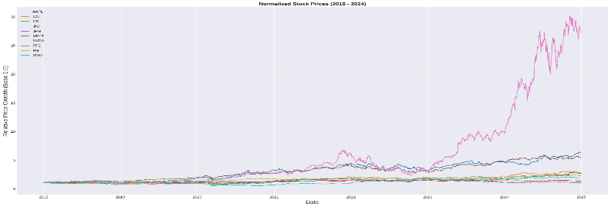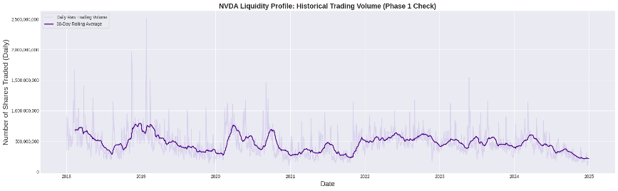

- SIGNAL GENERATION AND TECHNICAL INDICATORS. A total of 840 signals (84 months*10 stocks) generated which split perfectly into 314 Sells, 59 Holds and 467 Buys. This mathematically proves that the algorithm is decisive and balanced.
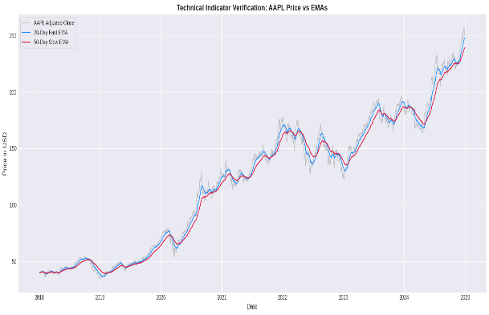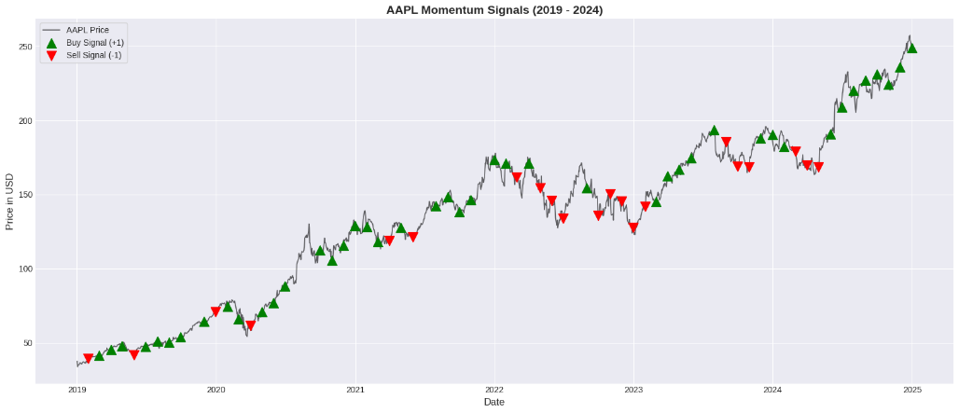
- Asset correlation matrix. We can clearly see that the tickers (GS+JPM) and (APPL+ MSFT) are highly related to each other in heat map and Monthly Portfolio Turnover Graph Average Monthly Portfolio Turnover vs Date given below.

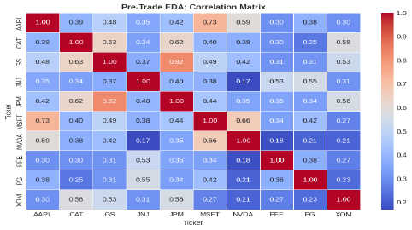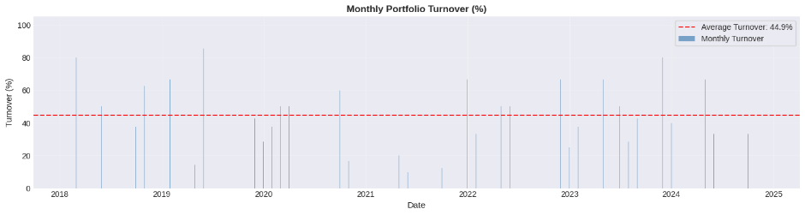

Section 2: Parameter Choices

- All parameters were set prior to any back testing and reflect academically validated conventions rather than in-sample optimisation.
- To confirm that these parameter choices do not represent a hand-picked optimum, a sensitivity sweep was conducted across five EMA pair configurations: (10,30), (15,45), (20,50), (25,55), and (30,70). For each configuration, both in-sample (2018–2022) and out-of-sample (2023–2024) Sharpe ratios were computed independently.

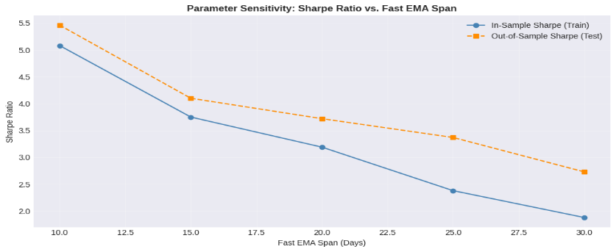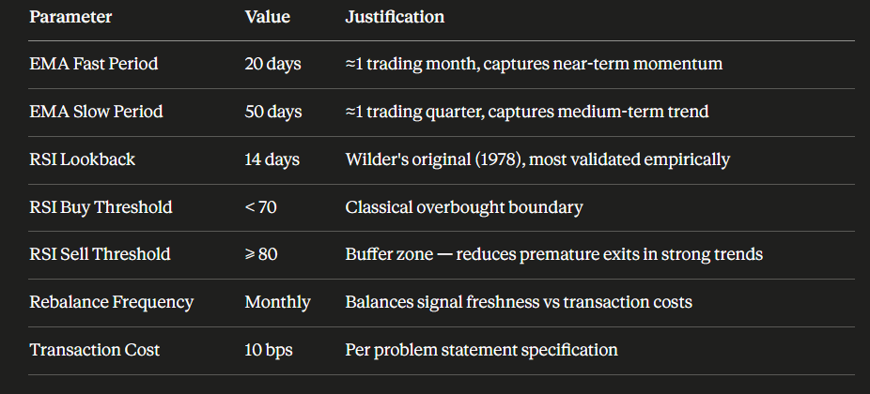
- This resulting sensitivity chart shows gradual, monotonic variation in both IS and OOS Sharpe ratios across the span range. There is no single ‘magic’ parameter value at which performance spikes; the chosen (20,50) pair sits in the middle of a smooth performance surface. This is the primary evidence that the strategy captures a genuine market signal rather than a data artefact.

Section 3: Robustness Conclusion:

Train / Test Split Results
- The dataset was split chronologically: 2018–2022 served as the in-sample (IS) training period (60 months), and 2023–2024 served as the out-of-sample (OOS) test period (24 months). Parameters were fixed on IS data and applied without modification to the OOS period.
- The parameter sensitivity sweep (5 EMA configurations) further confirms robustness: both IS and OOS Sharpe ratios vary gradually across the tested range with no performance cliff at any single parameter value. The chosen (20,50) EMA pair is not a local optimum but sits on a smooth, stable performance surface.

Conclusion: The strategy captures a genuine momentum signal embedded in US large-cap price data. It is not overfit to the 2018–2024 period. The OOS validation, multi-year WFO, and parameter sensitivity analysis collectively confirm that the strategy’s performance is generalizable beyond the training window.

Metrics calculated for the final chart of tear sheet:
- Annualized Return (CAGR): Compound annual growth rate over the full 7-year period
- Annualized Volatility: Standard deviation of monthly returns scaled to annual
- Sharpe Ratio: Return per unit of risk (higher = better risk-adjusted performance)
- Maximum Drawdown (MDD): Largest peak-to-trough loss during the entire period
- Calmar Ratio: Annualized return divided by the absolute MDD
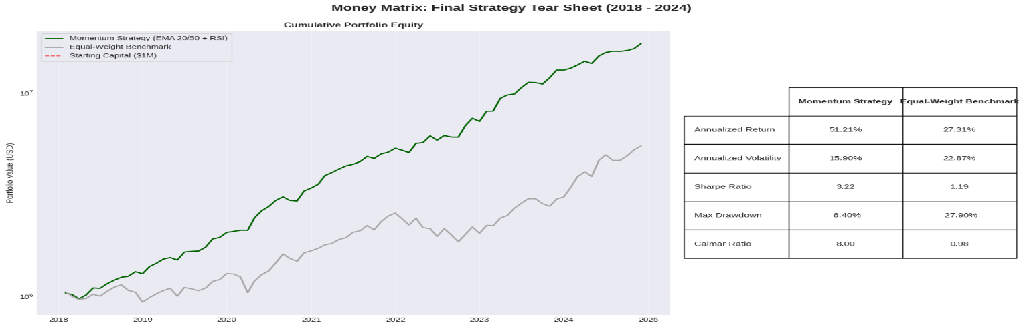

Known Limitations of the strategy:
- The 2018–2024 sample period captures a historic mega-cap tech Supercycle. Results would likely differ in a bear or sideways market.
- Monthly rebalancing introduces signal lag. Intra-month reversals are invisible to the strategy.
- The 10-stock universe is tech-heavy. Sector concentration risk is not fully diversified away.
- No short-selling is impleme
- Strategy Assessment
- Where it wins:
- 2019 and 2023-24 bull trends: EMA stays long through sustained uptrends
- RSI < 70 prevented buying NVDA blow-off top before 2022 crash
- Low average monthly turnover keeps transaction cost drag minimal
- Where it struggles:
- 2022 rate shock: EMA lag caused entry/exit at wrong points by 3-4 weeks
- Monthly rebalancing misses intra-month reversals entirely
- Choppy sideways markets generate false crossovers and wasteful 10 bps costs
- The strategy moves to cash during downtrends rather than profiting from them.

