AIRBNB DATA ANALYTICS DASHBOARD REPORT

# 1. Introduction

This report provides a detailed summary and insights derived from the Airbnb dataset, visualized through Power BI dashboards. The goal is to analyze key metrics such as room distribution, pricing trends, top hosts, and property listings to better understand Airbnb’s landscape.

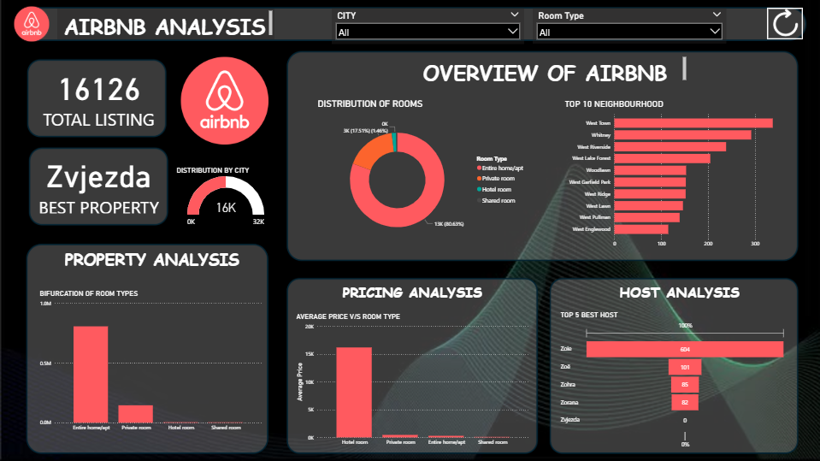

# 2. Summary Metrics

• Total Listings: 16,126

• Best Performing Property: Zvjezdza

# 3. Overview of Airbnb

The distribution of room types shows that the majority of listings are Entire Home/Apt, making up 80.6% (13K listings). Private rooms follow with 17.5% (3K listings), and hotel and shared rooms are negligible.

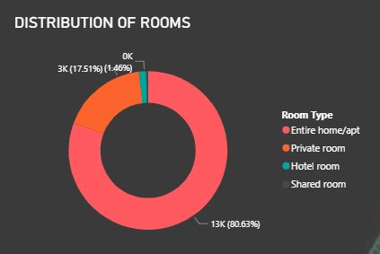

# 4. Top 10 Neighbourhoods

The most active neighbourhoods based on listing count are:  
1. West Town  
2. Whitney  
3. West Riverside  
4. West Lake Forest  
5. Woodlawn  
6. West Garfield Park  
7. West Ridge  
8. West Lawn  
9. West Pullman  
10. West Englewood

# 5. Property Analysis

The property analysis shows a dominant preference for Entire home/apt listings. Private rooms are second in volume, while hotel and shared rooms make up a small fraction.

# 6. Pricing Analysis

Hotel rooms, though fewer in number, command significantly higher average prices (approximately 17,000 units). Private rooms and entire homes are priced far lower in comparison.

# 7. Host Analysis

Top 5 hosts by number of listings are:  
1. Zoie – 604 listings  
2. Zoë – 101 listings  
3. Zohra – 85 listings  
4. Zorana – 82 listings  
5. Zvjezdza – Not listed in Top 5 by count but is the best-rated property.

# 8. Conclusion and Analysis

This Power BI dashboard provides valuable insights into Airbnb listings with emphasis on pricing trends, host performance, and neighbourhood distribution. Entire homes dominate the market, while hotel rooms demand the highest price. West Town is the most popular neighbourhood, and host 'Zoie' has the largest number of listings.