

**SMART GYM**

24/7 PERSONAL COACH

**Introduction**

The Smart Gym project makes fitness simple and fun by using smart technologies like posture tracking, custom workout plans, and an easy-to-use app. It’s made for everyone, no matter their fitness level, and gives exercises based on things like BMI, fitness goals, and experience. It uses Mediapipe to track posture in real time, helping users exercise safely and with good form. The app has a React-based design for smooth navigation, and features like exercise tracking and a leaderboard to keep users motivated and excited to stay active.

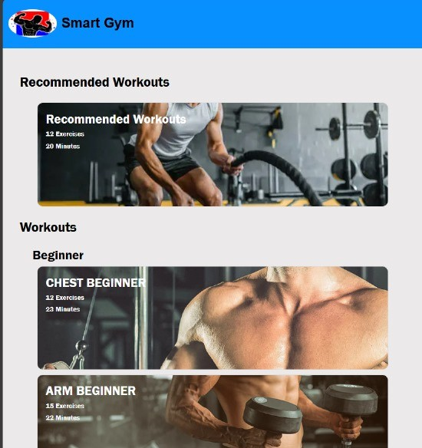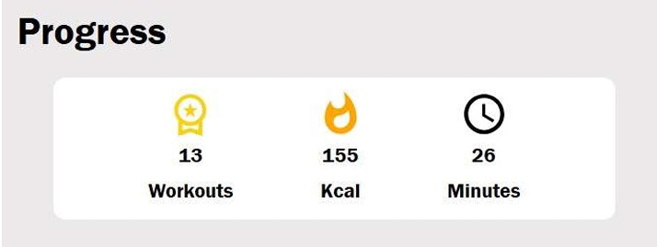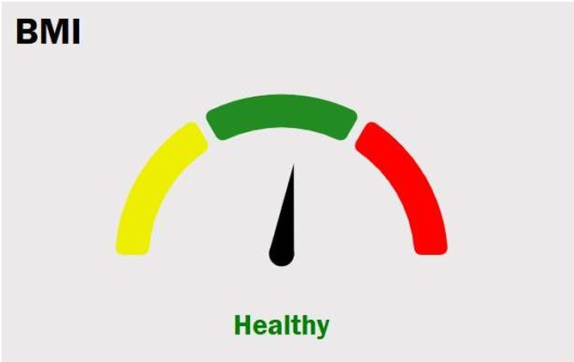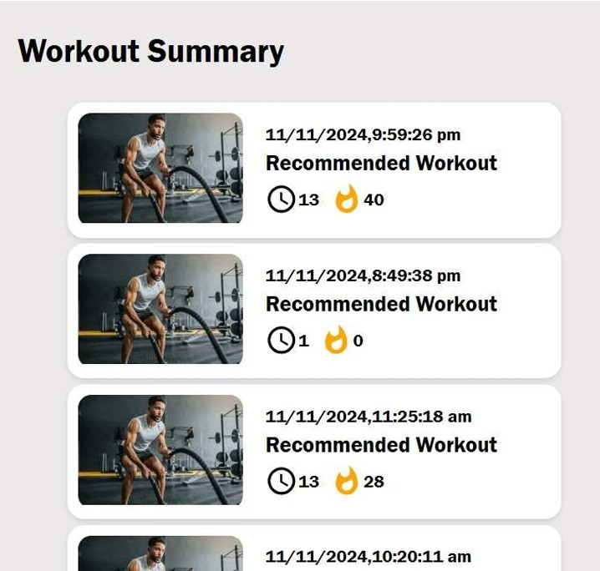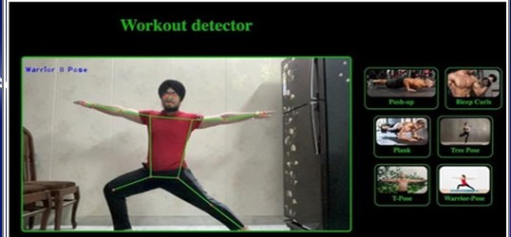

**Objectives:**

1. Design an intuitive interface that categorizes workouts and exercises, enablling users to easilly navigate through different sections.
2. Exercise recommendation according to llevell of individuall - beginner,

intermediate and advanced workouts.

1. Provide Detailled Feedback on Callories Burned and Rellevant Metrics based on user performance.



Developed by:

SUKHDEEP SINGH (2104198)

TRILOK SINGH (2104210)

TARUN SINGH (2104207)

Under Guidance of ER. DIANA NAGPAL