PROJECT-REPORT

Screenshots of the screens developed:

1. The Home Page when the Application starts

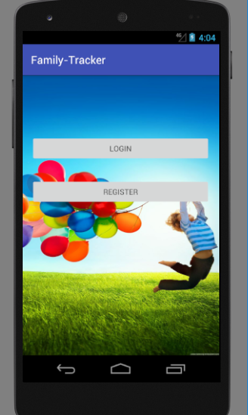

1. Login Screen

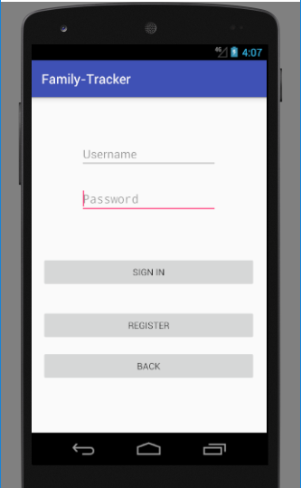

The default username and password is: “Admin” ,”1234” .

1. Google Maps screen or Location screen

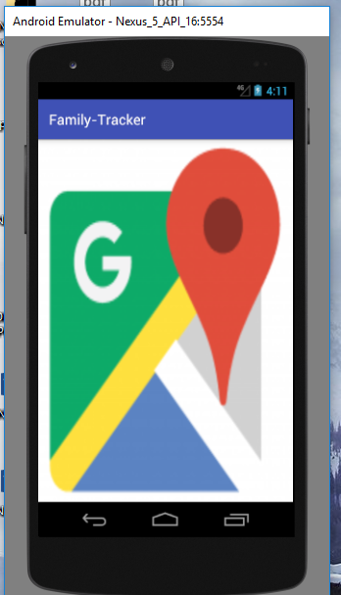

1. Working on google maps screen
2. Just added a background image of google maps.
3. Will be updated accordingly.
4. Registration Page

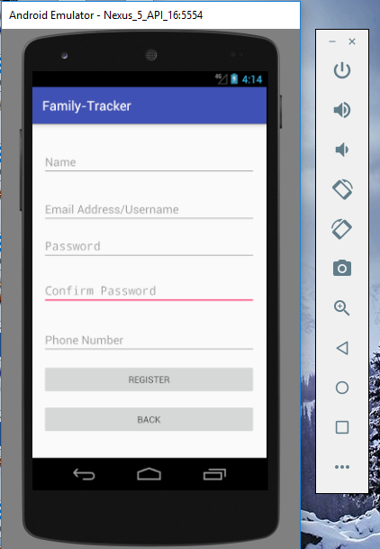

1. Working on creating a mock JSON response.
2. To save the data and then can be used for validation.