An Internship Report
of
Ethical Hacking Virtual Internship

Submitted
To

School of Computer Science and Engineering
IILM University, Greater Noida, U.P.

In partial fulfilment of the requirement of degree of
B.Tech (Computer Science and Engineering)



By

Roll Number of Student: 2410030767
Name of Student: TARUN KUMAR
Batch: 2024-2028

CANDIDATE'S DECLARATION

I, TARUN KUMAR, do hereby declare that the internship report titled "Ethical Hacking Virtual Internship" has been completed by me to fulfil the requirement for the award of the degree of Bachelor of Technology in Computer Science and Engineering. All the references have been quoted and I have not taken as such any material from any other source. I affirm that this report is my own and has not been submitted to any other institute for any degree/diploma requirement, and further I shall be solely responsible for any kind of copyright violation in this regard.

Signature:-
Student Name: TARUN KUMAR
Roll No.: 2410030767

ACKNOWLEDGEMENT

I am using this opportunity to express my gratitude to everyone who supported me throughout the Internship Program I am thankful for their aspiring guidance, invaluably constructive criticism and friendly advice during this work. I am sincerely grateful to them for sharing their truthful and illuminating views on a number of issues related to this work.

I would like to thank the AICTE - EduSkills Virtual Internship Program team Edus kills Academy, for providing me the opportunity and the structured platform to learn and gain hands-on exposure in the domain of Cybersecurity- Ethical Hacking. I am also thankful to my institute, IILM University, Greater Noida, and the faculty of the School of Computer Science and Engineering for their continuous support and encouragement.

I express my gratitude to my parents for their blessings.

Signature:-
Student Name: TARUN KUMAR
Roll No.: 2410030767

TABLE OF CONTENTS

1. Candidate's Declaration.. …………………………………………………………………..1
2. Acknowledgement……………………………………………………………………………..2
3. Internship Completion Certificate……………………………………………………….-
4. Project Description……………………………………………………………………………..1
4.1 Introduction………………………………………………………………………………………1
4.2 Organization Profile…………………………………………………………………………..2
4.3 Problem Statement……………………………………………………………………………3
4.4 Project Objectives……………………………………………………………………………..3
4.5 Scope of the Project………………………………………………………………………….4
4.6 Technologies and Tools Used…………………………………………………………….4
4.7 System Architecture………………………………………………………………………….5
4.8 Methodology…………………………………………………………………………………….6
4.9 Expected Outcomes………………………………………………………………………….7
4.10 Certificates of Completion and Communication Proof…………………….8

3. INTERNSHIP COMPLETION CERTIFICATE

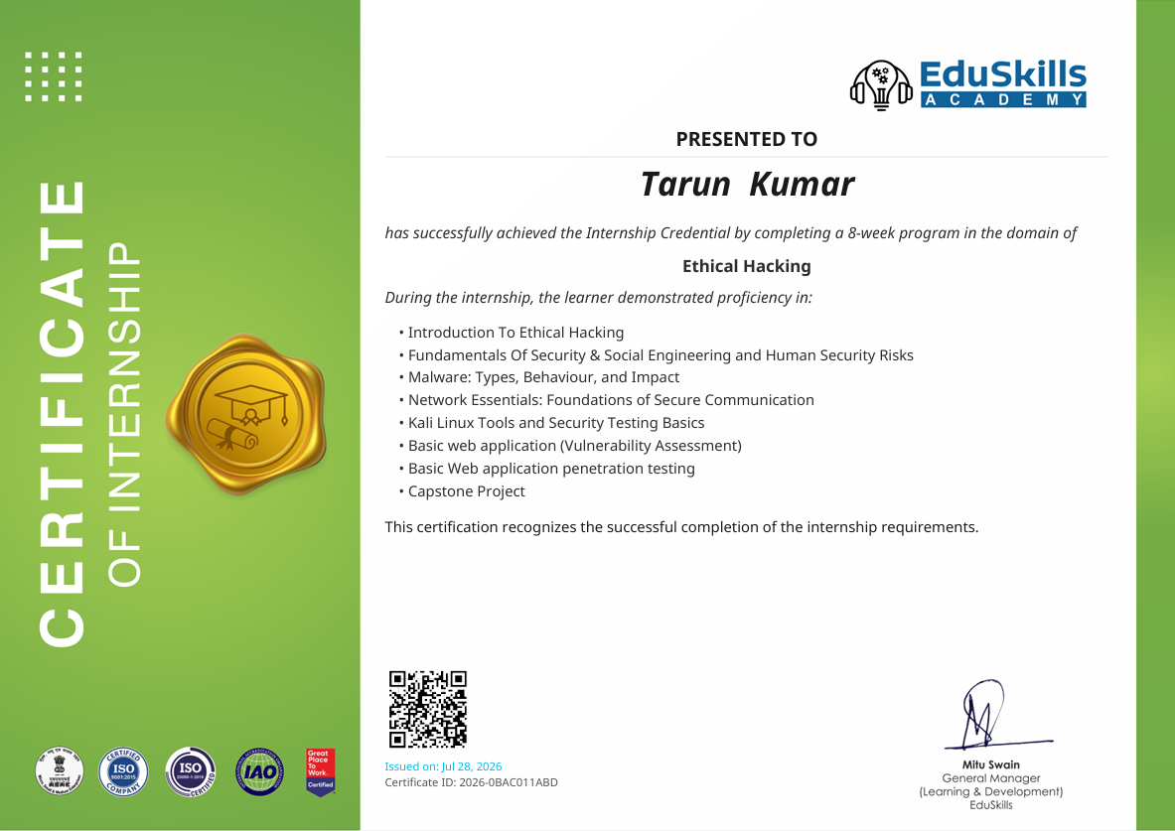

INTERNSHIP OFFER LETTER

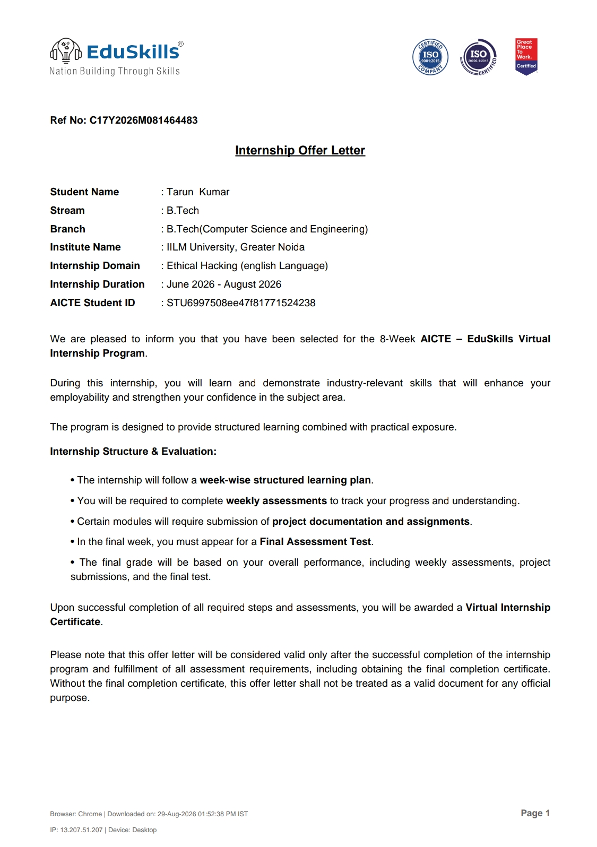

4. PROJECT DESCRIPTION
4.1 Introduction
This report presents a detailed account of the 8-week Virtual Internship undertaken under the AICTE – EduSkills Virtual Internship Program in the domain of Ethical Hacking. The internship was carried out from June 2026 to August 2026 as part of the academic requirements of the Bachelor of Technology (Computer Science and Engineering) programme at IILM University, Greater Noida.
The primary aim of this internship was to develop practical knowledge of ethical hacking and cybersecurity concepts. The internship focused on understanding common cyber threats, security principles, social engineering, malware, networking, Kali Linux, vulnerability assessment, web application security, and penetration testing.
The internship followed a structured week-wise learning plan combining conceptual learning with practical exposure, assignments, weekly assessments, and a final assessment. The programme also included a Capstone Project / Internship Grade Point Assessment as part of the overall evaluation.
4.2 Organization Profile
EduSkills is an organization working towards skill development and employability enhancement through industry-oriented learning programmes. The AICTE–EduSkills Virtual Internship Program provides students with structured learning opportunities in various technical domains.
The Ethical Hacking internship was conducted as an 8-week virtual internship programme under the patronage of AICTE and the National Internship Portal. The programme was supported by EduSkills Academy and was designed to provide students with practical exposure to cybersecurity and ethical hacking concepts.
The programme follows a week-wise structure with learning modules, assessments, project documentation or assignments wherever required, and a final assessment. Successful completion of the required activities and assessments leads to the award of a Virtual Internship Certificate.
4.3 Problem Statement
With the increasing use of computers, networks, web applications, and digital services, cybersecurity threats have become an important concern. Systems and users may face threats such as phishing, social engineering, malware, network-based attacks, and web application vulnerabilities.
A major challenge for students is to understand these security threats not only theoretically but also from a practical and defensive perspective. There is therefore a need to develop knowledge of how vulnerabilities can be identified, analyzed, and reported using appropriate ethical hacking methodologies and tools.
The problem addressed during this internship was to gain practical understanding of cybersecurity and ethical hacking techniques, including security fundamentals, social engineering awareness, malware analysis concepts, networking, Kali Linux, vulnerability assessment, and penetration testing.

4.4 Project Objectives

- To understand the fundamental concepts of ethical hacking and cybersecurity.
- To learn the purpose, legality, tools, and techniques associated with ethical hacking.
- To understand different types of cybersecurity threats and basic protection practices.
- To identify and understand social engineering attacks, including phishing and impersonation.
- To study different types of malware and understand methods for identifying, analyzing, and mitigating their effects.
- To understand fundamental networking concepts, protocols, IP addressing, and basic device configurations.
- To learn the fundamentals of Kali Linux and its role in ethical hacking and penetration testing.
- To understand the fundamentals of web application security and vulnerability assessment.
- To gain practical exposure to identifying and reporting security vulnerabilities in controlled environments.
- To understand the basic methodology of penetration testing using Kali Linux tools.
- To complete the assigned project/capstone activities and required assessments.
- To successfully complete the Final Assessment Test and Internship Grade Point Assessment.

  - Scope of the Project

The scope of this internship covers the fundamental concepts and practical aspects of ethical hacking and cybersecurity. The internship begins with an introduction to ethical hacking, including its purpose, legality, tools, and techniques, followed by cybersecurity fundamentals and common threats.

The scope further includes understanding social engineering attacks, different types of malware, networking essentials, and the use of Kali Linux for ethical hacking and penetration testing.
.
The later stages of the internship focus on basic web application development and vulnerability assessment, followed by penetration testing usin Kali Linux tools. The internship also includes capstone project /Internship Grade Point Assessment as part of
the evaluation process.

The internship was conducted as a virtual learning programme and focused on structured learning, practical exposure, assignments, weekly assessments, and the final assessment. The programme did not involve unauthorized testing of real-world systems or networks.

  - Technologies and Tools Used

Programming & Security Tools:

- Basic Web Application Technologies
- Kali Linux
- Ethical Hacking and Penetration Testing Tools

Cybersecurity Concepts:

- Ethical Hacking
- Cybersecurity Fundamentals
- Social Engineering
- Malware Analysis
- Network Security
- Vulnerability Assessment
- Penetration Testing

Networking:

- IP Addressing
- Network Protocols
- Basic Device Configuration

Application Security:

- Web Application Security
- Vulnerability Identification
- Vulnerability Assessment
- Security Testing

Learning and Assessment:

- Eduskills Virtual Internship Learning Platform
- Weekly Assessments
- Assignments and Project Documentation
- Final Assessment Test

  - System Architecture

The general architecture followed during the Ethical Hacking internship can be represented as a structured cybersecurity assessment workflow:

- Security Fundamentals Layer: Understanding cybersecurity principles, common threats, security risks, and basic protection practices.

- Networking Layer: Understanding networks, protocols, IP addressing, and basic network configurations required for security assessment.

- Threat Analysis Layer: Studying threats such as social engineering and malware and understanding methods used to identify and mitigate them.

- Kali Linux Layer: Using Kali Linux as a security testing environment and learning the tools and techniques used for ethical hacking and penetration testing.

- Vulnerability Assessment Layer: Assessing controlled web applications and systems to identify potential security vulnerabilities.

- Penetration Testing Layer: Applying ethical penetration-testing techniques using Kali Linux tools to identify and document vulnerabilities in an authorized environment.

- Assessment Layer: Weekly assessments, assignments/project documentation, and the Final Assessment Test were used to evaluate learning and progress throughout the internship.

  - Methodology

The internship followed a structured, week-wise methodology combining conceptual learning, hands-on labs, and quiz-based assessments, culminating in a Final Credential Validation as summarized in the table below.

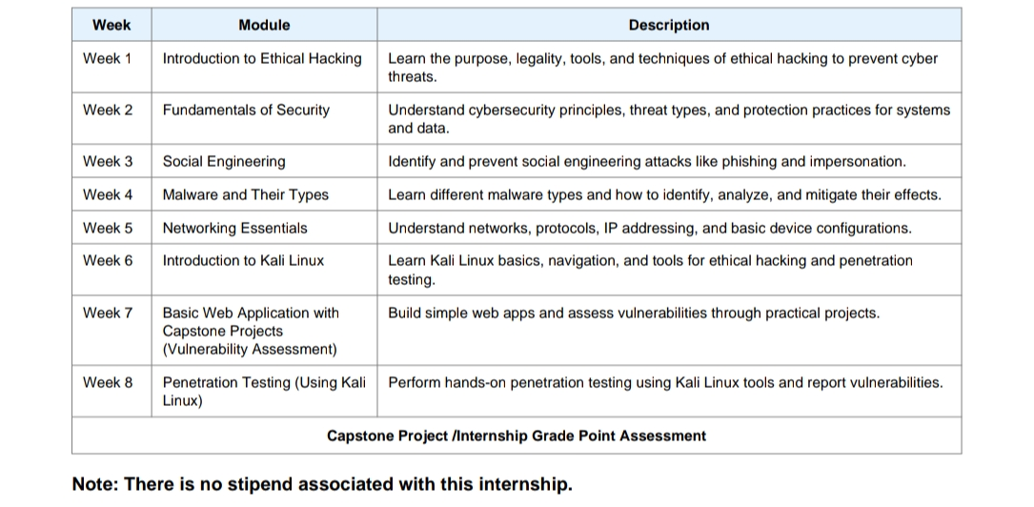

Each week concluded with quiz-based learning-pathway assessments and skill badges to evaluate conceptual understanding. In the final phase, a Final Credential Validation / Internship Grade Point Assessment was conducted, and the overall grade was based on performance across the weekly modules and this final assessment.

4.9 Expected Outcomes

- Ability to understand and explain the fundamental concepts of ethical hacking and cybersecurity.

- Practical understanding of common cybersecurity threats, including social engineering and malware, and their basic prevention and mitigation techniques.

- Understanding of networking essentials, including IP addressing, network protocols, and basic device configurations.

- Practical familiarity with Kali Linux and its use as an environment for ethical hacking and security testing.

- Ability to understand and perform basic vulnerability assessment of web applications in an authorized and controlled environment.

- Understanding of the basic methodology and process of penetration testing using Kali Linux tools.

- Ability to identify, analyze, and document potential security vulnerabilities in a controlled testing environment.

- Improved understanding of security testing practices and responsible use of ethical hacking techniques.

- Successful completion of the weekly learning modules, assignments, and assessments associated with the 8-week AICTE-EduSkills Ethical Hacking Virtual Internship.

- Successful completion of the Final Assessment Test and Capstone Project / Internship Grade Point Assessment as specified in the internship programme.

4.10 Certificates of Completion and Communication Proof

The Internship Offer Letter and the Internship Completion Certificate issued by EduSkills Academy, confirming successful completion of the 8-week AICTE - EduSkills Virtual Internship Program in Ethical Hacking, are attached in Chapter 3 of this report. The official completion e-mail from EduSkills Foundation are attached below as further communication proof.

