A ssignment

1. **Write a Java program to print the sorted list of integers by using one of the collection set**

**package** accolite;

**import** java.util.* ;

**public** **class** Annotations{

**public** **static** **void** main(String[] args) {

// **TODO** Auto-generated method stub

ArrayList<Integer> arr = **new** ArrayList<>() ;

arr.add(10) ;

arr.add(-1) ;

arr.add(3) ;

arr.add(1) ;

arr.add(11) ;

System.***out***.println("ArrayList before Sorting") ;

System.***out***.println(arr);

Collections.*sort*(arr);

System.***out***.println("ArrayList after Sorting") ;

System.***out***.println(arr);

}

}

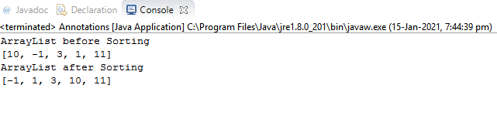

1. **Write a Java program to throw arithmetic exception using “throw” and “throws”**

**package** accolite;

**import** java.util.* ;

**import** java.lang.* ;

**public** **class** Annotations {

**public** **static** **int** division(**int** a , **int** b) **throws** ArithmeticException{

**int** ans ;

**if**(b == 0){

**throw** **new** ArithmeticException("Denominator cannot be 0");

}**else**{

ans = a/b ;

}

**return** ans ;

}

**public** **static** **void** main(String[] args) {

// **TODO** Auto-generated method stub

Scanner s = **new** Scanner(System.***in***) ;

**int** a = s.nextInt();

**int** b = s.nextInt();

**try**{

**int** ans = *division*(a,b) ;

System.***out***.println("Answer is : " + ans ) ;

}

**catch**(ArithmeticException e){

System.***out***.println(e) ;

}**finally**{

System.***out***.println("In finally block") ;

}

}

}

