1. Starting project with home page
2. When we click on car manufacturers, where we can see list with Manufacturers name, Year with and action buttons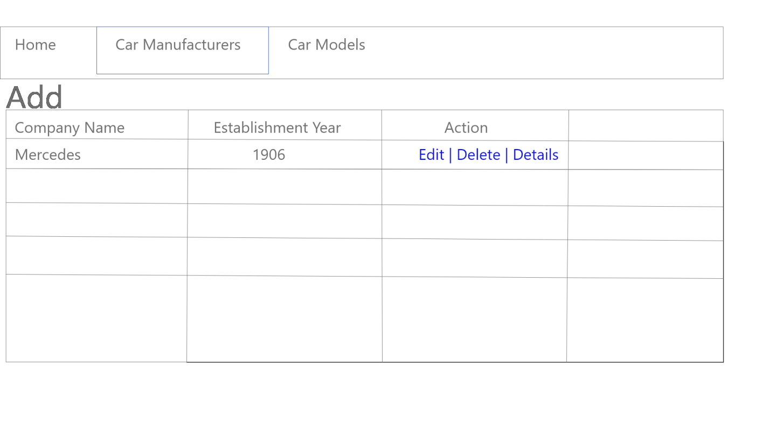
3. Add function

We see a [Add a New Manufacturer](http://localhost:52115/CarManufacture/Create) button, click on this button then page will redirect to create page

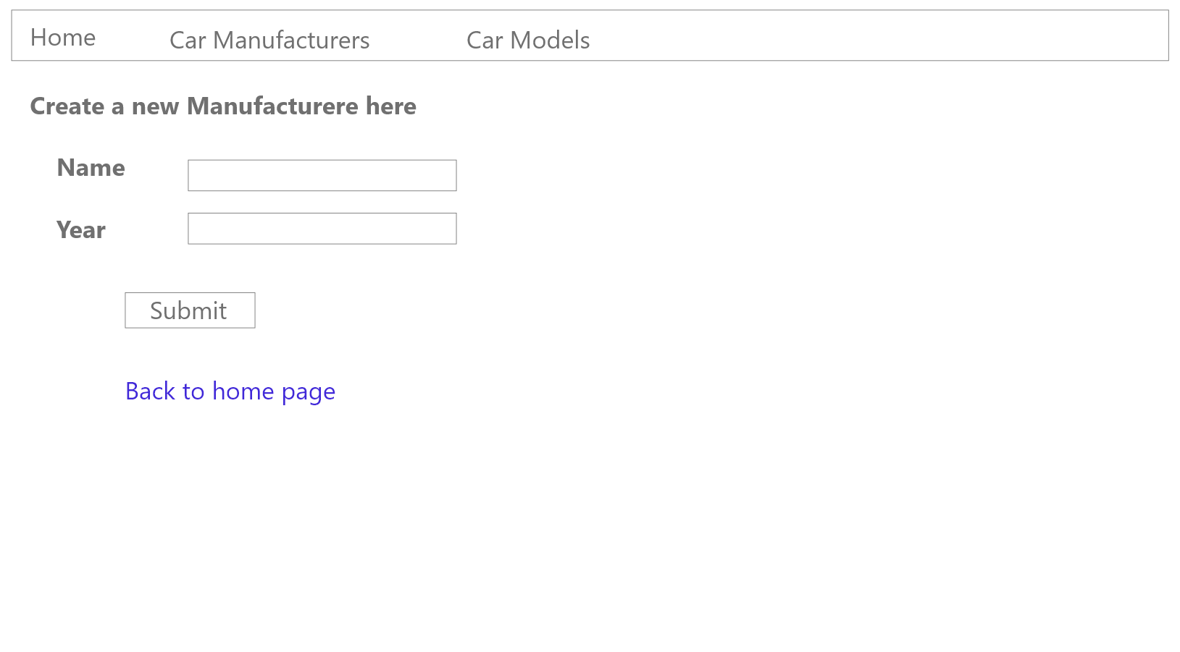

We can add new car manufacturer here,

Then after submit page will return to list page and new entry is added in list

1. View:-When we click on detail button, name of car manufacturer with their model appears on details page

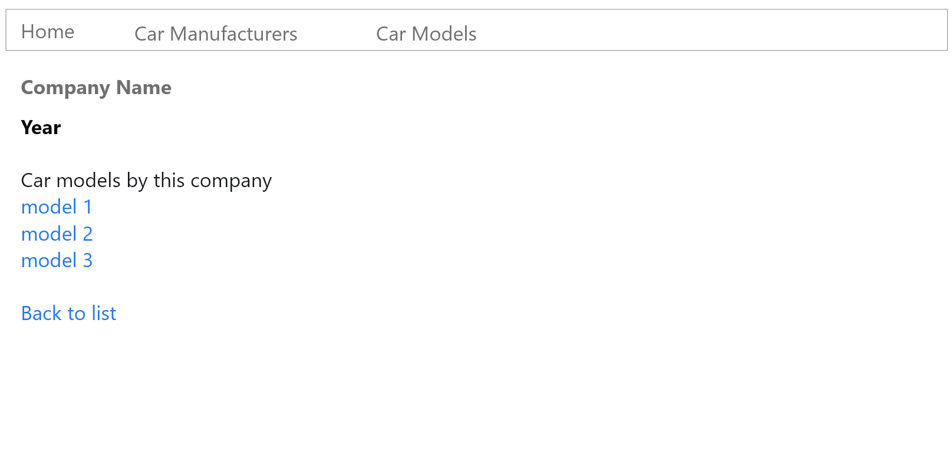

1. Edit:- when we click on edit button, we see a page which is same as create page

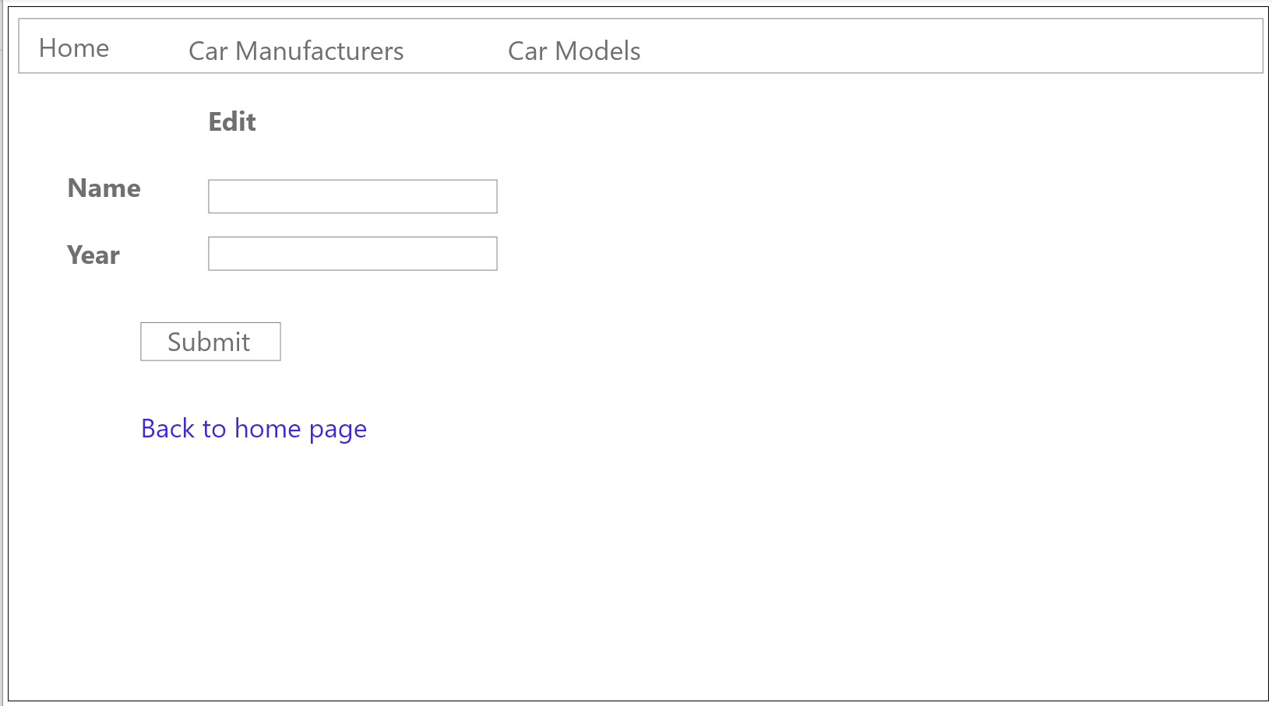

When we done changes click submit, list is now updated

1. Delete:- click on delete button and delete the row

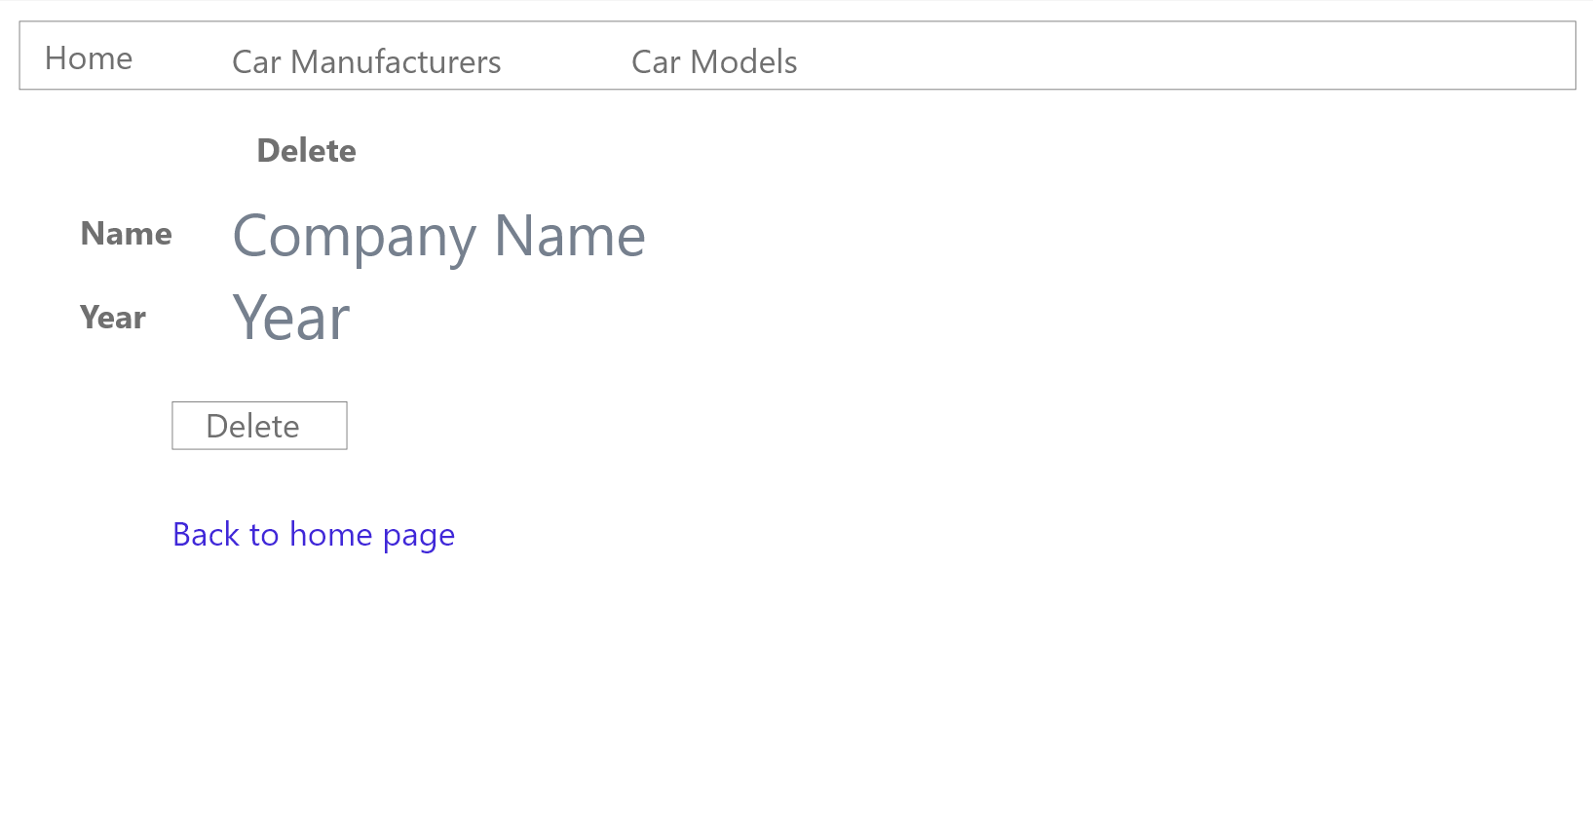

And after click on delete button that entry should be delete from database

1. **Car Model** List View

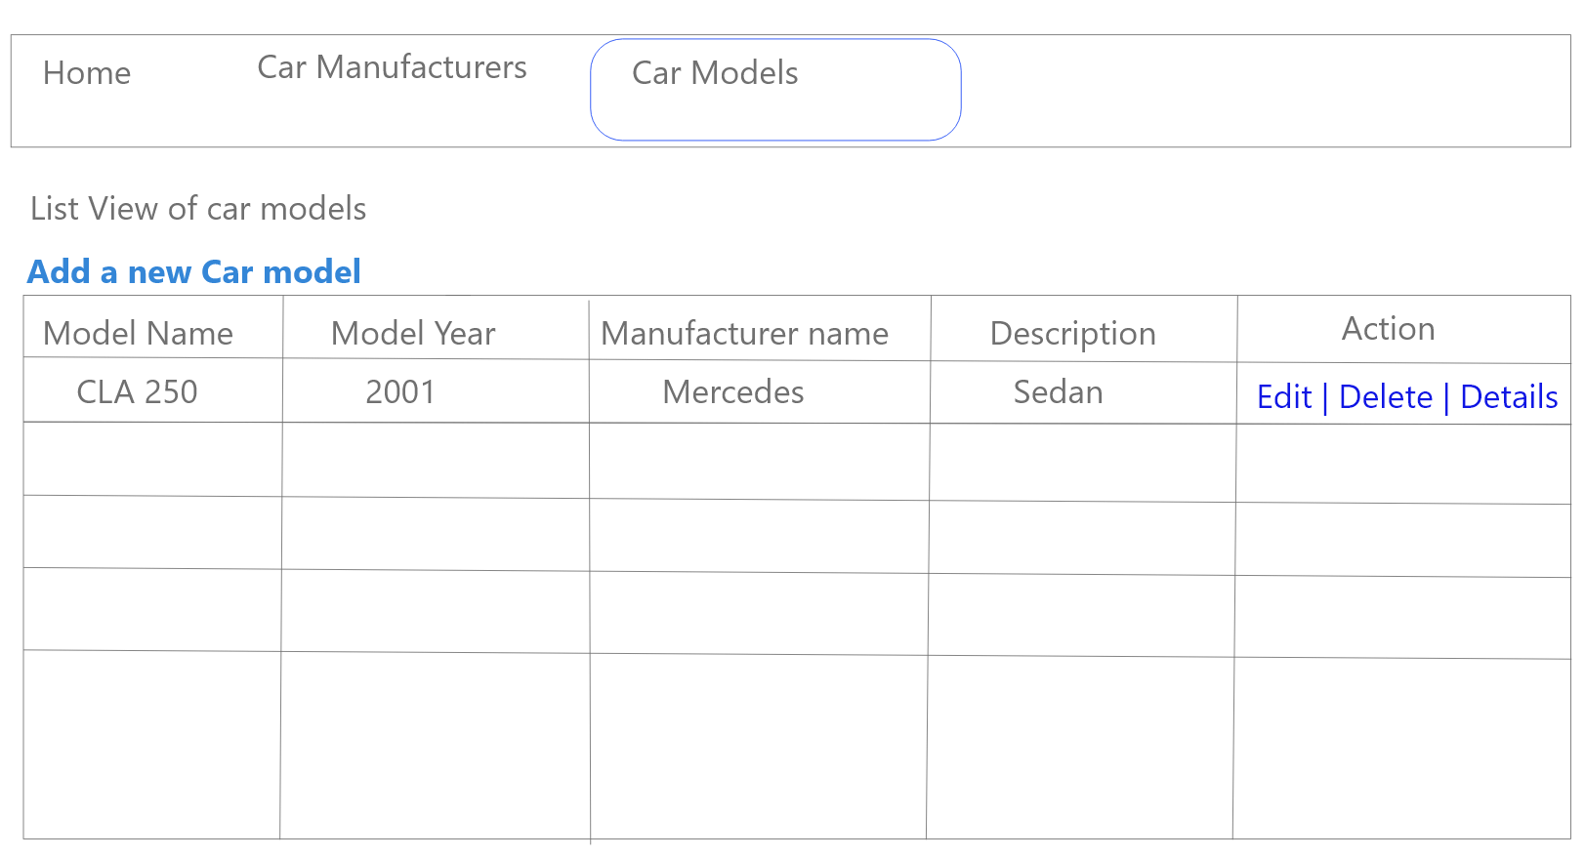

1. View

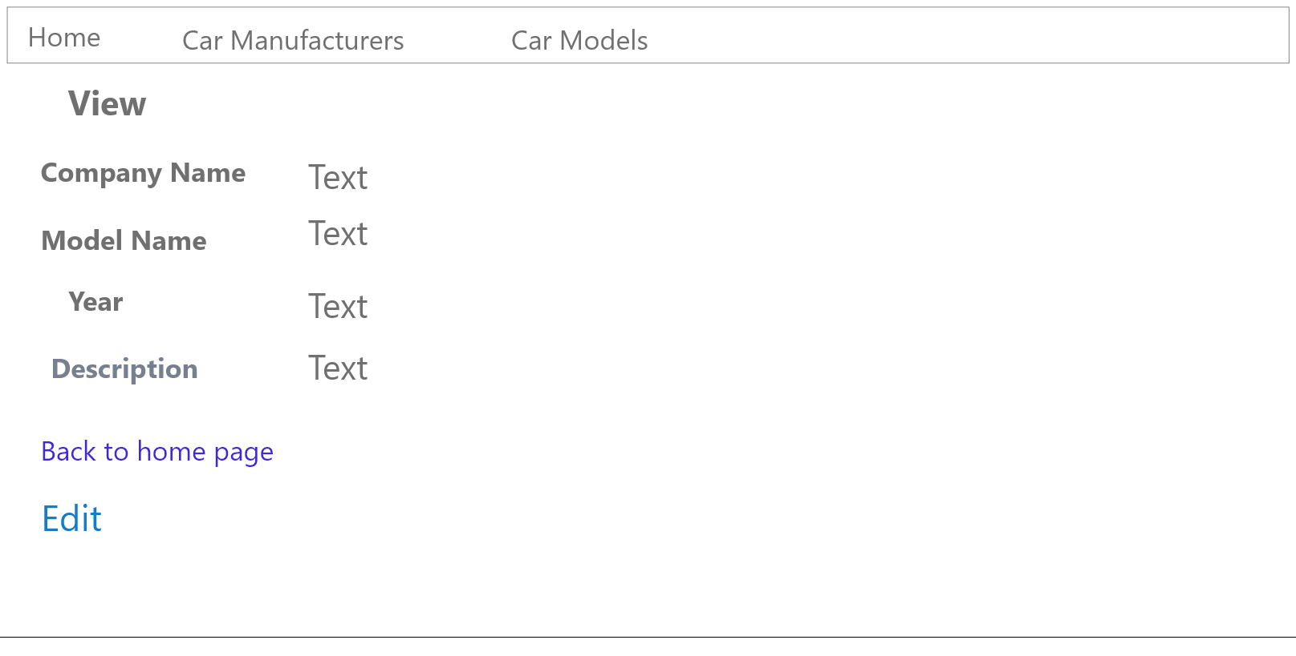

1. Edit

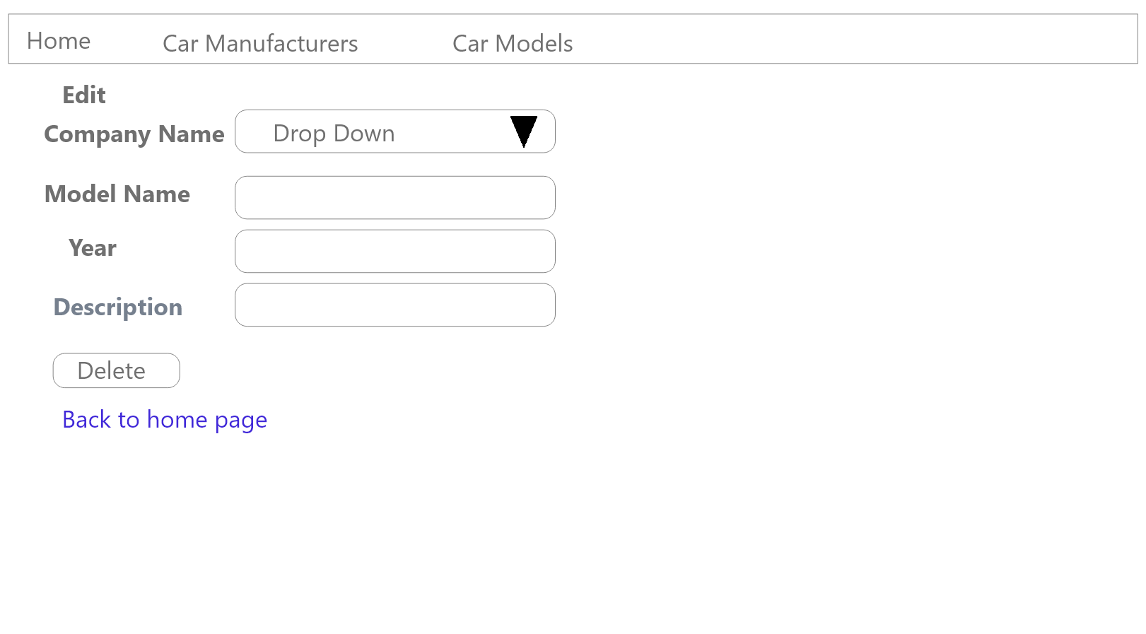

1. Delete

