Annexure 1 Title Page

GEN231: COMMUNITY DEVELOPMENT PROJECT

Title of the Project:

Plantation And making Awareness of Plants.

Name of the Organisation:

VIKAAS AGRI FOUNDATION.

Submitted by: Tarun Sai Phanindra Penumudi
Registration Number: 12306985

In partial fulfilment for the requirements of the award of the degree of

“B.Tech CSE”



School of Computer Science and Engineering
Lovely Professional University
Phagwara, Punjab.

Annexure-II

Student Declaration

To whom so ever it may concern

I, Tarun Sai Phanindra Penumudi Registration Number: 12306985 hereby declare that the work done by me on “Plantation and Making Awareness of plants ” from June ,2024 to, July, 2024, is a record of original work for the partial fulfilment of the requirements for the award of the degree B.Tech. CSE

Name of the Student: Tarun Sai Phanindra Penumudi
Registration Number: 12306985
Computer Science & Engineering Student.

Certificate:

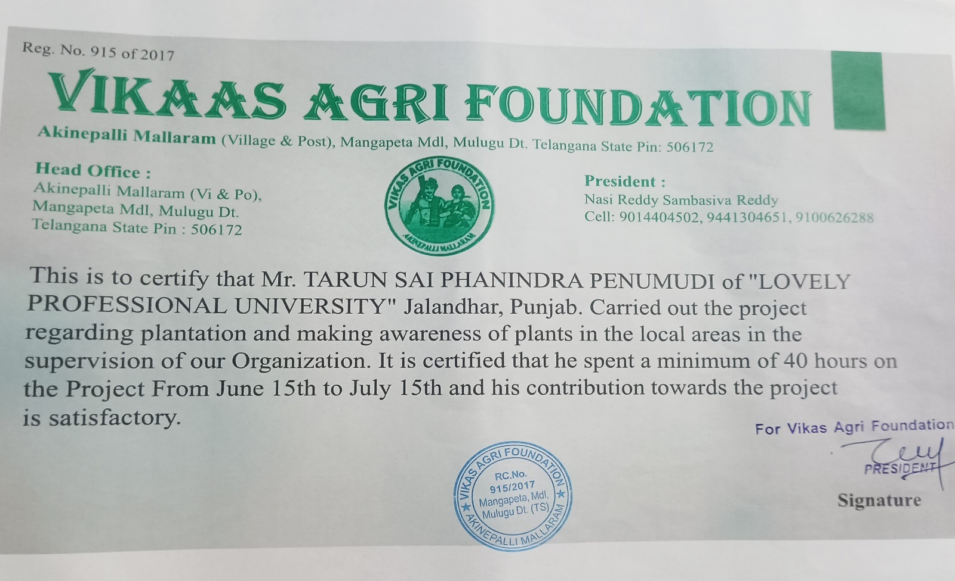

Introduction:

Environmental degradation, in fact, calls for proactive community actions, and one of the most effectives shall be through plantation and awareness of plants. This project deals with increasing the green cover and bringing awareness among the community about how plants are indispensable in maintaining a healthy environment. Plantation is not just greenery; it is fundamentally connected to agriculture and ecological adjustment. We increase the area of plant cover on farms to make a positive contribution to soil health, air quality, and ecosystem resilience.

Plants play a dual role in agriculture: on one hand, enriching the soil with organic matter is quite indispensable for retaining its fertility, while on the other hand, they prevent erosion, which is very important to preserve these farmlands as valued assets. Besides increasing the area of green space, this project also aims at demonstrating how plants contribute to sustainable agriculture by supporting biodiversity and improving water cycles.

This project will be about the understanding of the benefits of plants through events such as planting trees, the distribution of plants, and education workshops. Community activities will combine with agriculture to solve soil erosion, improve air and water quality, and land management in a sustainable manner. Finally, this will be one step toward an environmentally conscious and ecologically responsible community.

Problem Identification and Cause of the Problem

- The community was a complex nexus of issues that actually traced their causes to environmental and agrarian ones. A major problem was the reduction in green cover, as there was unbridled deforestation and urban sprawl.

- This brought in its wake soil erosion, whereby the topsoil-the lifeblood earth needed for agriculture-was just washed away, reducing agricultural productivity. On the other hand, this reduced green cover contributed to generally poorer air quality and disrupted local ecologies.

- Adding to these environmental problems were archaic farming practices. Farmers depended too much on chemical fertilizers and pesticides, which degraded the soil quality.

- These methods also led to reduced crop yields and made crops more susceptible to pests and diseases. Knowledge of modern, sustainable agricultural methodologies was lacking; hence, farmers were not using means that could enhance soil fertility and improve crop resilience.

- Added to this was the complete ignorance of the ways plantation activities could contribute in no small measure both to the protection of the environment and to agriculture.

- Since large-scale plantation efforts require an integrated approach with regards to resource availability and support within the community, most of its members showed a lack of awareness regarding long-term perspectives on sustenance and growth of green cover.

- This lack of knowledge and resources hindered the ability of the community itself to address the issue of environmental degradation and agriculturist concerns effectively.

- The problems arose due to environmental negligence, backward methods of agriculture, and general lack of awareness and plantation resources. The project was meant to redress the situation by restoring the green cover through adequate plantation and creation of awareness among the community for this end.

Objective to be achieved by Planting
1. Increase Green Cover in the Community:
Objective: To enrich the environmental health in the community by increasing the number of trees and plants, including a variety of species suitable to the local climate and soil conditions.
Description: Rehabilitation and extension of greenery will improve air quality and help in soil stabilization. This will be quantitatively achieved by the number of plants planted, and the qualitative achievement by the increased visibility of green cover over time.

2. Raise Awareness About the Importance of Plants
Purpose: To educate the members of the community on the values of plants and the need to continue having green spaces. It will entail workshops, seminars, and outreach.

Detail: It would ensure that information on environmental sustainability, the role of plants in the ecosystem, as well as individual contributions to plantations, is communicated with the aim of developing an environmentally conscious culture.

3. Soil Quality Improvement and Prevention of Erosion:
Objective: To address the problems of soil erosion through plantation strategies that stabilize the soil, preventing further degradation; this requires the selection of appropriate species with effective root systems.
Details: Improvement in soil structure, less runoff, and improved fertility of the soil; reduction in soil erosion, soil quality, health of planted spots will determine whether the outcome is successful or not.

4. Engagement and Involvement of Community Members:
Objective: Engage the community directly in the planting process to foster ownership and responsibility in green space care in their neighbourhoods. Examples of this may be organizing planting activities and volunteer events.
Details: The aim would be to involve the community in such a way that not only would the project get acceptance, but ultimately, it could also be sustained by the residents. The involvement would be measured from participation rates and community feedback on involvement.

5. Monitor and Evaluate the Impact of the Plantation Efforts:
Objective: To continuously assess the effectiveness of the plantation activities in achieving desired outcomes and impact on the community through continuous monitoring and evaluation of plant growth, soil conditions, and community feedback.
Details: This entails setting up evaluation criteria and indicators, which will evidence the success of the project. In this way, the influence that will emanate from the project will be understood, and at some other time, adjustments could be affected to maintain further projects.

6. Enhancing Local Biodiversity:
Objective: To contribute to the preservation and enhancement of local biodiversity by planting a diverse range of native and beneficial plant species.
Details: This objective focuses on creating habitats for various wildlife and supporting ecological balance. Success will be reflected in the increased presence of local flora and fauna and improved ecosystem health.

A Steps towards the Objective:
1.Improvement of Community Green Cover

Need Assessment and Planning:

Action: Assess the available green cover within the community and choose an area suitable for planting. Plan the planting with selected plant species along with the timeframe.
Details: Study of the community and consultation with experts in the field regarding the right type of plants and locations.
Resource Procurement:

Action: Solicitation of funds, plants, and all other related paraphernalia by finding ways such as grants, donations, and collaborations.
Details: Design a budget for acquiring all the materials needed for planting.

Organize Planting Events:

Action: Plan and publicize the planting activities to ensure community involvement.

Details: Organize logistics, mobilization of volunteers, and preparation of the site for activities involving planting.

Carry Out Planting and Maintenance:

Action: Perform vegetation based on the plan with subsequent maintenance.

Details: Execute the planting job according to the planting plan and do follow-up maintenance entailing early care and regular maintenance that includes watering, weeding, and monitoring.

Action: Observe plant growth and success of project, and record the outcome to share with the community.
Details: Observe plant health, make adjustments as needed, and celebrate successes together as a community.

2.Raise Awareness of the Importance of Plants
Key topics and messages to be conveyed:

Action: Identify subjects that are to be discussed - for example, how plants contribute positively to the environment, how plants maintain the life of an ecosystem, and what personal actions can be taken by individuals to reinforce planting practices.
Details: Devise clear, catchy messages to deliver to the community.
Organization of Educational Workshops and Seminars:

Action: Organize workshops or seminars to increase awareness about plants and their benefits to the community.
Details: Invite guest speakers, produce informative material, and lead interactive discussions.
Mobilize Community Outreach Efforts:

Action: Take on-site communications through social media, local newspapers, and community bulletin boards to pass information out.
Details: Design engaging posters, infographics, and social media posts highlighting key messages and events.
Engagement with Local Schools and Organizations:

Action: Collaboration with schools and local organizations for the inclusion of plant education into various programs.
Details: Give public presentations, help with school projects, and share resources with educational programs.
Create and Distribute Educational Materials:

Action: Create brochures, flyers, and information on a website that describes the importance of plants and what people can do to help.
Details: Make the materials easy to understand and visually appealing; distribute the materials at community events, businesses, and online sites.
Community Planting Days and Events:

Action: Community involvement events should be arranged where planting can be done, and the advantages of the plants can be shared with them.
Information: Involvement in planting activities coupled with educating them on those aspects will give hands-on experience as well as reinforce the message of green space importance.
Evaluate and Collect Feedback:

Action: The awareness drive that has been conducted should be rated and a feedback survey should also be taken from the participants.
Details: Use feedback to improve future campaigns and measure how your educational activities influence the knowledge of the community and its level of engagement.

3.Improve Soil Quality, Prevent Erosion
Soil Condition Assessment:

Action: The current soil quality and erosion in target areas will be assessed.
Details: The testing of the soil will be conducted along with observation of problem areas to determine the level of erosion or degradation of the soil.
Select Erosion-Resistant Plants:

Action: Plants that have hardy root systems that can hold the soil in place and at the same time improve the structure of the soil should be selected.
Details: Native and ground-cover plants recommended for erosion prevention will be selected.
Preparation and Improvement of Soil:

Action: Improve soil conditions before planting by incorporating organic matter into the soil and by proper preparation of soil.

Details: Add compost or other soil amendment to enhance the fertility and structure of the soil. Prepare the soil correctly for the plants to flourish well.

Apply Planting Techniques:

Action: Apply best practices in planting techniques that ensure the effective stabilization of soil.
Techniques to minimize runoff and soil movement include planting in offset rows or on terraces. Proper spacing and planting depth should be maintained for all plants.
Establish Maintenance:
Care on site after installation should be done to encourage plant growth and soil stabilization.
Regular watering, mulching, and erosion sign checking is included. Maintenance adjustments should be done according to the progress of plants and soil.
Monitor and Evaluate Impact:

Action: Planting and continued effectiveness monitoring to improve soil quality and prevent erosion.
Details: Periodically visit the site for visual detection of signs and symptoms of soil erosion. Observe the condition and health of the plants, and take further adjustment actions to ensure the success of the project is ongoing.
Documentation and Dissemination of Results:

Action: Document findings of the project; communication of results of successes and lessons learned.
Outputs: Reports are made and even presented to the community, indicating soil quality improvement as well as the efficiency in erosion prevention.

4.Engage and Involve Community Members
Plan Events for Community Involvement:

Action: Events may include planting days, workshops, education classes, and volunteer opportunities.
Detail: Events must be easily accessible and of interest to a wide range of individuals.
Publicize Through Various Means:

Action: Social media, newspapers, community boards, and fliers can be used to let others know about events and activities.
Detail: Create compelling content and a clear call to action to encourage involvement.
Develop Partnerships with Local Organizations:

Action: Collaborate with schools, businesses, and community groups to broaden the base of support.
Details: Increase participation through active networks and other resources currently established.

Provide Incentives and Recognition:

Action: Provide incentives or certificates of involvement; publicly recognize the effort given.
Details: Reward volunteers and other supporters as a motivational means to further action.

Gather Feedback and Adjust:

Action: Request responses from active participants to measure the effectiveness of involvement strategies.
Details: Feedback will be used to refine future activities, focusing on the improvement of community involvement strategies.

5.Monitoring and Assessing the Impact
Establish Clear Evaluation Criteria:

Action: Clearly define what success criteria and indicators would be measured to show the outcome of the efforts involved in plantation.
Details: This needs to incorporate plant growth, soil health, community participation.

Monitor Constantly:

Action: Periodic visits to evaluate the condition of the areas where plantation is done and, thus, the progress of the project.
Details: Healthy plants, stabilized soil, and other signs to identify problems, for instance, erosion and/or pest issues.
Collect and Analyze Data:

Activity: Key indicator information will be collected on plant survival rate, soil quality, and feedback within the community.
Information for: The information will be used to assess the project performance and identify potential areas for improvement.
Report Findings:

Activity: Reports on the results, successes, and setbacks of the project should be written and distributed.
Information for: Visual documentation should be included, like photographs and charts of progress and mapped impact.
Modify and Improve:

Action: The evaluation outcome should be used to make necessary adjustments and arrive at better planting in the future.
Details: In the process, provide necessary adjustments based on the feedback and information obtained to enhance project outcomes and effectiveness.

Effectiveness of the Project
The effectiveness of the plantation and awareness project can be ascertained from some major impacts it has created in the following manner:

Increased Green Cover:

Result: The green area has indeed increased within the community, and this is accurately quantifiable by the number of trees and shrubs planted.
Impact: Enhanced aesthetic value, air quality, and more environmental sustainability.
Improved Soil Quality and Reduced Erosion:

Result: Accomplished fixation of soil in targeted areas that resulted in reduced erosion and improved fertility of the soil.
Impact: Improved agricultural output with reduced soil degradation, leading to more judicious use of land.

Improved Community Understanding and Participation:

Result: The community will be more aware of why plants are important to them through workshops, seminars, and outreach programs.

Impact: The community is more actively involved in environmental activities, thus promoting an environment for better care and concern.

Environmental and Health Positive Outcomes:

Result: The biodiversity at the local level will improve, including air and water quality, and reduction in carbon footprint.
Impact: Healthier ecosystem and an improved quality of life among community members.
Sustainable Practices and Ongoing Maintenance:

Result: The time frames needed for this maintenance were to be established, which would ensure the perpetuity of health for the areas planted and further development of the community in its engagement.
Impact: Long-term sustainability of green open spaces, continued growth supported by the community with regard to environmental practices.

- identified Societal Problems: -

- Soil Erosion:

Problem: Soil erosion is one of the critical environmental hazards that leads to rich topsoil loss, reduction of agricultural output, and sedimentation of water bodies.
It is caused by deforestation, unsuitable practices of land use, and no grass cover on the ground.
Impact: Erosion reduces agricultural returns, causes land degradation, and pollutes water, possibly harming the aquatic life and reducing the quality of water for the communities.
Solution Through Project: The project is making certain that there is stabilization of soil and runoff reduction through planting of vegetation and encouraging growth of ground cover, thus preventing erosion. This helps in not just preserving soil fertility but also in land productivity and protection of water resources.

- Reduced Air Quality:

Air quality is generally poor in the area of cities and villages due to pollution, deforestation, and lack of vegetation. The level of CO2 and pollutants is very high, which creates many health problems and further leads to global change. Poor air quality could give rise to respiratory diseases, cardiovascular diseases, and degraded quality of life. It is also contributing to global warming and climate change, affecting the local and global environments adversely.
Solution Through Project: The plantation increases the green cover, thus absorbing CO2 and pollutants while producing oxygen. This improves air quality and better health outcomes for residents, contributing to mitigating the effects of climate change.

Conclusion
This plantation and plant awareness project demonstrates tremendous and relevant impacts on key environmental and social challenges. Thus, the project has embarked on firm efforts toward increasing green cover and enhancing plant education, addressing different critical issues related to soil erosion and reduced air quality.

To this day, the project has ensured that soil and its erosion are managed to prevent agricultural land loss, improving soil fertility and thus productivity and environmental viability. Equally important, increasing green spaces has played a pivotal role in enhancing air quality, thereby contributing to a healthy living environment and minimizing some adverse effects of pollution and climate change.

The project has also involved the community in environmental stewardship through increased awareness and participation in sustainable practices. These educational workshops, events within the community, and maintenance activities laid the foundation for long-term environmental responsibility and resilience.

The project has managed to improve soil health, raise awareness, and even involve the community. It will go to serve as a case study for what can be achieved with clear cut environmental goals in eliciting positive change that is sustained not only in the ecosystem but most importantly in the lives of the communities involved. As we forge ahead in adding to these successes, underlining the paramount importance of collective action in facing environmental challenges while fostering a more sustainable future, the project does so.

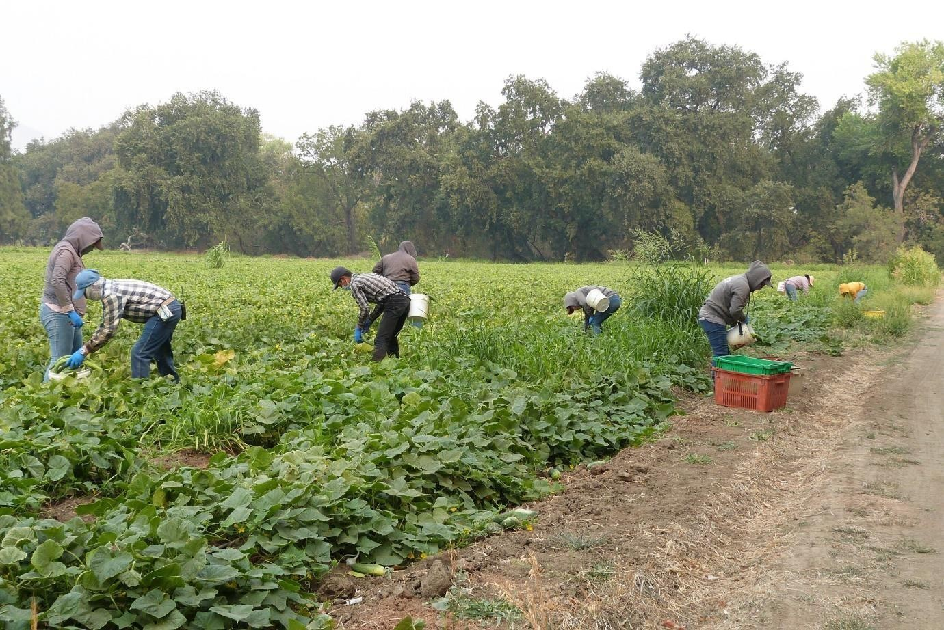
environmentally friendly appropriate technologies.

Leave the world better than you found it, take only what you need, strive not to harm life or the environment, and make restitution if you do, according to Paul Hawken (1993). The basic principle of sustainability is to cooperate
with, or at the very least not try to oppose, natural forces. The Latin word "sustain," which means "to keep in existence or maintain," comes from the root "sus," which comes from the verb "to hold" (tenure). It denotes
longevity or permanence. Sustainable, as it relates to agriculture, refers to farming methods that are able to continue to be productive and beneficial to society. Such a system must be environmentally sound, socially friendly, competitive in the marketplace, and resource-conserving. According to the definition of sustainable agriculture provided by the Technical Advisory Committee (TAC) of the Consultative Group on International Agricultural
Research (CGIAR), "sustainable agriculture is the successful management of resources for agriculture to satisfy the changing needs of humans, while
maintaining or improving the quality of the environment and conserving natural resources."

Modern definition:
Sustainable agriculture is the use of farming systems and practices which maintain or enhance
1.The economic viability of agricultural production 2.The natural resource base and
3.Other ecosystems which are influenced by agricultural activities.
This definition can be supplemented by some fundamental principles of sustainable agriculture:
- That farm productivity is enhanced over the long term
- That adverse impacts on the natural resource base and associated ecosystems are ameliorated, minimized or avoided
- That residues resulting from the use of chemicals in agriculture are minimized
- That net social benefit (in both monetary and non-monetary terms) from agriculture is maximized; and
- That farming systems are sufficiently flexible to manage risks associated with the vagaries of climate and markets.

The United States Department of Agriculture defined ‘sustainable agriculture’ as a management-system for renewable natural resources that provides food, income and livelihood for present and future economic productivity and ecosystem services of these resources.

Sustainable agriculture is a farm system that mimics as closely as possible the complexity of a healthy and natural ecosystem. It integrates three main goals.
- Environmental health.
- Economic efficiency
- Social- economic equity (community)

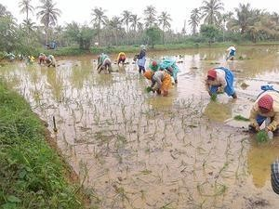

Environmental health
Biodiversity and the genetic resource base are linked to ecological sustainability. A sustainable ecology is built on increased genetic, species, and ecological variety. There are a number of potential solutions to the environmental issues brought on by capital and technology-intensive farming systems, and research is now being conducted to assess alternative systems. The primary aim is on reducing or eliminating agrochemical inputs through management adjustments that ensure adequate plant nutrition, integrated pest management, plant protection through nutrient sources, and efficient use of energy and water.

Economic efficiency
The farm must produce income in a competitive economy, not just in monetary terms but also in kind. Farmers make judgments in a dangerous, constantly changing environment, and they typically don't know the results of their decisions until after the fact. Major causes of risk in agriculture include yield and price variability. Technology advancements, legal and societal issues, as well as the human element itself, all add to the dangerous environment that farmers must operate in.

The risk of reduced profit is greatest when there is an excessive reliance on outside inputs. The farm should become self-sufficient, there should be equality in revenue distribution, and finally, the agricultural system's resilience should be boosted in order to stabilize the farm's economics.

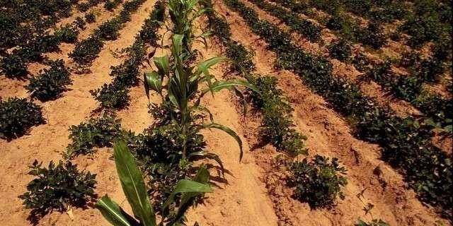
Intercropping for ecological and economic efficiency in agriculture

Community
A perfect farming system will undoubtedly ensure the farmers' nutritional and economic security, and sustainability reduces their reliance on the market. It should have equal access to resources that belong to common property. When a farm satisfies all of the following criteria, it can be called to be socially just:
- Whether the farm is getting fair share of price.
- Whether it is sufficient to maintain a family well-being.
- Whether he get enough remuneration to purchase his food.
- Whether the minimum wage requirement is attained.

Sustainable agriculture means, an integrated system of plant and animal production practices having a site-specific application that will, over the long term:
  - Satisfy human food and fibre needs.
  - Enhance environmental quality and the natural resource based upon which the agricultural economy depends
  - Make the most efficient use of non-renewable resources and on-farm resources and integrate, where appropriate, natural biological cycles and controls
  - Sustain the economic viability of farm operations
  - Enhance the quality of life for farmers and society as a whole.

Advantages

- Production cost is low
- Overall risk of the farmer is reduced
- Pollution of water is avoided
- Very little or no pesticide residue is ensured
- Ensures both short- and long-term profitability

Disadvantage
Since sustainable agriculture uses least quantum of inputs, naturally the output (yield) may also be less.

Basic features and concepts of sustainable systems

- Need to maintain or improve soil quality and fertility. This is often attained by increasing the organic matter content of the soil, and by minimizing losses from soil erosion.

- Production programs are designed to improve the efficiency of resource utilization. This will result in the most cost-effective use of water, fertilizers, and pesticides.

- An attempt is made to improve internal nutrient cycles on the farm, which will reduce the dependence on external fertilizers.

- Efforts are made to improve biological diversity on the farm. This will result in improved natural suppression of pests and may also help to improve internal nutrient cycling within the farm.

- Farm management and marketing programs are designed to minimize overhead costs and to increase returns, often by following alternative marketing schemes.

Problems and impact on agriculture

Particularly after World War II's end, the agricultural industry has seen significant upheaval. Due to new technology, mechanization, increasing chemical use, specialization, and government policies that favoured maximizing production, productivity in the production of food and fibre skyrocketed. There have been enormous expenses associated with these modifications, despite the fact that they have decreased numerous risks in farming and had many positive consequences. Topsoil loss, tainted groundwater, the demise of family farms, persistent disregard for the living and working circumstances of farm laborers, rising production costs, and the breakdown of social and economic structures in rural areas are prominent among these. Following is a list of agricultural issues:

- Decline in agricultural growth rate

- Decline in factor productivity

- Static or decline in food production

- Increasing malnutrition

- Shrinkage in net cultivated area

- Increasing environmental pollution

- Depleting groundwater table 8.Increasing cost of production
- Low farm income

- Increasing unemployment

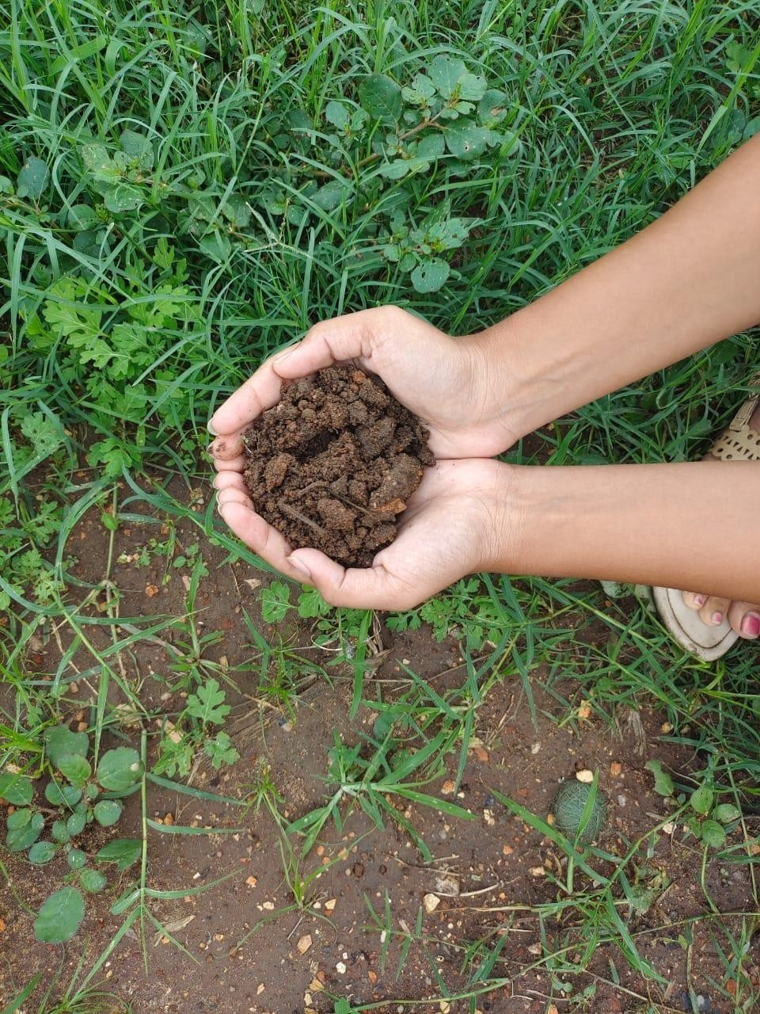

As a result, recent years have seen a plateau in agricultural productivity. The level of risk in the agriculture industry is further increased by problems like competing demands for water in the context of shifting demographics and its numerous end uses. These have significant effects on the security of one's food supply and

means of subsistence, and because agriculture production is risky, it may encourage people to move from rural to urban and suburban areas.

Indian agriculture now faces the challenge of ensuring food security amidst constraints such as stagnating net sown area,
deterioration of land quality, reduction in per capita land availability etc.

The challenges are:
- Need for more food: Around 310 M t of food grains in 2050
- Stagnating net sown area: 140 ± 2 M ha since 1970
- Land share under fallow: 38 per cent increase since 1951
- Per capita land availability: From 0.91 ha in 1951 to 0.32 ha in 2000 and to 0.19 ha is projected by 2050
(iv) Per capita net sown area: 0.33 ha in 1951 to 0.14 ha in 2001
Fostering rapid, sustainable and broad-based growth in agriculture
is
therefore, a key priority keeping in mind the overall socio-economic development trajectory of the country, especially in the light of existing vulnerabilities that relate to a shrinking land resource base, additional stresses arising from the non-agricultural sector and issues emerging due to changing climate. This necessitates a strategic approach with a renewed vision and redefined focus.

Indicators of agricultural sustainability

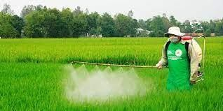

These help us to identify, quantify and evaluate the effect of agriculture. We will be able to see the consequences of our policies on

progress towards sustainability. Our future programmes and initiatives, as well as those of others, will be more easily and better targeted.

This set of indicators provides a means of measuring the economic social and environmental impacts of agriculture and to help assess the effectiveness of policies and the sustainability of the sector.

Social, environmental, and economic considerations must all be taken into account in order to make a fair assessment of how far agriculture has come towards sustainability. Tins urges the use of indicators that are reflective of the topics most important to agriculture and are also interconnected. Before inferences can be made about the sector's overall progress toward sustainability, it is important to carefully assess the trends that particular indicators reflect.

Indicators can demonstrate forward movement in the direction of sustainability. For instance, there has been a rise in the adoption of environmentally friendly fanning systems. Combining statistics for energy consumption and agricultural productivity reveals an increase in energy efficiency. However, other evidence point to a negative trend. For instance, many farming bird species are becoming less common. Due to the fact that they are based on existing data, several of the indicators in this set have not yet been fully developed. But over time, they ought to offer a more accurate
picture of the developments leading to a more sustainable agriculture sector.
Indicators are a collection of characteristics or measurements that represent a certain facet of agriculture. Quantitative data called indicators can be used to explain how something is evolving over time. Sustainability indicators take an integrated approach to studying economic, social, and environmental data. Many experts concur that the creation of sustainability indicators should be guided by at least three factors.

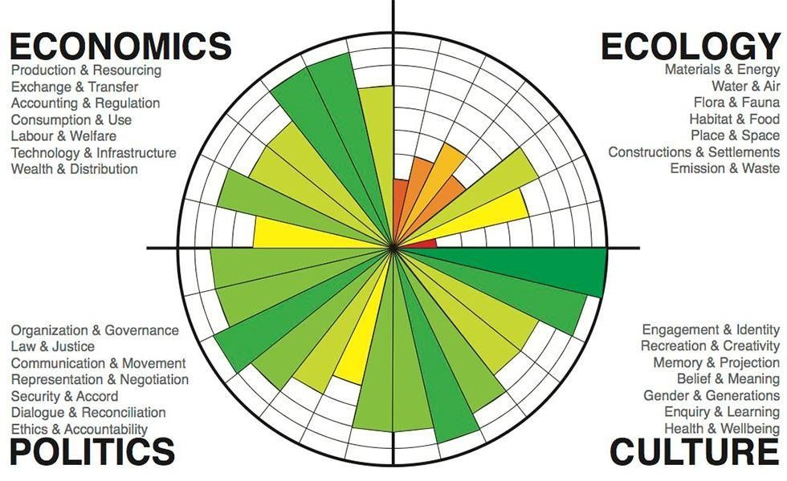

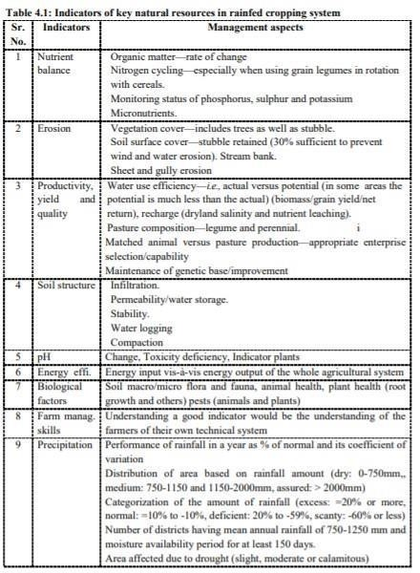

Since the 1980s, there has been a growing movement to examine the agricultural establishment's role in encouraging behaviour that lead to these social issues. The cause and effects of industrialization in the agricultural sectors have now been
recognized by environmentalists, who have suggested sustainable agriculture.

Agricultural practices have undergone significant transformation, particularly since the end of World War II (1939–1945). Productivity in the food and fibre industries expanded dramatically as a result of new technology, mechanization, greater
chemical use, specialization, and government initiatives that encouraged maximizing output. The decline of family farms, the continued disregard for the living and working conditions of farm laborers, rising production costs, and the breakdown of social and economic conditions in rural communities are just a few of the risks that these changes have brought to light.

A growing movement has emerged since the 1980s to question the role of the agricultural establishment in promoting practices that contribute to these social problems. Environmentalists have now realized the cause and consequence of industrialization in agricultural sectors and proposed sustainable agriculture.
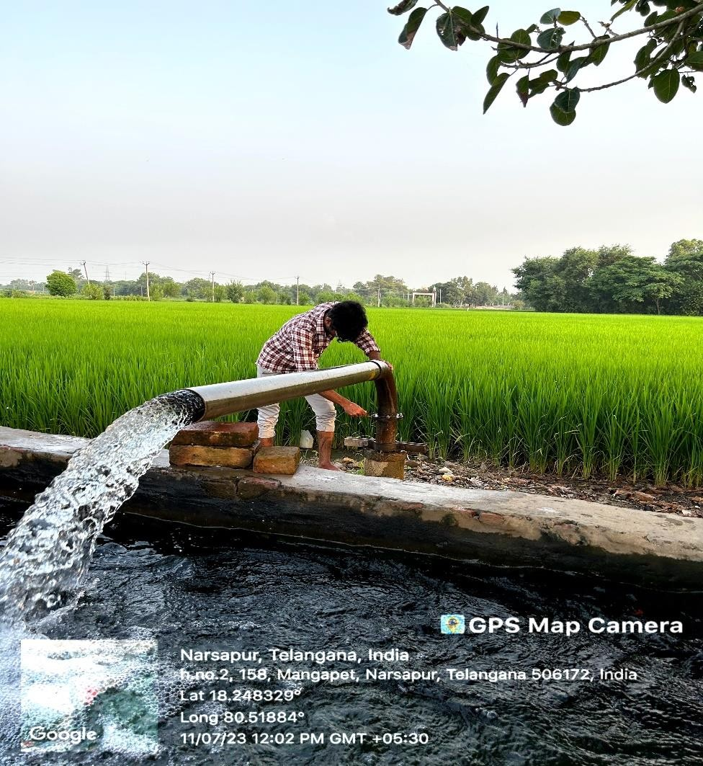

Principles of Sustainable Agriculture

Economic sustainability
A farm needs to be financially successful in order to be fully sustainable.
Numerous ways that sustainable agriculture can enhance a farm's economic viability. A farm's value may rise and payments for environmental services may be made in the medium and long terms as a result of improved soil
management, crop rotation, and water availability. In the short term,
improved soil management and crop rotation can increase yields. Depending on the unique features of the production system, economic viability can also be accomplished by, for example, lowering the costs of machinery, chemical fertilizer, and pesticides (for farmers who can afford these inputs).

Environmental sustainability
Common definitions of sustainable agriculture include ecologically sound techniques that either have negligible to no negative effects on natural ecosystems or even improve environmental quality and the natural resource base that supports the agricultural sector. The natural resource base, which includes land (soil), water, biodiversity, and wildlife and contributes to the conservation of natural capital, is typically protected, recycled, replaced, and/or maintained to achieve this. As needed, artificial fertilizers can be utilized to augment natural inputs. Sustainable agriculture avoids or uses to a minimum synthetic chemicals that are known to impair soil organisms, soil structure, and biodiversity.

Social sustainability
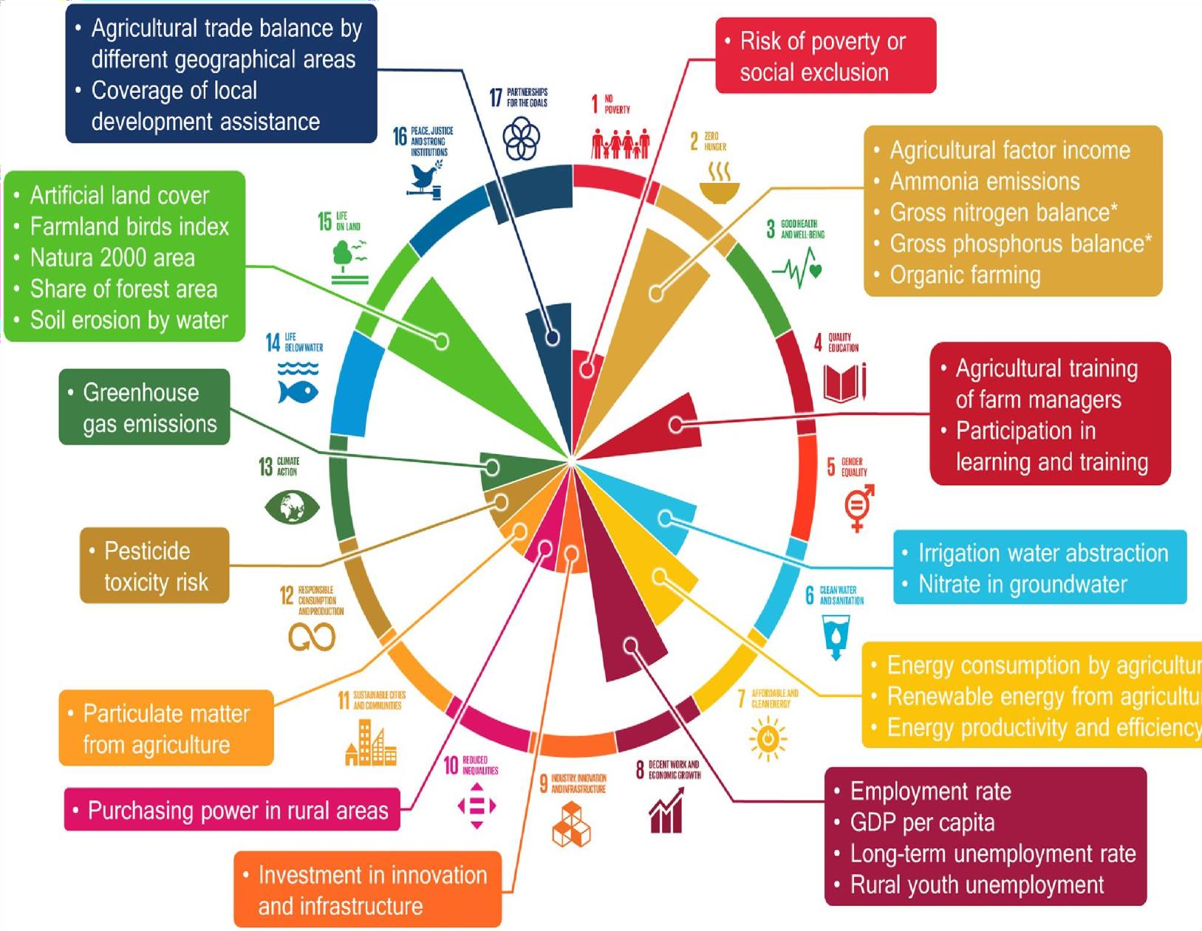
Social sustainability relates to the quality of life of those who work and live on the farm, as well as those in the surrounding communities. It includes ensuring equitable revenue or returns to different stakeholders of the agricultural production chain. In the context of high unemployment, sustainable agriculture can promote sharing of agricultural value added by more members of the community through more extensive use of available
labour, at least for some techniques, thus contributing to social justice and cohesion. Fair treatment of workers and choosing to purchase supplies locally

rather than from more distant markets are also elements of social sustainability. Although the above-mentioned elements are often discussed separately, they are not mutually exclusive: sustainable agriculture meets environmental, economic, and social objectives simultaneously. In many cases, sustainable agriculture practices are not new, but draw on traditional knowledge and practices, many of which have now been positively evaluated by scientific methods.

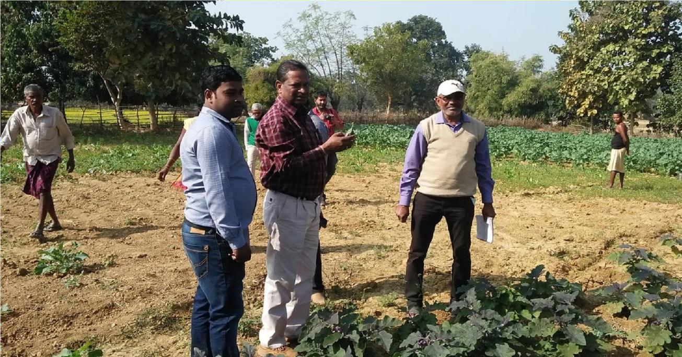

Sustainable agriculture, in a simple way, is “capable of maintaining productivity and usefulness to society indefinitely”. In other words, it is resource-conserving, socially supportive, commercially competitive, and environmentally sound. Under the law, the term sustainable agriculture means an integrated system of plant and animal production practices having a site specific application and such a system over the long term satisfies human food and fibber needs, enhances environmental quality and the natural resource base upon which the agricultural economy depends, makes the most efficient use of non-renewable resources and on-farm resources and integrate, where appropriate, natural biological cycles and controls, sustain the economic viability of farm operations and enhance the quality of life for farmers and society as a whole.

Therefore, sustainable agriculture does not mean a return to either the low yields or poor farmers that characterized the 19th century. Rather, sustainability builds on current agricultural achievements, adopting a sophisticated approach that can maintain high yields and farm profits without undermining the resources on which agriculture depends.
Sustainable agriculture refers to the ability of a farmland to produce food perpetually. It involves two key issues long-term effects of various practices
on soil properties and processes essential for crop productivity, and the long- term availability of inputs. Sustainable agriculture integrates three main goals environmental health, economic profitability and social economic
equity. A variety of philosophies, policies and practices have contributed to these goals. People in many different capacities from farmers to consumers have shared this vision and contributed to it.

Sustainable Agricultural Practices

There are many soils conservation best management practices that have been developed over the years. Methods for conserving are mostly directed at conserving the soil. Some of these falls under a general classification called conservation till-age. Strip-till, Ridge till, and No till are a few three of them that are discussed below.

- Strip Tillage: In this method we have specialized equipment that tills as small strip of the soil, not the whole breadth of the soil. The refuse from the previous crop is kept on the surface of the soil. But in some situations, we need to till and loosen the soil to attain better seed soil contact for improved germination.

· Ridge tillage: It is a variation of strip tillage where we actually are building slight, small ridges or hills across the field that we are going to plant into
.Again; this method relies on leaving the refuse from the previous crop on the surface.

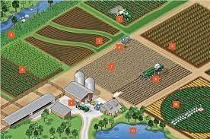

- No-till: As the word indicates we do not till the soil in preparation for planting. Here the crops are planted directly in the refuse from the old crop. No-till takes special equipment rather heavy equipment to cut through the refuse, particularly if it's something like corn. So, that you can cut through that refuse and open up a seed furrow for the seeds to be deposited in.

This leaving the refuse on the, on the surface helps conserve moisture and prevents in many, many ways wind blowing of the sand, and it adds organic matter to the soil. There are some other conservation best management practices that farmers use, such as:

- Grassed waterway: Here grasses are planted in a depression going across the field and in this depression is where the runoff mostly is captured from this field. And if we plant grasses in this waterway then we can slow down the water for one thing and prevent or minimize erosion. As we slow down the water, we give it a chance to infiltrate it into the soil. And also, those plants if they're actively growing, they can take up nutrients that might be in that runoff. So grassed waterways is a very important way to conserve soil and many other things like nutrients and water.
- Filter strip: Filter strips are typically areas of plants, maybe grasses that are planted along the edge of a field between the fields that we're growing crops and say, a stream or a pond. And the idea is that, as runoff moves from the

field towards the stream or water body, it passes through this filter strip and can be filtered.

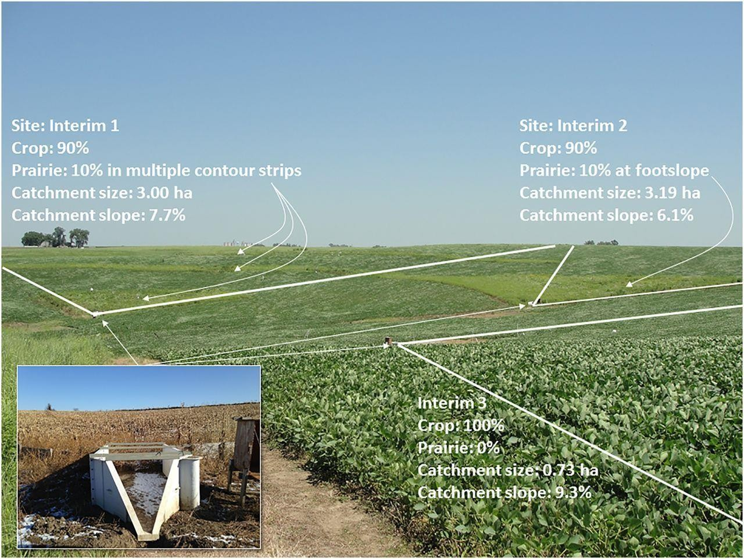

Sediment falls out and is collected in the filter strip, and the plants in the filter strip can take up nutrients and keep the sediment and nutrients from entering the water body. Filter strips and grassed waterways have several advantages. They slow down the water flow, slow down the speed, and so, erosion is greatly reduced and that gives time for the water to infiltrate into the soil. The plants can hold the soil in place and those plants can take up nutrients.

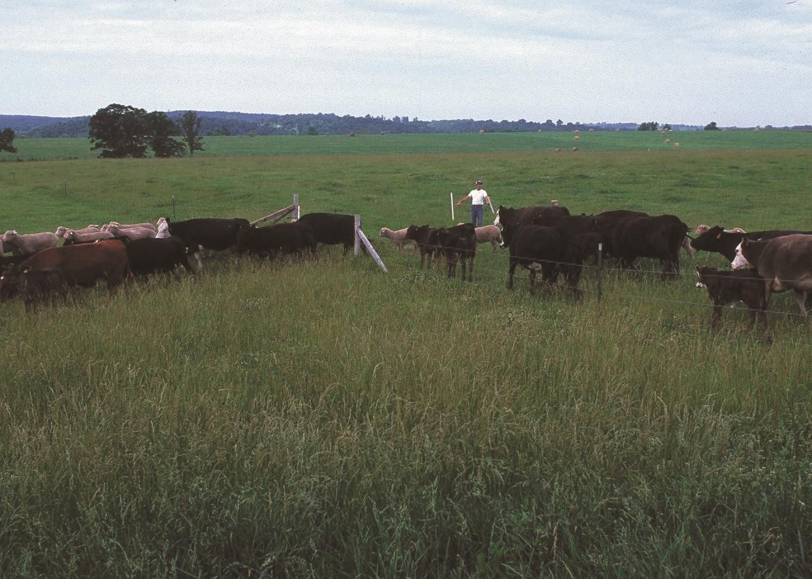

Achieving Sustainability

The whole idea about sustainability is about understanding some of the basics of our biological world, and our physical world, and how things work together. For example, understanding the nutrient cycles, how things go between the physical and the chemical world to the biological world in our cropping systems. And then determining how to take advantage of the knowledge and the research so that we can better put together best management practices and have tactics that farmers can adopt that will help them manage the nutrients and the water in their farming systems. Many farmers are already doing this some to a great degree, but there are also a lot of other farmers in this country and around the world who are still in need of assistance in understanding and adopting nutrient and water best management practices. Technology has been important along the way. If you look back over agriculture development and our increases in our ability to produce food, technology has played a large role and will continue to play an important role. However, with increasing advancement in technology for

producing more extensive farming methods, organic farming is overtaking these methods. While organic systems produce only 92% of the yield produced by conventional agriculture in developed countries, they produce 80% more than conventional farms in developing countries. Organic methods could produce enough food on a global per capita basis to sustain the current human population, without putting more farmland into production. Leguminous cover crops could fix enough nitrogen to replace the amount of synthetic fertilizer currently in use. These are some sustainable practices which have played substantial roles in yield increases:

- More efficient water uses in both dry land and irrigated farming.

- Improvements in organic matter accumulation in soils and carbon sequestration; and

- Pest, weed, and disease control emphasizing on-farm biodiversity and reduced pesticides through integrated pest management or other techniques.

Farming practices relevant for soil protection, conservation and
improvement; their uptake and related environmental objectives

SoCo focused its review on two specific farming systems, namely conservation agriculture and organic farming, along with a range of farming practices. The review considered their impact on soil quality and assessed, as far as possible, the uptake and benefit-cost effects in a broader sense.

No-tillage and reduced tillage, in combination with permanent soil cover (cover crops, crop residues) and crop rotation, are essential practices in conservation agriculture. These practices minimise the risk of soil degradation by increasing the organic carbon stock, thus improving biological activity, soil fertility, soil structure and the water-retention capacity of soils. As a consequence, soil erosion and nutrient runoff are reduced (with positive effects on water quality), and soil resistance to compaction is improved. In addition, significant cost savings with respect to labour and fuel consumption are reported. Nevertheless, switching to conservation agriculture might require significant capital investment (for example, in sowing equipment) and greater attention in the use of chemicals for weed control. Within the EU-27, Finland and Greece show the highest

uptake of no-tillage (more than 4.5 % of total arable land), while reduced tillage is practised on 40 to 55 % of the arable land in both Finland and the UK. Furthermore, conservation agriculture is a complex, site-specific farming system, requiring training of farmers and adaptation to local circumstances before maximum economic benefits can be obtained.

Organic farming, although different from conservation agriculture, has similar positive effects on soil organic carbon content and soil biodiversity. Energy consumption is reduced and beneficial effects are reported on water quality, in particular with respect to pesticides (which are strictly limited in organic farming), and on above-ground biodiversity (in particular species abundance and/or richness) and landscape. Net returns depend on yields, with some variation according to the crops. Over the period 1998-2005, the area under organic farming (including conversion areas) certified under Regulation (EEC) 2092/91 increased by 130 % in the EU-15, and by 2005 it amounted to 4 % of the total utilised agricultural area in the EU-25.

SoCo further reviewed the following specific farming practices: ridge tillage, contour farming, subsoiling, intercropping, grassland establishment and maintenance, agroforestry, buffer strips, and terracing. They were selected because of their potential to remedy soil degradation processes.

For example:
- ridge tillage has positive effects on moisture-holding capacity, soil fertility maintenance and biological activity, and thus on water erosion and nutrient run- off
- contour farming increases the soil’s infiltration capacity, may have positive effects on soil organic carbon content and results in controlling water and tillage erosion
- subsoiling has a beneficial effect on infiltration rate and capacity, but shows variable effects on nutrient cycling
- terracing has beneficial effects on infiltration rate and capacity, and thus on controlling water erosion.

The information derived from the literature review afforded some
insight into the cost and benefits of some of the practices, but on a case-by- case basis only. All studies reviewed clearly confirm that farming practice

impacts are site-specific, which prevents extrapolation to the European level. Nevertheless, two examples are worth mentioning. Buffer strips lead to a retraction in the productive area and investment in Executive summary 20 their establishment (seeding, planting). In return and depending on local conditions, they may replace or reduce the need for other nature restoration activities, in addition to mitigating the negative impacts of soil erosion and thus helping to improve the quality of watercourses. Cost-benefit analyses of terracing need to take social factors into account, since there is evidence that underlying trends in the socio-economic structure of the agricultural population have been leading to the abandonment of terraces and many authors report adverse effects of terracing once they are badly maintained or even abandoned.

Synthesis of land management practices and policy measures at regional level: case studies

In order to reach a sufficiently detailed level of analysis and to respond to the diversity of European regions, a case study approach was applied. Ten case studies were carried out in Belgium, Bulgaria, the Czech Republic, Denmark, France, Germany, Greece, Italy, Spain and the United Kingdom between spring and summer 2008. The results of the case studies were elaborated and fine-tuned through discussions at five stakeholder workshops (June to September 2008), which aimed to interrogate the case study findings in a broader geographical context. While the results of case studies are rooted in the specificities of a given locality, the combined approach allowed a series of broader conclusions to be drawn.

The selection of case study areas was designed to capture differences in soil degradation processes, soil types, climatic conditions, farm structures and farming practices, institutional settings and policy priorities. A harmonised methodological approach was pursued in order to gather insights from a range of contrasting conditions over a geographically diverse area.

The synthesis focused on the main soil degradation processes encountered in each case study area:
- water erosion, which is closely linked to compaction and loss of soil organic matter, is a major issue in all case study areas, with the exception of
the Bulgarian case study. Both organic matter decline and compaction

are experienced to a moderate or severe degree in all case study areas.
- diffuse contamination (especially excess of nutrients) is of particular importance in more intensively farmed areas such as the Belgian case but is also observed in other case study areas; and

- soil salinisation, which although a specific problem in the Bulgarian and Spanish case study areas, can be very severe wherever it occurs.

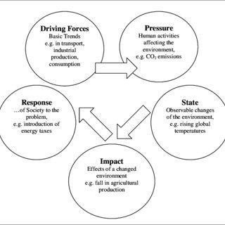

Comparing these results to the EU-wide stock-taking exercise, it is clear that these dominant degradation processes are not necessarily representative of the EU in its entirety. Other reported soil degradation processes include wind erosion, acidification (which is particularly problematic in eastern Europe) and soil sealing. Pressure arising from livestock farming, particularly nutrient loading from intensively stocked farms, was noted in some case studies and in the workshops and is also well documented elsewhere in Europe.

There is considerable physical and spatial variability in the soil degradation processes analysed, which are not uniform even within relatively small areas. This is because the nature and extent of a degradation process is

typically influenced by two interacting elements, namely the physical, environmental conditions in a given locality and the farming practices adopted.

The case studies further identified some of the complex causal chains between factors that shape the adoption of different farming systems and practices, and the ultimate impacts on agricultural soils. Some drivers are economic, such as agricultural commodity prices and energy prices; others are socio-cultural and technological, such as the trend towards using larger and heavier machinery to increase the efficiency of field operations.

Certain farming practices are compatible with good soil
management in one location but not necessarily in another. That said, it is helpful to divide practices into those that are broadly beneficial and those that are generally inappropriate. Beneficial practices are those that are well
adapted to local environmental and agronomic conditions, but also ones that serve to alleviate the risk. Inappropriate Final report on the project
‘Sustainable Agriculture and Soil Conservation (SoCo)’ 23 practices contribute to soil degradation, primarily on the farmer’s own land, but almost always have offsite impacts too.

Within the case study areas, there was a wide range of farming practices being used to protect, maintain or improve soil quality. Certain practices were associated with a particular type of farming system, some were pertinent only to a certain soil type, whereas others crossed these boundaries and could best be categorised as addressing a specific soil
degradation process. Most of the promising practices for the sustainable management of agricultural (mostly arable) soils, however, were not consistently adopted. Adoption was impeded by a number of barriers,
including technical factors such as the lack of adequate machinery and infrastructure, or the shortage of adequate information for farmers,
economic factors including the costs of new machinery and the risk of
income loss during transition periods, and because policy measures have not been appropriately targeted.

In addition, the case study interviews suggested that farmers were usually aware of the challenges but did not necessarily regard them as pressing. They did not express marked concerns about likely future effects of soil degradation processes. In this respect, the case studies

corroborated evidence from the impact assessment for the Soil Thematic Strategy and additional literature about the causes and drivers of soil degradation processes.

In most cases, stakeholders saw a mix of policy measures, combining voluntary incentive-based measures, mandatory measures, advice and support, as the way forward. More coordination, targeting, technical support and stronger monitoring were considered priorities. It appears that, by embodying new requirements with the potential to address key soil conservation, cross compliance has raised awareness of soil conservation among farmers. Provision of incentives through Agri- environment measures was widely regarded as necessary to increase the adoption and development of certain practices, ideally helping to bring about a transition to more sustainable practices, with farmers adapting to higher standards and an enhanced level of responsibility for soil quality with time.

Lack of data on the precise levels of soil degradation in many areas and rather limited monitoring of the impacts of adopting specific farming practices emerged. This leaves uncertainties as to which practices, adopted under what circumstances, might be most appropriate and cost- effective. Robust evaluation of policy impacts on soil conservation appears even scarcer.

Learning Outcomes

  - Learned how to effectively plan agricultural production and rotation systems, maintain and use records, crop enterprise budgets for decision making in agricultural production and marketing.
  - I gained an understanding of the current social, economic and technical challenges and opportunities in sustainable food production.
  - Developed an appreciation for the impacts of agricultural on natural resources, energy, environment, and climate change and some solutions for these issues.

  - Understood and applied scientific concepts and practices based on the scientific method and laboratory methods.
  - Become familiar with diverse field, nursery, and processing equipment, sampling techniques, and related data compilation and analysis.
  - Understood the scientific principles regarding soil physics, chemistry, and biology as it relates to fertility management, plant health, and food quality.
  - Developed a sound understanding of fundamental plant science, including taxonomy, physiology, plant propagation and horticultural practices as it applies to sustainable production.
  - Became familiar with crop protection using cultural, biological, and organic practices to prevent and manage weeds, diseases, and pests.

Conclusion

Sustainable development is largely about people, their well-being, and equity in their relationships with each other, in a context where nature- society imbalances can threaten economic and social stability. Because
climate change, its drivers, its impacts and its policy responses will interact with economic production and services, human settlements and human societies,
climate change is likely to be a significant factor in the sustainable development of many areas (e.g., Downing, 2002). Simply stated, climate change has the potential to affect many aspects of human development,

positively or negatively, depending on the geographic location, the economic sector, and the level of economic and social development already attained. Because settlements and industry are often focal points for both mitigation and adaptation policymaking and action, these interactions are likely to be at the heart of many kinds of development-oriented responses to concerns about climate change.

Impacts of climate change on development paths also include impacts of climate-change response policies, which can affect a wide range of development-related choices, from energy sources and costs to industrial competitiveness to patterns of tourism. Areas and sectors most heavily dependent on fossil fuels are especially likely to be affected economically, often calling for adaptation strategies that may in some cases require assistance with capacity building, technological development and transition financing.

References

https://www.coursera.org/learn/sustainable-agriculture

- George J. Hochmuth, Ph.D., Soil and Water Science Department, College of Agricultural and Life Sciences, Institute of Food and Agricultural Sciences, University of Florida.

- Sustainable Development, Innovation Briefs, Issue 7, May 2009.

- Bairagya Ramsundar, Journal of Economics and Sustainable Development, Population Growth and Sustainable Land Management in India, ISSN 2222- 1700, Vol.2, No.10, 2011, Page no.21

