SHASHI KUMAR B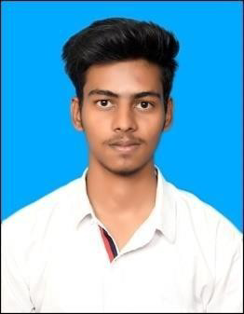

+91 6362449175 | [shashikumarb29@gmail.com](mailto:shashikumarb29@gmail.com) | [Github](https://github.com/Shashikumar216?tab=repositories) | [MyPortfolio](http://my-portfolio-dusky-rho-75.vercel.app/)

# SKILLS

* Proficient in **Hardware & Network**, **HTML**, **CSS**, **JS, C++, UI & UX**
* Experience with **MS office, SQL**, **Git** and **GitHub**
* **Team work and Collaboration, Adaptability and Learning**

# PROJECTS

AUGMENTED REALITY [AR] ARCHITECTURE VISUALIZATION APP

* + Developed an innovative mobile application for the construction industry, integrating Building Information Modelling (BIM) with Augmented Reality (AR) technology.
  + Leveraged **Unity game engine, C#** and **Vuforia SDK** to enable **marker-based tracking**

and seamless integration of **3D architectural models**.

* + The app allows for immersive 3D model visualization, and enhanced collaboration among architects, builders, and stakeholders.

SPORTS E-commerce Website

* + Utilized **HTML, CSS**, and **JavaScript** to create a fully functional **e-commerce platform**,
  + Integrated **JavaScript** to enhance user experience by adding interactive elements such as product filters, shopping cart functionality, and smooth transitions.

# EDUCATION

## BALLARI INSTITUTE OF TECHNOLOGY AND MANAGEMENT

BE in Computer Science 2021 – 2024 | **7.62 CGPA**

## GOVERNMENT POLYTECHNIC BALLARI

Diploma in Computer Science

2018 – 2021 | Percentage – **64.47%**

## ST. JOSEPH’S BOYS HIGH SCHOOL, BALLARI

SSLC 10th

2008 – 2018 | Percentage – **77.12%**

# LANGUAGES HOBBIES PERSONAL DETAILS

| * English | * Drawing | Date of Birth | : 21-02-2003 |
| --- | --- | --- | --- |
| * Kannada | * Cycling | Nationality | : Indian |
| * Hindi | * Reading Books | Address | : #175/B Ward 28, Azaad Nagar, |

Cowl Bazaar, Ballari-583102