These are the statements which are used to control the flow of the execution by some conditions
Conditional statements :
1) Simple if :- It is the type of conditional statement that executes True statement block if the condition is True
Syntax :
If condition :
True statement block
Diagram :
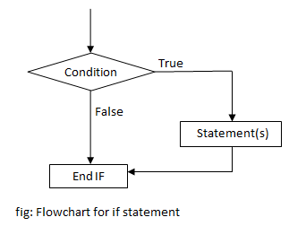
Q1)
Num=int(input('Enter the number'))
if(Num%2==0):
print(Num**2)

q2)
Str='aeiouAEIOU'
charr=input('enter the char')
if(charr in Str):
print('Its a vowel')

Q3)
CHAR=input('Enter the Char')
if(CHAR.isupper()):
print(ord(CHAR))
Q4)
Num=int(input('Enter the number'))
if(Num%9==0 and Num%3==0):
print(Num*Num*Num)
q5)
Num=int(input('Enter the number'))
if(Num>99 and Num<1000):
print('Its a 3 digit Number ')
Q6)
Num=int(input('Enter the number'))
if(Num%10==5):
print('This number have the last digit 5')
q7)
i=eval(input('enter a value:'))
if type(i) is float :
print('Its a float')

q8)
data=eval(input('Enter the data :'))
if type(data) in [int,float,complex,bool]:
print('It is the single value data')

q9)
a=eval(input('Enter the Str'))
if type(a) is int :
print( "is the Digit")
10)
Num=int(input('Enter the number'))
if(Num%3==0):
print('Its a multiple of 3')

