If- else
It will execute true statement block if the condition is True , Otherwise if will execute false statement block
Syntax and flow:
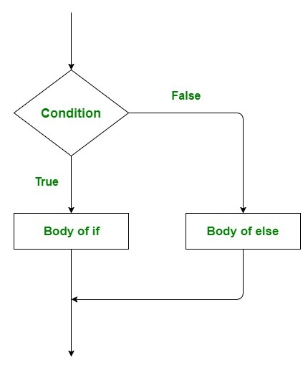

Q1) WAP to check wheater the data is mutable or not
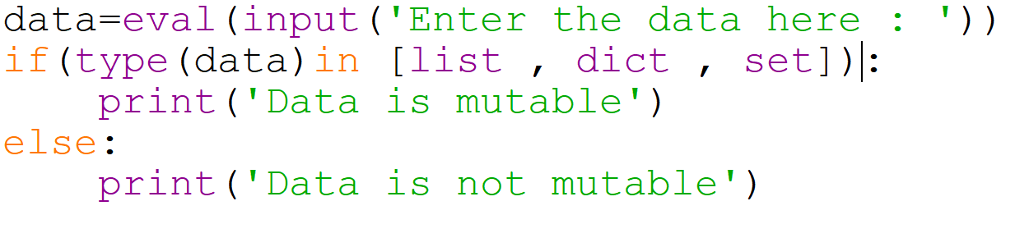
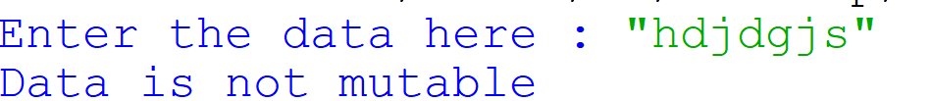
Q2) WAP to check whether the given character is digit or not
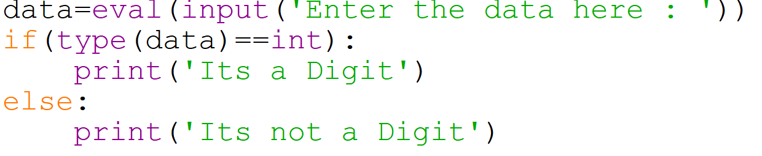
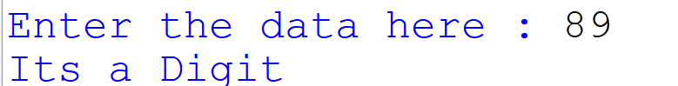
Q3) WAP to check wheather a char is special or not

