ROCK, PAPER, SCISSORS
TOURNAMENT SYSTEM
Project Report
Project: RPS Tournament System
Faculty Guide: Dr. Anjum Mansuri
Div : H
Roll No.: B08
Enrollment No.: 240004501210085
Name: Tarun Gadhvi
This report documents the key features implemented and tested in the RPS Tournament project, with screenshots and brief explanations of the work demonstrated.

1. Project Overview
The Rock, Paper, Scissors (RPS) Tournament System is a menu-driven Bash application developed in an Ubuntu Linux environment. It supports multi-round tournaments and single-round games, generates computer choices, determines outcomes, and presents match summaries. Supporting features include CSV-based match history, statistics, compressed backups, activity logging, and scheduled execution through cron.

2. Project Structure and Components
The project separates the main menu and application flow from reusable shell functions and data files. The main.sh script launches the application, while the lib directory contains function scripts. The data directory stores match and round records, logs stores activity information, and backups holds compressed snapshots.
A README.md provides project-level documentation.
3. Screenshots and Implementation Notes
Each screenshot below is followed by a short explanation of the feature or project activity it demonstrates.

Screenshot 1: Tournament Game — Five-Round Match
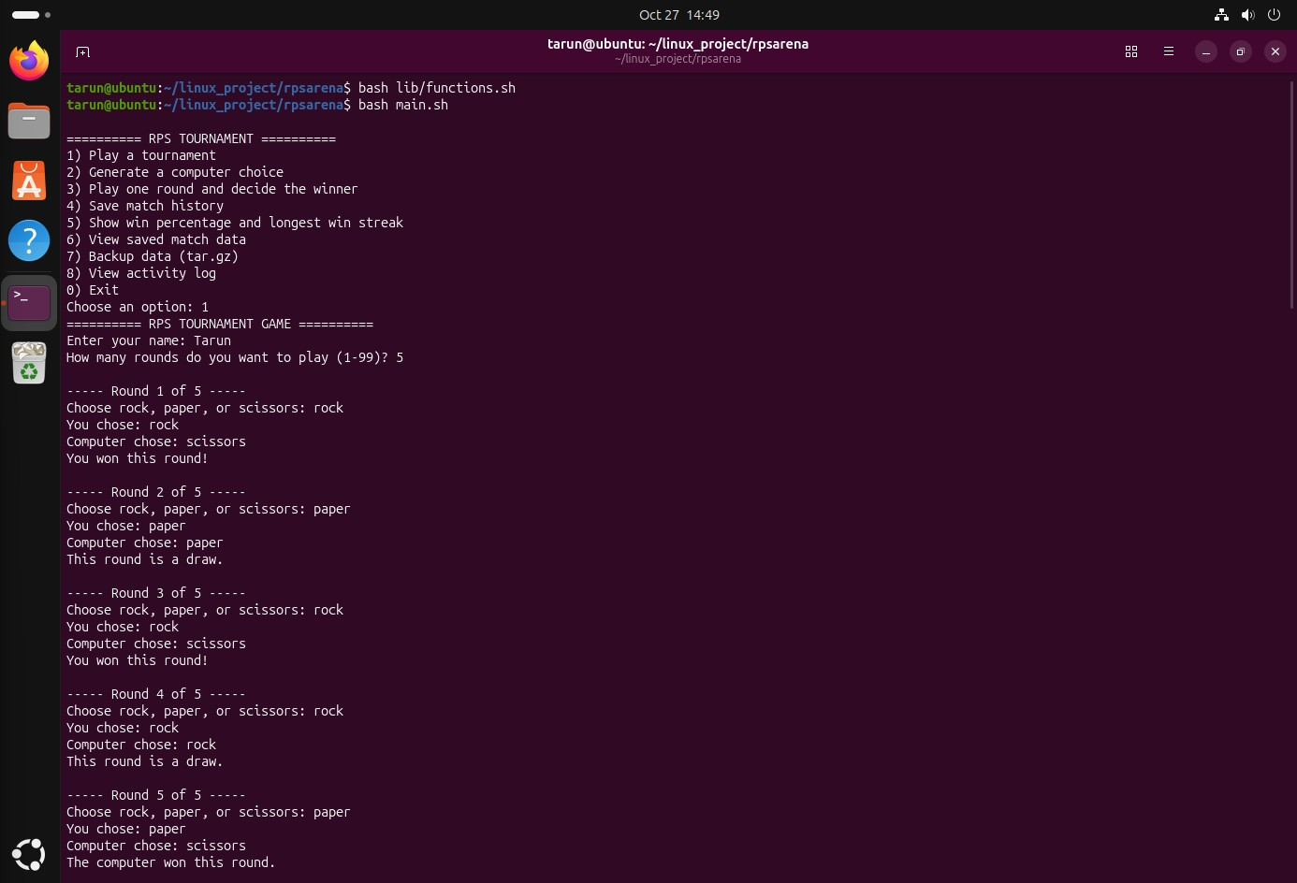
The main tournament option was tested by entering the player name and selecting five rounds. The program accepted rock, paper, and scissors inputs and generated a computer move for each round. It correctly reported round outcomes and displayed a final match summary with wins, losses, and draws.

Screenshot 2: Saving Match History
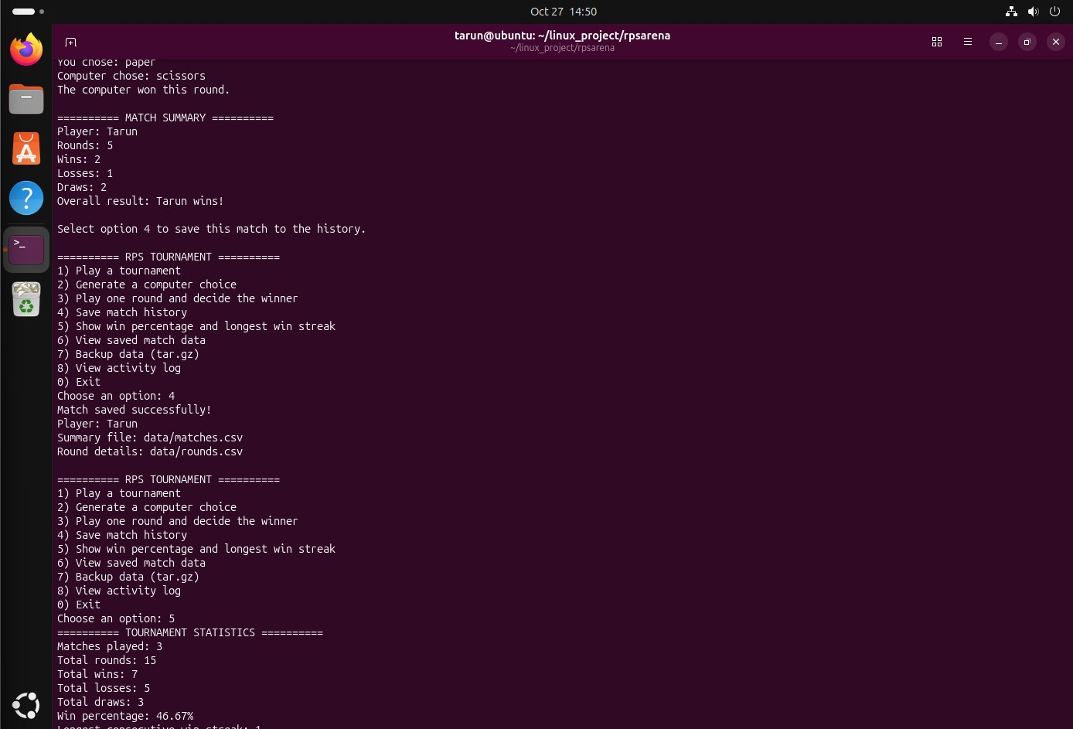
After the tournament, option 4 was used to save the result to the project’s history files. The application confirmed that the match was saved and identified the summary and round-detail CSV files. This demonstrates persistent storage of match-level and round-level results.

Screenshot 3: Statistics and Match History
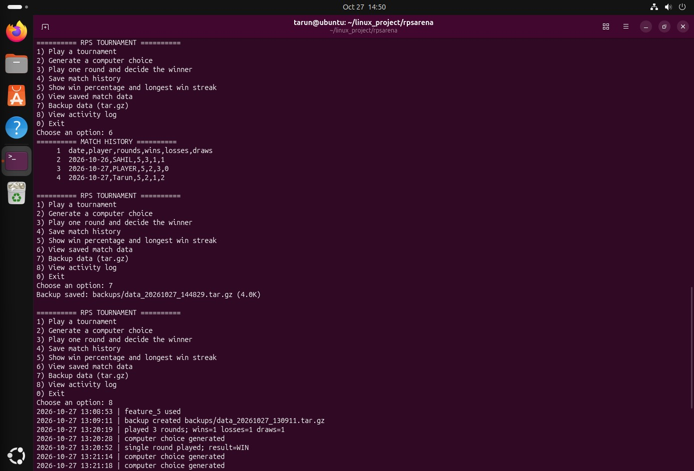
The statistics screen calculated totals across saved matches, including rounds played, wins, losses, draws, and win percentage. The history screen displayed saved records with dates and player names. These features make it possible to review past games and measure performance.

Screenshot 4: Backup and Activity Log
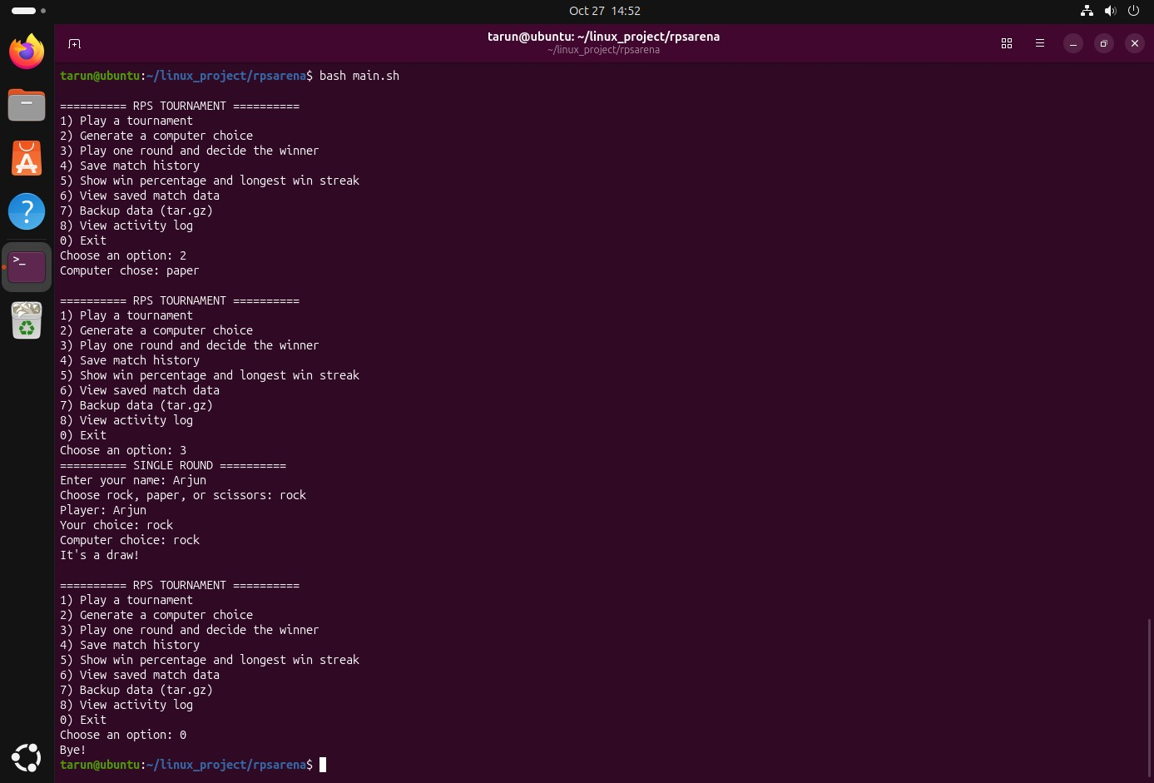
The backup feature created a compressed TAR.GZ archive in the backups directory. The activity log recorded timestamped events such as computer-choice generation, games played, and backup creation. Together, these functions support data recovery and basic project auditing.

Screenshot 5: Single-Round Game
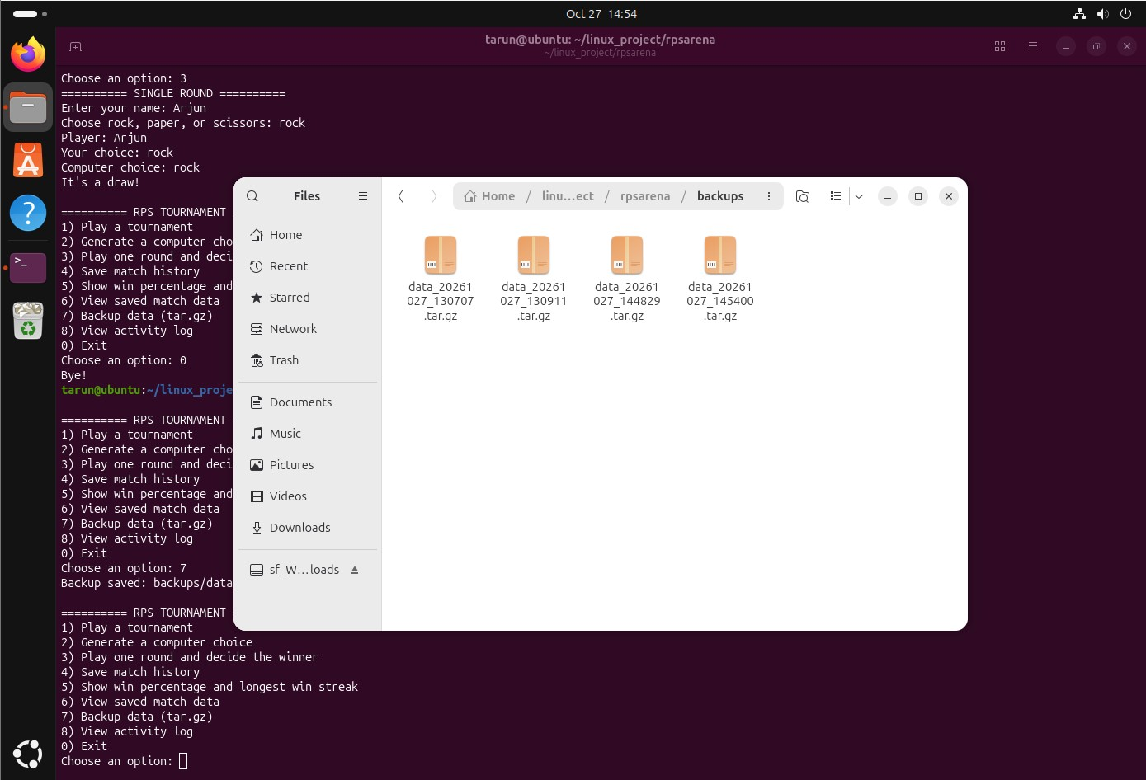
The single-round option was tested separately from the multi-round tournament. A player name and move were entered, the computer generated its choice, and the program correctly identified the result as a draw when both selected rock. This confirms the standalone round flow works.

Screenshot 6: Backup Files in the File Manager
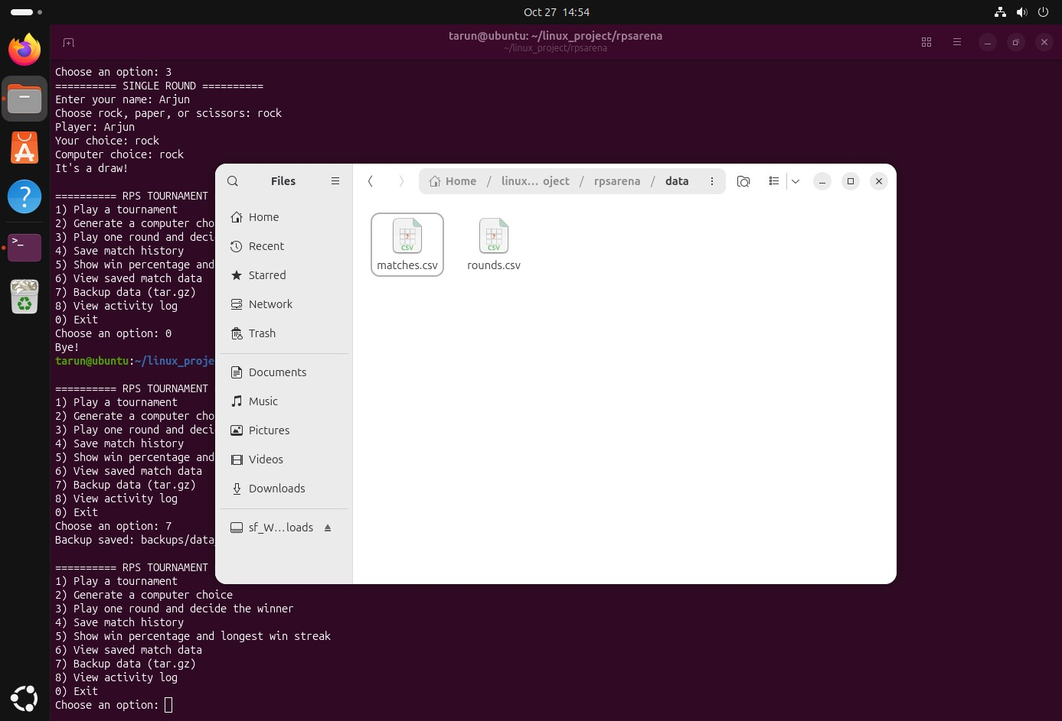
The file manager view shows multiple timestamped backup archives in the backups folder. Keeping separate archives allows earlier data snapshots to be retained. The screenshot provides visible evidence that backup files were generated by the application.

Screenshot 7: Project Data Files
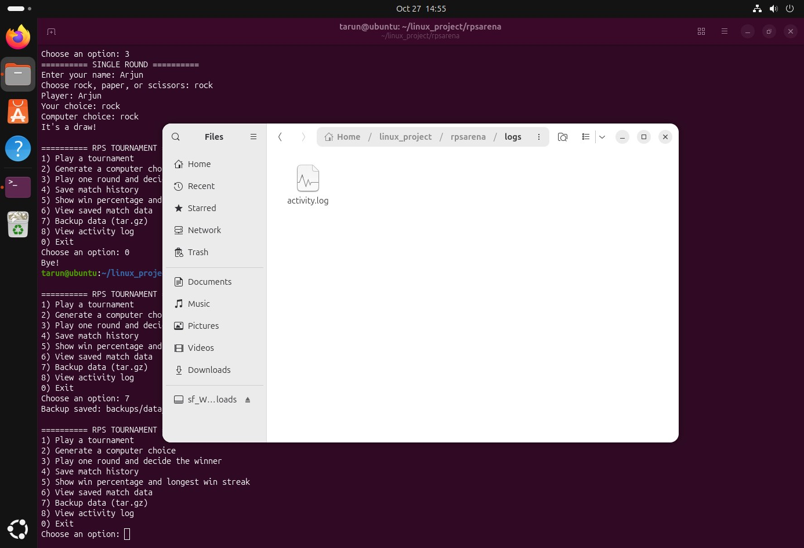
The data directory contains matches.csv and rounds.csv, which separate match summaries from individual round details. This structure keeps the records organised and makes them easier to inspect or use for reporting. The CSV files also provide a simple, portable storage format.

Screenshot 8: Activity Log File
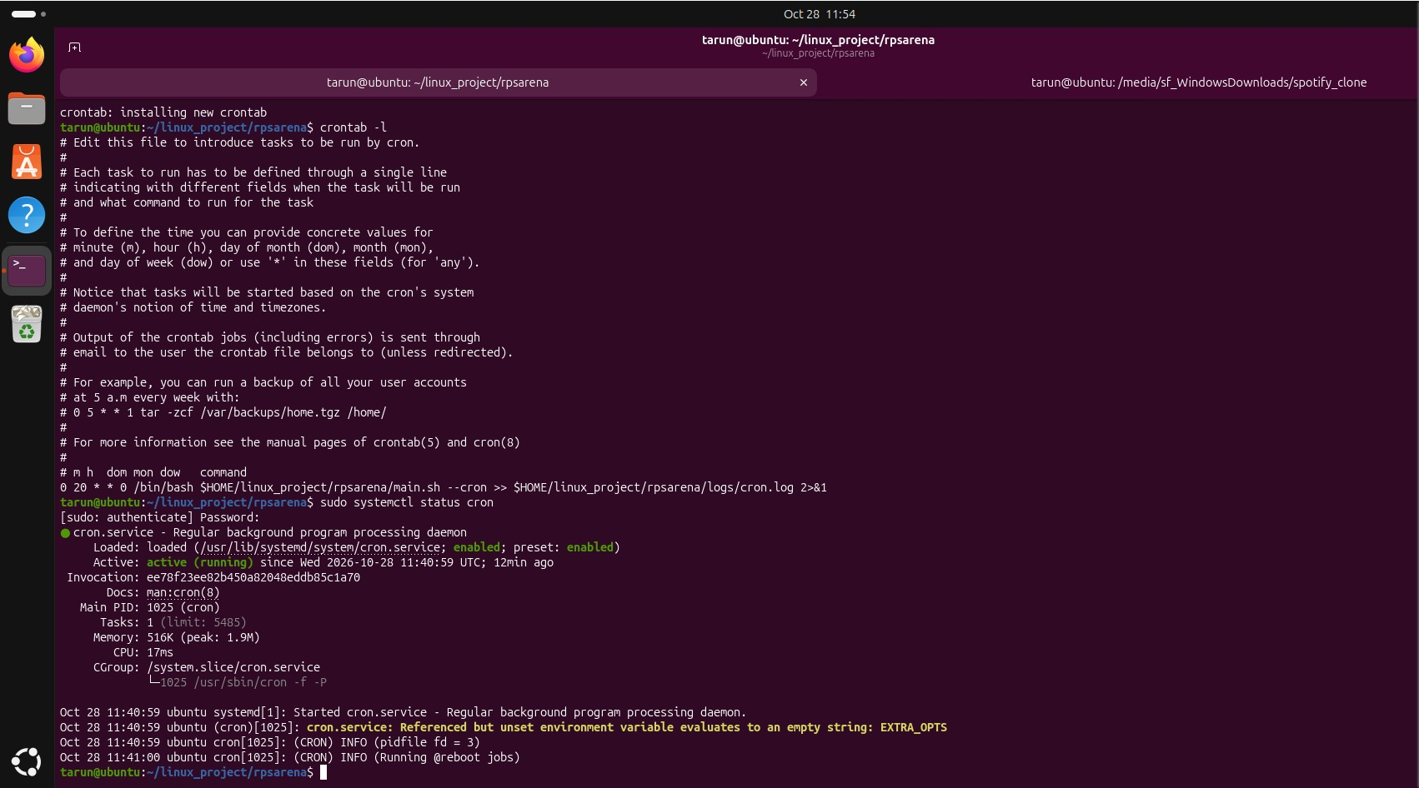
The logs directory contains activity.log, the file used to record important application events. The terminal output shows that the log includes timestamps and descriptions of actions performed during testing. This supports troubleshooting and helps demonstrate what happened during a session.

Screenshot 9: Cron Job Configuration
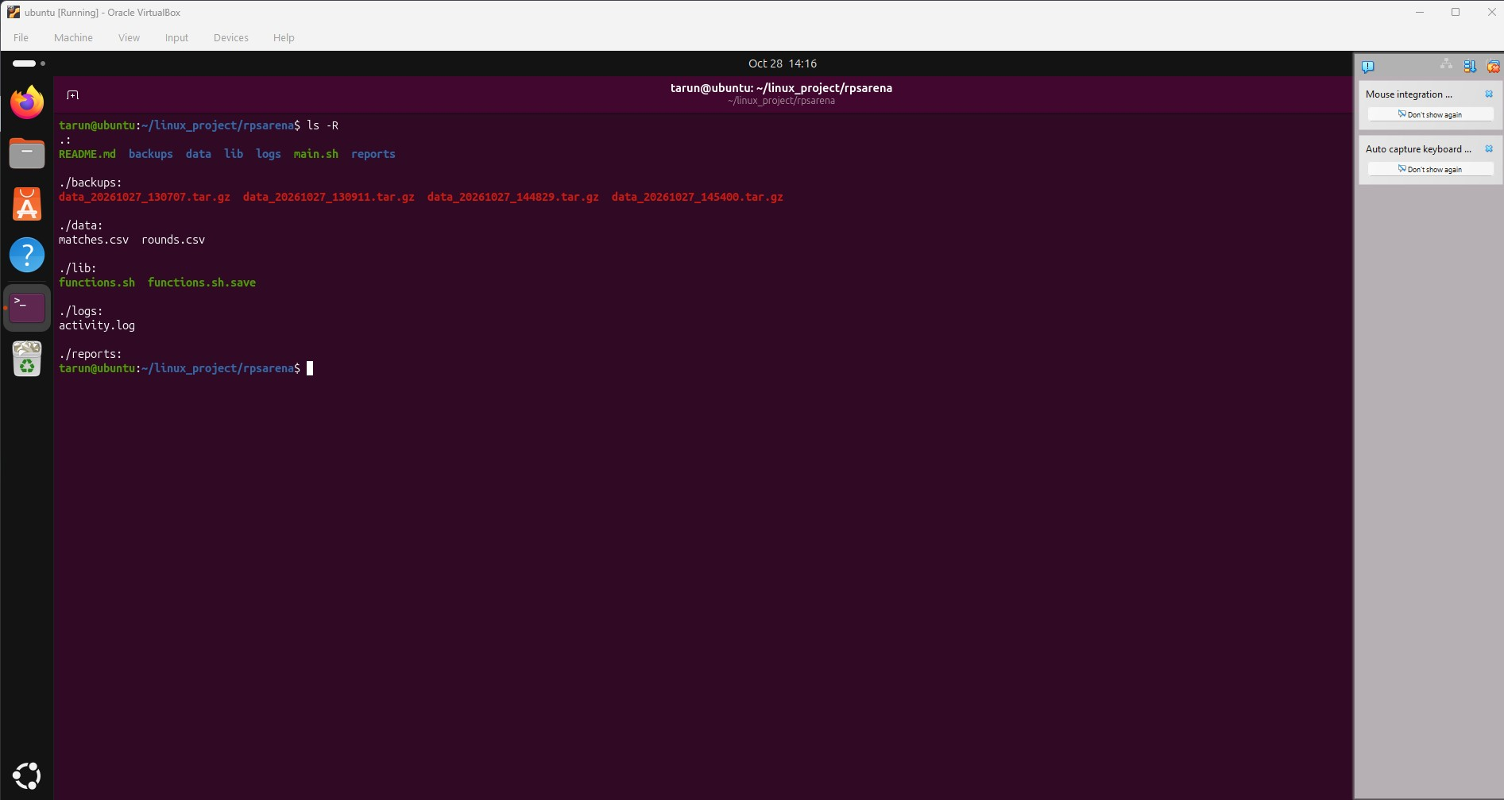
A user crontab entry was configured to run main.sh every day at 20:20, appending standard output and errors to logs/cron.log. The cron service status showed that the daemon was active and enabled. This verifies the scheduler is running, although the actual scheduled execution should also be confirmed by checking cron.log after the scheduled time.

Screenshot 10: Project Directory and Shell Files
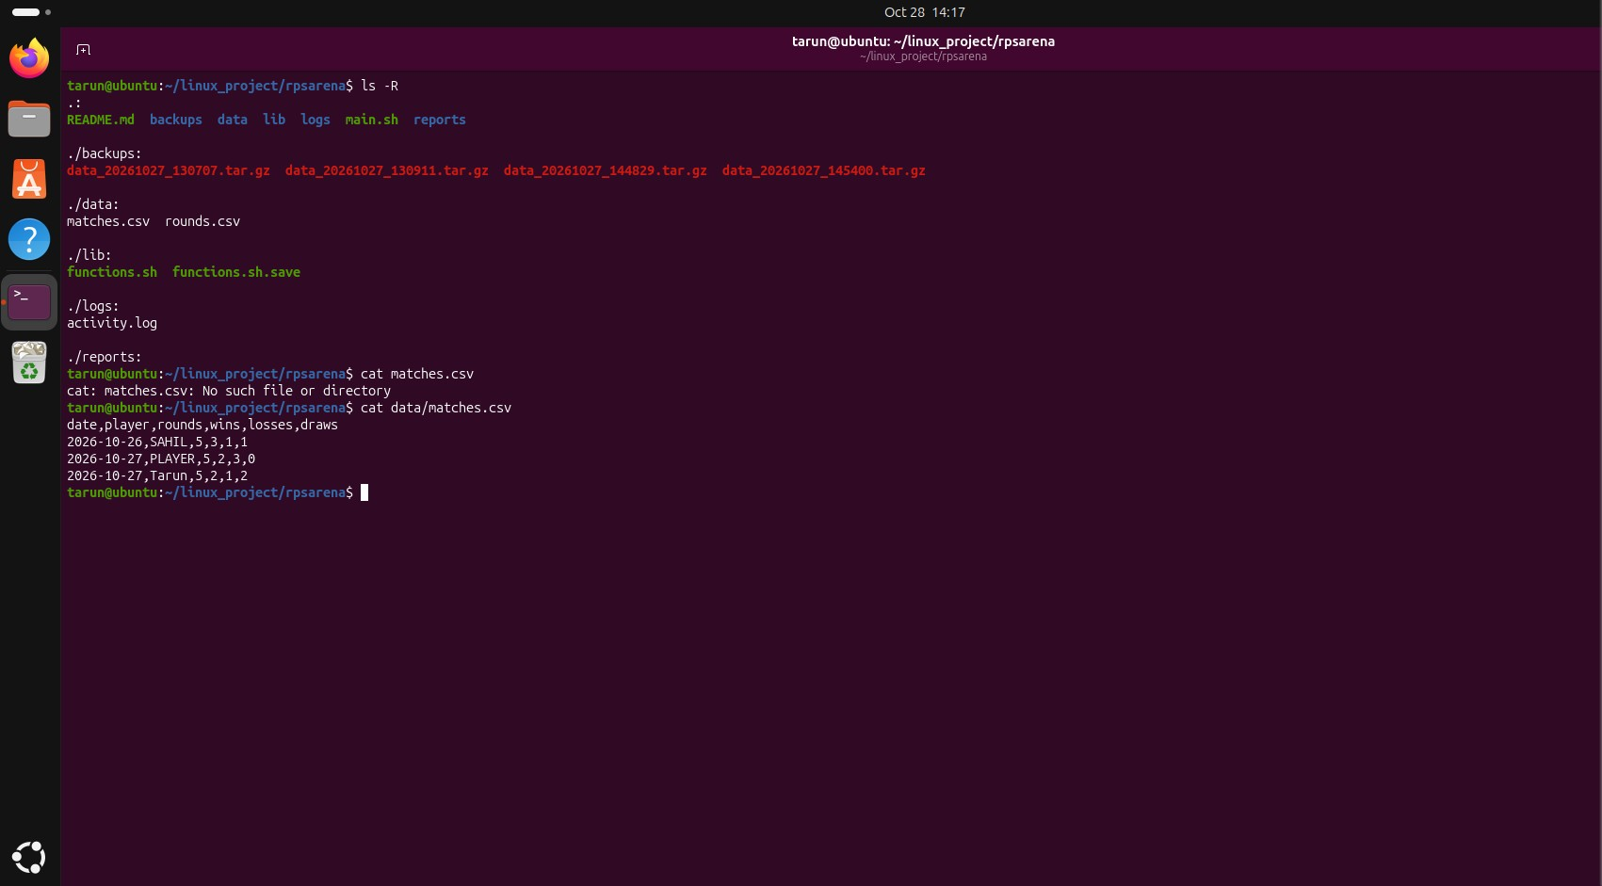
The project is organised into directories for backups, data, library functions, logs, and reports, with main.sh and
README.md at the root. The terminal listing confirms that the expected project structure exists. The shell scripts and supporting files keep game logic, saved data, and operational records organised.

4. Testing Summary
The screenshots provide evidence of successful testing of the main tournament flow, the single-round game, saving match history, viewing statistics, inspecting stored records, creating backups, and reviewing activity logs. The cron service is shown as active and enabled, and a daily schedule is present in the user crontab. To fully verify the scheduled job, check the output log after the configured execution time.

5. Conclusion
The project demonstrates practical use of Bash scripting and Linux tools to build a small interactive application with file-based persistence and system automation. It combines conditional game logic with CSV data management, logging, archiving, and cron scheduling. The implementation is organised into separate directories and includes visible test evidence for its principal features.
Note: This report describes only the features visible in the supplied screenshots. Any additional functionality should be verified against the actual source code before being claimed as implemented.

