**SURVEY ANALYSIS**

1. Which are the different activities in which you need to gather students who are interested in that activity?
2. Cultural Activities 65(62.5%)
3. Going for trip 80(76.9%)
4. Outdoor Playing 66(63.5%)
5. Searching representatives for various events. 37(35.6%)
6. Some kind of discussion 60(57.7%)
7. Study during exams. 48(46.2%)
8. Playing Computer Games 49(47.1%)
9. While going for movie. 62(59.6%)

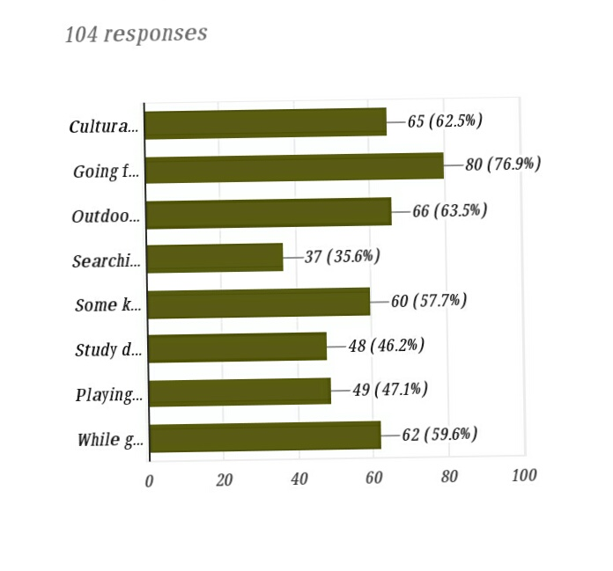

**Conclusion:**

1. How do you gather other colleagues (not from your near ones) for such activities?
2. Using Social Media 44.2%
3. Going Door to Door to each person 12.5%
4. Call Everyone 21.2%
5. Spread through your friends 21.2%
6. Others… 1%

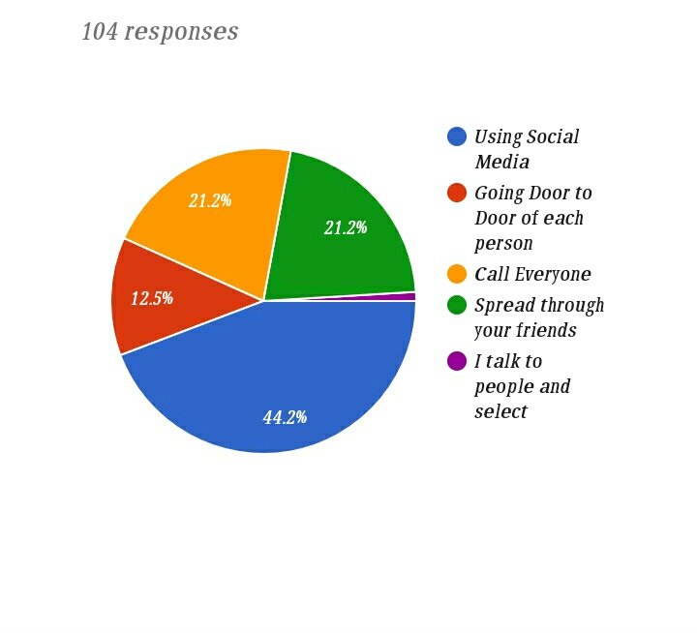

**Conclusion:**

1. Out of 10, how much difficulty you face in contacting and collecting interested people for such kind of activities?
2. - 1%
3. – 1%
4. – 6.7%
5. – 7.7%
6. – 17.3%
7. – 19.2%
8. – 27.9%
9. – 10.6%
10. – 5.8%
11. - 2.9%

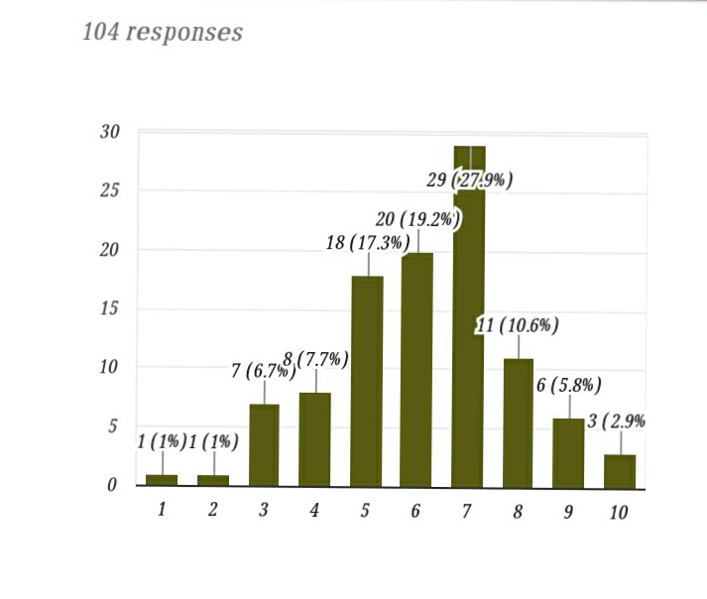

**Conclusion:**

1. On Average how much time (in minutes) does it take to contact and gather all the people?

**Conclusion:**

1. Would you appreciate mobile application which can reduce your efforts to just few seconds?

a) Yes 80.8%

b) No 18.3%

c) Maybe 1%

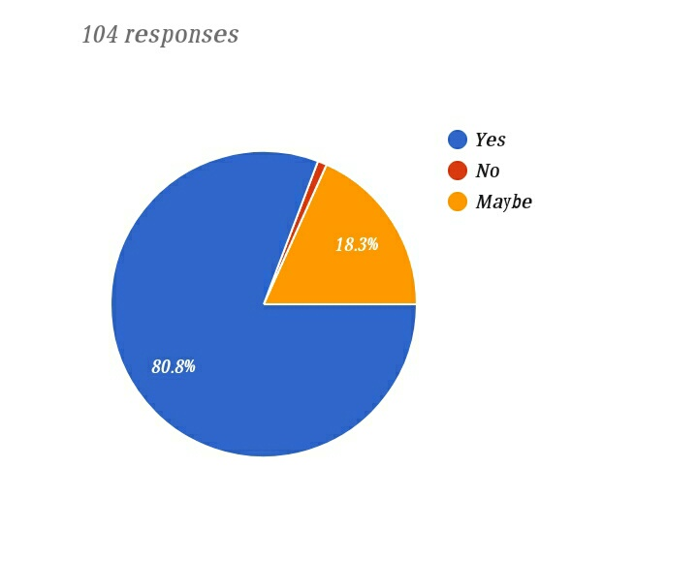

**Conclusion:**

**6)** How often do you need to gather people from nearby colleges (PDPU, GNLU etc)?

a) Never 46.2%

b) Very Few 46.2%

c) Frequently 4.8%

d) Most of the times 2.9%

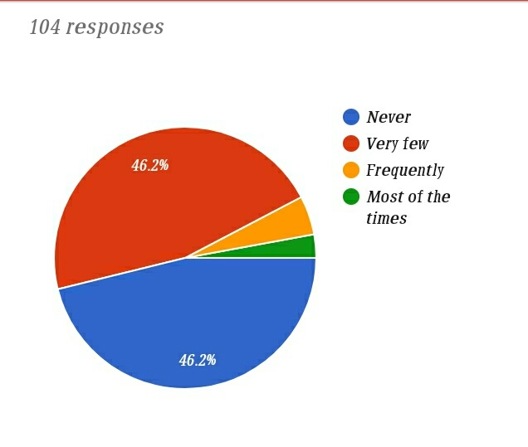

7) If you need people from nearby colleges also ,then these people can be:

a) Anyone interested 63.3%

b) Some selected people only 36.7%

**Conclusion:**

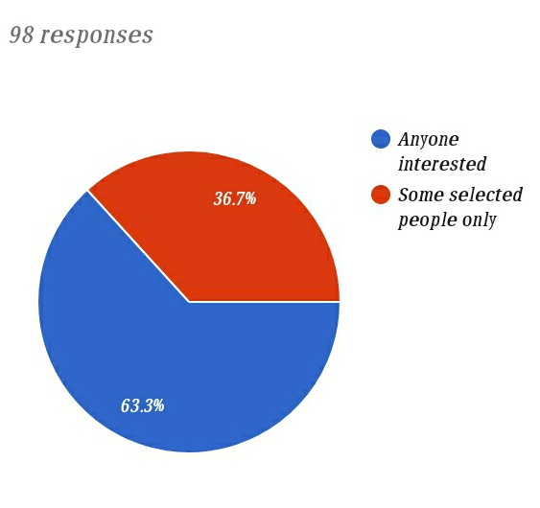

**Conclusion:**

**8)** Are you holding any position of any club (Sec/J. Sec) or Committee (Member)of our college?

a) Yes 73.1%

b) No 26.9%

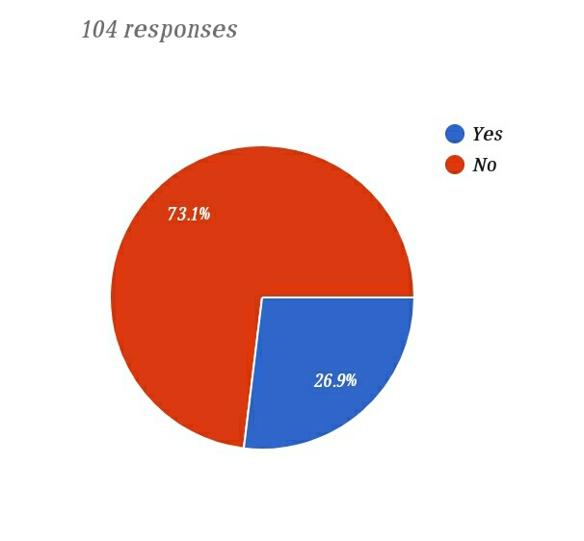

**Conclusion:**

9) How difficult it is to notify students for some Unofficial Events?

1 - 7.1%

2 - 21.4%

3 - 35.7%

4 - 32.1%

5 - 3.6%

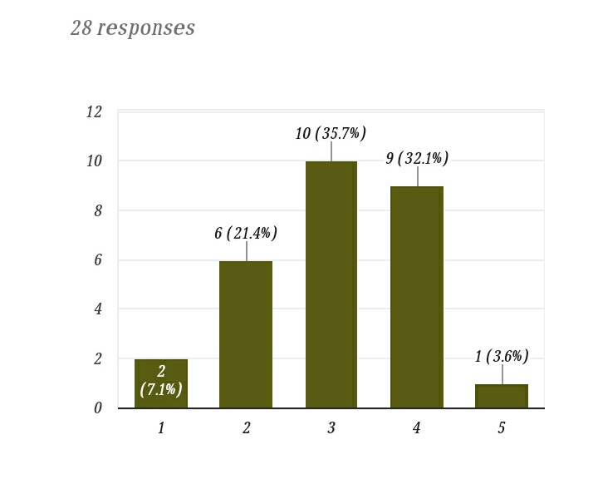

**Conclusion:**

10) How difficult it is to find Volunteers for any events?

1 - 0%

2 - 17.9%

3 - 32.1%

4 - 35.7%

5 - 14.3%

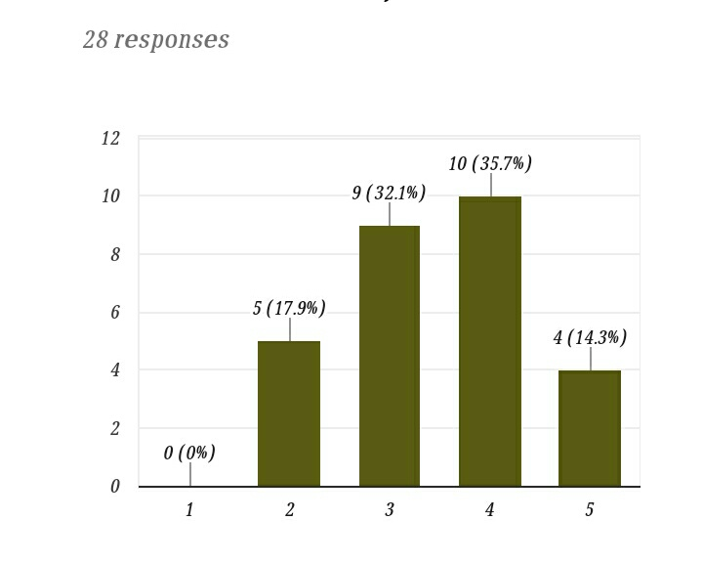

**Conclusion:**

11) On scale of 5, how much helpful this Application will be if we help you in notifying participants and volunteers?

1 - 3.6%

2 - 3.6%

3 - 14.3%

4 - 57.1%

5 - 21.4%

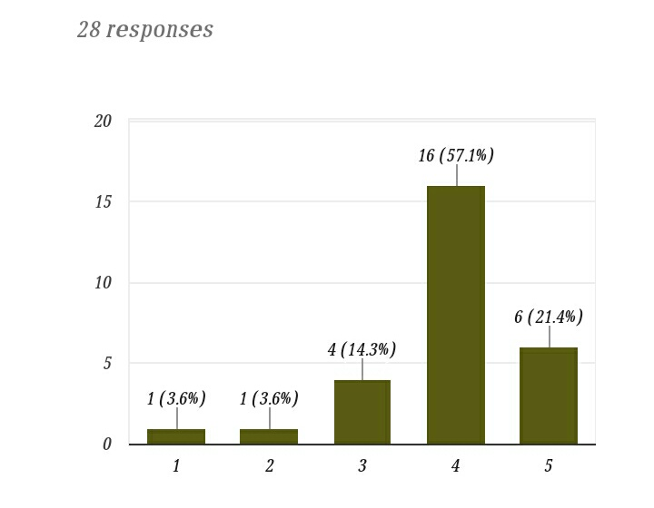

**Conclusion:**