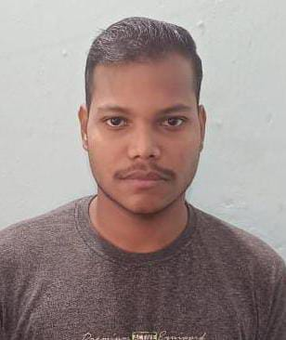

**Sambit Ranjan Pattniak**

Pursuing BSc in Physics Honours from Government

Autonomous College, Rourkela (2020-2023)

**Address:** Hariom Vihar, Brajrajnagar,

Dist– Jharsuguda, Odisha (768216)

**Mob.No:** +91 72052 65865

**Email-Id:** Sambitp5w5555@gmail.com

|  |  |  |  |  |
| --- | --- | --- | --- | --- |
| **QUALIFICATION** | **INSTITUTE/SCHOOL** | **BOARD** | **PASSING YEAR** | **PRECENTAGE** |
| BSC (Physics Honours) | Government Autonomous  College, Rourkela (GACR) | Sambalpur university  (UGC) | 2023 | 8.9 CGPA |
| 12th | DAV Public School,  Brajrajnagar | CBSE | 2020 | 84.6 % |
| 10th | Sikshaniketan School,  Brajrajnagar | ICSE | 2018 | 90 % |

1. Represented my college in NSS leadership program.
2. Did Diploma in Computer Application. (DCA)
3. Tutoring students of class 6 to 10.
4. Self-Exploring.
5. Reading Novels.
6. Gaining Knowledge.
7. Outdoor Sports

**Personal-Interests**

**Achievements & Awards**

1. Communication.
2. Problem solving.
3. Time Management.
4. Emotional Intelligence.

1. English
2. Hindi
3. Odia (Mother Language)

**Skills**

**Languages**

**Education Qualification**