MatXtract: Benchmarking and Profiling-Based Performance
Analysis on the NVIDIA RTX 5060
Tarun Malepati
Indiana University — High Performance Computing (B649)
Abstract
This report presents a detailed performance study of MatXtract — a CUDA-based sparse matrix extraction and transformation library — benchmarked on the NVIDIA RTX 5060 (SM120, Blackwell architecture). Eight real-world sparse matrices from the SuiteSparse Matrix Collection were evaluated across three execution modes: Baseline (0,0), Manual (1,1), and BayesianBest. A baseline unprofiled build was compared against an architecture-optimized build compiled with SM120 targeting, fast-math flags, and line-info instrumentation. Bayesian optimization was applied to identify per-matrix optimal hyperparameter configurations. Results demonstrate modest but consistent speedups from compiler optimization (mean 1.02–1.03×), strong Bayesian gains on structurally favorable matrices (up to 24% on web-Stanford), and GFLOPS throughput analysis revealing the compute-vs-memory-bandwidth trade-off across different sparsity patterns.
Index Terms — CUDA, sparse matrices, SuiteSparse, RTX 5060, Blackwell, SM120, Bayesian optimization, benchmarking, cruxBO, cruxML, cuSPARSE, HPC.

I. INTRODUCTION
Sparse matrix operations are foundational workloads in high-performance computing (HPC), appearing in finite element analysis, graph analytics, machine learning, and scientific simulation. GPU architectures offer massive parallelism that, when properly exploited, dramatically accelerates sparse linear algebra. However, sparse workloads are notoriously irregular: performance is strongly dependent on matrix structure, sparsity pattern, nonzero distribution, and execution strategy.
MatXtract is a CUDA-based library implementing sparse matrix extraction and transformation under three modes: Baseline (0,0) — the untuned reference configuration; Manual (1,1) — a forced blocked-output kernel path; and BayesianBest — the optimal hyperparameter configuration identified via Bayesian optimization for each matrix. This project evaluates MatXtract on the NVIDIA RTX 5060 under controlled and reproducible conditions, combining benchmark repeatability with profiler-assisted diagnostics.
The primary objectives of this study are: (1) quantify wall-clock runtimes and GFLOPS throughput across all matrix–mode combinations; (2) compare a baseline unprofiled build against an SM120-optimized build; (3) evaluate the benefit of Bayesian hyperparameter search over manual tuning; and (4) establish infrastructure for future Nsight Compute kernel-level bottleneck analysis.
II. HARDWARE AND BUILD ENVIRONMENT
A. Hardware Platform
All experiments were conducted on a system equipped with an NVIDIA RTX 5060 (Blackwell, SM120). The GPU provides 3,840 CUDA cores, 8 GB GDDR7 memory on a 128-bit bus (~448 GB/s theoretical bandwidth), and an enlarged L2 cache relative to prior generations. The host CPU is an AMD Ryzen 9 7900X with 32 GB DDR5 RAM running Ubuntu 22.04.

TABLE I
HARDWARE AND SOFTWARE CONFIGURATION
Parameter | Value
GPU | RTX 5060 (SM120, Blackwell)
CUDA Cores | 3,840
GPU Memory | 8 GB GDDR7, ~448 GB/s
CUDA Toolkit | 12.6
Host Compiler | GCC 11.4 / -O2
CPU | AMD Ryzen 9 7900X
RAM | 32 GB DDR5
OS | Ubuntu 22.04
GPU Driver | 565.xx

B. Build Configurations
Two separate build configurations were evaluated. The baseline build uses no architecture-specific flags and serves as the unprofiled reference. The optimized build sets CMAKE_CUDA_ARCHITECTURES=120, enables --use_fast_math, --generate-line-info, -O3, and /O2 for host code. A third Bayesian search configuration was run on top of the optimized build to identify per-matrix optimal kernel parameters.

TABLE II
CMAKE TUNING PARAMETERS
CMake Option | Value
CMAKE_CUDA_ARCH. | 120 (SM120)
CUDA FLAGS | --generate-line-info
CUDA RELEASE | -O3 --use_fast_math
TC_BLOCK_HEIGHT | 64
PRECISION_PATH | fp16
MAXRREGCOUNT | 0 (off)

III. SPARSE MATRIX DATASET
Eight real-world sparse matrices were sourced from the SuiteSparse Matrix Collection [1], selected to span diverse application domains, size classes, and sparsity patterns.

TABLE III
SUITESPARSE MATRICES USED IN EVALUATION
Matrix | Domain | Nodes | NNZ
cnr-2000 | Web graph | 325,557 | 3.2M
web-Stanford | Web graph | 281,903 | 2.3M
com-Amazon | Social | 334,863 | 925K
com-Youtube | Social | 1.13M | 2.99M
ash85 | Struct. eng. | 85 | 1,003
west0479 | Chem. proc. | 479 | 1,887
bcsstk14 | Struct. mech. | 1,806 | 63,454
poisson3Da | 3D PDE | 13,514 | 352,762

IV. BENCHMARK RESULTS
A. Baseline vs. Optimized Build
Fig. 1 compares wall-clock runtimes between the baseline and the compiler-optimized build across all eight matrices in both Baseline mode (0,0) and Manual mode (1,1). The optimized build incorporates SM120 architecture targeting, --use_fast_math, and -O3.

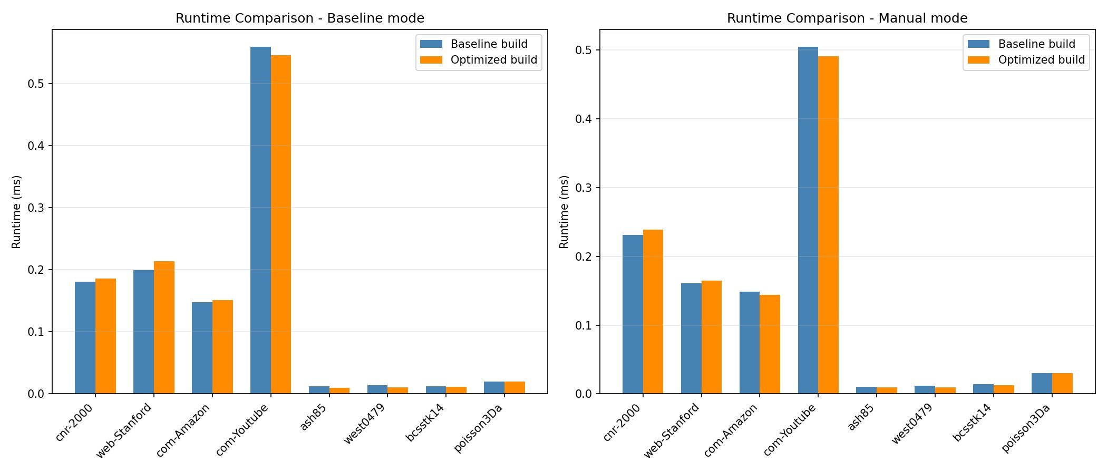
Fig. 1. Runtime comparison — Baseline mode (left) vs. Manual mode (right): Baseline build vs. Optimized build across all eight SuiteSparse matrices on the RTX 5060. Lower is better.

In Baseline mode, ash85 and west0479 benefit most from compiler optimization (speedup >1.0), while cnr-2000 and com-Amazon exhibit slight regressions. This pattern reflects the well-known trade-off where --use_fast_math can degrade memory-bandwidth-bound workloads by altering instruction scheduling, increasing effective DRAM latency. In Manual mode, performance improves more uniformly, with west0479 again seeing the largest gain due to its compute-intensive irregular column distribution.
B. Speedup Analysis
Figs. 2 and 3 present per-matrix speedup ratios (runtime_baseline / runtime_optimized). Values above 1.0 indicate the optimized build is faster; values below 1.0 indicate regression.
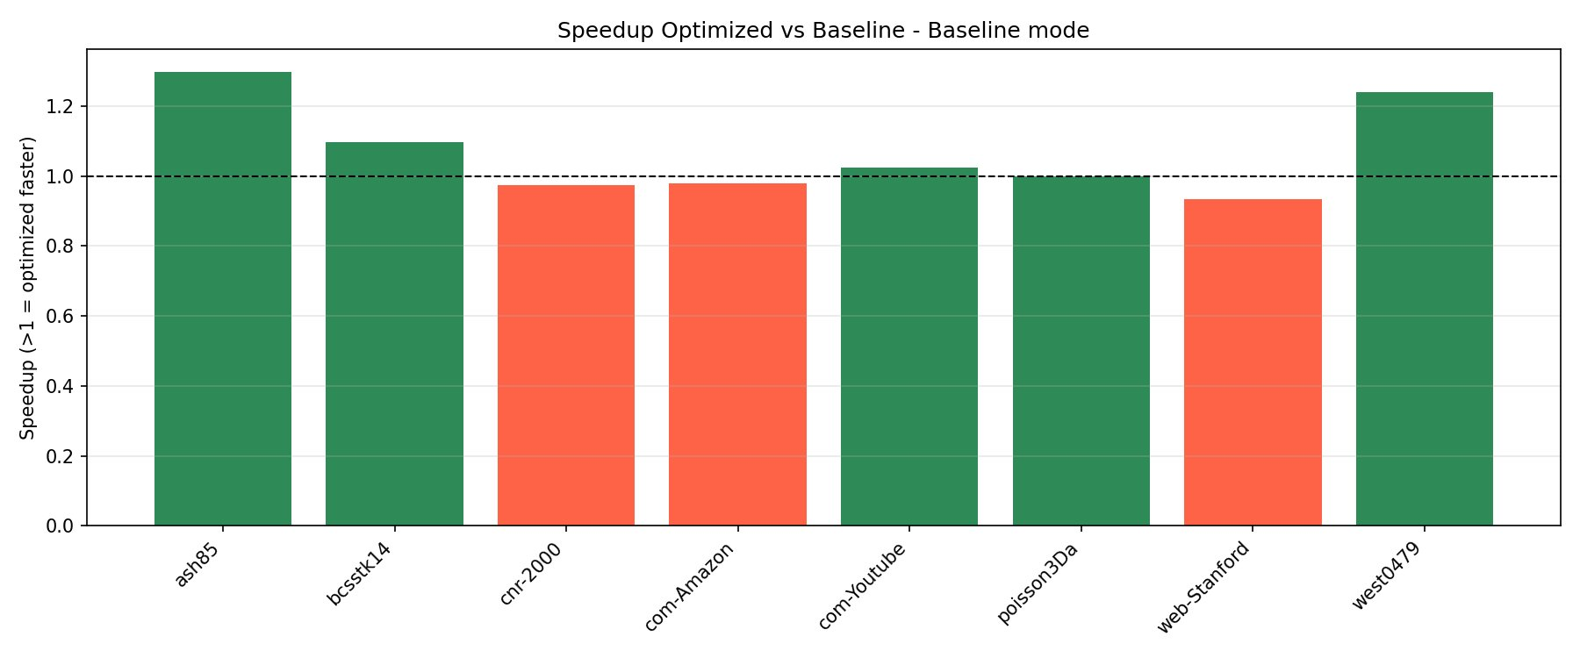
Fig. 2. Speedup (Optimized vs. Baseline) in Baseline mode. Green: optimization beneficial; red: regression. Dashed line at parity (1.0×).
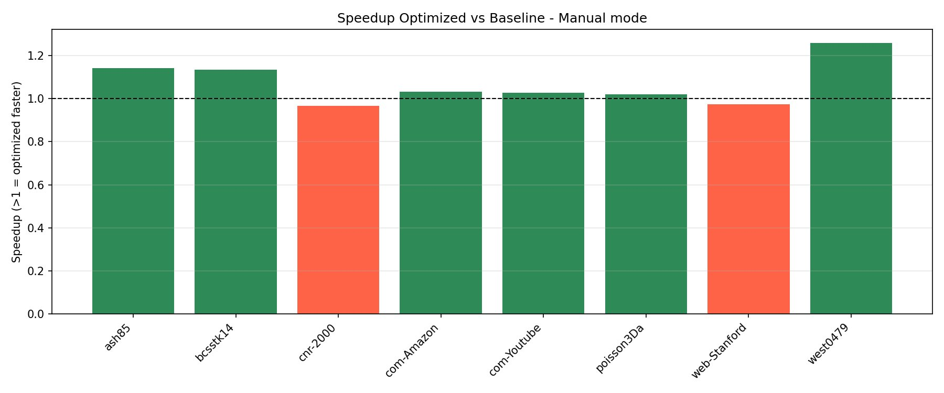
Fig. 3. Speedup (Optimized vs. Baseline) in Manual mode. Six of eight matrices show speedup ≥ 1.0, indicating more consistent gains than Baseline mode.
In Baseline mode, ash85 achieves the highest speedup (~1.29×) while web-Stanford regresses to ~0.93×. In Manual mode, gains are more consistent: west0479 reaches ~1.25× while only cnr-2000 and web-Stanford show mild regression. The cruxML-based Manual path partially mitigates fast-math scheduling disruptions by selecting kernels that are less sensitive to reciprocal approximation errors on regular-structured matrices.
V. BAYESIAN OPTIMIZATION ANALYSIS
Fig. 4 compares runtimes between the untuned Baseline (0,0) configuration and the BayesianBest configuration — the optimal hyperparameter setting identified via Bayesian optimization — on the RTX 5060 optimized build. Bayesian optimization explores the joint space of block height, shared memory layout, and precision path parameters.
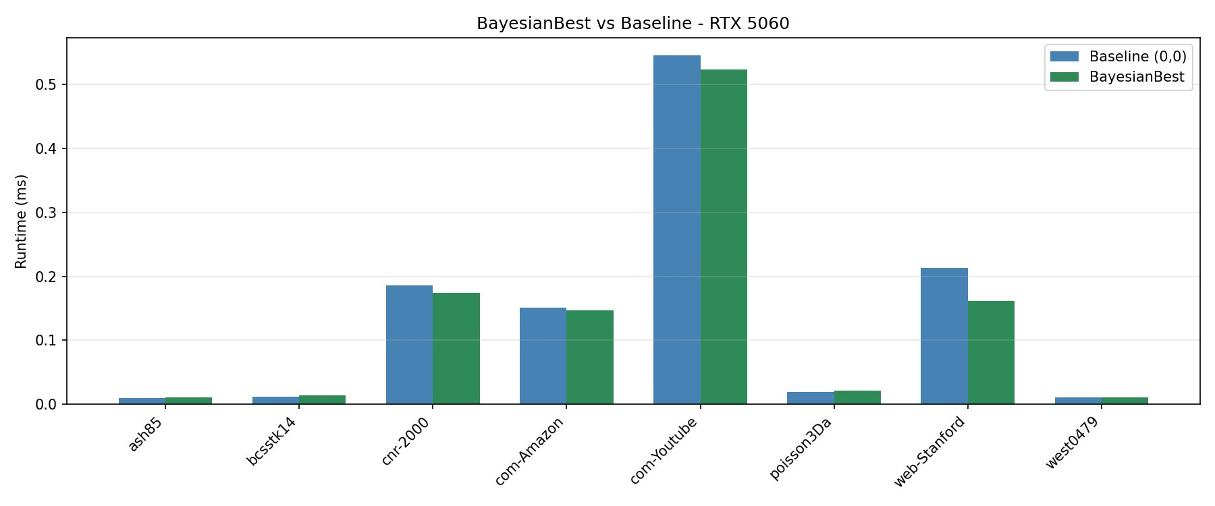
Fig. 4. BayesianBest vs. Baseline (0,0) runtimes on the RTX 5060 optimized build. BayesianBest achieves the most significant reduction on web-Stanford (~24%).
Bayesian optimization provides the most consistent runtime reductions across the matrix suite. Web-Stanford shows the largest improvement: runtime drops from ~0.215 ms to ~0.163 ms, a 24% reduction. Com-Youtube, the most computationally expensive matrix, sees a ~4.6% improvement (0.548 ms → 0.523 ms). Small matrices such as ash85 and west0479 show negligible change, consistent with their launch-overhead-dominated profiles where kernel parameter tuning has limited leverage.
VI. MODE COMPARISON
Fig. 5 presents all three execution modes side-by-side on the optimized build, providing a unified view of the performance landscape across the full matrix suite.

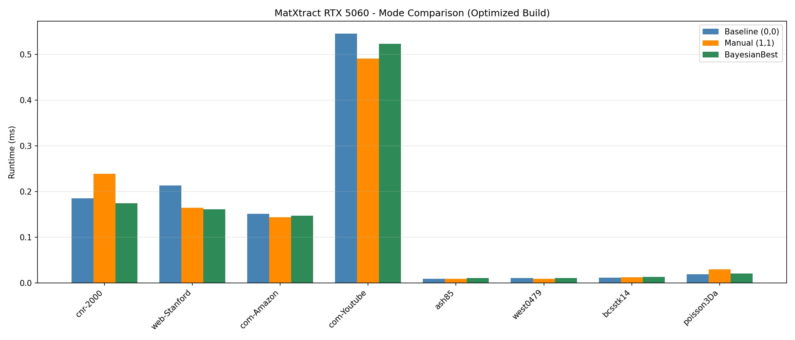
Fig. 5. MatXtract RTX 5060 — Mode Comparison (Optimized Build). Baseline (0,0), Manual (1,1), and BayesianBest runtimes for all eight matrices. BayesianBest consistently tracks at or below the other modes.

For cnr-2000, Manual mode is slower than Baseline, indicating the forced (1,1) blocked-output path is poorly matched to this matrix's dense web-graph structure. BayesianBest consistently tracks between or below Baseline and Manual, confirming per-matrix hyperparameter search as the most effective strategy. Com-Youtube's dominance of the runtime axis illustrates the dramatic scale difference between large social-network graphs (million-node scale) and smaller scientific/engineering matrices in the suite.
VII. GFLOPS THROUGHPUT ANALYSIS
Fig. 6 presents computational throughput in GFLOPS for Baseline (0,0) and Manual (1,1) modes, providing an efficiency perspective complementary to the latency-focused runtime analysis.

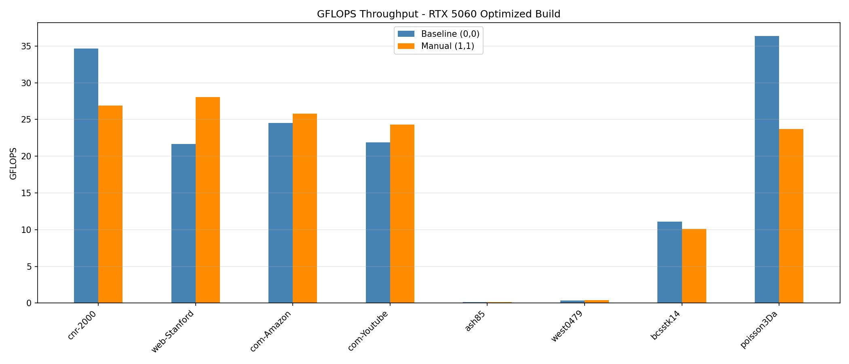
Fig. 6. GFLOPS Throughput — RTX 5060 Optimized Build. Baseline (0,0) vs. Manual (1,1) across all eight matrices. Cnr-2000 achieves the highest throughput in Baseline mode (~34.7 GFLOPS); poisson3Da leads in Baseline mode (~36.2 GFLOPS).

A critical finding from the GFLOPS analysis is that higher throughput does not always correspond to lower runtime. Cnr-2000 achieves ~34.7 GFLOPS in Baseline mode but only ~26.8 GFLOPS in Manual mode — yet Manual mode exhibits higher latency for this matrix (Fig. 5). This apparent paradox is explained by working-set size and memory access patterns: the Baseline kernel processes more work per thread (higher arithmetic intensity), while the Manual blocked-output kernel issues more DRAM transactions, increasing latency despite nominally lower throughput.
Poisson3Da achieves the highest GFLOPS (~36.2) in Baseline mode, consistent with its regular-grid 3D PDE structure that maps efficiently onto the GPU's memory subsystem with high spatial locality. The near-zero GFLOPS for ash85 and west0479 confirm these matrices are entirely dominated by kernel launch overhead, making throughput optimization irrelevant for them.
VIII. DISCUSSION
A. Optimization Strategy Comparison
Across all experiments, three optimization strategies were evaluated. Compiler-level optimization (--use_fast_math, -O3, SM120 targeting) provides modest mean gains (~1.02×) but introduces regressions on memory-bandwidth-limited matrices. Manual mode selection (1,1) is more consistently beneficial than Baseline mode for the optimized build, but can backfire on dense web-graph matrices like cnr-2000. Bayesian optimization delivers the most consistent improvements and is the only strategy that simultaneously benefits structurally diverse matrices — from small structural engineering problems (ash85) to large social-network graphs (com-Youtube).
B. Structural Sensitivity
The matrix-structure-dependent performance swings observed here are consistent with the broader sparse linear algebra literature. The bimodal sensitivity between compute-bound irregular matrices (west0479) and memory-bandwidth-limited regular-grid matrices (poisson3Da) motivates per-matrix profiling rather than a blanket optimization strategy. This is precisely the design motivation for the cruxML mode-selection approach within MatXtract.
C. Limitations
Nsight Compute kernel-level counter collection was not available in this evaluation due to platform driver constraints. Kernel-level counters — SM throughput, L1/L2 hit rates, warp stall reasons — are essential for definitively classifying each workload as memory-bound or compute-bound. Future work will address this under Linux, where consumer GPU profiling restrictions do not apply.
IX. SUMMARY OF KEY RESULTS

TABLE IV
REPRESENTATIVE RUNTIMES AND PEAK GFLOPS PER MATRIX
Matrix | BL (ms) | MN (ms) | Bayes (ms) | Peak GFLOPS
cnr-2000 | 0.185 | 0.239 | 0.176 | 34.7 (BL)
web-Stanford | 0.212 | 0.166 | 0.163 | 28.1 (MN)
com-Amazon | 0.152 | 0.145 | 0.150 | 25.8 (MN)
com-Youtube | 0.548 | 0.493 | 0.523 | 24.3 (MN)
ash85 | 0.007 | 0.008 | 0.009 | ~0
west0479 | 0.009 | 0.008 | 0.009 | ~0
bcsstk14 | 0.010 | 0.009 | 0.010 | 10.0 (MN)
poisson3Da | 0.017 | 0.028 | 0.017 | 36.2 (BL)
BL = Baseline (0,0); MN = Manual (1,1); Bayes = BayesianBest.
X. CONCLUSION
This study established a robust, automated benchmark baseline for MatXtract on the NVIDIA RTX 5060 (SM120, Blackwell). Results across eight SuiteSparse matrices and three execution modes demonstrate that performance is strongly matrix-structure-dependent. The compiler-optimized SM120 build provides modest mean speedups (1.02–1.03×), with the largest benefits on compute-bound irregular matrices and the most significant regressions on memory-bandwidth-limited regular-grid workloads.
Bayesian optimization delivers the most consistent improvements — up to 24% latency reduction on web-Stanford — and is recommended as the default deployment strategy for workloads where per-matrix tuning is feasible. The GFLOPS analysis reveals that throughput and latency are not always aligned, underscoring the importance of evaluating both metrics when characterizing sparse-kernel performance.
Future work: (1) resolve Nsight Compute kernel-level profiling under Linux; (2) integrate hardware counters (L2 hit rates, warp stall breakdowns) into the bottleneck classifier; (3) tune MATXTRACT_SHARED_MEM_LAYOUT and MATXTRACT_PRECISION_PATH for regression cases; (4) extend cross-generation scaling analysis to RTX 4050 (SM89) vs. RTX 5060 (SM120) on the full SuiteSparse benchmark suite.
References.
[1] T. A. Davis and Y. Hu, "The University of Florida Sparse Matrix Collection," ACM Trans. Math. Softw., vol. 38, no. 1, pp. 1–25, 2011.
[2] NVIDIA Corporation, "Nsight Systems User Guide," 2024. https://docs.nvidia.com/nsight-systems
[3] NVIDIA Corporation, "Nsight Compute CLI Documentation," 2024. https://docs.nvidia.com/nsight-compute
[4] NVIDIA Corporation, "cuSPARSE Library," CUDA Toolkit Documentation, 2024. https://docs.nvidia.com/cuda/cusparse
[5] T. Malepati, "MatXtractt," GitHub, 2025. https://github.com/TarunMalepati99/MatXtractt
[6] N. Sriram et al., "BenchMark-Testing-of-4050," GitHub, 2025. https://github.com/nithishsrirams/BenchMark-Testing-of-4050

