­­­ **TITLE OF THE PROJECT**

ELECTRONIC VOTING

*A*

*Mini Project Report*

*Submitted in partial fulfilment of the*

*Requirements for the award of the Degree of*

**BACHELOR OF ENGINEERING**

IN

**INFORMATION TECHNOLOGY**

By

**<LIKITH KAGITA><1602-19-737-020>**

**<TARUN NAIK><1602-19-737-050>**



**Department of Information Technology**

**Vasavi College of Engineering (Autonomous)**

**(Affiliated to Osmania University)**

**Ibrahimbagh, Hyderabad-31**

**2020**

**Vasavi College of Engineering (Autonomous)**

**(Affiliated to Osmania University)**

**Hyderabad-500 031**

**Department of Information Technology**



**DECLARATION BY THE CANDIDATE**

              We, **<Likith Kagita><Tarun Naik>,**bearing hall ticket number, **<1602-19-737-020><1602-19-737-050>**,respectively hereby declare that the project report entitled **<ELECTRONIC VOTING>**Department of Information Technology, Vasavi College of Engineering, Hyderabad, is submitted in partial fulfilment of the requirement for the award of the degree of **Bachelor of Engineering** in **Information Technology**

               This is a record of bonafide work carried out by me and the results embodied in this project report have not been submitted to any other university or institute for the award of any other degree or diploma.

**<Likith Kagita>**

**<1602-19-737-020>**

**<Tarun Naik>**

**<1602-19-737-050>**

(Faculty In-Charge)                  (Head,Dept of IT) 

**ACKNOWLEDGEMENT**

I thank the department of INFORMATION TECHNOLOGY, for introducing the subject “mini project” in BE third semester that let us learn and explore more features in “C programming language”.

I would also like to show my appreciation to our honourable principal, Dr S V RAMANA sir, for supporting us and our beloved mini project lecturer, Mrs LEELAVATHI mam, for letting us properly understand the process of doing the mini project using c and for providing insight and expertise that greatly assisted the project.

My family and friends will always be loved for sticking by me through thick and thin. THANK YOU!

**ABSTRACT**

The word “vote” means to choose from a list ,to elect or to determine . The main goal of voting (in a scenario involving the citizens of a given country) is to come up with leaders of the people’s choice . Most countries have problems when it comes to voting . Some of the problems involve ridging votes during election , inaccessible polling stations ,inadequate polling materials(like in ballot vote) and also inexperienced personnel . This voting system seeks to address the above issues . A proper program is inserted in system to get proper result and they should be trained on how to vote before the election time.  
  
How are we doing?  
-Using c language.  
-It mostly contains switch, void data type and printf statements.

**Introduction:**

Electronic voting in polling stations is in place in some of the world’s largest

democracies, and Internet voting is used in some, initially mainly small and

historically conflict-free, countries. Many countries are currently considering

introducing e-voting systems with the aim of improving various aspects of the

electoral process. E-voting is often seen as a tool for advancing democracy, building

trust in electoral management, adding credibility to election results and increasing the

overall efficiency of the electoral process. The technology is evolving fast and election

managers, observers, international organizations, vendors and standardization bodies

are continuously updating their methodologies and approaches.

Properly implemented, e-voting solutions can eliminate certain common avenues

of fraud, speed up the processing of results, increase accessibility and make voting

more convenient for citizens—in some cases, when used over a series of electoral

events, possibly even reducing the cost of elections or referendums in the long term.

Unfortunately not all e-voting projects succeed in delivering on such high promises.

The current e-voting technology is not problem-free. Legislative and technical

challenges have arisen in some cases; in others, there has been scepticism about or

opposition to the introduction of new voting technologies.

The inherent challenges of e-voting are considerable and linked to the complexities

of electronic systems and procedures. Many e-voting solutions lack transparency for

voters and even for election administrators. Most e-voting solutions are only fully

understood by a small number of experts and the integrity of the electoral process

relies largely on a small group of system operators instead of thousands of poll workers.

If not carefully planned and designed, the introduction of e-voting can undermine

confidence in the whole electoral process. It is therefore important to devote adequate

time and resources to considering its introduction and looking at previous experiences

of electronic voting

**TECHNOLOGY**

To implement any project successfully, there will be technological requirements which can either be software or hardware requirements.

**a) Software requirements:**

Since our project was supposed to be based on the C programming language, it is a bare necessity to have the knowledge and syntaxes of the language and a proper compiler and a text editor to run and write the programs.

Compiler: Many of the C compilers include:

Borland Turbo C

Tiny C compiler

Portable C compiler

GCC compiler

Clang

Among the many available compilers, we have installed and used the GCC compiler to run/execute the code for “Image Steganography” that we have written.

Text editor:

To actually write and complete a code in any language, a text editor is important. Some of the famous text editors are:

Vim editor

Notepad

Notepad++

From the above text editors, we chose vim text editor to write our code and execute it properly as it is user friendly in a Linux environment.

**PROPOSED WORK**

**A)Design**

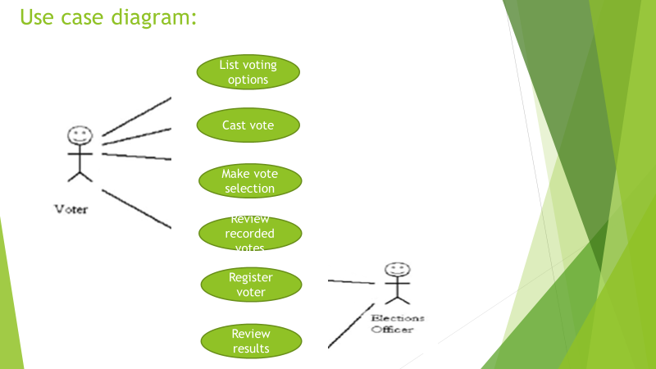

**B)Implementation:**

#include <stdlib.h>

#include<stdio.h>

#include<string.h>

void printMessageCenter(const char* message)

{

int len =0;

int pos = 0;

//calculate how many space need to print

len = (78 - strlen(message))/2;

printf("\t\t\t");

for(pos =0 ; pos < len ; pos++)

{

//print space

printf(" ");

}

//print message

printf("%s",message);

}

void headMessage(const char *message)

{

system("cls");

printf("\t\t\t###########################################################################");

printf("\n\t\t\t############ ############");

printf("\n\t\t\t############ Voting Machine ############");

printf("\n\t\t\t############ ############");

printf("\n\t\t\t###########################################################################");

printf("\n\t\t\t---------------------------------------------------------------------------\n");

printMessageCenter(message);

printf("\n\t\t\t----------------------------------------------------------------------------");

}

void welcomeMessage()

{

headMessage("Welcome to The Election");

printf("\n\n\n\n\n");

printf("\n\t\t\t *------------------*\n");

printf("\n\t\t\t =-=-=-=-=-=-=-=-=-=-=-=-=-=-=-=-=-=-=-=-=-=-=");

printf("\n\t\t\t = WELCOME =");

printf("\n\t\t\t = TO =");

printf("\n\t\t\t = ELECTRONIC =");

printf("\n\t\t\t = VOTING =");

printf("\n\t\t\t = MACHINE =");

printf("\n\t\t\t =-=-=-=-=-=-=-=-=-=-=-=-=-=-=-=-=-=-=-=-=-=-=");

printf("\n\t\t\t *------------------*\n");

printf("\n\n\n\t\t\t Enter any key to continue.....");

getch();

}

void main()

{

welcomeMessage();

int n,n1,n3,n4,n5,maxi,sum,pos,flag,k=0,co=0,br=0;

char filename[10];

char st[100][100],vote[100][100];

char sy[100],cp[20],t[100];

int count[100]={0};char n2,a;

printf(" ..................... WELCOME TO CLAIM YOUR RIGHT TO VOTE ......................\n");

printf("\n");

printf("\n");

printf("\n");

printf("\n\n\n");

headMessage("CANDIDATES");

printf("\nEnter the number of candidates participating in the election :\n");//entering candidate details

scanf("%d",&n5);

int i = 0,j;

while(i<n5)

{

int temp=0;

printf("\n\n\n");

printf("==========for %d candidate=========\n",i+1);

printf("\n\n");

printf("Enter the Name of the candidate : \n");

scanf("%s",st[i]);

printf("\nEnter the Symbol of the candidate :\n");

scanf(" %c",&a);

for(j = 0; j<i; j++)

{

if(sy[j] == a)

{

printf("\n\aThe symbol is already taken.\n\n");

printf("Please re-enter the details of the candidate.\n");

temp = 1;

break;

}

}

if (temp == 0)

{

sy[i] = a;

i++;

}

}

printf("\n\n\n");

printf("Enter 1 to vote or any other key to exit the poll :\n");

scanf("%d",&n1);

if(n1!=1)

exit(1);

while(n1==1)

{printf("\n\n\n");printf("\n\n\n");

printf("Press enter to continue....\n");

getch();

char *date = malloc(sizeof(char) * 8);

headMessage("VOTER DETAILS");

printf("\nEnter your voter ID\n");

scanf("%s",date);

strcpy(vote[k],date);

k++;

if(strcmp(t,date)==0)

co=-1;

for(i=0;i<k+1;i++)

{

if(strcmp(date,vote[i])==0)

co++;

}

if(co==1)

flag=0;

else

flag=1;

co=0;

if(flag==0)

{

FILE *fp = fopen("voters.csv", "r");

if (!fp) {

printf("Can't open file\n");

return 0;

}

char buf[1024];//Buffer of 1 kilo byte; Can be varied accordingly

int field_count = 0;

int entries = 0;

fgets(buf, 1024, fp);//Skip heading row

char *field = strtok(buf, ",");

while(fgets(buf, 1024, fp))

{ field_count = 0;

field = strtok(buf, ",");//Store next kilobyte into buffer;

if(strcmp(field,date) == 0)//Check if date matches input

{

while(field){

if (field_count == 0) {

printf("\nVOTER ID:\t");

}

if (field_count == 1) {

printf("NAME:\t");

}

if (field_count == 2) {

printf("AGE:\t");

}

printf("%s\n", field);

field = strtok(NULL, ",");

field_count++;

}

printf("\n");

}

}

fclose(fp);

printf("\n\n\n");printf("\n\n\n");

printf("Press any key to continue......\n");

getch();

printf("Cast your vote by selecting the symbol of your representative\n");

headMessage("CASTING THE VOTE");

printf("\n");printf("\n");printf("\n");

printf("Enter the symbol of your Representative :\n");

for(i=0;i<n5;i++)

{

printf("%d. %s (%c)\n",i+1,st[i],sy[i]);

}

int fl=0;

scanf(" %c",&n2);

for(i=0;i<n5;i++)

{

if(n2==sy[i])

{fl=1;

break;

}

else

fl=0;

}

if(fl==1)

{

for(i=0;i<n5;i++)

{

if(n2==sy[i])

count[i]++;

}

printf("\aThank You ! Your vote has been casted.\n");printf("\n\n\n");printf("\n\n\n");

printf("Press any key to continue\n");

getch();}

else{

strcpy(t,date);

printf("\n\n\n");

printf("\aWrong symbol is entered. Enter the correct symbol\n");

printf("The details are to be re-entered.\n");

printf("\n\n\n");

printf("Press any key to continue\n");

getch();

continue;

}

headMessage("MENU");

while(n1==1)

{

printf("\n");printf("\n");printf("\n");

printf("Enter your choice \n1. Results\n2. Difference between the votes of any two candidates\n3. Finish your voting\n4. EXIT the Poll\n ");

scanf("%d",&n);

if(n==1)

{

headMessage("Results");

printf("\n\n\n");

printf("The Result according to votes casted so far is as follows : \n");

printf("\n");printf("\n");printf("\n");

for(i=0;i<n5;i++)

{

printf(" %s( %c): %d\n",st[i],sy[i],count[i]);

}

}

else if(n==2)

{

headMessage("Difference");

printf("\n\n\n");

for(i=0;i<n5;i++)

{

printf("%d. %s (%c)\n",i+1,st[i],sy[i]);

}

printf("Enter the serial nos. of whose vote count differences are to be known : \n");

scanf("%d%d",&n3,&n4);

if(count[n3-1]==count[n4-1])

printf("It's a Tie between both the candidates'\n");

printf("\n\n\n");

printf("The difference between %s and %s is %d",st[n3-1],st[n4-1],count[n3-1]-count[n4-1]);

}

else if(n==3)

{

break;

}

else if(n>4)

{

printf("\aWRONG OPTION ENTERED TRY AGAIN");

}

else

n1=0;

}

}

else

printf("\a\a\a\a\aError!!!! You already casted your vote ");printf("\n\n\n");

printf("press any key to continue\n");

}

headMessage(" FINAL RESULTS");

for(i=0; i<n5; i++)

{

/* File name for storing Candidate details */

sprintf(filename, "file%d.apk", i+1);

FILE * fPtr;

/* If above operation is failed print error and exit */

if(fPtr == NULL)

{

/* File not created hence exit */

printf("Unable to create file.\n");

exit(EXIT_FAILURE);

}

/* Writing data in the file */

fPtr = fopen(filename, "w");

printf("\nCandidate : %s",st[i]);

fprintf(fPtr,"candidate:%s\n",st[i]);

printf("\t Symbol : %c",sy[i]);

fprintf(fPtr,"symbol:%c\n",sy[i]);

printf("\t Votes : %d\n",count[i]);

fprintf(fPtr,"votes:%d\n",count[i]);

/* Closing the file */

fclose(fPtr);

}}

GITHUB LINK : https://github.com/LikithKagita

https://github.com/TarunNaik04

**C)TESTING**

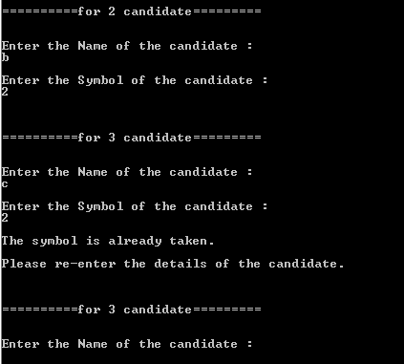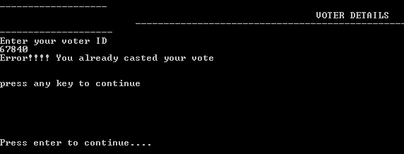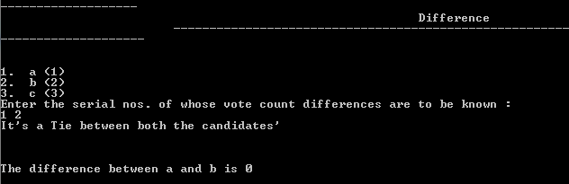

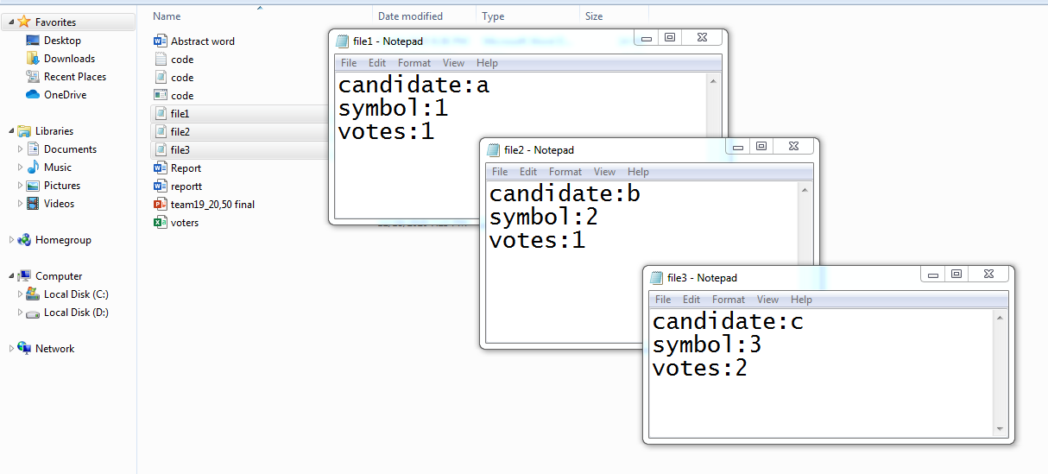

**RESULT**

1.A safe and secure election is established.

2.A proper result is obtained.

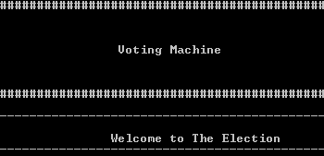 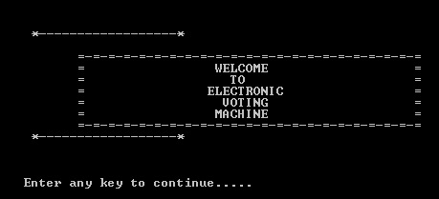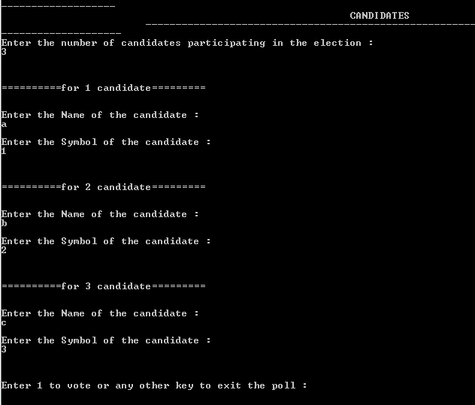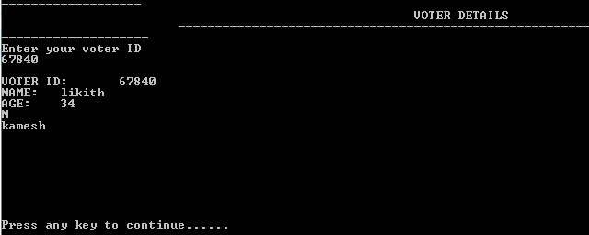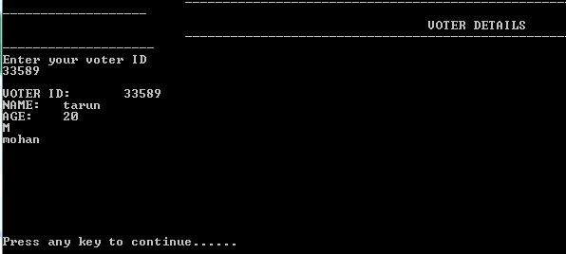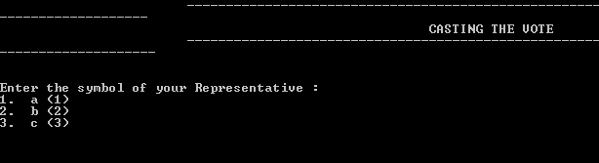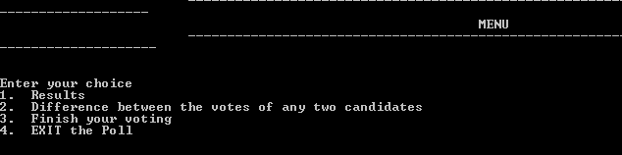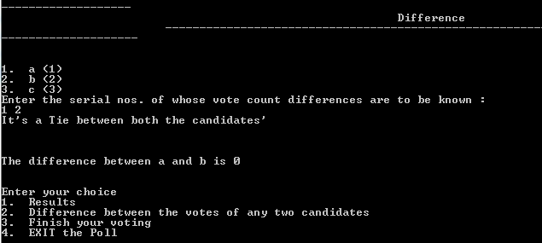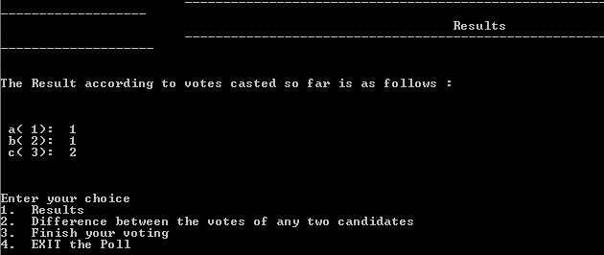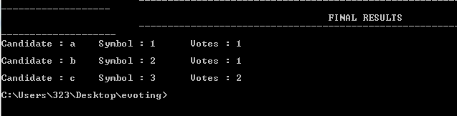

**Additional learning**

We learned how to manage time. Though we had lot of quizzes and assignments we somehow managed to pull up. This project helped us to gain interest in coding. From many topics we choose electronic voting and we went through a lot but as a team we faced them. We had an amazing experience working together.

Team work made understanding of our project a lot easier and helped us to be more creative in various steps of its development. We also had to revise a lot of concepts regarding programming in C, which made our basics even stronger and also helping us to be even more confident.

**Discussion and Future Work**

We have a lot of plans that we would like to add a lot of elements to our project. We would like to add more file types and also graphs and also improve our security.

I would like to make the code more simpler and easy to understand.

**References**

We took ideas and thoughts from seniors and also used our textbook for reference.