

**TRIBHUVAN UNIVERSITY**

INSTITUTE OF SCIENCE AND TECHNOLOGY

**AMRIT SCIENCE CAMPUS**

LAINCHAUR, KATHMANDU



**SUBMITTED BY**

Name: Tarun Regmi

Roll No: 2012/078

BIT 1st Sem

**SUBMITTED TO**

Gyani Ray

Lecturer

Amrit Science Campus

# MS DOS

**LAB-3: MS DOS**

Microsoft Disk Operating System (MS-DOS) is an operating system developed for PCs with x86 microprocessors. It is a command line based system where all commands are entered in text format and there is no graphical user interface. MS-DOS was the most widely used member of the disk operating system family. It was the leading operating system choice for IBM PC-compatible computer systems from the 1980s to the mid-1990s. MS-DOS has been gradually replaced by systems with a graphical user interface, especially Microsoft Windows.

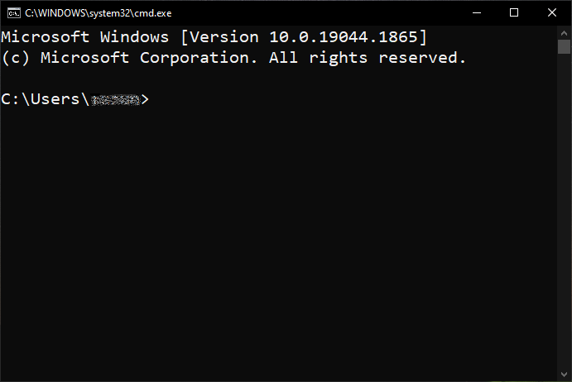Currently, MS-DOS is not used. However, the command shell, well known as the Windows command line, is still used by many. The image below is an example of a Windows command line window running on Microsoft Windows 10.

**Fig: Command Prompt**

To open Command Prompt in a window, click Start button and search Command Prompt (cmd). Then click on the Command Prompt app.

## MS DOS Command

Some common command and their uses in MS DOS:

### CD

CD (Change Directory) is a command for changing directories on the MS-DOS and Windows command lines.

**Syntax:**

\> cd [path]

|  |  |
| --- | --- |
| **Example** | **Meaning** |
| \> cd \user\profile\programs | Change directory forward to programs |
| \> cd .. | Moves back one directory. |
| \> d: | Change directory to D drive |
| \> cd\ | Goes to the highest level (the root) of the drive. |

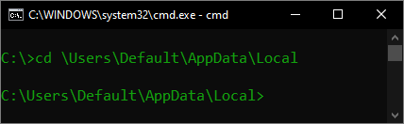

### CLS

The cls command allows the user to clear everything on the screen, leaving only the prompt.

**Syntax:**

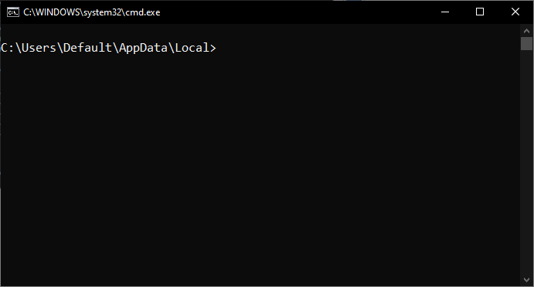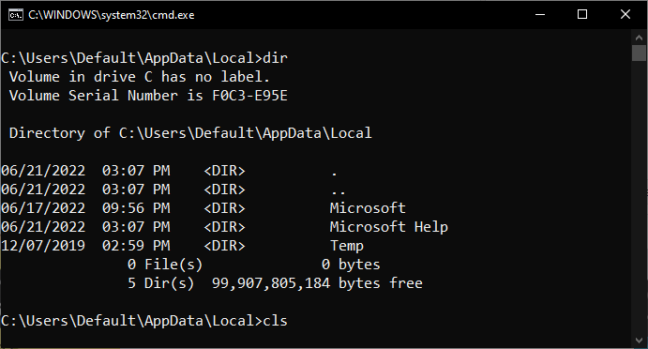\> cls

### DATE

The date command can view or change the current date of the system clock.

**Syntax:**

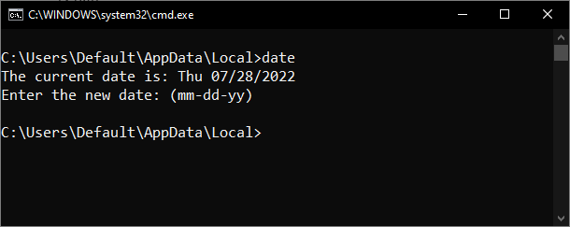\> date

### DIR

The dir command displays information about files and directories and available disk space. By default, it displays the name, size, and last modification time of all files in the current directory.

**Syntax:**

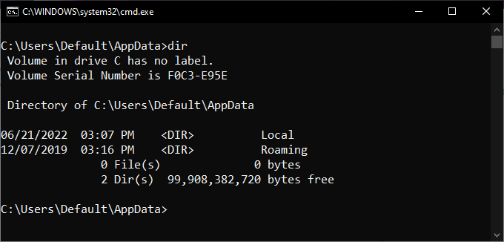\> dir

|  |  |
| --- | --- |
| **Example** | **Meaning** |
| \> dir | Lists all files and directories in the current directory. |
| \> dir *.exe | Lists any file whose name has the file extension ".exe". |
| \> dir *.txt *.doc | List any files whose name has the file extension ".txt" or ".doc". |

### EXIT

The exit command is used to withdraw from the currently running application and the MS-DOS session.

**Syntax:**

\> exit

### HELP

The help command is used to access information and help files from the MS-DOS prompt or the Windows command line.

**Syntax:**

\> help

### HOSTNAME

The hostname command displays the hostname of the machine that is running it.

**Syntax:**

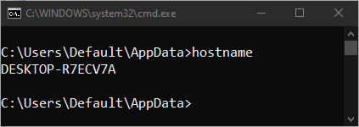\> hostname

### MD and MKDIR

The md and mkdir commands allow users to create directories.

**Syntax:**

\> md [dir_name]

\> mkdir [dir_name]

|  |  |
| --- | --- |
| **Example** | **Meaning** |
| \> md tmp | Create tmp directory |
| \> mkdir ts\ts1 | Create a ts directory and create a ts1 directory in the test directory. |

### MOVE

The move command allows users to transfer files or directories from one directory to another, or from one drive to another.

**Syntax:**

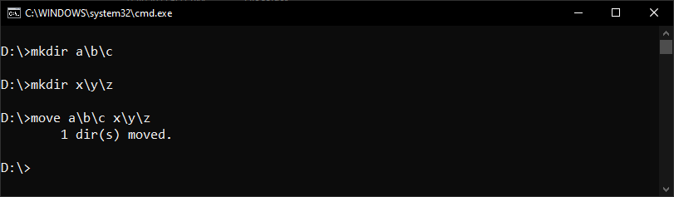\> move [path_to_current] [path_to_destination]

|  |  |
| --- | --- |
| **Example** | **Meaning** |
| \> move a b | Move dir. a in b |
| \> move a\b\c x\y\z | Move dir. c in z |

### REN and RENAME

The ren and rename commands change the name of files and directories.

**Syntax:**

\> ren [old_path/name] [new_path/name]

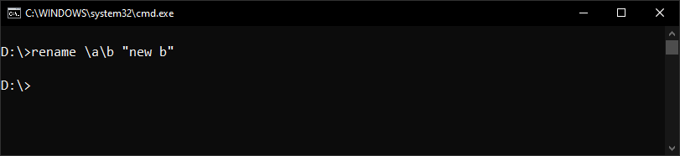\> rename [old_path/name] [new_path/name]

|  |  |
| --- | --- |
| **Example** | **Meaning** |
| \> ren d:\a z | Change the name of the directory "a" to "z" |
| \> ren *.txt *.doc | Rename all text files with the ".txt" file extension to files with ".doc" extension. |

### COPY

The copy command allows users to copy one or more files to an alternate location.

**Syntax:**

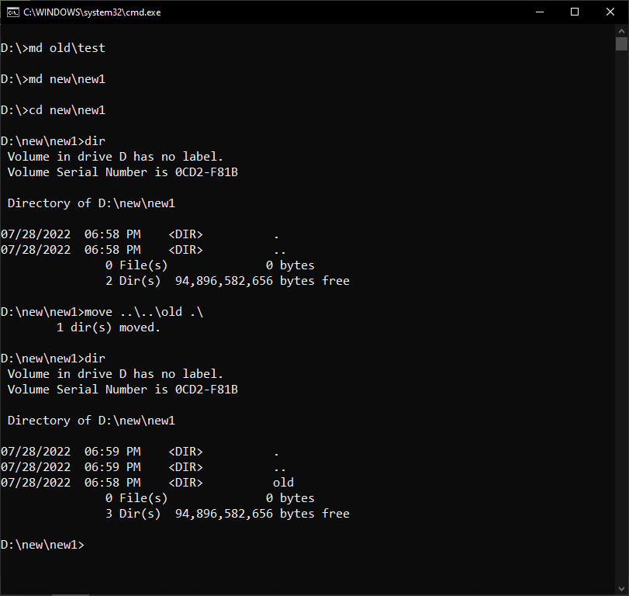\> copy [path_to_current] [path_to_destination]

## Some External Command

External commands are MS-DOS commands that are not included in command.com. External commands are usually external commands because they are very demanding or not commonly used commands.

### ARP

The arp command displays, adds, and removes arp information from network devices.

**ARP Syntax:**

arp -s inet_addr eth_adr [if_addr]

arp -d inet_addr [if_addr]

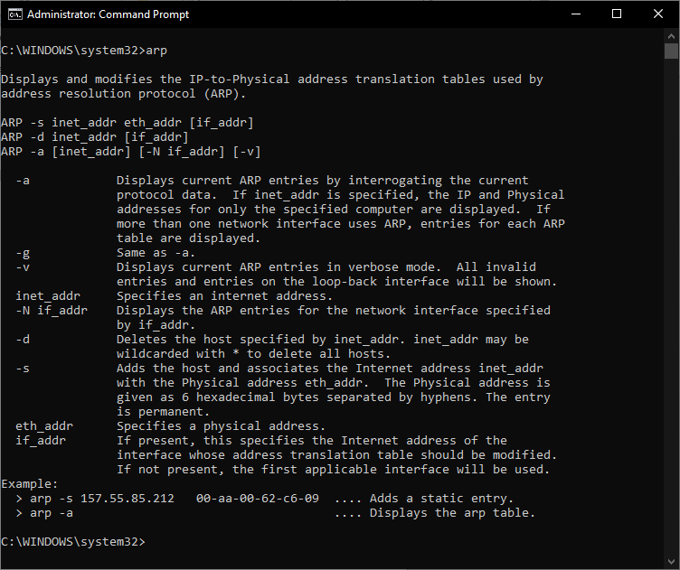arp -a [inet_addr] [-N if_addr]

### SHUTDOWN

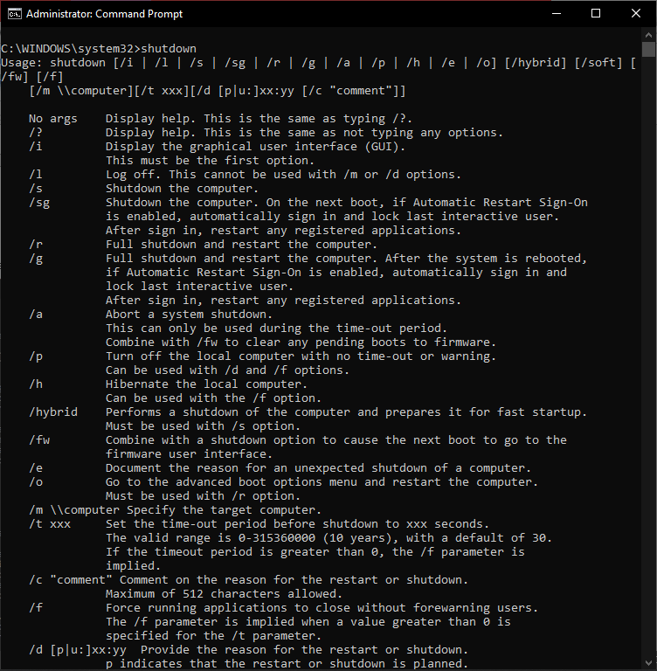The shutdown command allows you to shut down a Windows computer from the command line. It also has additional features that are not available in Windows.

### MSBACKUP

Msbackup is a later MS-DOS application that enables users to back up the data on their computer. The Windows version is known as mwbackup.

### ROUTE

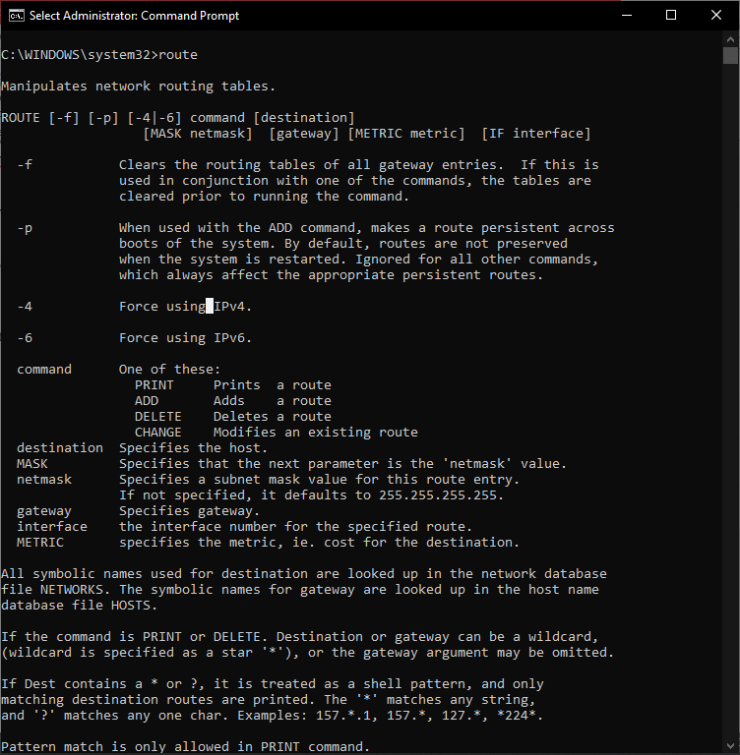The route command is used to manually configure the routes in a routing table.

### SCANDISK

Microsoft ScanDisk was first introduced with MS-DOS 6.2. It is a software utility capable of checking the hard drive and floppy diskette for any disk errors.

### POWER

The power command allows users to conserve power on computer portables.

### PING

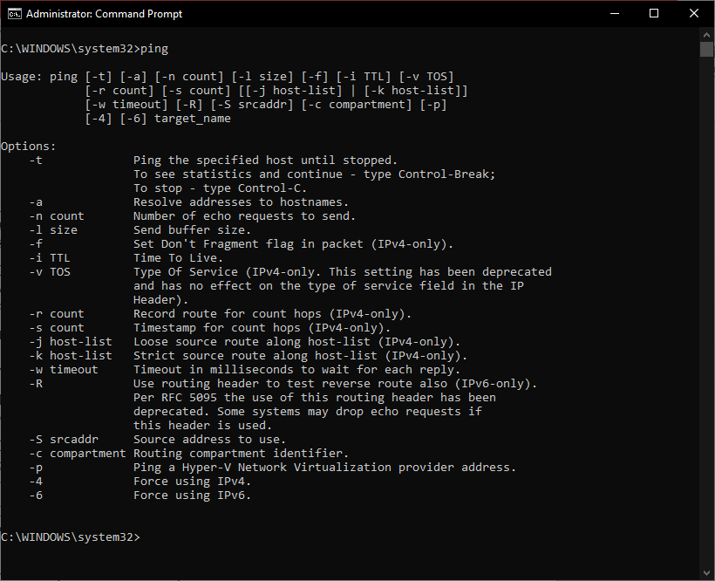The ping command helps determine the TCP/IP network's IP address and issues with the network and assists in resolving them.