

**TRIBHUVAN UNIVERSITY**

INSTITUTE OF SCIENCE AND TECHNOLOGY

**AMRIT SCIENCE CAMPUS**

LAINCHAUR, KATHMANDU



**Spreadsheet**

**SUBMITTED BY**

Name: Tarun Regmi

Roll No: 2012/078

BIT 1st Sem

**SUBMITTED TO**

Gyani Ray

Lecturer

Amrit Science Campus

# What is spreadsheet (MS Excel)? Briefly describe its function and application.

Spreadsheet is an application software capable of organizing, storing and analyzing data in tabular form. The application can provide digital simulation of paper accounting worksheets. They can also have multiple interacting sheets with data represented in text, numeric or in graphic form. With these capabilities, spreadsheet software has replaced many paper-based systems, especially in the business world. Originally developed as an aid for accounting and bookkeeping tasks, spreadsheets are now widely used in other contexts where tabular lists can be used, modified and collaborated. Microsoft Excel, Google Sheets, Lotus Symphony, LibreOffice, etc are popular example of spreadsheet.

## Microsoft Excel (MS Excel)

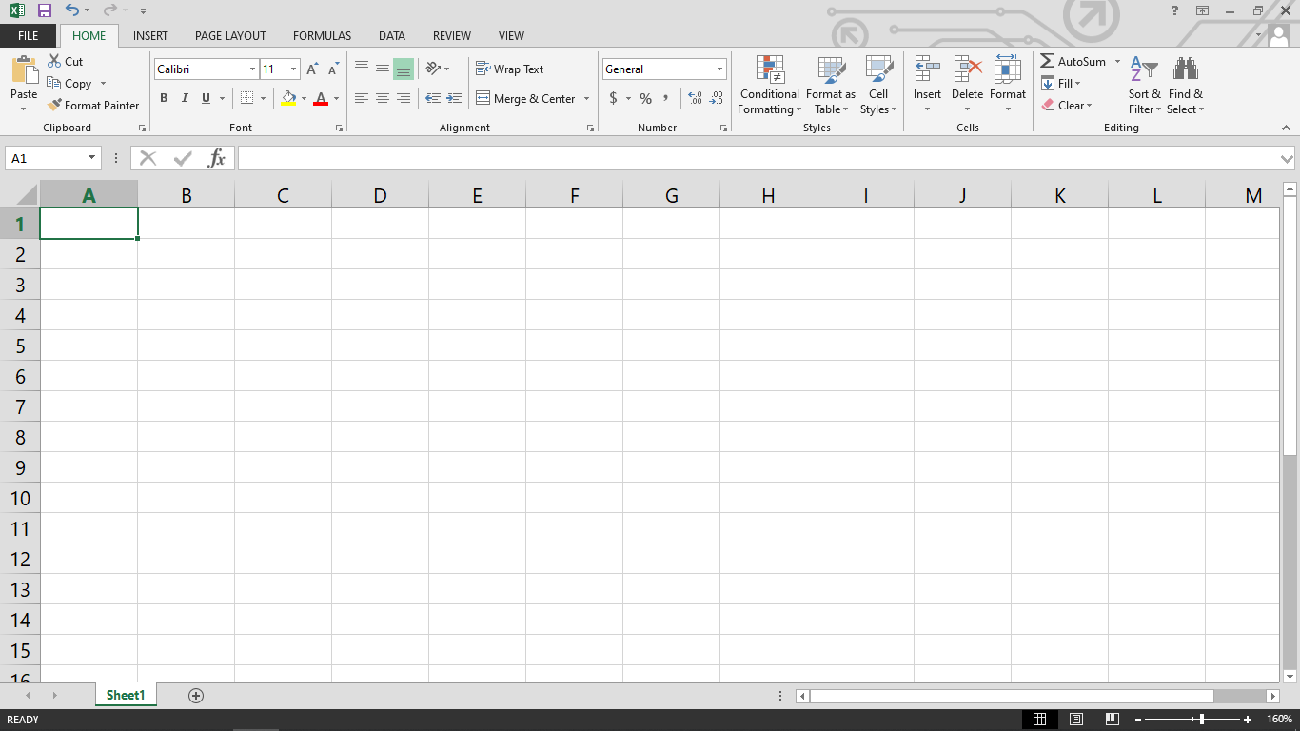Microsoft Excel is a software program produced by Microsoft that allows users to organize, format and calculate data with formulas using a spreadsheet system. This software is part of the Microsoft Office suite and is compatible with other applications in the Office suite. Like other Microsoft Office products, Microsoft Excel can now be purchased through the cloud on a subscription basis through Office 365.

**Fig: MS Excel Interface**

### How to open MS Word in In Compute?

Follow following steps to open MS Excel in computer.

1. Click on **START**
2. Search **MS Excel**
3. Click on **MS Excel Icon**

### How to create Excel File?

Follow following steps to create excel file.

1. Open **MS Excel**
2. Click on **Blank workbook**
3. 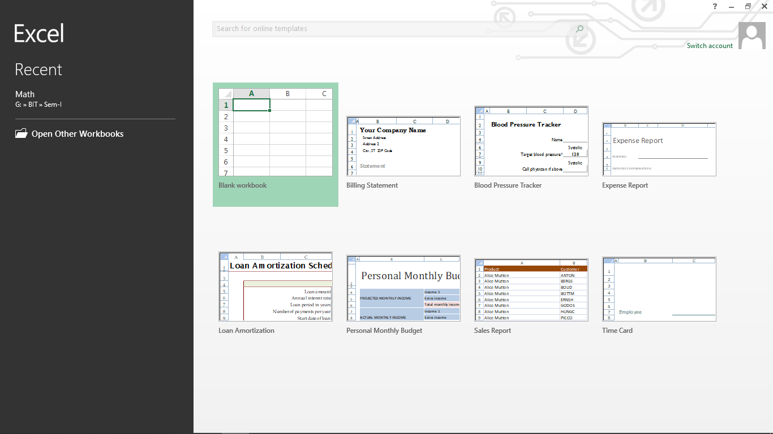Or click on other available template

**Fig: Creating excel file**

After creating the file if you want to save the created file then follow the below steps to save that file.

1. Click on **FILE BUTTON**
2. Click on **Save**

### Features of MS Excel

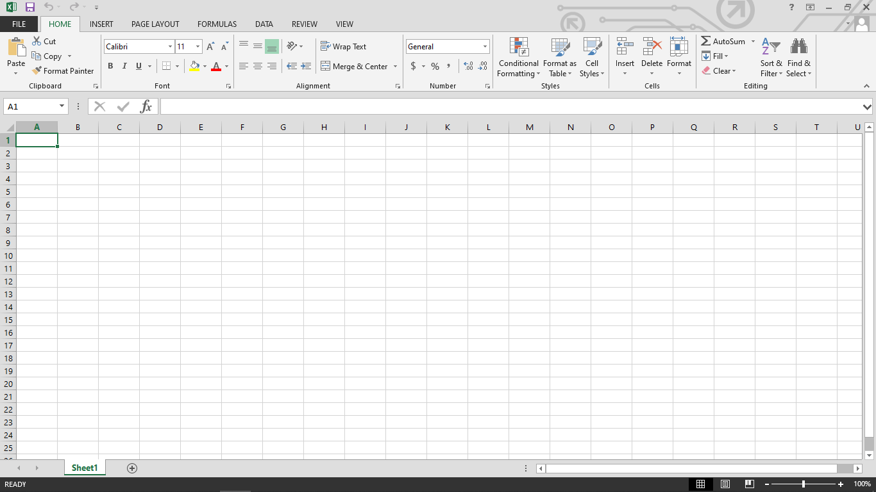The image given below shows the different elements and categories which are available in MS Excel.

**Fig: Features of excel**

#### Home

This has options like font size, font styles, font color, background color, alignment, formatting options and styles, insertion and deletion of cells and editing options.

#### Insert

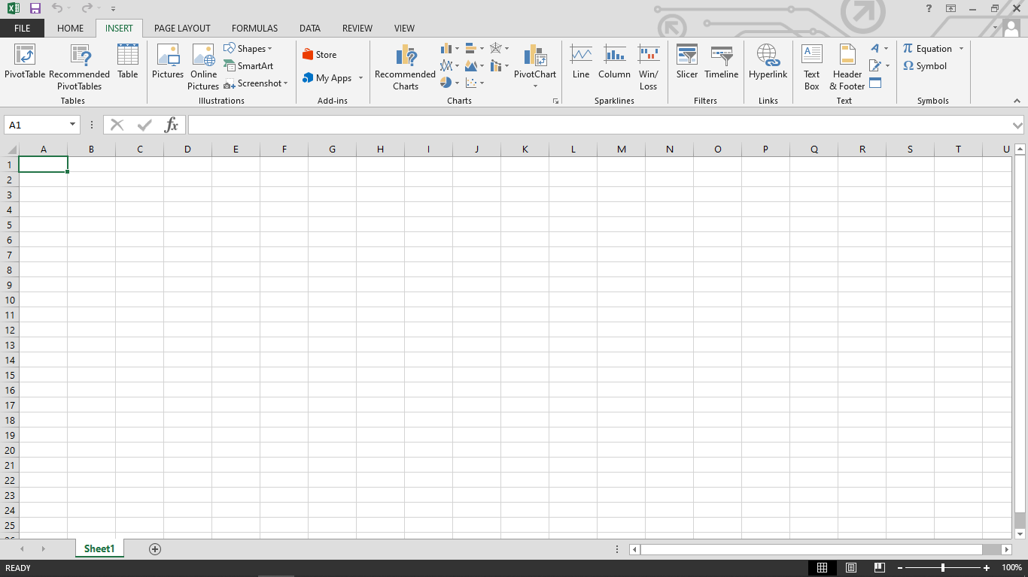Comprises options like table format and style, inserting images and figures, adding graphs, charts and spark lines, header and footer option, equation and symbols.

**Fig: Insert**

#### Page Layout

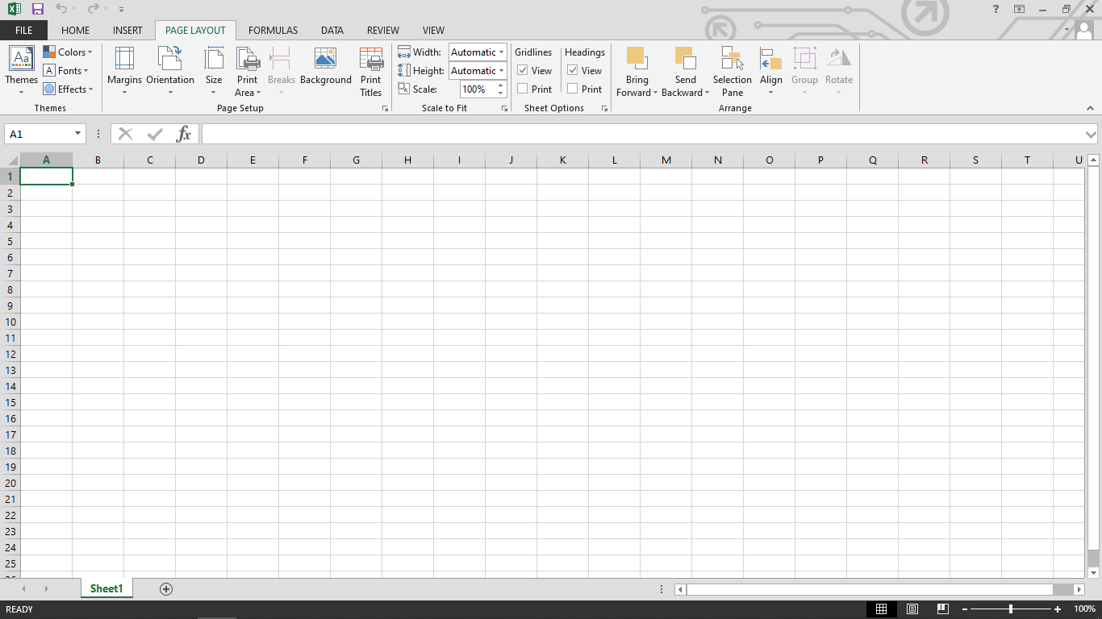Themes, orientation and page setup options are available under the page layout option.

**Fig: Page layout**

#### Formulas

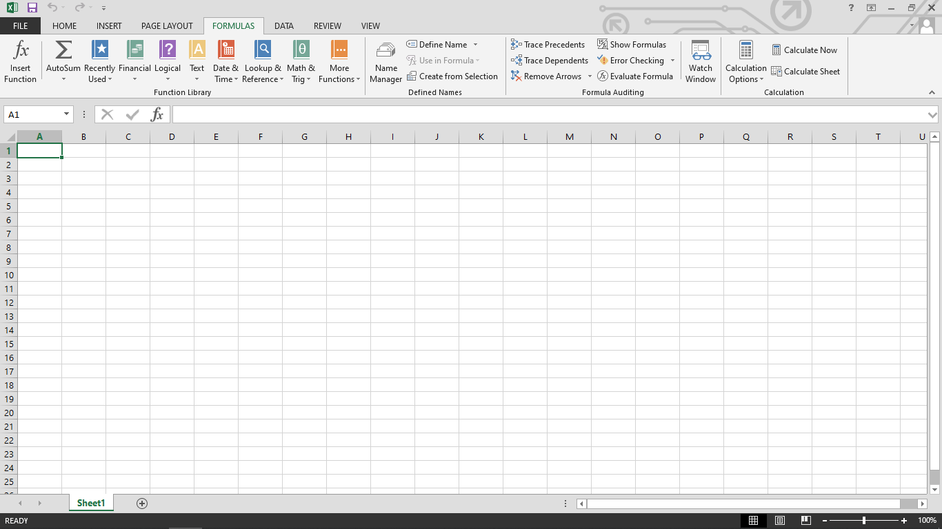Since tables with a large amount of data can be created in MS excel, under this feature, you can add formulas to your table and get quicker solutions.

**Fig: Formulas**

#### Data

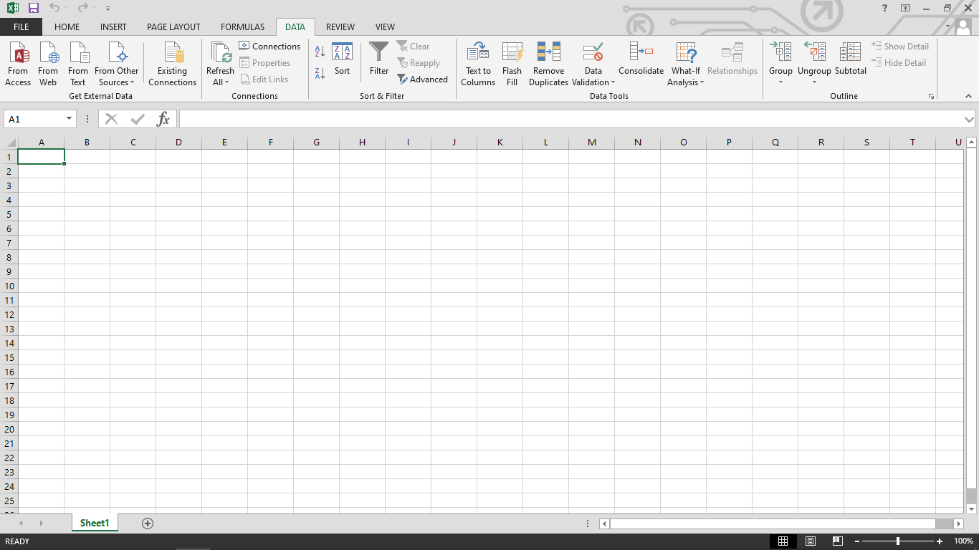Adding external data (from the web), filtering options and data tools are available under this category.

**Fig: Data**

#### Review

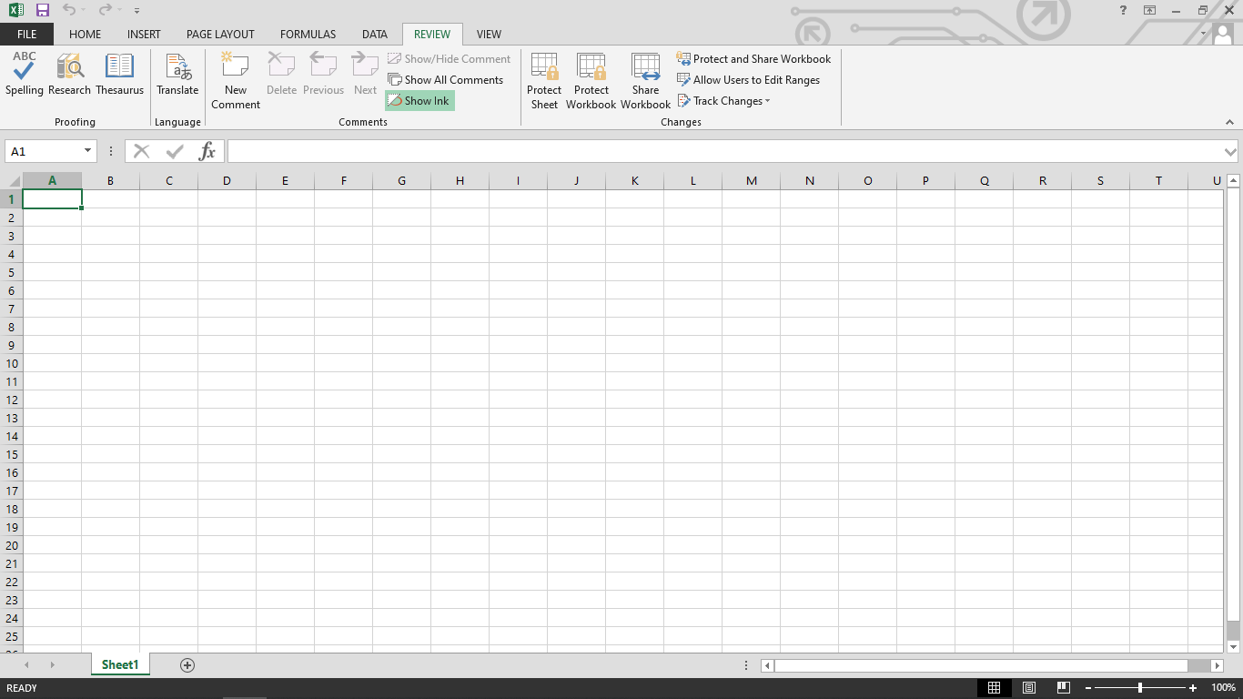Proofreading can be done for an excel sheet (like spell check) in the review category and a reader can add comments in this part.

**Fig: Review**

#### View

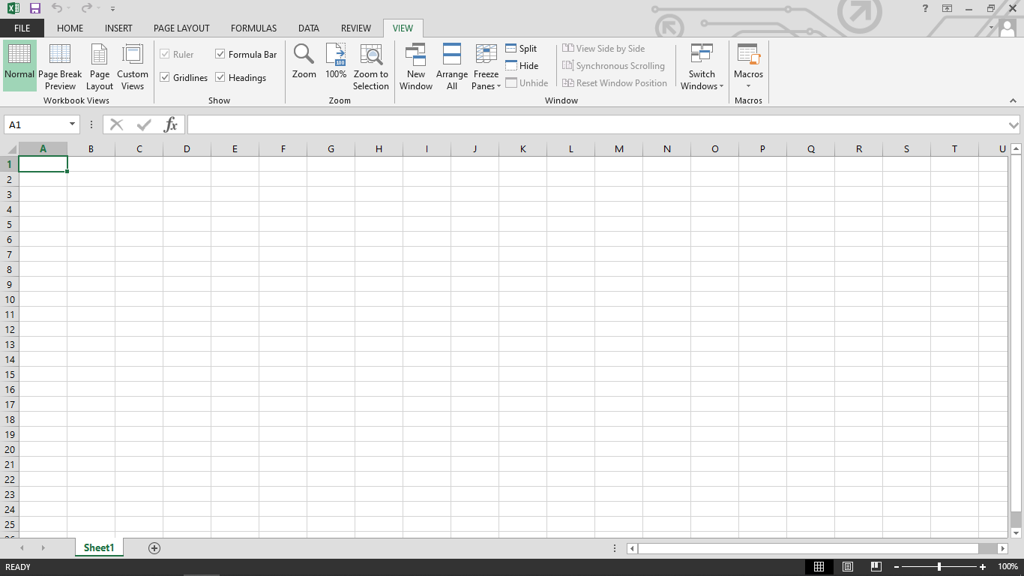Different views in which we want the spreadsheet to be displayed can be edited here. Options to zoom in and out and pane arrangement are available under this category.

**Fig: View**

#### Mark Sheet Using MS Excel