Program2:

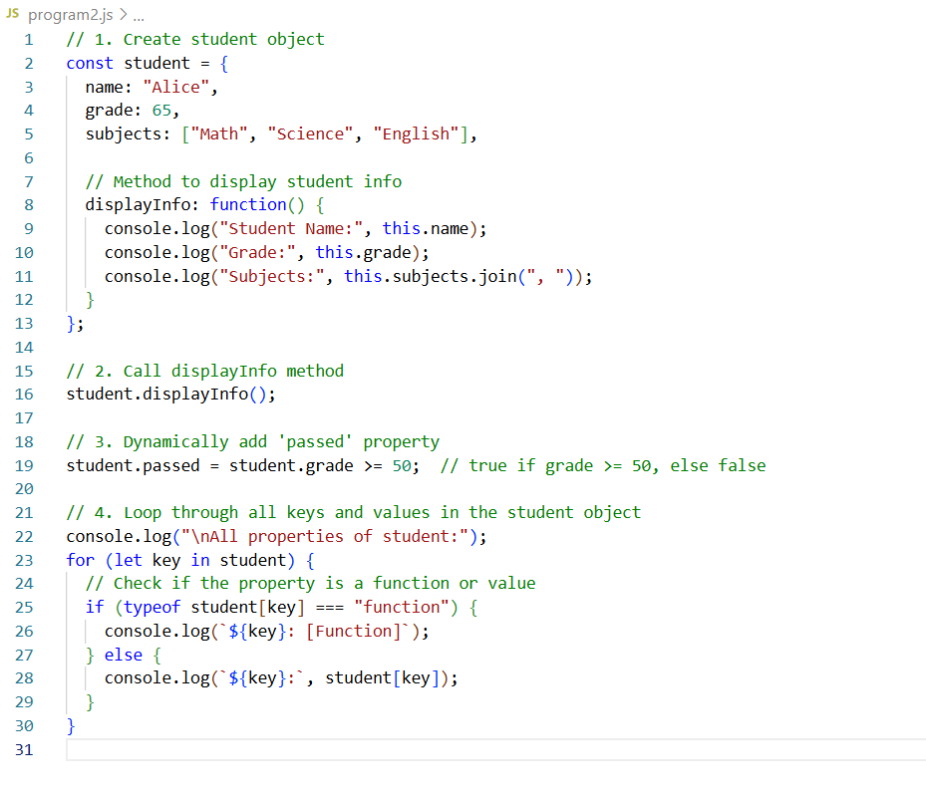
Execution steps:
Check node js is installed or not
>node -v
>node program2.js

