**Machine Learning for Trading**Project 6: Manual Strategy  
Tharun Saranga (tsaranga3)

**Part 1: Technical Indicators**

The following Technical Indicators are considered in this project to assist with the Manual Strategy.

1. Simple Moving Average (SMA)
2. Bollinger Bands
3. Moving Average Convergence Divergence (MACD)
4. True Strength Indicator (TSI)

**Simple Moving Average (SMA):**

Simple Moving Average is the average of price over a specified period. SMA is used to indicate the price movement in a smooth curve. The SMA crossover with price informs us with the trend of the price moment.   
SMA is calculated using the following formula:

$${SMA}_{t}=\frac{1}{n}\sum_{i=1}^{n}{{Price}_{t-i}}$$

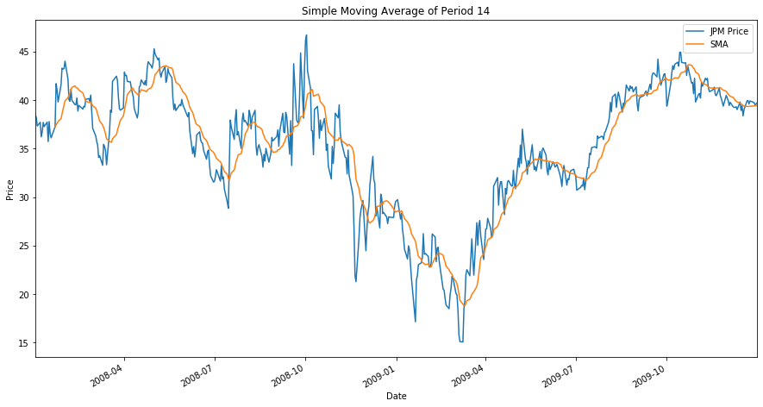The average of the price over a moving window of period 14 is used in the experiments.

Figure 1: Simple Moving Average of Period 14

**Bollinger Bands:**

Bollinger Bands are the pair of curves one above and one below the price curve at two standard deviations from the simple moving average of the price. It provides the signal of overbought and oversold stock. Bollinger Bands shows the volatility of the stock as well with the distance between the two bands. Bollinger Bands are mostly used with other indicators.

The two bands are called upperBand and lowerBand. The are spaced two standard deviations away from the simple moving average. STD is the standard deviation.

upperBand = SMA + 2*STD(price)  
lowerBand = SMA - 2*STD(price)

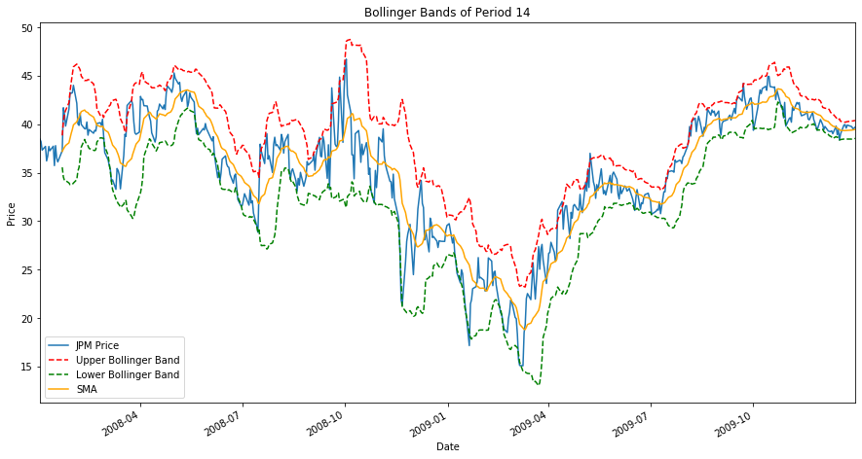

Figure 2: Bollinger Bands of Period 14

**Moving Average Convergence Divergence (MACD):**

MACD is a trend following momentum indicator that shows relation between two different moving averages of different time periods. Generally, MACD is calculated with 12-period exponential moving average and 26-period exponential moving average. The difference between the two is the MACD line. This oscillates around 0. If the MACD is above zero, the price is in up trend and if the MACD is below zero, the price is in down trend. The more distant the MACD is from zero the stronger the trend.

MACD is calculated as follows:

MACD = 12_Period EMA – 26_Period EMA

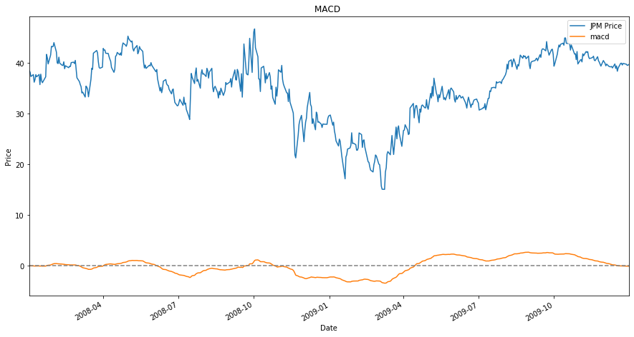

Figure 3: Moving Average Convergence Divergence Indicator

**True Strength Index (True Strength Index):**

True Strength Index is a double smoothed indicator that uses two levels of EMA operations on price momentum. The first level is of 25 window length and the second level is of 13 window length. TSI is calculated as:

$$TSI= \frac{EMA((EMA(m,r),s)}{EMA((EMA(abs(m),r),s)}*100$$

m: difference between today’s and yesterday’s price  
 EMA(m,r): Exponential Moving Average of m over a period of r  
 r = 25   
 s = 13

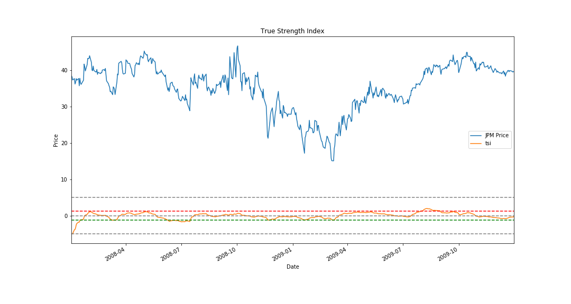The TSI output is bound between +100 and -100 but most values fall between +25 and -25. These values suggest overbought and oversell levels respectively. TSI can also indicate the direction of the trend. A rising TSI suggests an up-trend and a falling TSI suggest a down-trend. But for the purpose of this experiment the output is scaled to +5 and -5. The overbought and oversell are scaled accordingly.

Figure : True Strength Index of the Price

**Part 2: Theoretically Optimal Strategy**

Theoretically Optimal Strategy is created by seeing into the future and making trades such that the returns are maximum. Since, we already know the future it is easy to make the trades for optimal profits. We will buy shares when tomorrow’s price is more than today’s price and sell it when tomorrow’s price is less than todays. This is optimal only when there are not commissions and extra transactions fees associated. This kind of portfolio will give us the upper bound of the optimal performance. The Benchmark is just buying shares in the beginning and holding it until the end. The following are the results from the experiment:

Cumulative Return of Optimal Strategy Fund: 5.7861  
Standard Deviation of Optimal Strategy Fund: 0.004547823197907996  
Average Daily Return of Optimal Strategy Fund: 0.0038167861508578197  
------------------------------------------------------------------  
Cumulative Return of Benchmark Fund: 0.012299999999999978  
Standard Deviation of Benchmark Fund: 0.017004366271213767  
Average Daily Return of Benchmark Fund: 0.00016808697819094035

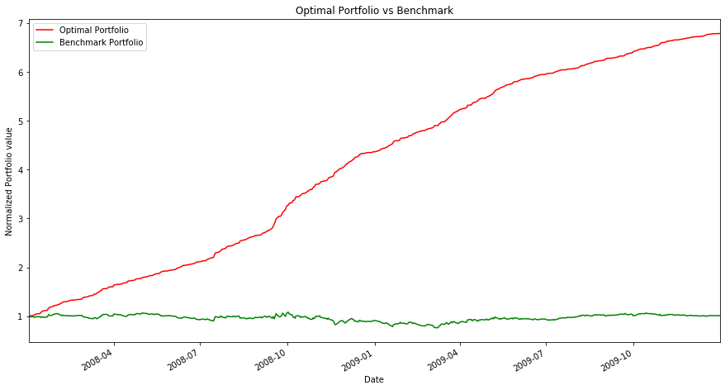**Part 3: Manual Rule-Based Trader**

Figure 5: Portfolio Value of Optimal Strategy Fund and Benchmark Fund

To create a Manual Strategy all the three indicators described above are used with threshold conditions. SMA tells us the partial trend of the price. If the price is above the SMA then it is likely to be in increasing trend, if it is below the SMA it is likely to be in decreasing trend. The Bollinger bands help us in determining the strength and direction of the trend. It is believed that if the price touches or crosses the any of the band the price is likely to move in that direction. MACD also gives us the strength and direction of the trend. If the MACD is increasing the trend is strengthening in the positive direction and if the MACD is decreasing the trend is strengthening in the negative direction. Using these characteristics of the indicators a Manual Strategy is formulated with some threshold values. If MACD is increasing and price above SMA and more than upper Bollinger band then BUY. If MACD is decreasing and price is less than SMA and less than lower Bollinger band then SELL.

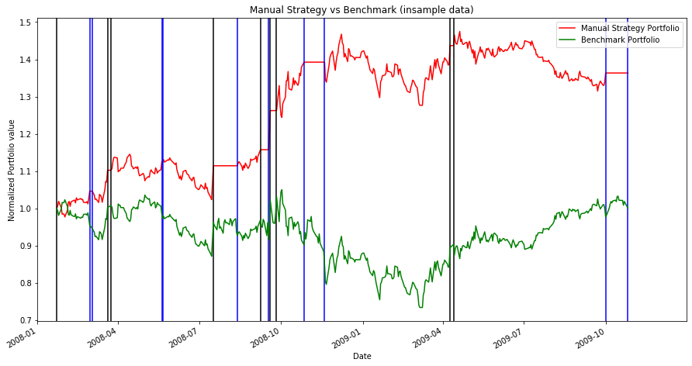

Figure 6: Portfolio Value of Manual Strategy and Benchmark with insample data.   
The Blue vertical lines show BUY signal and Black vertical lines show SELL signal

**Part 4: Comparative Analysis**

Manual Strategy performed better on the insample data than outsample data. But, in both cases it performed better than the Benchmark. The insample data has less volatile data and the conditions were specific to this data. The outsample data is price decreasing overall and the manual conditions were not specific to this data. Even with these differences the Manual Strategy performed better than Benchmark.

|  |  |  |  |  |
| --- | --- | --- | --- | --- |
|  | Manual Strategy | | Benchmark | |
|  | **insample** | **outsample** | **insample** | **outsample** |
| Cumulative Returns | 0.36329 | 0.20199 | 0.01229 | -0.07520 |
| Standard Deviation | 0.01171 | 0.00645 | 0.01700 | 0.00799 |
| Avg Daily Returns | 0.00076 | 0.00041 | 0.00016 | -0.000137 |

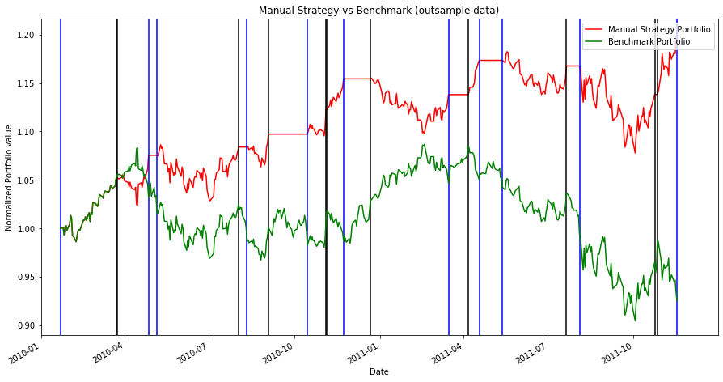Figure 6: Table showing the performance of the Manual Strategy and Benchmark for insample and outsample data

Figure 7: Portfolio Value of Manual Strategy and Benchmark with outsample data.  
The Blue vertical lines show BUY signal and Black vertical lines show SELL signal