Real-Time Face Recognition for Secure Smart Home Automation

Dr. C. R. Rathish
New Horizon College of Engineering
Bengaluru, India
r.rathish87@gmail.com
Vinay Krishnan
New Horizon College of Engineering
Bengaluru, India
vinayvkrishnan66@gmail.com
Dr. Sonia Maria D’Souza
New Horizon College of Engineering
Bengaluru, India
s1985md@gmail.com
Tarun S
New Horizon College of Engineering
Bengaluru, India
tarunthobs09@gmail.com
Priyanshu Roy
New Horizon College of Engineering
Bengaluru, India
roypriyanshu09@gmail.com
Kavya Sivakumar
New Horizon College of Engineering
Bengaluru, India
itskavya2002@gmail.com

Abstract— Face recognition is a very critical component in numerous applications, including security systems, personalized user interfaces, and user access. This paper presents a real-time face recognition system implemented by using TensorFlow. Comprising four modules – Visual Perception, Dynamic Facial Profiling, Cognitive Identity Mapping, and Integration and Adaptation – the architecture captures and preprocesses visual data streams, and revolutionizes facial analysis. Incorporating AI with IOT (Internet of Things) can increase the efficiency of the home automation system. The proposed approach offers robustness against variations in lighting, facial expressions, and poses, making it suitable for real-world applications.
Keywords—Face recognition, TensorFlow, Visual Perception, Dynamic Facial Profiling, Cognitive Identity Mapping, Integration and Adaptation, IoT

Introduction
Smart home automation has revolutionized the way we interact with our living spaces, offering convenience, energy efficiency, and enhanced security. However, ensuring secure access to smart devices and services remains a critical challenge. Traditional authentication methods such as passwords and PINs are susceptible to security breaches and user inconvenience. Face recognition technology presents an attractive alternative, offering seamless and secure authentication based on unique biometric features. This paper explores the integration of advanced face recognition algorithms into smart home environments to enhance security and user experience. The CCTV) is one of the best examples. CCTV services bring a profound cost-effective form of security by identifying criminal activity, detecting suspects, and more. However, the widespread usage of face recognition systems (or CCTV services) has raised new challenges in terms of privacy for IoT scenarios [2]. Because of these concerns, US and UK federal agencies [3] are pushing forward new regulations to protect their privacy, i.e., a ban on facial recognition systems. Public privacy concerns are not only regarding the facial database but also about the recordings from the CCTV surveillance system that is in use. The use of a local server and a database to store information can make this issue less frightening. The modularity of the facial recognition model allows the ability to modify the system accordingly and securely.

Smart Home Automation System
The adoption of a local server bolsters data privacy and security. With data processing and storage confined within the home network, the risk of sensitive information being transmitted over external networks is significantly diminished. This localized approach to data management enhances overall security by minimizing potential vulnerabilities inherent in cloud-based solutions. Smart home systems are an effective way to be aware of strangers trying to barge in and to keep the home secure.
Only when an authorized person is recognized the facilities and features in the house are curated accordingly and if otherwise, there is an alert that is sent to the police station nearby. These systems integrate smart devices like lights, thermostats, door locks, cameras, and sensors, allowing users to remotely manage their home environment via a mobile app or an external interface. With features such as automation, and voice assistant integration, users can customize routines, trigger actions based on certain behavior or mood, and control devices using voice commands. Remote access enables monitoring and management from remote areas efficiently, Energy management features optimize usage by keeping applications in sleep if not required. Overall, home automation systems using AI offer independent living hopes, convenience, efficiency, and enhanced security through centralized control and automation.

FACE RECOGNITION
Face recognition technology is a method of artificial intelligence that focuses on identifying, verifying and detecting individuals based on their facial features. It operates by analyzing unique facial characteristics such as the distance between the eyes, the shape of the nose, and the shape of the face. By leveraging advanced algorithms and machine learning techniques, face recognition systems can accurately match faces by using a database of known individuals or detect faces in real time.
This technology has found multiple applications across various industries, including security, law enforcement, banking, and consumer electronics. In security and law enforcement, face recognition is used for surveillance, and access control, aiding in investigations and crime prevention. In banking, it facilitates personalized experiences, fraud detection, and identity verification for transactions. Consumer electronics devices like smartphones and laptops increasingly feature face recognition as a convenient and secure authentication method which is very crucial in this age of time.
Despite its many benefits, face recognition also raises concerns regarding privacy, surveillance, and biases in algorithmic decision-making. As technology continues to evolve, ongoing discussions around regulations and responsible deployment are essential to ensure its fair use while maintaining its potential for innovative ideas and societal benefit.
In summary, the integration of face recognition technology into home automation and security systems helps integrate various convenience and critical features to work based on the recognized face to allow access and control the pre-set changes to be made.

SYSTEM Architecture
The system architecture contains opening the camera and capturing streams, detecting a face from the live stream, and then recognizing whose face is it by matching from the database. The human face is the best feature for identification for a unique authentication method. Because each human has a certain type of shape, if the face is an identification tool for smart home systems it is easy and efficient. Different algorithms have attained models of the differing images which will be compared with the original images which are already stored in the database as reference points [1].

1. Modules:
1.1 Visual Perception Module:
Purpose: The Visual Perception module serves as a primary sensory interface of the smart home system, enabling real-time acquisition and pre-processing of visual data streams.
Function: Equipped with advanced optical sensors, this module captures high-quality video frames, leveraging algorithms inspired by visual processing to synthesize raw visual data into a holistic environmental representation.
Output: Generates abstract visual representations with the help of encoding spatial and temporal patterns, facilitating subsequent cognitive processing and analysis.
1.2 Dynamic Facial Profiling Module:
Purpose: The Dynamic Facial Profiling module revolutionizes facial analysis for detection within dynamic video streams, employing a context-aware approach to face detection.
Function: Utilizing cutting-edge computer vision techniques, this module dynamically profiles facial features, integrating multi-modal data fusion to achieve facial recognition accuracy.
Output: Provides the facial profiles enriched with contextual metadata, enabling a deeper understanding of human presence and behaviour within the smart home environment.
1.3 Cognitive Identity Mapping Module:
Purpose: The Cognitive Identity Mapping module recreates biometric authentication through the lens of cognitive computing, transcending conventional recognition paradigms to capture the individual identity.
Function: Leveraging principles from cognitive neuroscience, this module employs hierarchical neural networks to emulate human cognition, mapping facial features onto a multi-dimensional cognitive space. It incorporates machine learning techniques to capture not only physical attributes but also behavioural and emotional nuances.
Output: Reveals holistic identity representations, reflecting the complex interplay of many cognitive factors shaping human identity, by giving advantage to personalized smart home experiences aligned with individual preferences and behavioural patterns.
1.4 Integration and Adaptation Layer:
Purpose: The Integration and Adaptation Layer creates the seamless integration of individual modules, facilitating dynamic adaptation to the ever-evolving environmental conditions and user interactions.
Function: This layer integrates outputs from the Visual Perception, Dynamic Facial Profiling, and Cognitive Identity Mapping modules, creating a workflow for real-time facial recognition. It incorporates feedback mechanisms to adapt system behaviour based on user feedback and environmental cues, ensuring better and adaptive smart home functionalities.
Output: Manages the flow of information between modules, enabling real-time decision-making and adaptation to dynamic environmental stimuli and user interactions for a better experience.

This innovative face recognition system architecture embodies an excellent approach to human-centric computing, leveraging principles from cognitive science and contextual intelligence to redefine smart home security and user experiences within the user’s space.
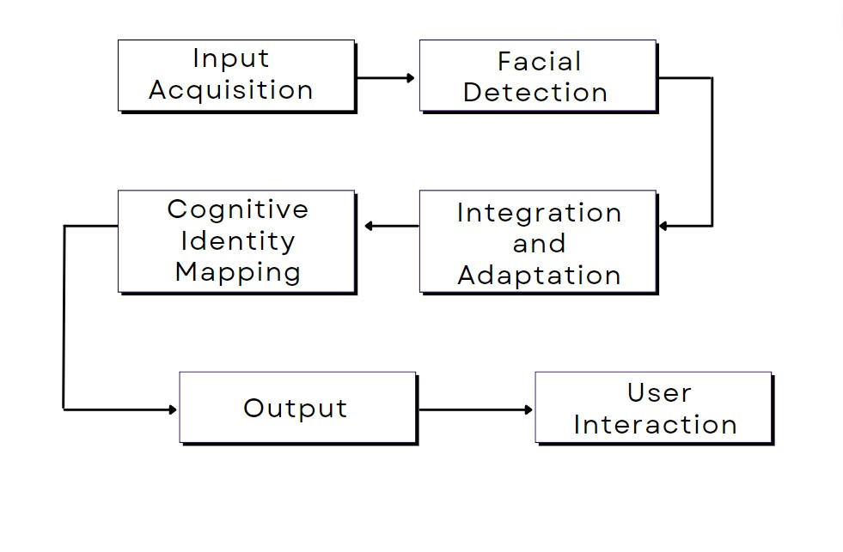
Fig 1. Workflow of model

2. Workflow:
2.1. Input Acquisition:
Visual Perception Module captures high-resolution video frames using advanced optical sensors.
Then input streams are preprocessed to enhance quality and reduce noise.
2.2. Facial Detection and Profiling:
Visual data is fed into the Dynamic Facial Profiling Module.
Context-aware face detection algorithms identify and track faces within the streams.
The facial features are dynamically profiled, and contextual cues from the environment are integrated to master facial recognition accuracy.
2.3. Cognitive Identity Mapping:
Detected faces and contextual data are processed by the Cognitive Identity Mapping Module.
The hierarchical neural networks emulate human cognition to map facial features onto a multi-dimensional cognitive space.
Machine learning techniques with cognitive psychology principles capture physical attributes, behavior, and emotional states.
2.4. Integration and Adaptation:
Outputs from all three modules Visual Perception, Dynamic Facial Profiling, and Cognitive Identity Mapping modules are integrated by the Integration and Adaptation Layer.
The feedback mechanisms analyze user interactions and environmental cues, facilitating dynamic adaptation of system behavior.
Real-time decision-making ensures adaptive smart home functionalities.
2.5. Output Generation:
The coordinated flow of information between modules generates abstract visual representations and identity profiles.
Nuanced identity representations, enriched with contextual data, empower personalized smart home experiences aligned with individual preferences and behavioral patterns.
2.6. User Interaction and Security:
The system facilitates user interactions based on identified user and contextual cues.
Enhanced security is maintained through robust and adaptive biometric authentication mechanisms.
Users can personalize smart home experiences and access controls based on their recognized preferences.
2.7. Continuous Monitoring and Improvement:
The system continuously monitors the environment, user interactions, and feedback.
Machine learning algorithms adapt and optimize system performance on collected data.
Regular updates and improvements are implemented to enhance functionality and user experience.
This workflow illustrates the seamless integration of modules to enable advanced facial recognition capabilities within smart home environments while prioritizing user security.

3. Advantages:
Enhanced Security: Utilizing advanced face recognition algorithms to ensure secure access control and prevent unauthorized entry into the smart home environment.
Personalized User Experience: Recognizes authorized users and provides customized access and experiences to smart home functionalities based on their identities.
Data Privacy: Avoiding the transmission of sensitive data over external networks by processing and storing data locally within the home environment.
Low-Latency Operations: Facilitates faster response times for user commands by processing data locally, reducing delays associated with cloud-based solutions.
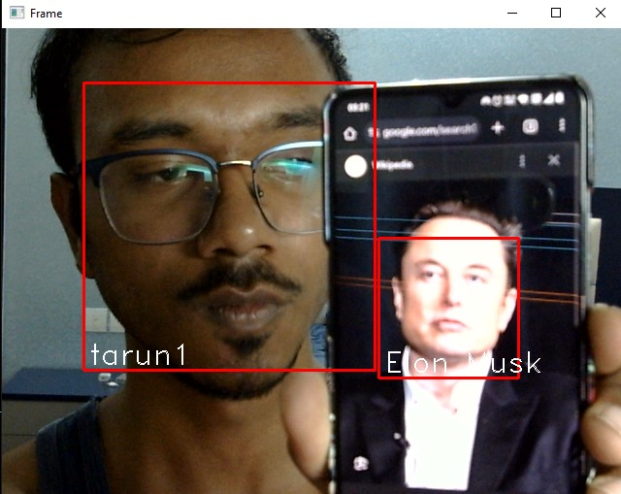
Fig 2. Face Recognition results

4. Future Extensions:
Multi-Factor Authentication: Integration of multiple biometric modalities, such as voice recognition, or fingerprint scanning, or retinal scanning for enhanced security and reliability.
Predictive Analysis: Utilization of AI-based algorithms for predictive analysis and adaptive automation, and adjusting smart home settings according to personal needs.
Integration with IoT Devices: Increasing of the system’s potential to seamlessly integrate with a wide range of IoT devices, enabling comprehensive smart home automation capabilities.

The proposed system architecture offers a comprehensive solution for smart home automation, leveraging advanced face recognition technology that uses deep learning algorithms to provide secure, personalized, and responsive access control within the smart home environment.

References

- Dr.V.Pandimurugan,An mol Jain ,Yash Sinha , “IoT based Face Recognition for Smart Applications using Machine Learning” 2020.
- Wanli Xue, Wen Hu, Praveen Gauranvaram, Sanjay Jha, “An Efficient Privacy-preserving IOT System for Face Recognition” 2020.
- “San Francisco becomes the first us city to ban facial recognition by government agencies,”https://www.theverge.com/2019/5/14/18623013/sanfrancisco-facial-recognition-ban-vote-city-agencies, accessed: 2019-08-05.

