Name: Tarun Rajput
Registration no. : 12305028
University Name: Lovely Professional University

Project Name: Resume

CPP Code:-
#include <iostream>
#include <fstream>
using namespace std;

int main() {
string name, email, phone, education, experience, skills, hobbies;

cout << "Enter your full name: ";
getline(cin, name);

cout << "Enter your email: ";
getline(cin, email);

cout << "Enter your phone number: ";
getline(cin, phone);

cout << "Enter your education details: ";
getline(cin, education);

cout << "Enter your work experience: ";
getline(cin, experience);

cout << "Enter your skills (comma-separated): ";
getline(cin, skills);

cout << "Enter your hobbies (comma-separated): ";
getline(cin, hobbies);

// Write data to resume_data.txt, overwrite if it already exists
ofstream file("resume_data.txt", ios::trunc);
if (file.is_open()) {
file << name << endl;
file << email << endl;
file << phone << endl;
file << education << endl;
file << experience << endl;
file << skills << endl;
file << hobbies << endl; // New line for hobbies
file.close();
cout << "\n✅ Resume data saved to 'resume_data.txt'." << endl;
} else {
cout << "❌ Unable to open file!" << endl;
}

return 0;
}

Screen Shots of Code C++:

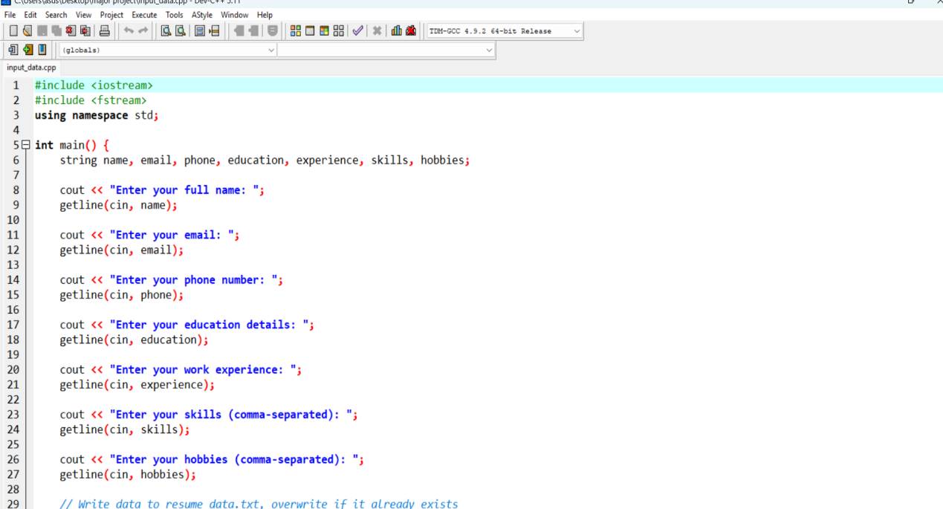

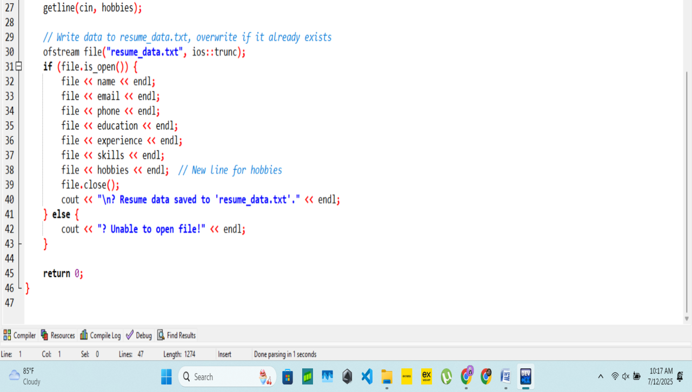
Python and HTML Code:-

import os
from datetime import datetime

# Read data from resume_data.txt
with open("resume_data.txt", "r") as file:
lines = [line.strip() for line in file.readlines()]

# Unpack all 7 fields (including hobbies)
name, email, phone, education, experience, skills, hobbies = lines

# Load the HTML template
with open("templates/resume_template.html", "r") as template_file:
html_template = template_file.read()

# Replace placeholders in template
html_filled = html_template.replace("{{NAME}}", name)
html_filled = html_filled.replace("{{EMAIL}}", email)
html_filled = html_filled.replace("{{PHONE}}", phone)
html_filled = html_filled.replace("{{EDUCATION}}", education)
html_filled = html_filled.replace("{{EXPERIENCE}}", experience)
html_filled = html_filled.replace("{{SKILLS}}", skills)
html_filled = html_filled.replace("{{HOBBIES}}", hobbies)

# Create output folder if it doesn't exist
os.makedirs("output", exist_ok=True)

# Create timestamp-based filename
timestamp = datetime.now().strftime("%Y-%m-%d_%H-%M-%S")
html_filename = f"resume_{timestamp}.html"
html_path = os.path.join("output", html_filename)

# Save final HTML resume
with open(html_path, "w", encoding="utf-8") as output_file:
output_file.write(html_filled)

print(f"✅ HTML Resume generated: {html_path}")

# Optional PDF Export (if pdfkit is installed)
try:
import pdfkit
pdf_filename = html_filename.replace(".html", ".pdf")
pdf_path = os.path.join("output", pdf_filename)
pdfkit.from_file(html_path, pdf_path)
print(f"✅ PDF Resume exported: {pdf_path}")
except ImportError:
print("⚠️ Skipping PDF export (pdfkit not installed)")

<!DOCTYPE html>
<html lang="en">
<head>
<meta charset="UTF-8">
<title>{{NAME}} - Resume</title>
<style>
body {
font-family: 'Segoe UI', Tahoma, Geneva, Verdana, sans-serif;
background-color: #f4f4f4;
color: #333;
margin: 0;
padding: 0;
}

.container {
max-width: 800px;
margin: 30px auto;
background: #fff;
padding: 30px;
box-shadow: 0 0 10px rgba(0,0,0,0.1);
border-radius: 8px;
}

h1, h2 {
color: #2c3e50;
margin-bottom: 10px;
}

p {
margin: 6px 0;
}

.section {
margin-top: 25px;
}

.info {
background-color: #eaf2f8;
padding: 15px;
border-left: 4px solid #3498db;
margin-bottom: 20px;
}

.label {
font-weight: bold;
}
</style>
</head>
<body>
<div class="container">
<h1>{{NAME}}</h1>

<div class="info">
<p><span class="label">Email:</span> {{EMAIL}}</p>
<p><span class="label">Phone:</span> {{PHONE}}</p>
</div>

<div class="section">
<h2>Education</h2>
<p>{{EDUCATION}}</p>
</div>

<div class="section">
<h2>Experience</h2>
<p>{{EXPERIENCE}}</p>
</div>

<div class="section">
<h2>Skills</h2>
<p>{{SKILLS}}</p>
</div>

<div class="hobbies">
<h2>Hobbies</h2>
<p2>{{Hobbies}}</p>
</div>

</div>
</body>
</html>

Automate File(.bat) Code:-

@echo off
cls
echo =====================================
echo ONLINE RESUME GENERATOR (CMD)
echo =====================================
echo.

:: Ask for user input
set /p NAME=Enter your full name:
set /p EMAIL=Enter your email:
set /p PHONE=Enter your phone number:
set /p EDUCATION=Enter your education:
set /p EXPERIENCE=Enter your experience:
set /p SKILLS=Enter your skills (comma-separated):
set /p HOBBIES=Enter your hobbies (comma-separated):

:: Overwrite resume_data.txt with new input
(
echo %NAME%
echo %EMAIL%
echo %PHONE%
echo %EDUCATION%
echo %EXPERIENCE%
echo %SKILLS%
echo %HOBBIES%
) > resume_data.txt

echo.
echo Generating resume...
py generate_resume.py

echo.
echo Opening resume in browser...
for /f %%i in ('dir /b /o:-d output\resume_*.html') do (
start "" output\%%i
goto end
)

:end
Pause

Screen Shots of Implementation in cmd:-
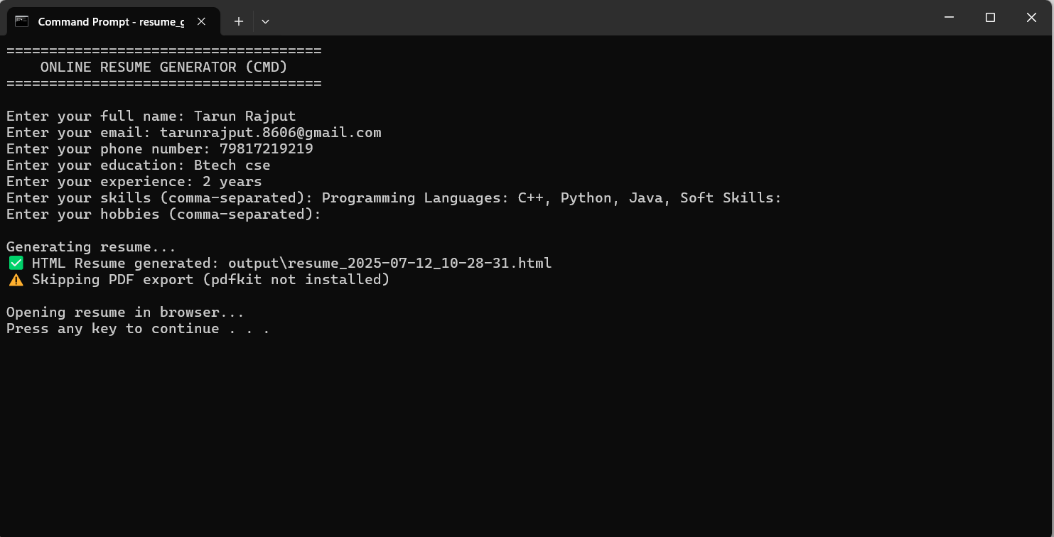
Output:-
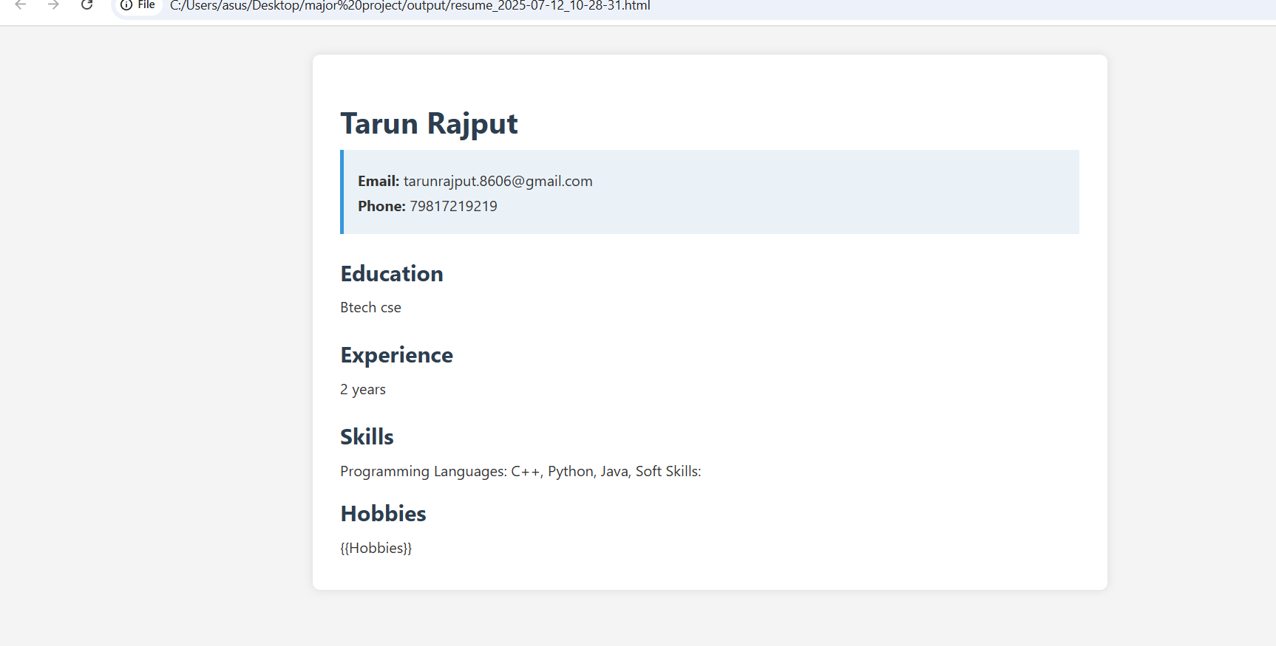

Github link:-

https://github.com/TarunUk/Major-project

