**SUBMISSION**

**Found bugs or issues :**

1. **Clicking the "Reset" button in the report actually saves the report instead of resetting it.**

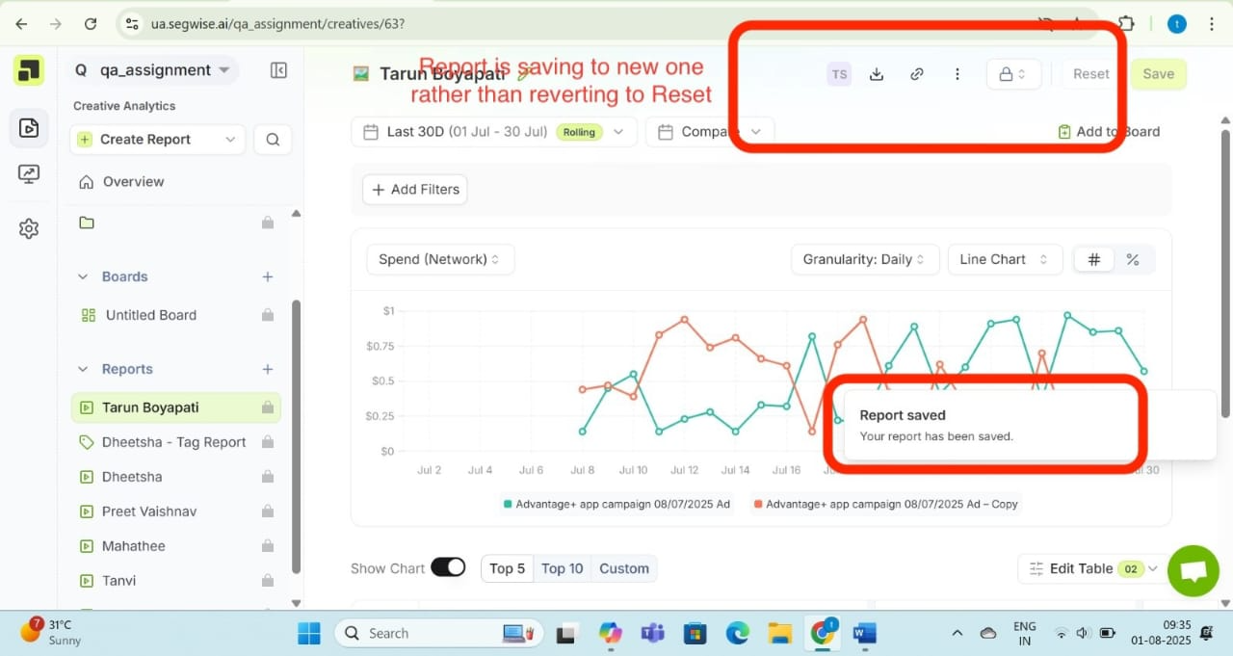

**2. When a large number of characters are entered in the report name, the UI breaks—the text overflows into the chat and table sections.**

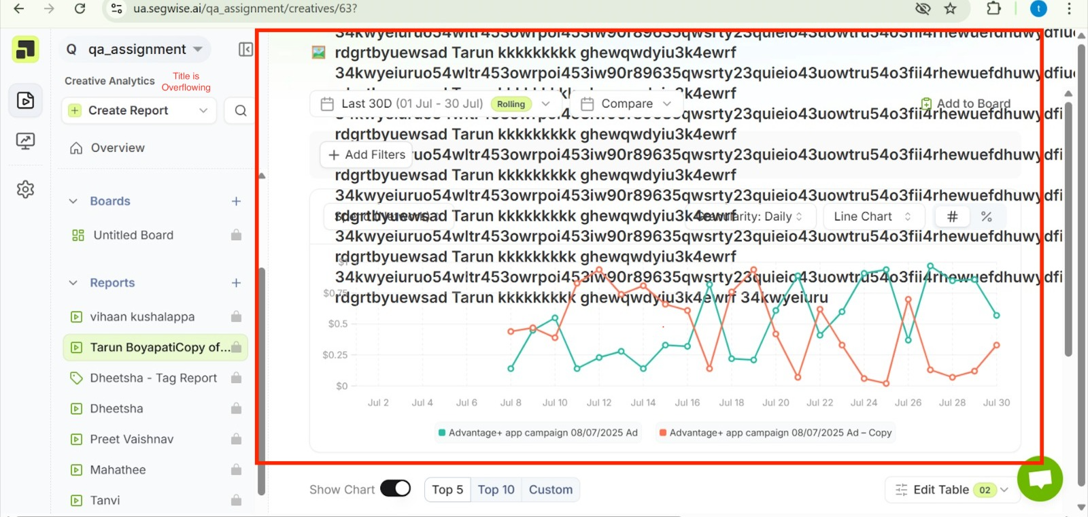

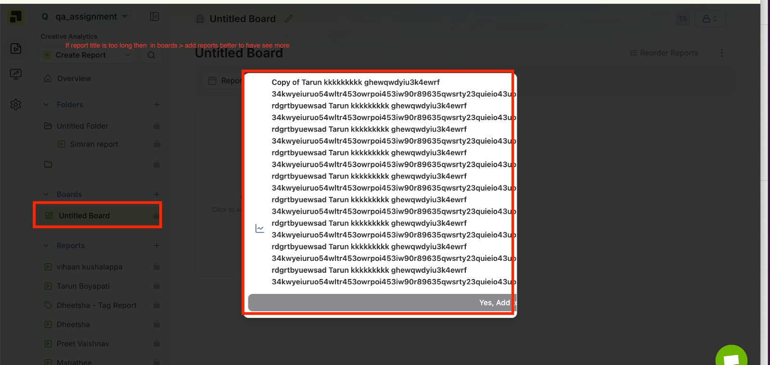

**3.The logout option is missing or not displayed in the user interface.**

**Test cases :**

1. **Valid Login Test  
   Input correct email and password , User should login successfully.**
2. **Manual Navigation to Dashboard  
   Login with valid credentials. If not redirected, manually visit the dashboard URL , Dashboard should load properly.**
3. **Open Report Creation Dialog  
   Click the "+" icon next to the Reports section,Report creation dialog should open.**
4. **Double-Click “Create Report” Quickly  
   Open the report creation dialog and double-click the “Create” button quickly , Only one report should be created.**
5. **Duplicate Report Name  
   Create a report using an existing name ,Should either be allowed or blocked with a validation message.**
6. **Delete Report  
   Click the delete/trash icon on a report and confirm deletion , Report should be removed from the list.**
7. **Create Report with Special Characters  
   Use special characters like @ in the report name and create the report,App should either accept it or show a validation warning.**
8. **Use Back Button from Report View  
   Open a report, then click the browser's back button,Application should handle navigation gracefully.**
9. **Access Dashboard Without Login  
   Try visiting the dashboard URL directly in a new or incognito browser session without logging in , User should be redirected to the login page.**

**10.Session Persistence via Cookies  
After logging in, close and reopen the page , User should remain logged in due to stored cookies.**

**Suggestions :**

1. **Duplicate Report Handling  
   The system currently allows creating multiple reports with the same name. There should be a validation or warning to avoid duplicates.**
2. **User Attribution for Reports  
   Each report should indicate its creator—for example, by showing "Created by me" next to reports made by the logged-in user.**
3. **Sidebar Expansion Issue  
   The sidebar is not expanding or sliding to the right when interacted with. This affects usability on smaller or dynamic layouts.**

|  |
| --- |
|  |