Partition-Key Design and Capacity Mode in Amazon DynamoDB: An Empirical Performance-Cost Evaluation under Serverless Workloads
Rasool Basha Durbesula
24205478
MSc in Cloud Computing
National College of Ireland

Abstract
Amazon DynamoDB meters every request in capacity units and rejects those that exceed the units available, so table configuration governs price and responsiveness at the same time. The benchmarking literature that compares persistence models establishes its findings on self-hosted infrastructure, where capacity units, throttling and per-operation price are not measurable quantities, and reports relative ordering rather than absolute figures. What a given configuration costs, and what it concedes in latency or rejected requests, is therefore unestablished. This proposal specifies a factorial experiment on the managed service in which three partition-key designs are crossed with two capacity modes and exercised by read-heavy, write-heavy, mixed and burst workloads driven from serverless functions. Latency percentiles, throttled requests, consumed capacity units and cost per ten thousand operations are recorded, retaining the baseline study's latency and throughput measures for comparability.
Keywords: Amazon DynamoDB, partition-key design, capacity mode, serverless cost, request throttling

Introduction
Serverless applications increasingly delegate persistence to a fully managed, metered database rather than to a database the application team operates. Amazon DynamoDB is the most widely deployed instance of that arrangement within Amazon Web Services (AWS). Its distinguishing property is not elasticity alone but metering: every read and write consumes read capacity units (RCU) or write capacity units (WCU), requests that exceed the units available are rejected rather than queued, and the bill follows consumption directly.
Two decisions govern that consumption and both are taken early. The partition key determines how items are distributed across partitions, and therefore whether load concentrates on one of them. The capacity mode determines whether units are reserved in advance or charged on demand. Neither decision is easily reversed once a table holds data, and both are frequently taken by default.
The evidence available to inform those decisions does not measure their consequences. Pantelic et al. (2026) benchmark relational and non-relational persistence across read-heavy, write-heavy and mixed microservice workloads as concurrency rises, concluding that the persistence model and the workload composition, rather than the hardware, drive observed performance. The finding is carefully established, but it is established on a self-hosted single node and reported as relative ordering.
That setting cannot yield the quantities a practitioner needs. A self-hosted node has no capacity units to consume, no throttling mechanism to trigger and no per-operation price to accrue. The dependent variables of interest are properties of the metering arrangement itself, so they do not merely go unmeasured in that design: they do not exist within it.
That absence frames the question this study answers: how does Amazon DynamoDB table configuration determine the performance-cost trade-off under serverless workloads?
The consequence reaches beyond any single deployment. A team choosing a partition key and a capacity mode is choosing simultaneously how fast the table responds, how often it rejects work, and what it costs each month, yet has no measured basis for weighing those against one another. Research on cloud data systems, meanwhile, has formalised the metering mechanism without measuring a workload against it, leaving the mechanism described but its consequences unquantified.
The question breaks into four objectives. The first quantifies how partition-key design affects latency and throttling under each workload profile. The second quantifies how capacity mode affects throttling and cost at equivalent load. The third determines whether the configuration that minimises latency also minimises cost. The fourth expresses each configuration as a position on the resulting trade-off surface.
Existing work cannot answer this question because each body of it stops short of the measurement. Benchmarking studies establish relative ordering on infrastructure that has no metering. System-design papers formalise capacity accounting without exercising it with a tenant workload. Vendor documentation states the billing rules but reports no measurements (Amazon Web Services, 2025). This study therefore measures latency, throttling and cost together on the live service, under configurations that are varied deliberately rather than observed as deployed.
For practitioners the deliverable is a trade-off surface spanning key design and capacity mode, reported in absolute latency, rejected-request rate and cost per ten thousand operations, and the reviewed studies are collectively unable to supply it. The methodological outcome is a protocol for attributing a price to a configuration decision on a service whose meter the experimenter does not control.
The remainder proceeds as follows. Section 2 works through the literature along three lines: that benchmarking and skew research establish what governs performance but on systems carrying no meter; that cost-model and serverless work formalises or prices the meter without varying a table under it; and that the levers a tenant actually holds therefore remain unmeasured. Section 3 specifies the factorial design, the workloads and cost derivation, the hypotheses and the tests that decide them, the ethical position and the twelve-week schedule. Section 4 lists the works cited.

Literature Review

Benchmarking Persistence for Cloud Workloads
Benchmarking work on cloud persistence has established what varies and what does not, while holding the economics outside the frame. Pantelic et al. (2026) compare relational and non-relational engines across workload compositions and concurrency levels, isolating the persistence model as the dominant factor. Bodner et al. (2025) take the complementary position, benchmarking serverless compute and storage services and deriving the points at which serverless provision becomes cheaper than provisioned alternatives. The first controls the engine and ignores price; the second prices the infrastructure but does not vary how a table is keyed.
The methodological divide matters for what each can conclude. Pantelic et al. (2026) run on a self-hosted node, which grants full control at the price of removing the metering that defines a managed service, while Bodner et al. (2025) measure the managed services directly but treat storage as a service to be selected rather than a table to be configured.
A third line holds the engine constant and varies only the distribution of access across keys. Kanellis et al. (2025) report that separating hot records from cold yields between 2.1 and 11.9 times the throughput of established key-value stores under a Zipfian profile in which ninety per cent of operations reach eighteen per cent of records. That qualifies Pantelic et al. (2026) rather than confirming them: within a single engine the distribution of requests across keys is itself decisive, and the partition key is what determines it. Their store has no meter, so skew appears there as a throughput effect and never as a price.
Li, Wang and Zhang (2023) isolate key placement as the sole independent variable. Static hash placement across thirty-two shards leaves the busiest shard carrying more than five times the load of the lightest and costs up to thirty-five per cent of throughput, an effect an order of magnitude larger than the cross-shard traffic usually held responsible. Their workload-aware remedy cuts confirmation delay by up to ninety per cent. This is the measured chain from key design to tail latency that Pantelic et al. (2026) cannot supply, and it goes further than Kanellis et al. (2025), who show skew matters but not that changing the key repairs it; it is the closest published indication that the third treatment level proposed here may win. Two limits qualify the transfer: imbalance there surfaces as queueing delay rather than a rejected request, and the remedy is server-side migration, a lever no tenant of a managed service holds.
Benchmarking therefore establishes that workload composition governs performance, and skew research establishes that key distribution governs throughput, while neither establishes what either costs on a metered service. What the literature on cloud cost does establish is considered next.

Cost and Capacity in Metered Cloud Storage
The cost literature approaches the same arrangement from the opposite direction. Lei et al. (2024) formalise request-unit consumption and a multi-tenant cost model for a cloud-native database service, describing precisely the accounting by which a metered store charges its tenants. Haubenschild and Leis (2025) survey cloud transactional architectures and their cost characteristics, establishing that the economics follow from architectural choices rather than from workload alone. Both explain how charging works without reporting what a defined workload is charged.
van Renen and Leis (2023) show why latency alone is the wrong measure for a metered service. On an identical one-terabyte, twenty-tenant workload a per-query metered warehouse cost approximately US$155 against US$22.80 for a provisioned cluster, a 6.8-fold difference, while returning about twice the median query speed. That stands in tension with Bodner et al. (2025): where break-even points treat each service as a unit of selection, here the latency-optimal and the cost-optimal choice diverge inside one comparison, which is the third objective stated here. Their benchmark nonetheless varies neither a partition key nor a capacity mode, and no rejected request enters its cost model.
Storage-engine research narrows the gap without closing it. Zhou et al. (2024) design a contract-aware log-structured store that suppresses latency spikes under cloud storage contracts, showing that tail behaviour and cost contracts are coupled at the engine level, where Lei et al. (2024) describe that coupling as an accounting rule rather than measuring its latency cost. The coupling they demonstrate operates beneath the managed-service interface, however, where a practitioner cannot reach it; the levers available above that interface are the key design and the capacity mode.
Control without metering cannot price, and metering without control cannot attribute. This proposal varies configuration deliberately on the metered service, so that a measured cost can be attributed to a design decision. Table 1 summarises the contrast between the reviewed studies and this proposal, and why none of them suffices for a configuration decision is set out next.
Table 1 Reviewed studies contrasted with the proposed evaluation
Study | Approach | Evaluation methodology | Limitations | Research gap left open | How this proposal differs
Pantelic et al. (2026) | Compare relational and non-relational persistence | Self-hosted single node; read, write and mixed workloads; latency and throughput | Relative trends only; no cost, capacity-unit or throttling measurement | Absolute metered cost of a configuration is unknown | Measures latency, throttling and cost on the live metered service
Lei et al. (2024) | Cloud-native multi-model NoSQL service | System design with request-unit consumption and multi-tenant cost model | Formalises charging; runs no controlled tenant workload against it | What a defined workload actually consumes is unknown | Exercises the metering with a controlled factorial workload
Haubenschild and Leis (2025) | Cloud transactional architecture and cost | Analytical survey of cloud OLTP architectures | Architecture level; table configuration not varied | Effect of a configuration decision is unknown | Varies key design and capacity mode directly
Zhou et al. (2024) | Contract-aware log-structured store | Storage-engine design with latency-spike suppression | Operates below the managed-service interface | Levers available to a tenant remain unmeasured | Confines itself to levers a tenant can actually set
Bodner et al. (2025) | Serverless infrastructure performance and cost | Micro-benchmarks and end-to-end workloads; cost break-even points | Services treated as units of selection, not configuration | Within-service configuration cost is unknown | Varies configuration within one managed service

Why This Research Is Necessary
Five strands of prior work bear on this question and each stops short of it for a different reason. Benchmarking optimises for engine comparison rather than configuration, as Pantelic et al. (2026) do. Skew research establishes that key distribution governs throughput, but Kanellis et al. (2025) and Li, Wang and Zhang (2023) both do so on systems where no request is ever rejected. Cost-model work formalises the metering without exercising it, in Lei et al. (2024) and Haubenschild and Leis (2025) alike. Serverless evaluation prices services rather than their configuration, which is where Bodner et al. (2025) and van Renen and Leis (2023) part company over whether price or latency decides. Engine-level research reaches the mechanism, but Zhou et al. (2024) work below the interface at which a tenant can intervene.
The practical consequence is that a team choosing a partition key and a capacity mode has no evidence relating those choices to latency, rejected requests and cost together. This proposal supplies that evidence through controlled experimentation on the metered service and pre-committed statistical analysis. The space those shortfalls leave open is stated as a niche in the next subsection.

Research Niche
No existing study simultaneously varies partition-key design, varies capacity mode, measures throttling and prices the result per operation on a live metered service. No reviewed study meets more than two of the four simultaneously: Pantelic et al. (2026) vary workload with experimental control but have no meter to read, while Lei et al. (2024) model the meter exactly but run no controlled configuration sweep. A configuration decision needs all four together. Each reviewed design answers its own question well and cannot, by its construction, answer this one.
The baseline for this study is Pantelic et al. (2026). What their setting cannot produce - consumed capacity, throttling and price - is exactly what a configuration decision turns on, and that absence is the problem taken up here. This study measures those quantities directly on Amazon DynamoDB as a function of partition-key design and capacity mode, retaining their latency and throughput measures so that the managed-service result can be read against the ordering they report.
The contribution is a controlled empirical evaluation that varies partition-key design and capacity mode together on the live metered service while measuring latency, throttling, consumed capacity units and per-operation cost within a single design, which is the combination no reviewed study performs. Its output is a surface relating three key designs and two capacity modes to latency, rejected-request rate and cost per ten thousand operations. The reviewed evidence points three ways: throttling should fall furthest under burst load with the workload-aware key, provisioned capacity should undercut on-demand only past a sustained-utilisation threshold, and whichever configuration minimises latency should not prove to be the one that minimises cost. Setting these down beforehand commits the study to a result it can be wrong about, and the trade-off surface is informative in either case.
Practitioners benefit from configuration guidance grounded in measurement rather than convention. The research community gains an absolute, metered account of a managed store against which self-hosted benchmarking results can be calibrated. Deferred to future work are global secondary indexes, multi-region tables, caching layers and adaptive-capacity behaviour observed over longer horizons. Section 3 specifies the experiment that measures the surface described here.

Research Method & Specification
A factorial experiment answers this question. Three partition-key designs are crossed with two capacity modes, giving six table configurations, each exercised by four workload profiles driven from serverless functions. Figure 1 shows the arrangement.
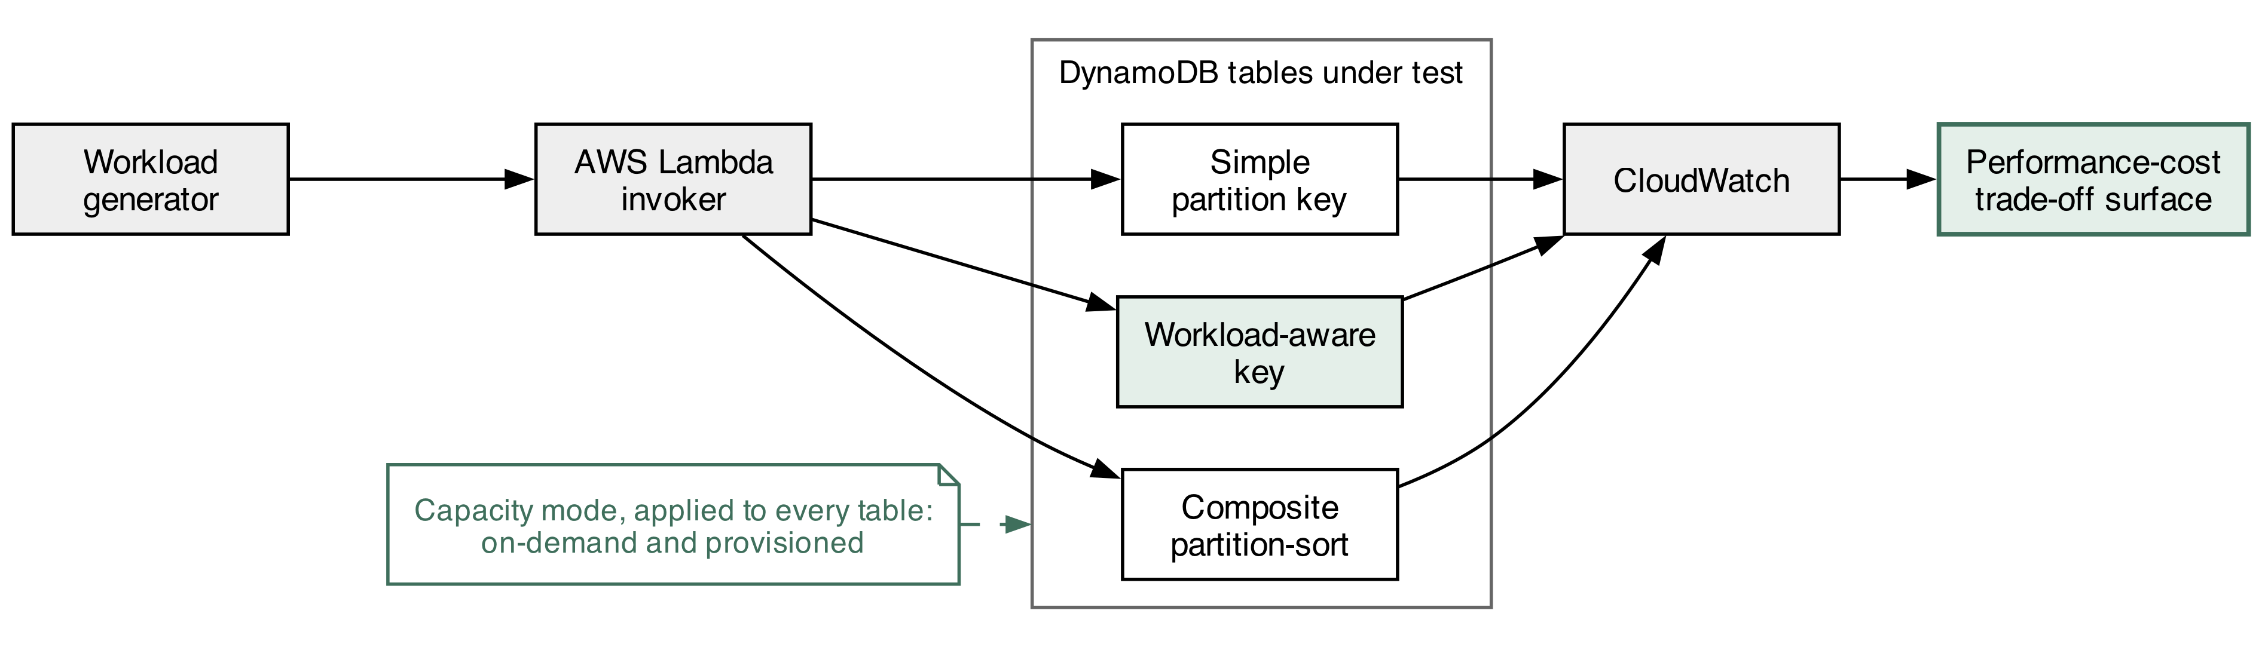
Figure 1 Factorial experimental setup

Research Method
Two independent variables are crossed factorially. The partition-key design has three levels. The first is a simple partition key on the order identifier and the second a composite partition-sort key pairing customer identifier with order timestamp. The third is a workload-aware key, in which the simple key carries a computed shard suffix drawn from a fixed range, so that writes which would otherwise concentrate on one partition are spread across several. The capacity mode has two levels, on-demand and provisioned. Crossing the two yields the six table configurations of Figure 1. Workload profile is a conditioning factor applied to every configuration, at four levels: read-heavy, write-heavy, mixed and burst. Item size is deliberately not part of the factorial. Because capacity units are consumed in proportion to item size, a cost result obtained at one payload would not generalise, so item size is varied separately at 1 KB, 8 KB and 32 KB in a sensitivity run over the best- and worst-performing configurations only.
The dependent variables are the mean latency, the ninety-fifth and ninety-ninth latency percentiles, the successful-operation rate, the count of throttled requests, the consumed read and write capacity units, and the estimated cost per ten thousand operations. Latency and throughput are recorded on the same terms as Pantelic et al. (2026), which is what allows the metered result to be positioned against their relative ordering.
Held fixed throughout are the region, the account, the item schema, the request batch size, the client library and the hour-of-day block in which runs are issued. Adaptive capacity is the first complication. DynamoDB redistributes throughput toward hot partitions over time, redistributing throughput toward hot partitions over time. König et al. (2023) show from production Database-as-a-Service traces that a control plane continually reallocates capacity and relocates replicas as tenant demand shifts, reducing capacity violations by seventy-one per cent where it does so well, which makes the capacity assigned to a table a moving function of the provider's own optimisation rather than a fixed experimental condition. A measurement taken immediately after a load change therefore differs from one taken later; each configuration is held at load for a fixed settling interval before measurement begins, and the interval is reported. The invoking functions are the second: they may contribute cold-start latency unrelated to the table, warm-up invocations precede every measured batch and the run order is randomised across configurations.
Internally, cost is derived from published unit prices applied to consumed capacity rather than read from a bill, which attributes it precisely but assumes those rates hold; the derivation is stated so that it can be recomputed. External validity is bounded by a single account, a single region and a single table class, and nothing here is offered as a statement about competing providers. In construct terms, estimated cost per ten thousand operations excludes storage and data-transfer charges, isolating the request-path cost the configuration actually governs.

Research Resources
Three managed services carry the experiment: DynamoDB itself, AWS Lambda to issue the invocations and Amazon CloudWatch to collect the metrics. All six table configurations are expressed as infrastructure as code (IaC), which makes provisioning and teardown repeatable and keeps spend under control. Published capacity-unit prices (Amazon Web Services, 2025) supply the cost coefficients.
The items written to the table are synthetic order records fabricated for this study. Each table is loaded with one million items spread over ten thousand distinct customer identifiers, at the 1 KB, 8 KB and 32 KB payload sizes used in the sensitivity run. Access is deliberately skewed: keys are drawn from a Zipfian distribution parameterised so that roughly ninety per cent of operations reach ten per cent of keys. Uniform access would concentrate load on no partition and would leave the workload-aware key with nothing to correct, so the skew is a precondition of the comparison rather than an incidental choice. The four workload profiles are parameterised by mix and arrival rate: read-heavy at ninety-five per cent reads, write-heavy at seventy per cent writes and mixed at an even split, each sustained at two hundred operations per second; burst alternates sixty seconds at that rate with thirty seconds at five times it. Request batches are fixed at twenty-five items. Nothing personal, proprietary or belonging to a third party enters the experiment, and nobody participates in it, and all load stays within free-tier-safe limits, which bounds both expenditure and the demand placed on shared infrastructure.

Evaluation
The question is settled by comparing the dependent-variable distributions across the six configurations under matched workload profiles. Objectives one and two follow directly from those comparisons. Objective three turns on a single test: whether the configuration with the lowest latency also carries the lowest cost. A negative answer would demonstrate that the two goals stand in tension and have to be balanced rather than satisfied together. The fourth is addressed by plotting each configuration on the surface spanned by latency, rejected-request rate and cost.
A null and an alternative hypothesis are declared for every comparative objective. For key design, H0 holds that mean latency is equal across the three designs at a given workload and H1 that at least one design departs from the others. For capacity mode, H0 holds that throttled-request rate does not differ between on-demand and provisioned capacity at equivalent load and H1 that it does. For the joint objective, H0 holds that the latency-optimal and cost-optimal configurations coincide and H1 that they diverge. None of the pairs is one-sided, because nothing in the reviewed measurements justifies naming a direction ahead of the data.
The choice of test follows a normality assessment rather than preceding it. Where the distributions are normal, the primary analysis is a two-way analysis of variance over key design and capacity mode including their interaction term. The interaction is the term of interest, not a nuisance. The practitioner question is which configuration wins under which condition, and that is an interaction rather than two independent main effects, so a design analysed one factor at a time would discard the quantity it was built to estimate. Partial eta-squared is reported for every term, and a significant interaction is followed by simple-effects comparisons with Tukey's honestly significant difference across the three key designs. Where normality fails, which tail-latency data frequently do, the aligned rank transform is applied before the same factorial model so that the interaction remains estimable, with epsilon-squared reported alongside.
Tests are conducted at an alpha of 0.05 with Holm-Bonferroni adjustment, since every hypothesis draws on a single measurement campaign. Replication is fixed in advance rather than deferred to the data: each of the six configurations is exercised thirty times under each workload profile, a count chosen so that a medium effect of f equal to 0.25 is detectable at eighty per cent power in the two-way model. The smallest difference treated as practically meaningful is set before collection at ten per cent of baseline mean latency and five per cent of cost per ten thousand operations. The pilot confirms that observed variance is consistent with that calculation rather than fixing the count after the fact, and the rules for reading the result are written down before any measurement is taken.

Ethical Considerations of the Research
No participants take part and no personal data is handled at any stage; every item is manufactured for the experiment, which places consent and data-protection duties outside the study's scope. The considerations that do arise are of a different kind.
Generating sustained and bursty load against a commercial service must remain within the provider's acceptable-use terms. All traffic originates in the researcher's own account and stays inside free-tier-safe bounds, which keeps shared capacity clear and leaves other tenants unaffected. Measurement is not free: capacity consumed is capacity billed. Run counts follow the power calculation rather than being pushed as high as the budget allows, which caps spending and with it the energy, and so the environmental cost, spent to obtain the result.
Reporting integrity is at stake in particular ways here. The analysis plan and the cost derivation are settled before any measurement exists. Throttled and failed operations are published rather than written off as noise. Every statement of results carries its single-account, single-region scope with it, because a reader who took a cost figure to be general would draw the wrong conclusion from it. If the measurements expose service behaviour the provider has not documented, that finding goes to the provider first and is published afterwards. Infrastructure definitions, workload code and the collected measurements are released so that any figure reported here can be recomputed from source.

Project Plan
Figure 2 sets out the twelve-week schedule. Weeks one and two go to standing up the three table designs and writing the workload generator, ending in a rig that can be rebuilt from scratch. Measurement then proceeds by workload profile from week three, with the capacity-mode sweep overlapping the later profiles and the item-size sensitivity runs closing the campaign in week eight.
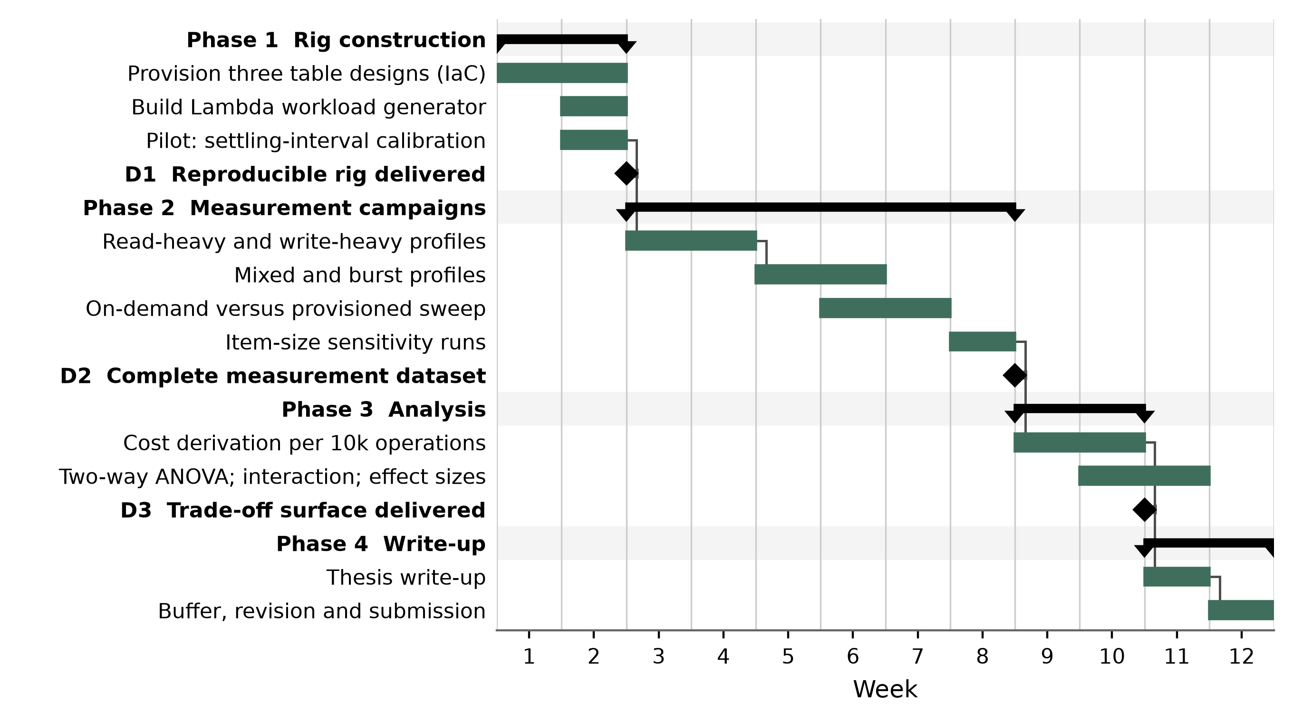
Figure 2 Twelve-week project plan
Cost derivation runs from week nine and the statistical testing from week ten, the write-up begins in week eleven, and week twelve stays free as contingency. Each phase terminates in a named deliverable, and the principal schedule risk is that adaptive capacity lengthens the settling interval required per configuration, which the pilot run is designed to quantify before the main campaigns begin.

References
Amazon Web Services (2025) Amazon DynamoDB developer guide: read/write capacity mode. Available at: https://docs.aws.amazon.com/amazondynamodb/latest/developerguide/HowItWorks.ReadWriteCapacityMode.html (Accessed: 12 June 2026). [Vendor documentation - cited for the billing mechanism only]
Bodner, T., Radig, T., Justen, D., Ritter, D. and Rabl, T. (2025) 'An empirical evaluation of serverless cloud infrastructure for large-scale data processing', in Proceedings of the 28th International Conference on Extending Database Technology. OpenProceedings, p. 935. doi: 10.48786/edbt.2025.76. [Conference - CORE Ranking B (ICORE2026)]
Haubenschild, M. and Leis, V. (2025) 'OLTP in the cloud: architectures, tradeoffs, and cost', The VLDB Journal, 34(4), 42. doi: 10.1007/s00778-025-00913-z. [Journal - JCR Impact Factor 5.97 (2024), Q1]
Kanellis, K., Chandramouli, B., Hart, T. and Venkataraman, S. (2025) 'From FASTER to F2: evolving concurrent key-value store designs for large skewed workloads', Proceedings of the VLDB Endowment, 18(12), pp. 4910-4923. doi: 10.14778/3750601.3750615. [Conference - CORE Ranking A* (ICORE2026)]
König, A.C., Shan, Y., Newatia, K., Marshall, L. and Narasayya, V. (2023) 'Solver-in-the-loop cluster resource management for Database-as-a-Service', Proceedings of the VLDB Endowment, 16(13), pp. 4254-4267. doi: 10.14778/3625054.3625062. [Conference - CORE Ranking A* (ICORE2026)]
Lei, H., Li, C., Zhou, K., Zhu, J., Yan, K., Xiao, F., Xie, M., Wang, J. and Di, S. (2024) 'X-Stor: a cloud-native NoSQL database service with multi-model support', Proceedings of the VLDB Endowment, 17(12), pp. 4025-4037. doi: 10.14778/3685800.3685824. [Conference - CORE Ranking A* (ICORE2026)]
Li, M., Wang, W. and Zhang, J. (2023) 'LB-Chain: load-balanced and low-latency blockchain sharding via account migration', IEEE Transactions on Parallel and Distributed Systems, 34(10), pp. 2797-2810. doi: 10.1109/TPDS.2023.3238343. [Journal - JCR Impact Factor 5.6 (2023), Q1]
Pantelic, N., Matic, L., Jakovljevic, L., Eric, S., Eric, M., Stefanovic, M. and Djordjevic, A. (2026) 'Benchmarking SQL and NoSQL persistence in microservices under variable workloads', Future Internet, 18(1), 53. doi: 10.3390/fi18010053. [Journal - JCR Impact Factor 3.6 (2024), Q2]
van Renen, A. and Leis, V. (2023) 'Cloud analytics benchmark', Proceedings of the VLDB Endowment, 16(6), pp. 1413-1425. doi: 10.14778/3583140.3583156. [Conference - CORE Ranking A* (ICORE2026)]
Zhou, Y., Zhou, J., Lu, K., Zhan, L., Xu, P., Wu, P., Chen, S., Liu, X. and Wan, J. (2024) 'A contract-aware and cost-effective LSM store for cloud storage with low latency spikes', ACM Transactions on Storage, 20(2), pp. 1-27. doi: 10.1145/3643851. [Journal - JCR Impact Factor 2.80 (2024), Q2]

