Isolating Cold-Start Latency Reduction in AWS Lambda Across Runtime, Package-Size and Warming Controls
Kondragunta Lakshmi Chaitanya
25171216
MSc in Cloud Computing
National College of Ireland

Abstract
Cold-start latency remains the most visible performance penalty in serverless computing, yet the configuration studies that guide practitioner decisions report aggregate execution duration in which the initialisation component is averaged away. What proportion of that penalty a developer can remove using only controls available without paid platform features is therefore unquantified. This proposal specifies a controlled experiment in which three functionally equivalent functions, written in Python, Node.js and Java, are deployed in default and optimised variants and invoked under idle, steady and burst conditions. Initialisation duration is isolated from end-to-end latency and reported with tail percentiles, alongside cold-start frequency, error rate and invocation cost. Duration and cost measures are retained from the baseline configuration study so that the isolated penalty can be positioned within the space already mapped. The contribution is a quantified decomposition of the penalty by adjustable control.
Keywords: AWS Lambda, cold start, serverless computing, deployment package size, latency-cost trade-off

Introduction
Serverless platforms allocate execution environments on demand, and the interval required to create one before a function can run is charged to the request that triggers it. This initialisation interval, commonly termed the cold start, has attracted sustained attention. Golec et al. (2024) survey more than a hundred studies and classify mitigation strategies into caching, application-level optimisation and machine-learning approaches. Joosen et al. (2025) demonstrate the scale of the phenomenon in production, reporting 11.9 million cold starts within a single month of platform traces and identifying runtime language and dependency deployment time among the principal contributors. Amazon Web Services (AWS) Lambda exposes several settings that plausibly govern the interval: the language runtime, the size of the deployment package, the memory allocation, and the invocation pattern that determines whether an environment is reused.
The configuration guidance available for these settings does not isolate the interval it would need to explain. Bluemke and Zdanowski (2025) evaluate twenty-three memory configurations across two processor architectures with repeated runs and confidence intervals, which is a careful treatment of the configuration space. Their measurement is nonetheless of steady-state duration and cost on a single Python runtime. Initialisation is therefore averaged into aggregate duration rather than separated from it, runtimes are not compared, and the package-size and warming controls a developer adjusts are not varied. A design reporting aggregate duration cannot recover the initialisation component, because the quantity has been absorbed into the statistic published; further repetition would not retrieve it.
The alternative literature removes the phenomenon rather than measuring it. Saravana Kumar and Selvakumara Samy (2025) forecast invocation demand with deep learning and pre-provision environments accordingly, reducing cold starts effectively but depending on provisioned concurrency, a paid feature. Wen et al. (2025) establish separately that single-run serverless measurements mislead and that repeated measurement with tail percentiles is required for any defensible claim. What remains absent is a controlled measurement of how much of the penalty the freely available controls remove, and of what each removal costs.
Research Question. The above research problem motivates the following research question: How much of AWS Lambda cold-start latency can be removed by developer-adjustable controls, and at what cost?
Four objectives address this question. The first isolates and quantifies the initialisation component across the Python, Node.js and Java runtimes. The second quantifies the effect of deployment-package size and memory allocation on that component. The third quantifies the effect of a low-frequency warming schedule on the proportion of invocations that incur initialisation. The fourth expresses each observed reduction against the invocation cost incurred to obtain it.
The study contributes a decomposition of the cold-start penalty attributable to each freely adjustable control, obtained under controlled conditions and reported with effect sizes. Practitioners gain a basis for choosing between runtime migration, dependency pruning, memory increase and warming, decisions currently guided by convention. The research community gains a measurement that locates the initialisation component within the configuration space existing studies map in aggregate, together with a decision matrix indicating when a low-cost adjustment suffices.
Section 2 reviews the benchmarking and cold-start literature, contrasts the designs employed and identifies the research niche. Section 3 sets out the experimental design, the tooling and workload, the evaluation and analysis plan together with its hypotheses, the ethical position adopted, and the twelve-week schedule.

Literature Review

Configuration and Benchmarking of Serverless Functions
Rigour in serverless measurement is well established, but it has been directed at different targets. Bluemke and Zdanowski (2025) sweep memory allocation across two architectures and report confidence intervals, treating configuration as the independent variable and aggregate duration as the outcome. Copik et al. (2021) instead construct a reusable benchmark suite spanning multiple platforms, treating the platform as the object of comparison and supplying standardised workloads for it. The former achieves depth within one provider and one runtime; the latter achieves breadth across providers while remaining general-purpose. Neither isolates initialisation, because in both the quantity is reported inside a broader duration measure.
Wen et al. (2025) impose a constraint that both must satisfy. Examining performance variance in serverless platforms, they show that single measurements are unreliable and that tail percentiles are necessary for defensible comparison. Bluemke and Zdanowski (2025) meet this requirement through repeated runs and interval estimates, which is why their configuration findings are usable at all. Wen et al. characterise variance itself rather than testing any control, however, so the requirement they establish has not been applied to a comparison of adjustable cold-start controls.
Measurement rigour is therefore available and its requirements are known. What the cold-start literature specifically has established is considered next.

Cold-Start Characterisation and Mitigation
The cold-start literature divides between describing the penalty and removing it. Golec et al. (2024) classify more than a hundred studies and observe that mitigation work concentrates on caching, application-level optimisation and machine-learning prediction. Saravana Kumar and Selvakumara Samy (2025) exemplify the last category, forecasting demand and pre-provisioning environments to eliminate the interval. A survey maps the field without generating measurement; a mitigation study shows the penalty can be removed at a price. Neither quantifies what remains once the freely available controls have been applied, which is the position most developers occupy.
Two approaches to the same phenomenon rest on incompatible access assumptions. Saravana Kumar and Selvakumara Samy (2025) require provisioned concurrency, a paid capability, so their result speaks to operators willing to reserve capacity. Joosen et al. (2025) observe the phenomenon as it occurs across a production platform, decomposing cold-start duration into pod allocation, dependency deployment and scheduling delay. The first prescribes an intervention unavailable within free-tier limits; the second describes behaviour without intervening at all. A developer choosing between pruning a dependency and raising memory is served by neither.
That second point locates this study relative to its two closest prior works, which miss the question from opposite sides. Joosen et al. (2025) analyse observational traces at a scale no experiment could reach and identify runtime language and dependency deployment time as consequential. Because the data is observational, the controls were set by whichever operators deployed the functions, so the study reports association rather than the effect of a deliberate adjustment. Bluemke and Zdanowski (2025) do manipulate configuration deliberately, but report it against aggregate duration, in which the initialisation component is no longer visible. Observation without manipulation cannot attribute; manipulation without isolation cannot measure. This proposal manipulates each control while holding the others constant and isolates the initialisation interval, so a measured reduction can be attributed to a specific decision.
The literature therefore describes the penalty comprehensively and removes it expensively, without measuring what free adjustment accomplishes. Table 1 sets out the comparison.
Table 1 Reviewed studies contrasted with the proposed work
Study | Approach | Evaluation methodology | Strengths | Limitations | How this proposal differs
Bluemke and Zdanowski (2025) | Configuration sweep for duration and cost | 23 memory sizes, two architectures, repeated runs with confidence intervals | Broad configuration coverage; statistically careful | Single Python runtime; steady-state aggregate; initialisation averaged away | Isolates initialisation; compares three runtimes; varies package size and warming
Joosen et al. (2025) | Production cold-start characterisation | Month-long trace; 11.9 million cold starts decomposed | Industrial scale; separates cold-start components | Observational; controls fixed by the operators observed | Manipulates each control while holding others constant
Saravana Kumar and Selvakumara Samy (2025) | Predict demand and pre-provision | Deep-learning forecasting with provisioned concurrency | Substantially reduces cold starts | Requires a paid capability; removes rather than measures the interval | Measures what remains adjustable without paid features
Golec et al. (2024) | Systematic review and taxonomy | More than one hundred studies classified | Authoritative map of mitigation approaches | Synthesises existing work; generates no new measurement | Supplies the controlled measurement the survey finds absent
Copik et al. (2021) | Serverless benchmark suite | Modular, multi-platform benchmarking infrastructure | Standardised and reusable methodology | General-purpose; does not isolate initialisation | Adopts its conventions, narrowed to the cold-start component
Wen et al. (2025) | Performance variance in serverless platforms | Repeated measurement with tail percentiles | Establishes that single runs mislead | Characterises variance; tests no control | Applies its requirements to a control-comparison design

Research Niche
A single structural limitation recurs across the reviewed designs. Studies reporting aggregate execution duration have absorbed the initialisation interval into the statistic they publish, so no volume of further measurement recovers it; the information was discarded at the point of aggregation. Studies eliminating cold starts through reserved capacity have removed the quantity of interest rather than measured it. Studies observing production traces cannot vary the controls, because the controls were fixed by the operators being observed. Each design is sound for its own question and incapable of answering this one.
Bluemke and Zdanowski (2025) characterise AWS Lambda duration and cost across twenty-three memory configurations but deliberately measure steady-state behaviour on a single Python runtime, so the initialisation component is averaged into aggregate duration rather than isolated. This study isolates that component across three runtimes and varies the package-size, memory and warming controls a developer can adjust without paid features, retaining the duration and cost measures they report so that the isolated penalty can be positioned within the configuration space they map.
The expected contribution is a quantified decomposition of the cold-start penalty by adjustable control, each reduction paired with its cost consequence and tested for significance. Anticipated findings are that runtime choice dominates the other controls in magnitude, that dependency pruning yields a smaller reduction obtainable without rewriting application logic, and that low-frequency warming reduces how often initialisation occurs without shortening the instances that do. Practitioners benefit from a decision matrix distinguishing adjustments worth making from those that are not. The research community gains an isolated measurement placeable alongside aggregate configuration results and against which prediction-based mitigation can be judged. Deferred to future work are provisioned concurrency and snapshot-based startup as paid comparators, further runtimes, container-image packaging and cross-provider replication.

Research Method & Specification
A controlled experiment answers this question. Three functionally equivalent functions performing an identical computation are implemented in Python, Node.js and Java, deployed behind a single gateway endpoint, and each provided in a default and an optimised variant. Invocation pattern and configuration are varied while the workload itself is held identical. Figure 1 shows the arrangement.
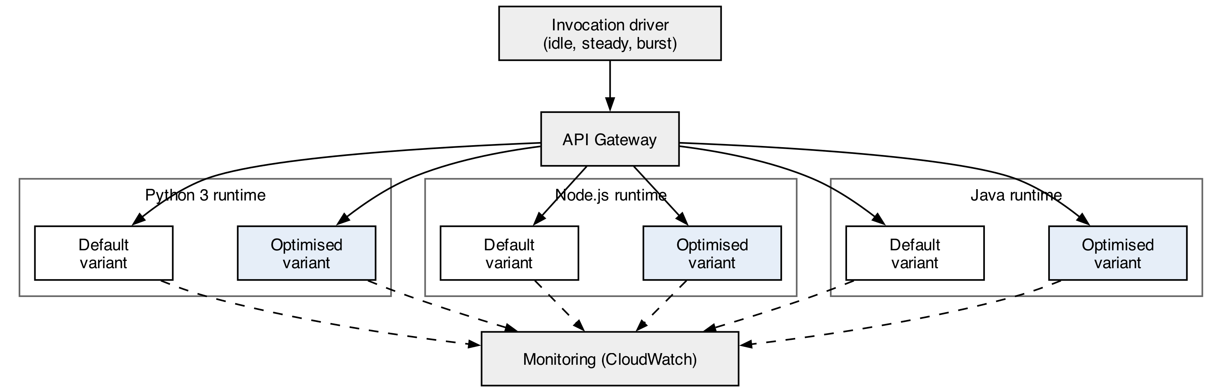
Figure 1 Experimental setup: three runtimes in default and optimised variants

Research Method
The independent variables are the language runtime, the deployment-package size determined by dependency pruning, the memory allocation, and the presence or absence of a low-frequency warming schedule. Invocation pattern is a conditioning factor with three levels: idle-triggered invocations intended to guarantee a new environment, steady low-rate traffic, and bursts. The dependent variables are the reported initialisation duration, end-to-end latency at the fiftieth, ninety-fifth and ninety-ninth percentiles, the proportion of invocations incurring initialisation, the error rate, and the cost per thousand invocations. Aggregate execution duration and cost are recorded as well, because these are the measures reported by Bluemke and Zdanowski (2025) and retaining them is what allows the isolated interval to be positioned within their results.
Region, account, payload, computation performed, processor architecture and time-of-day blocking are held constant. Two confounds require handling. First, environment reuse is decided by the platform rather than the experimenter, so an invocation intended to be cold may be served warm; each invocation is therefore classified by whether an initialisation interval was reported rather than by intent, and only genuinely cold invocations enter the initialisation analysis. Second, platform performance drifts over time, and Wen et al. (2025) show that such variance can be mistaken for a treatment effect; configurations are therefore interleaved rather than run in blocks, and the order is randomised.
The design carries three threats to validity. Internally, an optimised variant differs from its default in more than one respect unless pruning, memory and warming are varied separately, so each is manipulated independently before any combined variant is measured. Externally, results are obtained from one provider, one region and one account, and no claim is made about other platforms. In construct terms, the reported initialisation duration is the platform's own account of environment setup and may exclude scheduling delay that a user nevertheless experiences; end-to-end latency is recorded alongside it so that both perspectives remain visible.

Research Resources
The experiment requires AWS Lambda, a gateway endpoint and Amazon CloudWatch, with function packages built reproducibly so that each variant differs from its default in a recorded manner. Repeated invocation is driven by a scheduled script rather than a managed load service, which keeps the invocation pattern under experimental control. Test data consists of a fixed synthetic payload used identically across every runtime and variant; no personal, private or third-party data is involved and no human participants take part. Copik et al. (2021) supply the workload-design conventions followed here, narrowed from platform comparison to runtime comparison within a single platform. The design remains within free-tier and low-cost limits, which is itself a condition of the research question rather than only a practical constraint.

Evaluation
The question is settled by comparing initialisation duration and cost across variants under matched invocation patterns. The first three objectives are addressed by those comparisons, taken control by control. The fourth is addressed by expressing each statistically supported reduction as a ratio of milliseconds saved to additional cost per thousand invocations, which produces the decision matrix.
Each comparison is stated as a hypothesis pair. For the runtime comparison, the null hypothesis holds that mean initialisation duration does not differ across Python, Node.js and Java, against the alternative that at least one runtime differs. For package size, the null hypothesis holds that dependency pruning does not change initialisation duration, against the alternative that it does. For warming, the null hypothesis holds that a low-frequency schedule does not change the proportion of invocations incurring initialisation, against the alternative that it does. Each is non-directional, since the direction of the package-size and warming effects is not established in the reviewed literature.
Normality is assessed before a test is selected. Where it holds, one-way analysis of variance is used for the three-runtime comparison and an independent-samples t-test for each two-level control, with eta-squared and Cohen's d reported respectively. Where it does not, which the tail behaviour reported by Wen et al. (2025) makes likely, the Kruskal-Wallis and Mann-Whitney U tests are substituted, with epsilon-squared and rank-biserial correlation. The significance level is 0.05, and the Holm-Bonferroni correction is applied because several hypotheses draw on one collected dataset. Sample sizes per configuration are fixed from the pilot so that a reduction of practical interest is detectable, and the threshold below which a reduction is judged not worth its cost is set before collection begins.

Ethical Considerations of the Research
The study recruits no participants and gathers no personal data of any kind; the payload is synthetic and fixed, so consent and data-protection duties are never engaged. The remaining considerations are of a different kind. Repeated invocation consumes billable compute, and the experiment is bounded by pilot-derived sample sizes rather than run to exhaustion, both to control cost and to limit the energy, and therefore the environmental cost, incurred for the knowledge obtained. Repeated invocation must equally remain inside the provider's acceptable-use terms: invocation volumes stay within published service limits and within the researcher's own account, so no shared capacity is placed under pressure and no other tenant is affected. Should the measurements expose undocumented platform behaviour, responsible disclosure to the provider will precede publication of that finding. Reporting integrity requires that the analysis plan and the cost threshold be fixed before any data exists, that invocations discarded as warm be counted and reported rather than silently dropped, and that the single-provider and single-region scope accompany every summary of the findings, since a practitioner reading a latency reduction as general would be misled. Function code, package manifests and collected measurements will be published so that the comparison can be repeated independently.

Project Plan
The plan spans twelve weeks and is shown in Figure 2. Provisioning and instrumentation occupy the first two weeks and end in a validated measurement pilot that fixes sample sizes. Four measurement tracks then run with deliberate overlap, each isolating one control: runtime, package size, warming schedule and memory allocation. Overlapping them is possible because the tracks share a single deployed estate and differ only in which variable is varied, and it leaves slack that sequential execution would not. Burst and idle replication follows in week eight. Analysis occupies weeks nine to eleven, write-up week eleven, and week twelve is held as buffer. The principal schedule risk is that new environments cannot be obtained on demand, which the idle-triggered pattern established during the pilot is designed to mitigate.
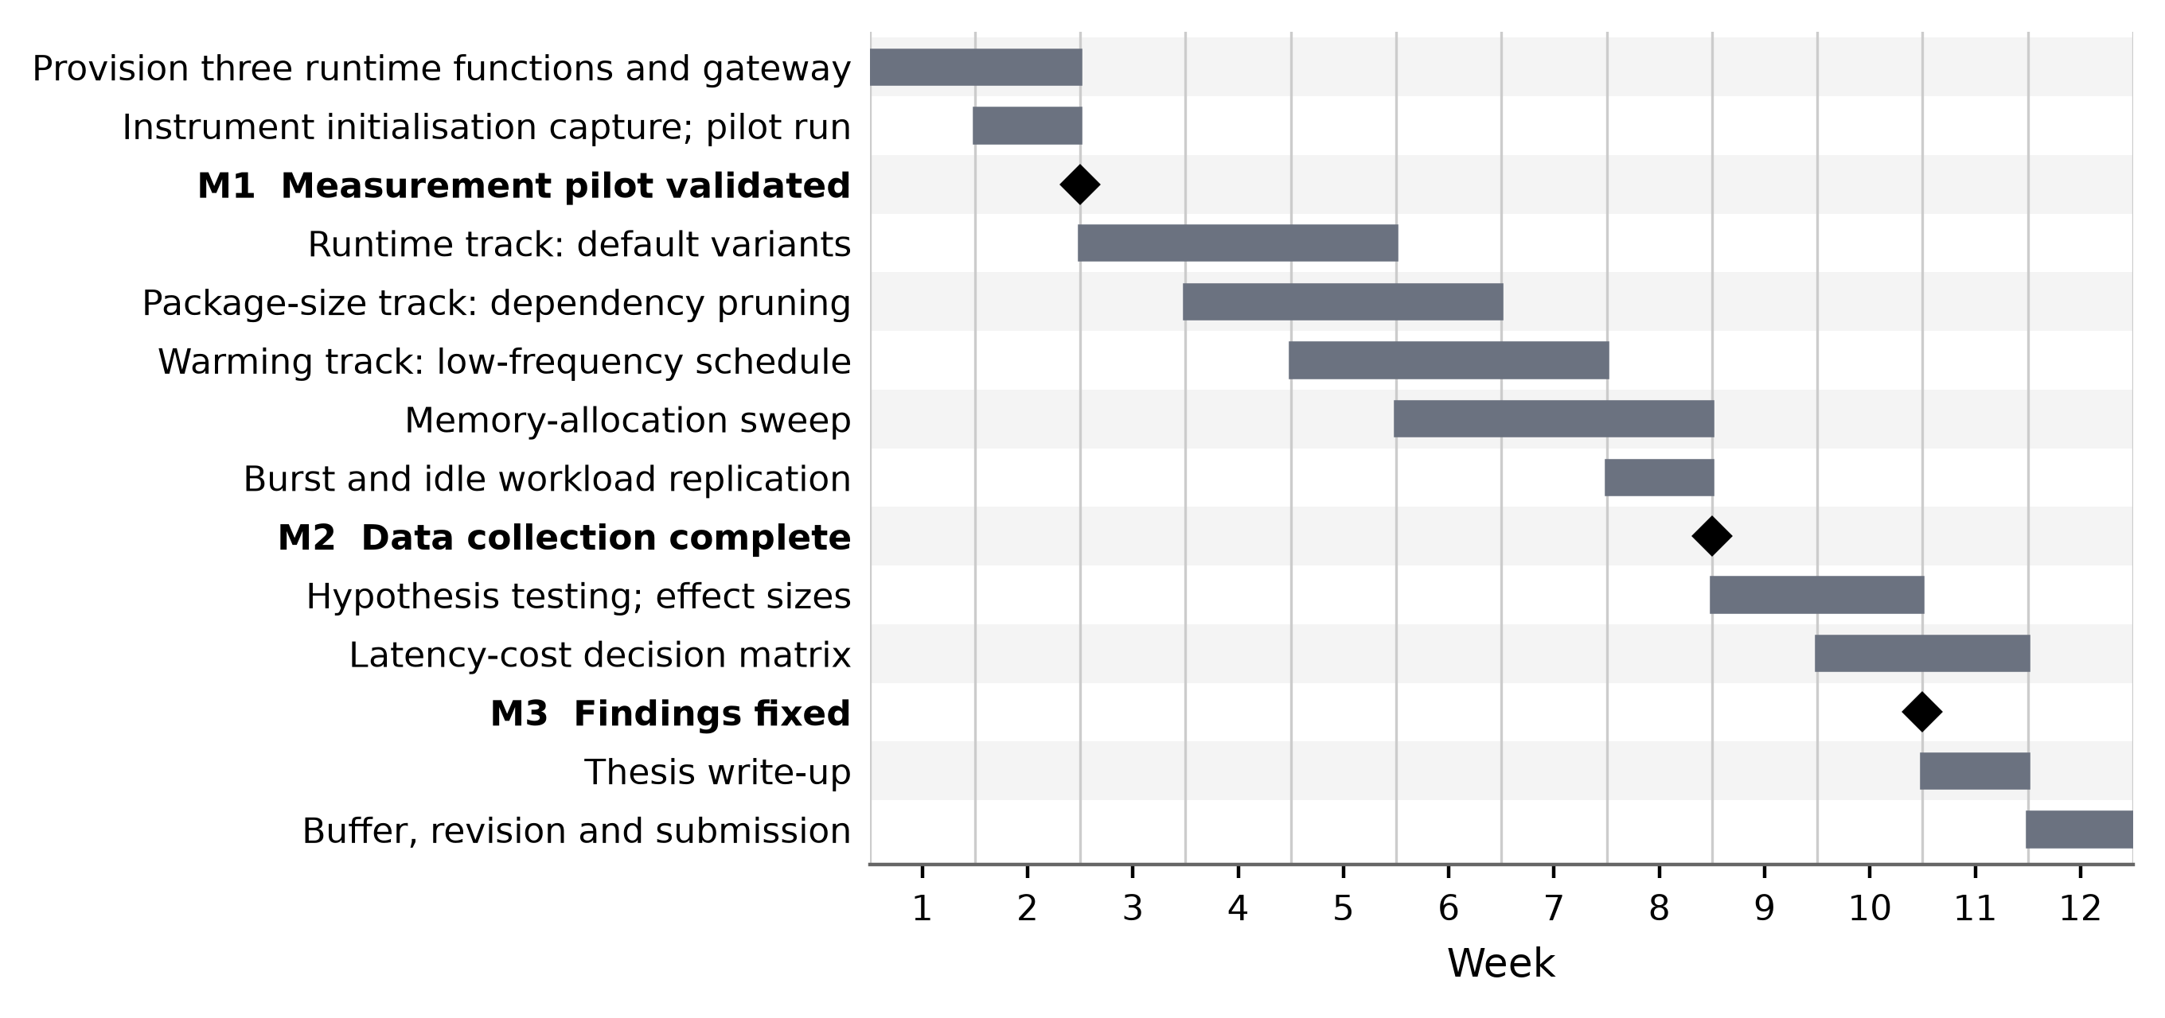
Figure 2 Twelve-week project plan

References
Bluemke, I. and Zdanowski, A. (2025) 'Evaluation of configurations of AWS Lambda functions', International Journal of Electronics and Telecommunications, 71(3), pp. 1-9. doi: 10.24425/ijet.2025.153619. [Journal - Scopus-indexed, Q3; no JCR Impact Factor; Google Scholar citations: 1 (accessed 26 July 2026)]
Copik, M., Kwasniewski, G., Besta, M., Podstawski, M. and Hoefler, T. (2021) 'SeBS: a serverless benchmark suite for function-as-a-service computing', in Proceedings of the 22nd International Middleware Conference. New York: ACM, pp. 64-78. doi: 10.1145/3464298.3476133. [Conference - CORE Ranking A (ICORE2026)]
Golec, M., Walia, G.K., Kumar, M., Cuadrado, F., Gill, S.S. and Uhlig, S. (2024) 'Cold start latency in serverless computing: a systematic review, taxonomy, and future directions', ACM Computing Surveys, 57(3), pp. 1-36. doi: 10.1145/3700875. [Journal - JCR Impact Factor 23.8 (2024), Q1]
Joosen, A., Hassan, A., Asenov, M., Singh, R., Darlow, L., Wang, J., Deng, Q. and Barker, A. (2025) 'Serverless cold starts and where to find them', in Proceedings of the Twentieth European Conference on Computer Systems. New York: ACM, pp. 938-953. doi: 10.1145/3689031.3696073. [Conference - CORE Ranking A (ICORE2026)]
Saravana Kumar, N. and Selvakumara Samy, S. (2025) 'Cold start prediction and provisioning optimization in serverless computing using deep learning', Concurrency and Computation: Practice and Experience, 37(4-5), e8392. doi: 10.1002/cpe.8392. [Journal - JCR Impact Factor 2.60 (2024)]
Wen, J., Chen, Z., Sarro, F. and Wang, S. (2025) 'Unveiling overlooked performance variance in serverless computing', Empirical Software Engineering, 30(2), 59. doi: 10.1007/s10664-025-10615-3. [Journal - JCR Impact Factor 4.33 (2024), Q1]

