Lightweight Fault Detection and Localisation in AWS Serverless Microservices: Accuracy and Monitoring Overhead against Deep-Learning Baselines
Yashaswini Penumarthi
24262404
MSc in Cloud Computing
National College of Ireland

Abstract
The most accurate published detectors of microservice faults reach their accuracy by training deep models on large labelled telemetry corpora. A newly deployed, cost-constrained serverless service has no such corpus and no budget for training compute, so those methods are not merely expensive in that setting but inapplicable to it. How much accuracy a rule-based alternative forfeits, and what monitoring it costs, is unquantified. This proposal specifies a controlled evaluation in which threshold and deviation rules over CloudWatch telemetry, combined with X-Ray trace-dependency ranking, are exercised against injected faults in an order-processing microservice. Accuracy is reported as precision, recall, F1, detection delay and top-k localisation, and overhead as telemetry volume, added latency and cost. Reproducible baselines on a published benchmark supply the comparison, so the accuracy conceded is measured rather than asserted.
Keywords: serverless observability, fault localisation, AWS X-Ray, monitoring overhead, anomaly detection

Introduction
Faults in microservice systems propagate. A timeout in one dependency surfaces as elevated latency in every service downstream of it, so the service reporting the symptom is rarely the service at fault. Observability tooling exists to close that gap, and in Amazon Web Services (AWS) two managed sources carry the necessary signal: CloudWatch, which records metrics and logs, and X-Ray, which records the trace of a request through the services it touches.
The most accurate published methods for exploiting that signal are learned. Xing et al. (2025) report an F1 score of approximately 93 per cent for detection and comparable top-three accuracy for localisation, using a dual-channel deep model with causal inference. Zhang, J. and Yang (2026) reach competitive accuracy on processor resources alone, and Zhang, W. et al. (2026) localise root causes through a dependency graph with language-model assistance.
Each of those results carries a precondition that its target setting satisfies and another setting does not. A supervised detector must be trained, and training requires labelled examples of the failures it is meant to recognise. A serverless service deployed last month has produced no such history, holds no labels, and is typically operating under a cost ceiling that excludes hours of training compute. The barrier is not expense but data availability, and no amount of engineering effort removes it.
What remains available in that setting is the untrained alternative: fixed thresholds, deviation from a short rolling baseline, and the dependency ordering that a trace already encodes. Such rules require no history. How much accuracy they concede, and what continuous tracing and logging cost in volume, latency and money, has not been measured against the learned methods on common terms.
This study therefore asks: what accuracy-overhead position does rule-based fault detection and localisation occupy relative to learned baselines in serverless microservices?
The question matters beyond a single deployment. A team standing up a small service must decide how much observability to instrument before any failure history exists, and currently has no evidence relating that decision to the detection accuracy it buys or the overhead it incurs. The research community, meanwhile, evaluates detection accuracy in isolation from its monitoring cost, so the two are not jointly characterised anywhere in the reviewed literature.
Four objectives follow from it. The first quantifies detection accuracy under injected faults as precision, recall, F1 and detection delay. The second quantifies localisation accuracy as top-k accuracy and mean rank of the true root-cause service. The third measures the monitoring overhead incurred, in telemetry volume, added latency and estimated cost. The fourth positions the result against learned baselines evaluated on common data.
Existing work cannot answer this question because accuracy and overhead are never measured together on comparable terms. Learned methods report accuracy obtained under data conditions the target setting cannot supply, and report no monitoring cost at all; benchmarks and untrained trace analysis supply the means and the feasibility respectively, but neither establishes a position. This study therefore measures both dimensions on one design and reports them jointly.
In practical terms the study yields an accuracy-overhead position for rule-based detection, something a team can weigh before it commits to instrumentation and something none of the reviewed work is equipped to provide. The methodological outcome is a comparison protocol that makes an untrained method and a trained one legible to one another, which is itself a contribution given that they cannot be run on the same inputs.
The remainder is organised as follows. Section 2 reviews the detection literature in three moves: that learned methods set the accuracy ceiling but presuppose a labelled corpus; that untrained and threshold-based methods establish feasibility, and in places parity, without pricing what they observe; and that a published benchmark now supplies the substrate on which the two can be compared, leaving the comparison itself unperformed. Section 3 specifies the two-arm design, the injection procedure and datasets, the three-leg comparison protocol, the hypotheses and the tests that decide them, the ethical position and the twelve-week schedule. Section 4 lists the works cited.

Literature Review

Learned Detection and Localisation in Microservices
Learned detection has converged on accuracy while diverging on cost. Xing et al. (2025) combine two telemetry channels with causal inference and report detection F1 near 93 per cent with comparable top-three localisation. Zhang, J. and Yang (2026) pursue the same accuracy target under an explicit resource constraint, using dynamic graph networks and recurrent modelling on processor resources alone. The first optimises for accuracy and accepts the training burden; the second reduces the hardware burden while retaining the model.
Retaining the model retains its precondition. Both approaches require a labelled corpus of past failures from which to learn what a failure looks like, and Zhang, J. and Yang (2026) observe additionally that combining heterogeneous signals introduces feature redundancy and modelling complexity. Reducing the compute needed to train does not reduce the history needed to train on, which is the constraint that binds in a newly deployed service.
The reported accuracy also depends on how the decision boundary is set. Liu et al. (2023) evaluate multivariate detection on production cloud metrics and report an average F1 of 0.9494 against 0.8892 for the strongest deep baseline at a tenth of its runtime, but state that thresholds are swept manually and that the baselines' own automatic threshold selection is replaced by the same procedure. Part of the reported separation is therefore attributable to tuning the boundary rather than to the model behind it, which matters here because the quantity they tune by hand is the quantity a rule-based arm must fix in advance and never revise.
Graph-based localisation illustrates the same boundary from a different direction. Zhang, W. et al. (2026) construct a dependency graph and enlist a language model to assist recovery, reporting effectiveness in smaller systems while noting scalability limits in larger ones. The dependency structure they exploit is available without training, but the language-model component reintroduces a per-invocation cost that the reported evaluation does not quantify.
Learned methods therefore establish the accuracy ceiling and its price in data. Because the research question asks what accuracy survives when that data is unavailable, the untrained alternatives are considered next.

Lightweight Alternatives and the Cost of Observing
Reporting accuracy without reporting overhead withholds half of the decision. A team instrumenting a small service is choosing simultaneously how much it will detect and how much telemetry it will pay to emit, and neither Xing et al. (2025) nor Zhang, W. et al. (2026) report the second quantity.
Whether the accuracy premium is large is itself contested. Schmidl, Wenig and Papenbrock (2022) re-implement seventy-one detection algorithms over 976 time series and find the best cost-benefit performer to be an untrained statistical detector reaching an average AUC-ROC of 0.83 at 2.2 milliseconds per point, concluding that deep learning is not yet competitive once training cost is counted. Set beside Xing et al. (2025), whose figure presupposes an assembled labelled corpus, this suggests the premium may be smaller than the precondition it imposes. Their series are largely univariate rather than correlated cloud metrics, however, and AUC-ROC is threshold-free, so the study ranks detectors without settling where an operating threshold belongs.
El Khairi et al. (2024) dispense with training entirely, deriving a baseline at runtime from peer replicas of the same service and flagging a snapshot whose dissimilarity from the replica set exceeds a threshold fixed by sweep, reporting average precision of 91.08 per cent and recall of 98.35 per cent that hold steady across updates which degrade trained baselines. This is direct evidence against the premise that untrained detection must concede accuracy, and a precedent for fixing a threshold by calibration rather than assertion. It presupposes several concurrent comparable replicas, which independently scaled serverless instances may not provide, and it neither ranks root causes nor prices the observation.
Untrained localisation is nonetheless established as viable. Zhang, C. et al. (2024) localise performance issues by searching for attribute combinations that are frequent in anomalous traces and rare in normal ones, requiring no trained model and validating the approach at a flagship software-engineering venue. Their method uses traces alone, however, and reports neither the monitoring overhead it incurs nor its accuracy relative to learned detectors, so it stops exactly where El Khairi et al. (2024) also stop: viability demonstrated, position unestablished.
The comparison those studies leave open has recently become tractable. Pham et al. (2025) publish a benchmark comprising 735 labelled failure cases across three microservice systems, with metrics, logs and traces collected for each, together with fifteen reproducible baselines. Between them, Zhang, C. et al. (2024) and Pham et al. (2025) hold both halves of the answer and neither joins them: viability without comparison cannot establish a position, and a comparison substrate without a study does not produce one.
The reviewed approaches and their distance from this proposal appear in Table 1. Viability and comparability having been treated separately in the literature, the four directions that leave the question unanswered are drawn together next.
Table 1 Reviewed approaches contrasted with the proposed evaluation
Study | Approach | Evaluation methodology | Strengths | Limitations | How this proposal differs
Xing et al. (2025) | Dual-channel deep learning with causal inference | Trained on labelled telemetry; F1 and top-3 localisation reported | Highest published accuracy | Requires labelled history and training compute absent in new serverless services; no overhead reported | Measures accuracy attainable without any training history, and the overhead it costs
Zhang, J. and Yang (2026) | Dynamic graph networks with recurrent modelling | Processor-only spatiotemporal detection | Removes the accelerator requirement; notes signal redundancy | Still a learned model requiring a labelled corpus | Requires no corpus at all
Zhang, W. et al. (2026) | Graph-based localisation with language-model assistance | Dependency-graph construction and assisted recovery | Effective in smaller systems | Assisting model adds unreported per-invocation cost; scalability limits acknowledged | Uses dependency ordering only, and prices the observation
Zhang, C. et al. (2024) | Attribute-based trace localisation | Search for attribute combinations frequent in anomalous traces | Learning-free; validated at a flagship venue | Traces only; no accuracy comparison against learned methods; no overhead figure | Adds metrics and logs, compares against learned baselines, and reports overhead
Pham et al. (2025) | Benchmark and evaluation harness for root-cause analysis | 735 labelled failure cases, three systems, fifteen reproducible baselines | Enables like-for-like comparison on identical inputs | Supplies data and baselines rather than findings; no cloud cost or latency dimension | Uses it as the comparison substrate and adds the overhead measurement it cannot provide

Why This Research Is Necessary
Prior work approaches this problem from four directions, none of which arrives at the measurement the question demands. Deep-learning detection reports the highest accuracy but under conditions the target setting cannot meet, as Xing et al. (2025) and Zhang, J. and Yang (2026) both illustrate. Untrained and threshold-based methods establish feasibility, and in Schmidl, Wenig and Papenbrock (2022) and El Khairi et al. (2024) something close to parity, without positioning themselves against learned accuracy or pricing the observation; Liu et al. (2023) show how much of the apparent gap is threshold tuning. Graph-based localisation in Zhang, W. et al. (2026) dispenses with some training while reintroducing an unreported per-invocation cost, where Zhang, C. et al. (2024) avoid that cost but forgo the comparison. Benchmark infrastructure from Pham et al. (2025) supplies labelled failures and reproducible baselines but reports no findings of its own, and Mertz and Nunes (2023) and Huang et al. (2024) price observation without relating it to any detection outcome.
The practical consequence is that a team cannot tell what accuracy it forfeits by instrumenting rules instead of training a model, nor what either choice costs to run. This proposal addresses that absence through controlled fault injection, evaluation against reproducible baselines on common data, and pre-committed statistical analysis. The next subsection states precisely the niche this leaves.

Research Niche
No existing study simultaneously evaluates an untrained detection method, compares it against learned baselines on common data, measures localisation as well as detection, and reports the monitoring overhead incurred. Not one of the reviewed studies satisfies more than two of these four at once: Xing et al. (2025) measure detection and localisation accuracy but neither compare against an untrained method nor report overhead, while Pham et al. (2025) supply common data and baselines without measuring overhead or producing a study. An instrumentation decision turns on all four at once. Every reviewed design serves its own purpose competently; none was built to answer this one, and none reports the measurements that answering it would require.
Xing et al. (2025) are the baseline for this study. Their accuracy is reached by training on a labelled telemetry corpus that a newly deployed, cost-constrained service cannot supply, having produced no failure history to label, and that absence is the problem taken up here. This study measures how much of that accuracy a rule-based CloudWatch and X-Ray method retains under injected faults, reporting F1 and top-k on the same terms so the accuracy conceded is quantified rather than assumed, together with the monitoring overhead it costs.
The contribution is a jointly reported accuracy-overhead position for untrained detection and localisation in serverless microservices, a pairing no reviewed study performs, together with the protocol that makes an untrained and a trained method comparable at all. Read together, the reviewed results support three expectations, each stated as a threshold so that a measurement can contradict it: that the rule-based arm concedes no more than ten percentage points of F1 against the strongest reproducible baseline; that it concedes more than ten points in top-three localisation accuracy; and that it reduces telemetry volume by at least half. Committing to these in advance keeps them refutable, and the accuracy-overhead position stands whichever direction each turns out to run.
Practitioners benefit from evidence relating instrumentation choices to detection outcomes before any failure history exists. The research community gains a jointly measured accuracy-overhead account against which learned detectors can be assessed on a dimension they do not currently report. Section 3 specifies the evaluation that occupies this niche. Deferred to future work are multi-service topologies, online rule adaptation, hybrid rule-and-model detection and cross-provider replication.

Research Method & Specification
A controlled evaluation with two detection arms answers this question. An order-processing microservice is instrumented, faults are injected under a controlled script, and the resulting telemetry is analysed by a rule-based arm and compared against reproducible learned baselines. Figure 1 shows the arrangement and the experimental workflow.
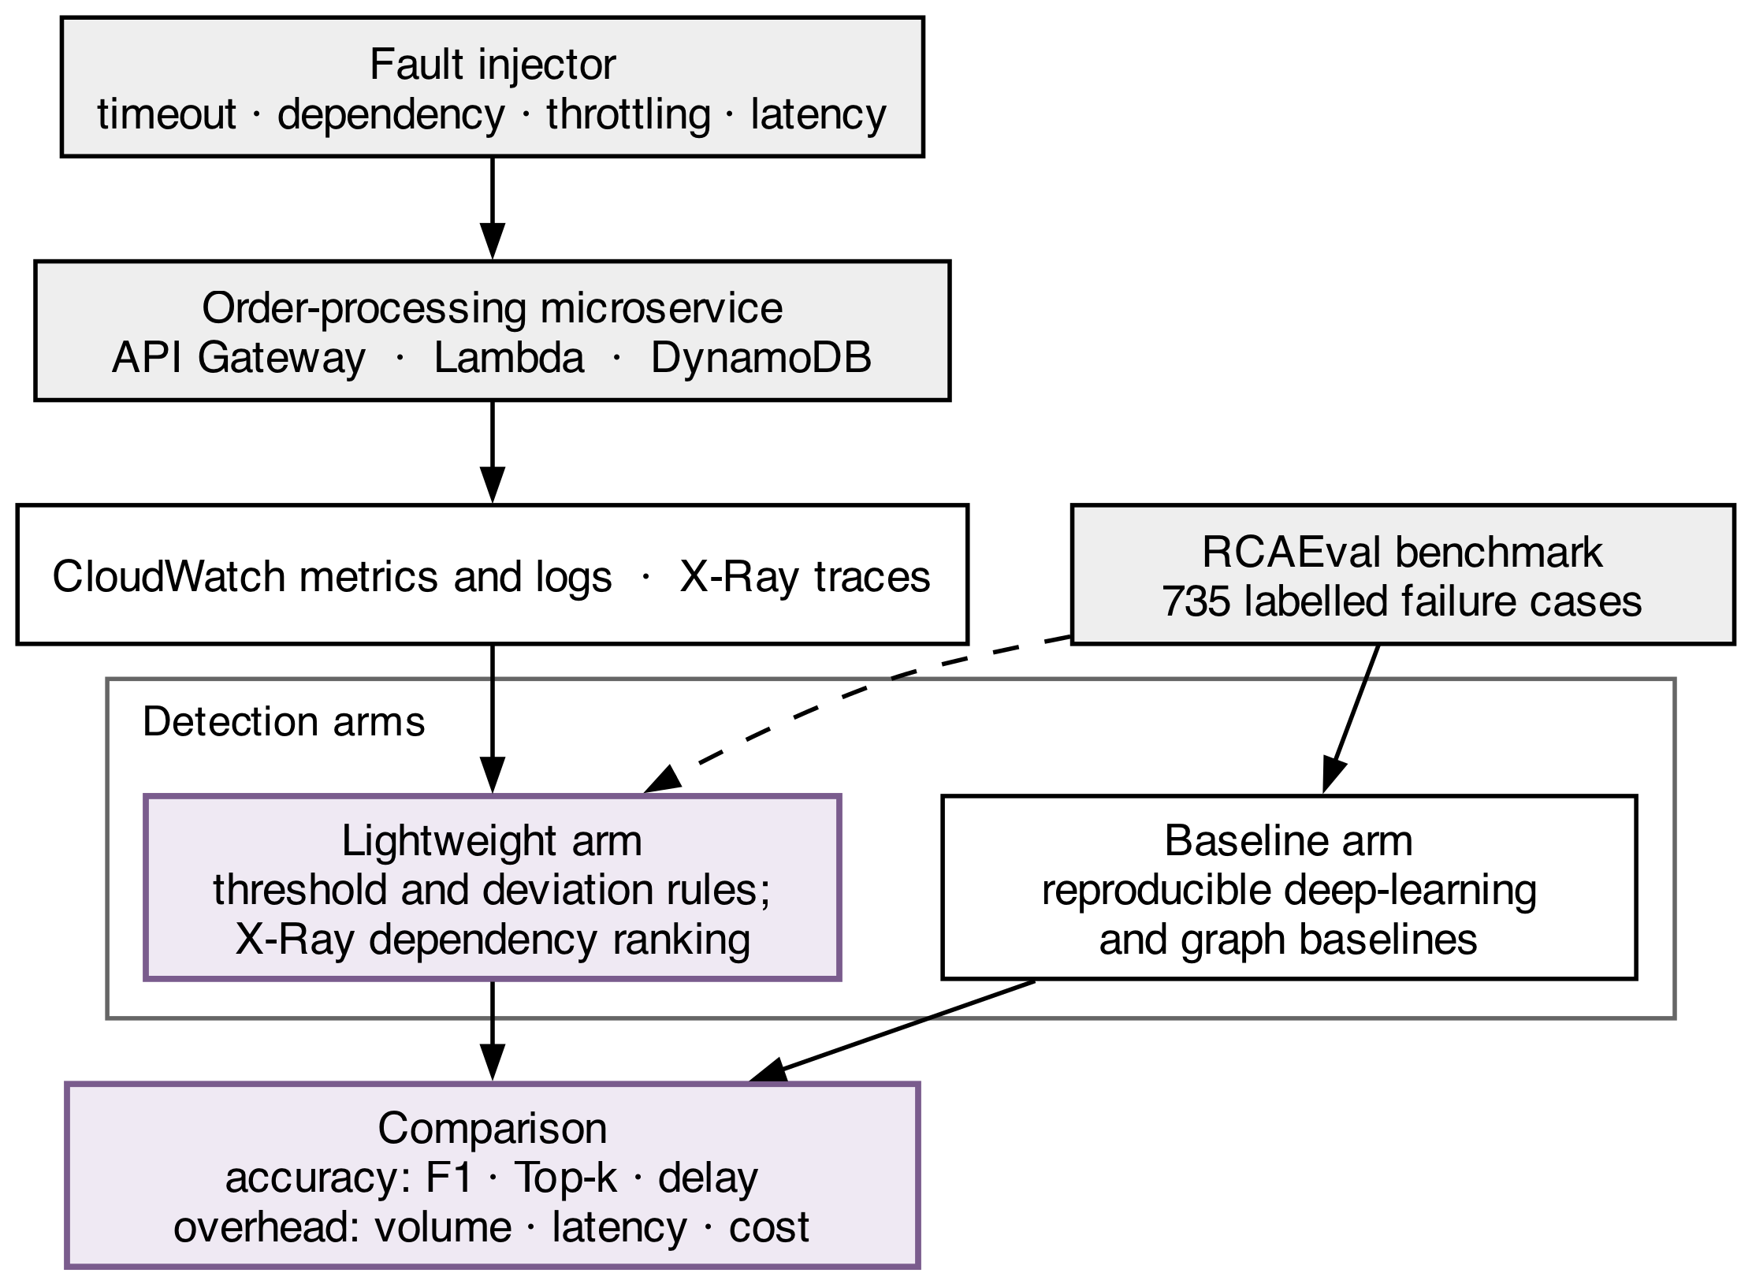
Figure 1 Experimental setup and comparison workflow

Research Method
The independent variables are the detection method, at two levels comprising the rule-based arm and the learned baseline arm; the fault type, at four levels comprising timeout, dependency failure, throttling and elevated latency; and the load level, at two levels comprising a steady baseline rate and a peak rate five times that baseline, included because a detector's false-positive behaviour under load is not the same as its behaviour at rest. The system under test is a single order-processing microservice composed of an API Gateway endpoint, serverless functions and a managed table. The rule-based arm is specified concretely rather than left as a category. Three CloudWatch metrics are monitored per service: invocation error count, duration, and throttle count. A detection is raised when a metric departs from a rolling baseline computed over the preceding thirty minutes by more than three standard deviations, or when it crosses a fixed threshold set at the ninety-ninth percentile of the calibration period, whichever fires first. Baseline window and thresholds are derived once over a fault-free calibration period of twenty-four hours and are not revised afterwards. Localisation ranks each service appearing in the traces that span the detection window by combining the proportion of failed traces in which it appears with its depth in the dependency graph, so that a service both frequently implicated and close to the observed symptom ranks highest; that ordering is what top-k accuracy and mean rank are scored against.
The dependent variables fall into two families. Accuracy is measured as precision, recall, F1 and detection delay for detection, and as top-k accuracy and mean rank of the true root-cause service for localisation. Overhead is measured as emitted log and trace volume, added end-to-end latency and estimated monitoring cost. Mertz and Nunes (2023) establish that this quantity is material and policy-dependent, reporting throughput reductions of 13.5 to 23.1 per cent under uniform sampling against 4.6 to 11.6 per cent under an adaptive policy, so the sampling policy under which any overhead figure is obtained is stated with it. Huang et al. (2024) further show that telemetry volume and diagnostic quality are not monotonically opposed, a state-aware sampler raising top-one root-cause accuracy by an average of 32.63 per cent while retaining a small fraction of traces; a reduction in monitoring cost is therefore not scored here as an automatic concession of accuracy. F1 and top-k are recorded on the same terms as Xing et al. (2025), which is what permits the untrained result to be positioned against the learned ceiling.
Fault labels are ground truth by construction: the injector records what it injected and when, so every detection can be scored without manual annotation. The injected taxonomy is aligned to the fault categories published with the benchmark, which keeps the two comparison legs commensurable.
Region, account, service topology, workload generator and rule thresholds are held constant across arms. Genuine platform variability is the first complication, since an injected fault may coincide with it, so a fault-free control period precedes each campaign and establishes the false-positive floor against which detections are scored. Tracing is the second: the act of tracing perturbs the latency being measured, which is the overhead under study rather than a nuisance; latency is therefore recorded with tracing enabled and disabled, and the difference is reported as the overhead figure.
Internally, rule thresholds tuned on the same data they are evaluated on would overstate accuracy, so they are fixed on a held-out calibration period and never revised thereafter. External validity extends no further than one provider, one topology and one service, and larger or heterogeneous systems lie outside what these measurements can speak to. In construct terms, the published accuracy of learned methods was obtained on their own datasets and is reported as a ceiling under ideal data conditions rather than as a same-rig result.

Research Resources
Five managed services carry the experiment: Lambda, API Gateway, DynamoDB, CloudWatch and X-Ray. Both the service and its instrumentation are declared in infrastructure code, so every configuration can be stood up and torn down identically and the bill stays bounded. Fault injection is implemented in the service and dependency-access paths under control of a scheduled script, so that injection times are recorded exactly. Each fault type has a defined mechanism: a timeout by holding the dependency call beyond the client deadline; a dependency failure by returning an error response from the invoked service; throttling by driving the table past its provisioned capacity; and elevated latency by inserting a delay drawn from a configured range. Each injection runs for sixty seconds and is separated from the next by a five-minute recovery window, so that a detection cannot be attributed to a preceding fault.
Two datasets support the study. The first is generated on the researcher's own infrastructure: synthetic order transactions carrying no personal, private or third-party data, with faults injected under the controlled script. The second is the published benchmark of Pham et al. (2025), which supplies 735 labelled failure cases across three microservice systems together with fifteen reproducible baselines, and which is used under its published licence.

Evaluation
The comparison is conducted on three legs, because an untrained method and a trained one cannot simply be run on the same inputs. First, the published figures of Xing et al. (2025) are cited as the accuracy ceiling attainable under ideal data conditions, explicitly as a reference point and not as a same-rig comparison. Second, the rule-based arm is run over the benchmark data of Pham et al. (2025) alongside the reproducible baselines distributed with it, which yields a like-for-like accuracy comparison on identical inputs. Third, the overhead dimension is measured on the researcher's own AWS service, because the benchmark carries no cloud cost or latency figures and cannot supply them. That third leg is asymmetric, and is reported as such rather than presented as a measured difference. Overhead is obtained directly for the rule-based arm, which runs against a live instrumented service. It cannot be obtained for the learned baselines, which execute offline over recorded telemetry and never instrument a running system. The comparison therefore reports the untrained arm's overhead in absolute terms and bounds the learned arm's from below by the telemetry its published inputs would require, and every overhead claim is qualified by that asymmetry.
The generated dataset is validated in several ways. Fault labels are ground truth by construction; the injected taxonomy matches the benchmark's published categories; and the rule-based arm's accuracy on the benchmark is used to confirm that its accuracy on the researcher's own rig falls in a consistent range. Where the two diverge, the divergence is reported rather than reconciled.
Every comparative objective carries an explicit null and alternative. Detection: H0 states that F1 does not differ between the rule-based arm and the reproducible baselines on common benchmark data; H1 that it does. Localisation: H0 states that top-k accuracy does not differ between arms; H1 that it does. Overhead: H0 states that enabling tracing does not change end-to-end latency; H1 that it does. All are non-directional, since the magnitude of any accuracy concession is exactly what is unknown.
No test is chosen until the distribution has been checked for normality. Where it holds, an independent-samples t-test is applied to each two-arm comparison with Cohen's d as effect size; where it does not, the Mann-Whitney U test is substituted with rank-biserial correlation. Detection delay and latency distributions are reported at the median and upper percentiles rather than the mean alone, since both are expected to be right-skewed.
An alpha of 0.05 governs each test, adjusted by the Holm-Bonferroni method because the hypotheses are evaluated over one body of collected evidence. Replication is fixed in advance rather than deferred: each of the four fault types is injected sixty times per arm, a count chosen so that a difference of ten percentage points in F1 is detectable at eighty per cent power for a two-sample comparison at that alpha. Ten percentage points is likewise the smallest difference treated as practically meaningful. The pilot confirms that observed variance is consistent with that calculation rather than setting the count afterwards, and the decision rule is recorded before collection begins: the rule-based arm counts as competitive if its F1 falls within ten points of the strongest reproducible baseline while reducing telemetry volume by at least half.

Ethical Considerations of the Research
No people are involved in this study and nothing personal is recorded by it; every transaction is fabricated for the experiment, which puts consent and data-protection duties outside its scope. The benchmark dataset is published for research use and is used under its stated licence, with attribution.
Injecting faults into a commercial platform, and driving load through it, has to stay within the terms of acceptable use that the platform publishes. Faults are induced only in services the researcher owns, inside the researcher's own account, at load levels held below free-tier-safe thresholds; shared capacity is therefore never strained and no neighbouring tenant experiences the experiment. Compute and telemetry are both billed, so the power calculation rather than the budget determines how many runs occur. That ceiling limits the money spent and, with it, the energy and the environmental burden the study imposes.
Reporting integrity requires particular care where a comparison flatters the proposed method. The rule thresholds are fixed before evaluation and not revised afterwards; the published accuracy of learned methods is reported as a ceiling under their own data conditions rather than as a defeated competitor; false positives from the fault-free control are reported alongside detections; and the single-provider and single-topology scope accompanies every summary. Any platform behaviour the measurements expose that the provider has not documented is reported to the provider before it appears in the write-up. Service definitions, injection scripts, rule configurations and the measurements themselves are made available, so another researcher can reproduce the comparison end to end.

Project Plan
The twelve-week schedule appears in Figure 2. Deploying the instrumented microservice and building the fault injector occupy the first four weeks and conclude with a fixed fault taxonomy aligned to the benchmark's categories, which is the precondition for both comparison legs.
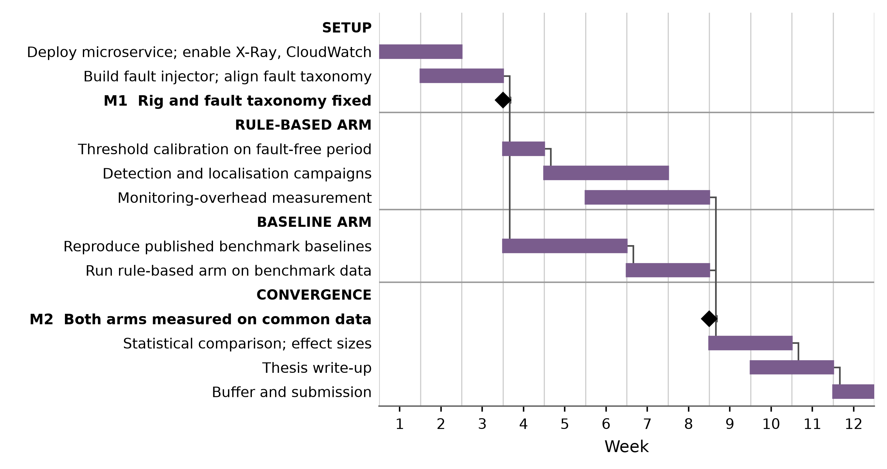
Figure 2 Twelve-week project plan
Threshold calibration occupies week four, after which the detection and localisation campaigns run to week eight and the overhead measurement to week nine. The baseline arm proceeds in parallel from week four, reproducing the published baselines before the rule-based arm is run over the same benchmark data. Weeks nine to eleven are given to statistical comparison, the write-up runs from week ten, and week twelve remains as contingency. The principal schedule risk is that reproducing the benchmark baselines proves more demanding than published, which the early alignment work is designed to expose while there is still time to narrow the baseline set.

References
El Khairi, A., Caselli, M., Peter, A. and Continella, A. (2024) 'ReplicaWatcher: training-less anomaly detection in containerized microservices', in Proceedings of the 2024 Network and Distributed System Security Symposium. Reston, VA: Internet Society. doi: 10.14722/ndss.2024.24286. [Conference - CORE Ranking A* (ICORE2026)]
Huang, H., Zhang, X., Chen, P., He, Z., Chen, Z., Yu, G., Chen, H. and Sun, C. (2024) 'TraStrainer: adaptive sampling for distributed traces with system runtime state', Proceedings of the ACM on Software Engineering, 1(FSE), pp. 473-493. doi: 10.1145/3643748. [Conference - CORE Ranking A* (ICORE2026)]
Liu, J., Yang, T., Chen, Z., Su, Y., Feng, C., Yang, Z. and Lyu, M.R. (2023) 'Practical anomaly detection over multivariate monitoring metrics for online services', in Proceedings of the 2023 IEEE 34th International Symposium on Software Reliability Engineering. Piscataway: IEEE, pp. 36-45. doi: 10.1109/ISSRE59848.2023.00045. [Conference - CORE Ranking A (ICORE2026)]
Mertz, J. and Nunes, I. (2023) 'Software runtime monitoring with adaptive sampling rate to collect representative samples of execution traces', Journal of Systems and Software, 202, 111708. doi: 10.1016/j.jss.2023.111708. [Journal - JCR Impact Factor 3.8 (2024), Q2]
Pham, L., Zhang, H., Ha, H., Salim, F. and Zhang, X. (2025) 'RCAEval: a benchmark for root cause analysis of microservice systems with telemetry data', in Companion Proceedings of the ACM Web Conference 2025. New York: ACM, pp. 777-780. doi: 10.1145/3701716.3715290. [Conference - The Web Conference, CORE Ranking A* (ICORE2026); Companion track]
Schmidl, S., Wenig, P. and Papenbrock, T. (2022) 'Anomaly detection in time series: a comprehensive evaluation', Proceedings of the VLDB Endowment, 15(9), pp. 1779-1797. doi: 10.14778/3538598.3538602. [Conference - CORE Ranking A* (ICORE2026)]
Xing, S., Wang, Y. and Liu, W. (2025) 'Multi-dimensional anomaly detection and fault localization in microservice architectures: a dual-channel deep learning approach with causal inference for intelligent sensing', Sensors, 25(11), 3396. doi: 10.3390/s25113396. [Journal - JCR Impact Factor 3.5 (2024), Q2]
Zhang, C., Dong, Z., Peng, X., Zhang, B. and Chen, M. (2024) 'Trace-based multi-dimensional root cause localization of performance issues in microservice systems', in Proceedings of the IEEE/ACM 46th International Conference on Software Engineering. New York: ACM, pp. 1-12. doi: 10.1145/3597503.3639088. [Conference - CORE Ranking A* (ICORE2026)]
Zhang, J. and Yang, H. (2026) 'CPU-only spatiotemporal anomaly detection in microservice systems via dynamic graph neural networks and LSTM', Symmetry, 18(1), 87. doi: 10.3390/sym18010087. [Journal - JCR Impact Factor 2.2 (2024), Q2]
Zhang, W., Yang, Z., Peng, F., Zhang, L., Chen, Y. and Chen, R. (2026) 'GALR: graph-based root cause localization and LLM-assisted recovery for microservice systems', Electronics, 15(1), 243. doi: 10.3390/electronics15010243. [Journal - JCR Impact Factor 3.82 (2024), Q2]

