Evaluating MQTT Quality-of-Service Reliability in AWS IoT Core for Device-to-Cloud Telemetry under Intermittent Connectivity
Uday Kiran Reddy Dodda
X25166484
MSc in Cloud Computing
National College of Ireland

Abstract
More than four fifths of observed MQTT traffic is published without delivery guarantees, a default that is defensible on a stable network and reckless once devices disconnect. Which applies is unmeasured for managed brokers, because published comparisons run on self-hosted brokers the experimenter controls, and the one large-scale managed-broker study leaves varying quality-of-service levels and intermittent connectivity as future work. This proposal specifies a controlled disconnection experiment on AWS IoT Core in which simulated devices publish identical telemetry at each available service level while disconnections of fixed duration are imposed on a schedule. Every published message is matched against its delivered record, so loss and duplication are counted rather than inferred, and latency, reconnection time and service cost are reported beside them. The outcome is a measured price for a guarantee currently taken on trust.
Keywords: MQTT, quality of service, AWS IoT Core, message reliability, intermittent connectivity

Introduction
Telemetry from connected devices reaches the cloud over a publish-subscribe protocol, and on constrained hardware that protocol is almost always MQTT. The publisher chooses a quality-of-service (QoS) level for each message, and that choice is the only reliability control it holds. Level 0 delivers at most once and never retries. Level 1 delivers at least once, holding the message until the broker acknowledges it, at the price of possible duplication.
The choice is made once, in code, and rarely revisited. Innamorati et al. (2026) scanned the IPv4 address space, identified 14,386 reachable brokers and captured roughly 3.2 billion messages over two weeks, finding that more than 88% of that traffic is published at level 0. Whatever the protocol permits, deployed practice overwhelmingly forgoes the guarantee.
Whether that default is sensible depends entirely on the network, and wireless devices do not have stable networks. They move out of coverage, exhaust batteries, and reconnect minutes later. The protocol specifies what each level promises but not what a broker actually does across such an interruption, because that behaviour is a property of the implementation: how long a session is retained, how deep its queue runs, when a held message expires and whether a reconnecting client is throttled.
On a self-hosted broker those properties can be inspected and changed. On a managed service they cannot. AWS IoT Core, the ingestion endpoint used here, fixes them by policy and exposes only levels 0 and 1 for device-to-cloud publishing (Amazon Web Services, 2026). The tenant chooses a level and inherits everything else, which makes the consequence of that choice an empirical question rather than a configuration one.
The consequence is therefore an empirical question rather than a documented one: to what extent does publishing at quality-of-service level 1 rather than level 0 reduce telemetry message loss in AWS IoT Core when the publishing device undergoes controlled disconnections of varying duration?
The evidence available reads two ways. Ko and Lee (2025) measured level 0 losing only 2.10% of messages on a stable laboratory network, at 95.0 ms mean latency against 150.2 ms for level 1, which makes the common default look like a reasonable trade. Lima et al. (2025) measured reconnecting publishers losing approximately half of all messages at level 0 while level 1 lost none, which makes the same default look indefensible. Both were measured on brokers the authors operated.
Neither reading transfers to a managed endpoint, because the machinery deciding the outcome belongs to the provider. What the protocol guarantees is documented; what the platform delivers across an interruption it governs is not.
This breaks into four objectives. The first quantifies message loss at each service level across disconnections of controlled duration. The second quantifies duplication and end-to-end latency, which are the price of any reliability gained. The third measures reconnection behaviour and how much of the backlog survives it. The fourth expresses each configuration as a position on the resulting reliability-cost surface.
The proposed solution is a controlled disconnection experiment rather than an observational study. Every message carries an identifier written to a device-side log before publication, and delivered records are matched against that log, so loss and duplication are counted against known ground truth rather than inferred from broker-side counters.
The contribution is a measured price for a guarantee currently taken on trust: how many telemetry messages survive a disconnection at each level on a managed broker, what duplication and latency that survival costs, and what it adds to the bill. Practitioners gain evidence for a decision made in code and rarely revisited.
Section 2 reviews what deployed practice and stable-network measurement establish about the service levels, then what impairment studies establish about broker behaviour under stress, before showing why neither answers the question for a managed endpoint. Section 3 specifies the experimental design, the metrics and statistical treatment, the ethical position and the schedule.

Literature Review

Quality of Service in Deployed MQTT Practice
Two studies bracket the question on stable networks and disagree about what the default costs. Innamorati et al. (2026) establish the default itself, finding more than 88% of 3.2 billion captured messages published at level 0 across 14,386 brokers. Ko and Lee (2025) then measure what that costs in a working deployment, reporting 2.10% packet loss and 95.0 ms latency at level 0 against 99.2% delivery and 150.2 ms at level 1. Read together they suggest a rational trade: a small loss rate bought for a third off the latency.
The trade holds only while the link does. Jeddou et al. (2022) show why transferring such figures is unsafe, finding that the ordering between service levels by delay reverses as link round-trip time grows, so a result obtained on a local network does not predict behaviour over a wide-area path to a regional cloud endpoint. A laboratory measurement therefore establishes the trade under one network condition and cannot be generalised to another.
What deployed practice and stable-network measurement establish, then, is the default and its cost when nothing goes wrong. What happens when something does is considered next.

Measuring Broker Reliability under Impairment
Impairment studies show the picture changing sharply. Gruener et al. (2021) degraded the network beneath several brokers and found level 0 delivery falling to 83% at 30% packet loss, while level 1 worst-case tail latencies exceeded thirty seconds; killing a broker mid-run separated implementations that were indistinguishable at steady state, with VerneMQ losing 1.75% of messages and duplicating 8.52% where others lost and duplicated almost none. Lima et al. (2025) then isolated publisher churn specifically, measuring approximately 50% loss at level 0 against none at level 1.
Those two results are the closest existing work to this study and they share a decisive limitation: both instrument brokers the authors operate. Gruener et al. impair the network beneath a broker they control, and Lima et al. evaluate bridge architectures they configure. Neither observes a client-side disconnection from a managed endpoint whose session retention, queue depth, message expiry and reconnection throttling are set by the provider and cannot be varied by the experimenter.
The baseline for this study is Shvaika et al. (2025), who demonstrate a Kafka- and Redis-backed broker sustaining messaging for over one hundred million clients and characterise its throughput and persistence at steady high load. They state explicitly that varying service levels, intermittent connectivity and varying client conditions were left to future work. That omission is consequential rather than cosmetic: the divergence Gruener et al. (2021) expose between brokers is entirely invisible in steady-state throughput figures, so scaling well and surviving an interruption are separate claims.
Their companion study reinforces the point from the opposite direction. Shvaika, Shvaika and Artemchuk (2025) isolate the offline-message store for persistent-session subscribers at level 1, reporting saturation between 30,000 and 60,000 messages per second, but measure it while every client remains connected. The replay path is therefore characterised for capacity and never exercised across an actual reconnection, which is the moment it exists to serve.
Dizdarević et al. (2024) benchmark several broker implementations across a compute continuum and come nearest to combining the two conditions, yet fix their impairment-sensitive tests at level 0 on the stated assumption of a stable connection. Their degraded-network and loss-sensitive conditions consequently never coincide, and no client ever disconnects. Panagou et al. (2025), reviewing managed IoT platforms including the one used here, concede that their assessment rests on vendor documentation and free-tier trials with high-stress load testing beyond scope.
Table 1 sets the reviewed studies against this proposal. The columns that matter are managed broker, client disconnection and per-message ground truth, and no reviewed row carries all three.
Table 1 Reviewed studies contrasted with the proposed experiment
Study | Broker | Service levels varied | Client disconnection | Per-message ground truth | What it leaves open
Innamorati et al. (2026) | Observed, in the wild | Observed only | No | No | Whether the observed default is rational under loss
Ko and Lee (2025) | Self-hosted | Yes | No | Partial | Behaviour once the link is impaired
Gruener et al. (2021) | Self-hosted | Yes | Network impaired, not client | Yes | Managed-broker behaviour
Lima et al. (2025) | Self-hosted bridge | Yes | Publisher churn | Yes | Provider-governed session retention
Dizdarevic et al. (2024) | Managed and self-hosted | Fixed at level 0 under impairment | No | No | Level comparison under impairment
Shvaika et al. (2025) | Self-hosted, purpose-built | No, steady load | No | No | Named as future work by the authors
This proposal | Managed (AWS IoT Core) | Yes, both available levels | Yes, controlled duration | Yes, device-side log | Answers the above for a managed endpoint

Why This Research Is Necessary
Three things are settled. The default is settled: level 0 dominates deployed traffic (Innamorati et al., 2026). The cost of that default on a stable network is settled, at a few per cent of messages for roughly a third off latency (Ko and Lee, 2025). And its behaviour under broker-side impairment is settled, with delivery falling to 83% under heavy loss and implementations diverging once a broker fails (Gruener et al., 2021).
What is not settled is what happens across a client-side disconnection on a broker the tenant does not control. Every impairment result above comes from a self-hosted broker; Dizdarević et al. (2024) hold the service level fixed precisely when the network is degraded; the baseline names the gap as future work; and its companion measures the replay path only while clients stay connected. The one review covering the managed platform in question rests on documentation rather than measurement.
The practical consequence is that a team choosing a service level for a fleet that regularly drops offline has no measured basis for the choice, and cannot obtain one from the specification, because what is at issue is the provider's implementation of it. This proposal supplies that measurement.

Research Niche
No existing study measures message loss across a client-side disconnection, at more than one service level, on a managed broker, against per-message ground truth. Not one reviewed study satisfies more than two of those four at once: Gruener et al. (2021) vary the level and impair the network but on a self-hosted broker with no client disconnection; Lima et al. (2025) disconnect publishers but instrument their own bridge; Dizdarević et al. (2024) measure managed and self-hosted deployments but hold the level fixed under impairment. Each reviewed design answers its own question competently; none was built to answer this one.
Shvaika et al. (2025) are the baseline. Their design measures a broker they built, under the one condition in which the service level matters least, and names the unexamined conditions itself. That absence is the problem taken up here. This study inverts the arrangement, measuring a broker the tenant cannot modify under the conditions the baseline set aside, and retains delivery completeness as the shared measure so the results can be read against theirs.
Two expectations are recorded as thresholds so a measurement can contradict them: that level 1 loses fewer than a tenth as many messages as level 0 across disconnections exceeding one minute, and that it does so at a duplication rate above 1%, which is the cost side of the same guarantee. A third is left open, because the reviewed evidence gives no basis for predicting whether held messages survive a long disconnection at all on this platform.
Section 3 specifies the experiment. Deferred to future work are service level 2, which this platform does not expose for device-to-cloud publishing, multi-region ingestion, physical rather than simulated devices, and brokers other than the one measured here.

Research Method & Specification
A controlled disconnection experiment answers this question. Simulated devices publish identical telemetry at each service level while disconnections of fixed duration are imposed on a schedule, and every message is matched against a device-side record. Figure 1 shows the arrangement.
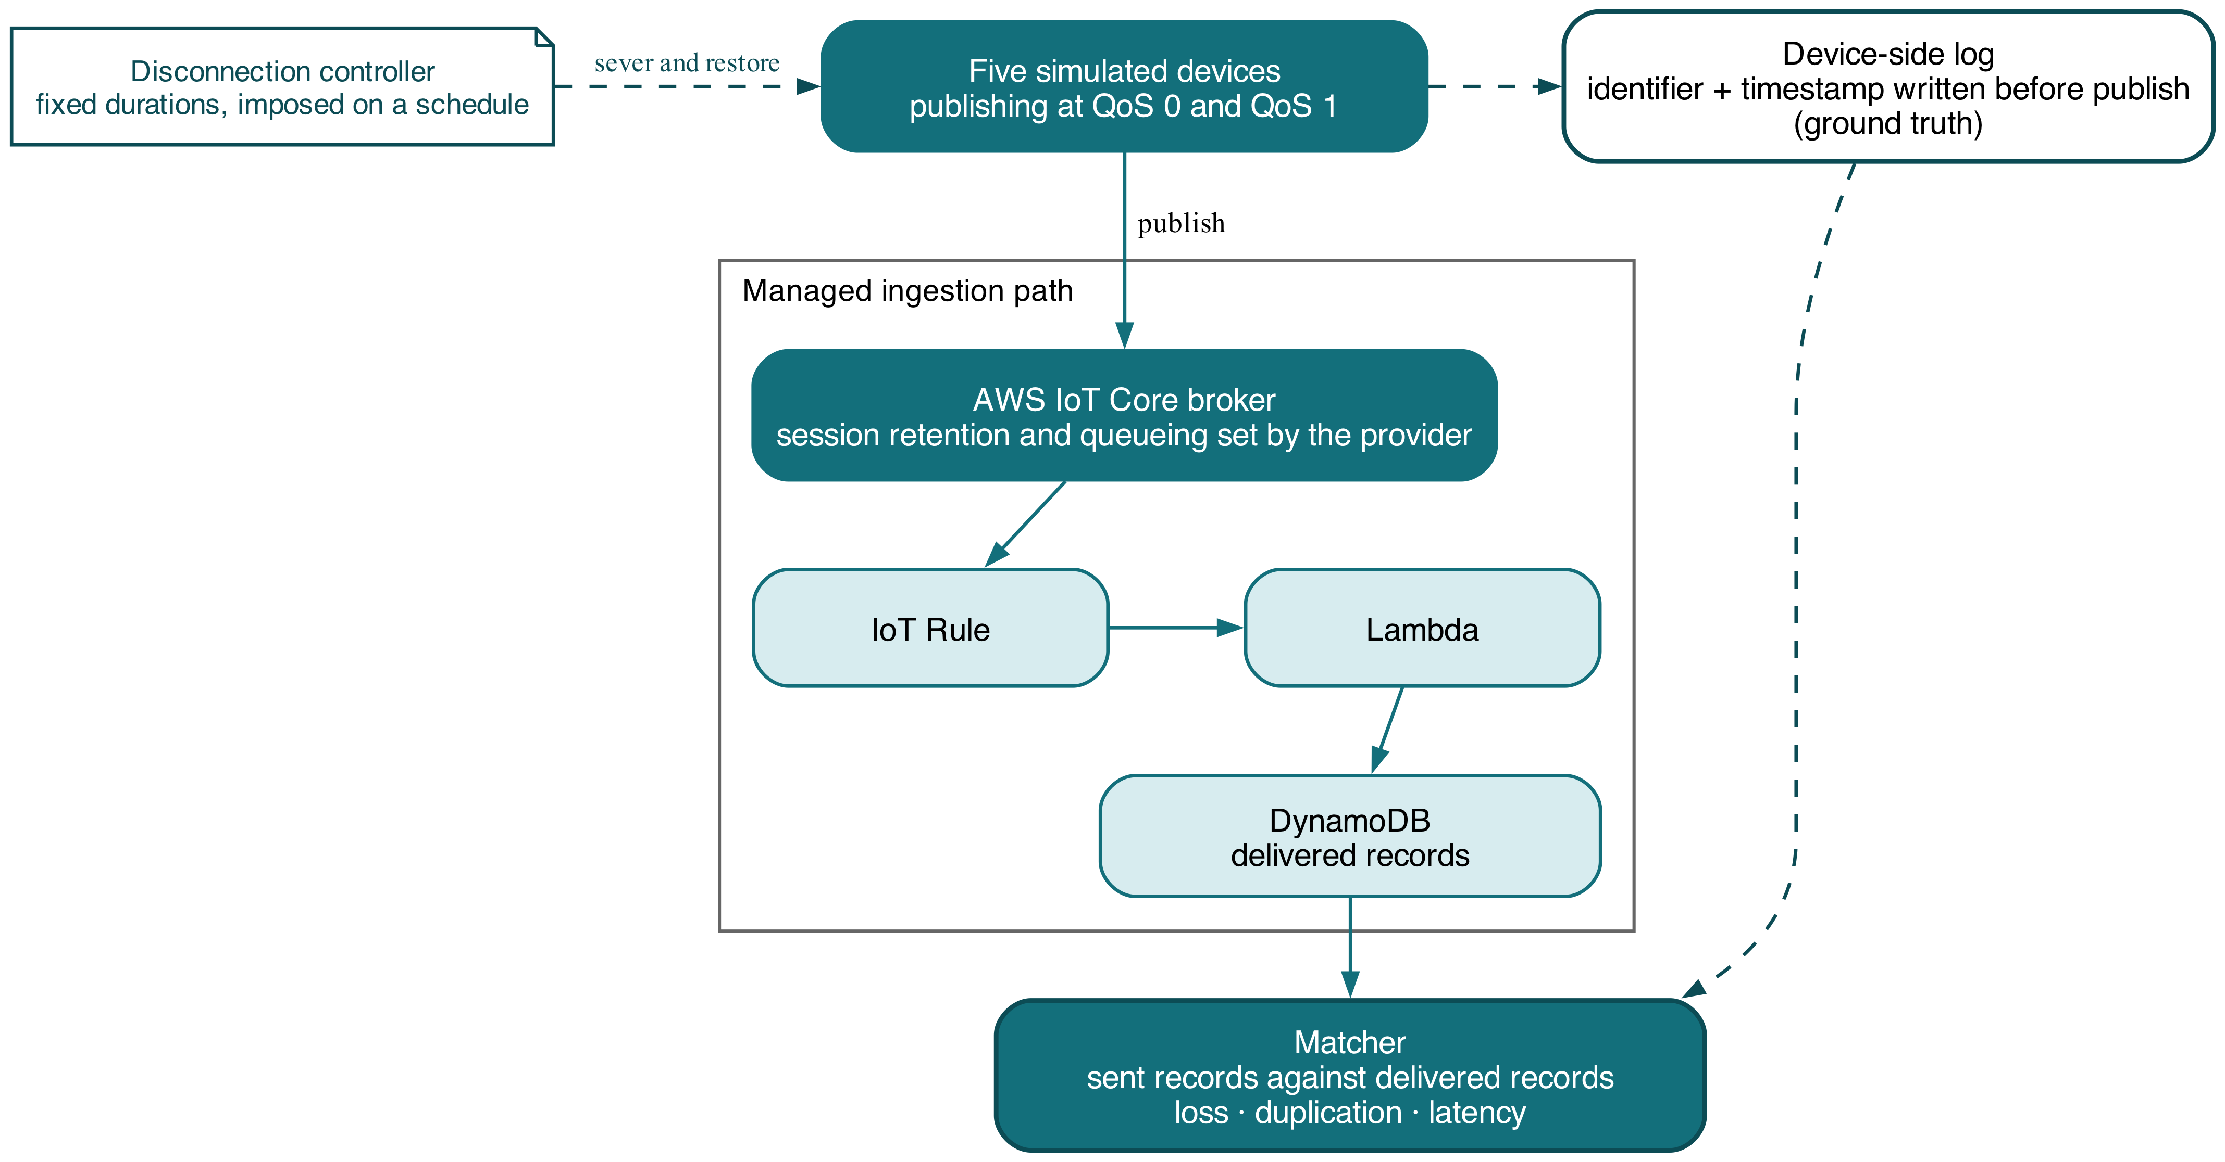
Figure 1 Experimental setup: publication path, disconnection control and matching

Research Method
Two independent variables are crossed. The service level has two levels, 0 and 1, which are the only ones the platform exposes for device-to-cloud publishing (Amazon Web Services, 2026); the study is therefore not artificially restricted but bounded by the service under test. Disconnection duration has four levels: none, fifteen seconds, one minute and five minutes, chosen to span the range over which a held message plausibly survives, expires or is discarded. Publication rate is a conditioning factor at two levels, steady and bursty, since a backlog accumulated during an interruption is what the reconnection has to clear.
The dependent variable is the proportion of published messages lost end to end. Secondary measures are the duplicate-delivery rate, end-to-end latency at the mean and the ninety-fifth and ninety-ninth percentiles, reconnection time, rule-trigger success rate and estimated service cost per configuration. Delivery completeness is recorded on the same terms as Shvaika et al. (2025), which is what allows the managed-broker result to be read against their steady-load account.
Ground truth is what makes loss countable. Each simulated device writes a message identifier and a timestamp to a local log immediately before publishing, so the population of intended messages is known independently of the broker. Delivered records are matched against that log on identifier; an identifier absent downstream is a loss, and one appearing twice is a duplicate. Without the device-side log, loss could only be inferred from broker counters, the limitation that confines Innamorati et al. (2026) to observation.
Held constant are the region, the account, the device count at five, the payload size, the client library and its version, the session configuration and the hour-of-day block in which runs are issued. Two confounds require handling. Disconnections must be imposed rather than awaited, or their duration is unknown; connectivity is severed programmatically at the client and restored on a timer. Separately, a reconnecting client may be throttled in a way that resembles loss, so reconnection time is measured directly and reported beside the loss figure.
Internally, the devices are simulated processes rather than physical hardware, so radio behaviour and power management are absent and the disconnection is cleaner than a real one. External validity is bounded by one managed platform in one region. In construct terms, estimated cost is derived from published unit prices applied to counted operations rather than read from a bill, and the derivation is stated so it can be recomputed.

Research Resources
The experiment requires AWS IoT Core as the broker, a rules action routing each delivered message to a Lambda function, and a DynamoDB table holding the delivered records against which the device-side log is matched. All are provisioned from infrastructure code so that every configuration is created and destroyed identically and spend stays bounded.
The test data is synthetic telemetry generated for this study: numeric sensor readings of fixed payload size carrying a sequence identifier. No personal data, no production traffic and no third-party data is involved, and no participants take part. Five simulated devices publish one thousand messages each per configuration at five-second intervals, which keeps the whole campaign inside free-tier-safe limits while producing enough messages for a loss rate of a few per cent to be estimated with useful precision.
The device simulator, the infrastructure definitions and the collected measurements are released, so that any figure reported here can be recomputed from source rather than taken on trust.

Evaluation
The question is settled by comparing loss rates between the two service levels at each disconnection duration under matched publication rates, which answers objectives one and two. Objective three comes from the reconnection-time and backlog measurements taken as connectivity is restored, and objective four from plotting each configuration on the surface spanned by loss, duplication and cost.
Each comparison is stated as a null and an alternative before any data exists. For loss, H0 holds that the proportion of messages lost does not differ between the two service levels at a given disconnection duration, and H1 that it does. For duplication, H0 holds that the duplicate rate does not differ between levels, and H1 that it does. For latency, H0 holds that mean end-to-end latency does not differ, and H1 that it does. The loss and duplication pairs are directional, because the protocol's own definition makes the direction predictable and the question is the magnitude; the latency pair is not.
Loss and duplication are proportions of a known population, so each level pair is compared with a two-proportion z-test, and the interaction between service level and disconnection duration is examined with a chi-squared test across the full contingency table. Latency is heavily right-skewed at the tail, so normality is assessed first and the Mann-Whitney U test with rank-biserial correlation is used where it fails. Every reported difference carries a 95% confidence interval.
Tests are conducted at an alpha of 0.05 with Holm-Bonferroni adjustment, since every hypothesis draws on one measurement campaign. Replication is fixed in advance: each of the sixteen configurations is repeated five times, giving 5,000 published messages per configuration and enough resolution to detect a difference of one percentage point in loss at eighty per cent power. The smallest difference treated as practically meaningful is set beforehand at one percentage point of loss and five per cent of cost.

Ethical Considerations of the Research
No participants take part and no personal data is handled at any stage. Every message is synthetic telemetry generated for the experiment and every device is a simulated process, which places consent and data-protection duties outside the study's scope. The considerations that do arise are of a different kind.
Publishing sustained and bursty traffic to a commercial service must remain within the provider's acceptable-use terms. All traffic originates in the researcher's own account, addresses only resources created for the study, and stays inside free-tier-safe bounds. Deliberate disconnection is performed at the client and never against the platform, so nothing resembling a denial-of-service pattern is generated.
Measurement is not free: every published message and every rule invocation is billed. Run counts follow the power calculation rather than being pushed as high as the budget allows, which caps spending and with it the energy, and so the environmental cost, spent to obtain the result.
Reporting integrity is at stake in a particular way, because the study evaluates a named commercial service. The analysis plan and the cost derivation are settled before any data exists. Lost and duplicated messages are reported rather than discarded as noise, since they are the finding. Every statement of results carries its single-account, single-region, simulated-device scope. Should the measurements reveal undocumented platform behaviour, that goes to the provider before publication.

Project Plan
Figure 2 sets out the twelve-week schedule. Weeks one to three build and validate the rig: the device simulator, the ingestion path and the matching procedure, ending in a pilot that confirms a message published locally can be traced to a delivered record.
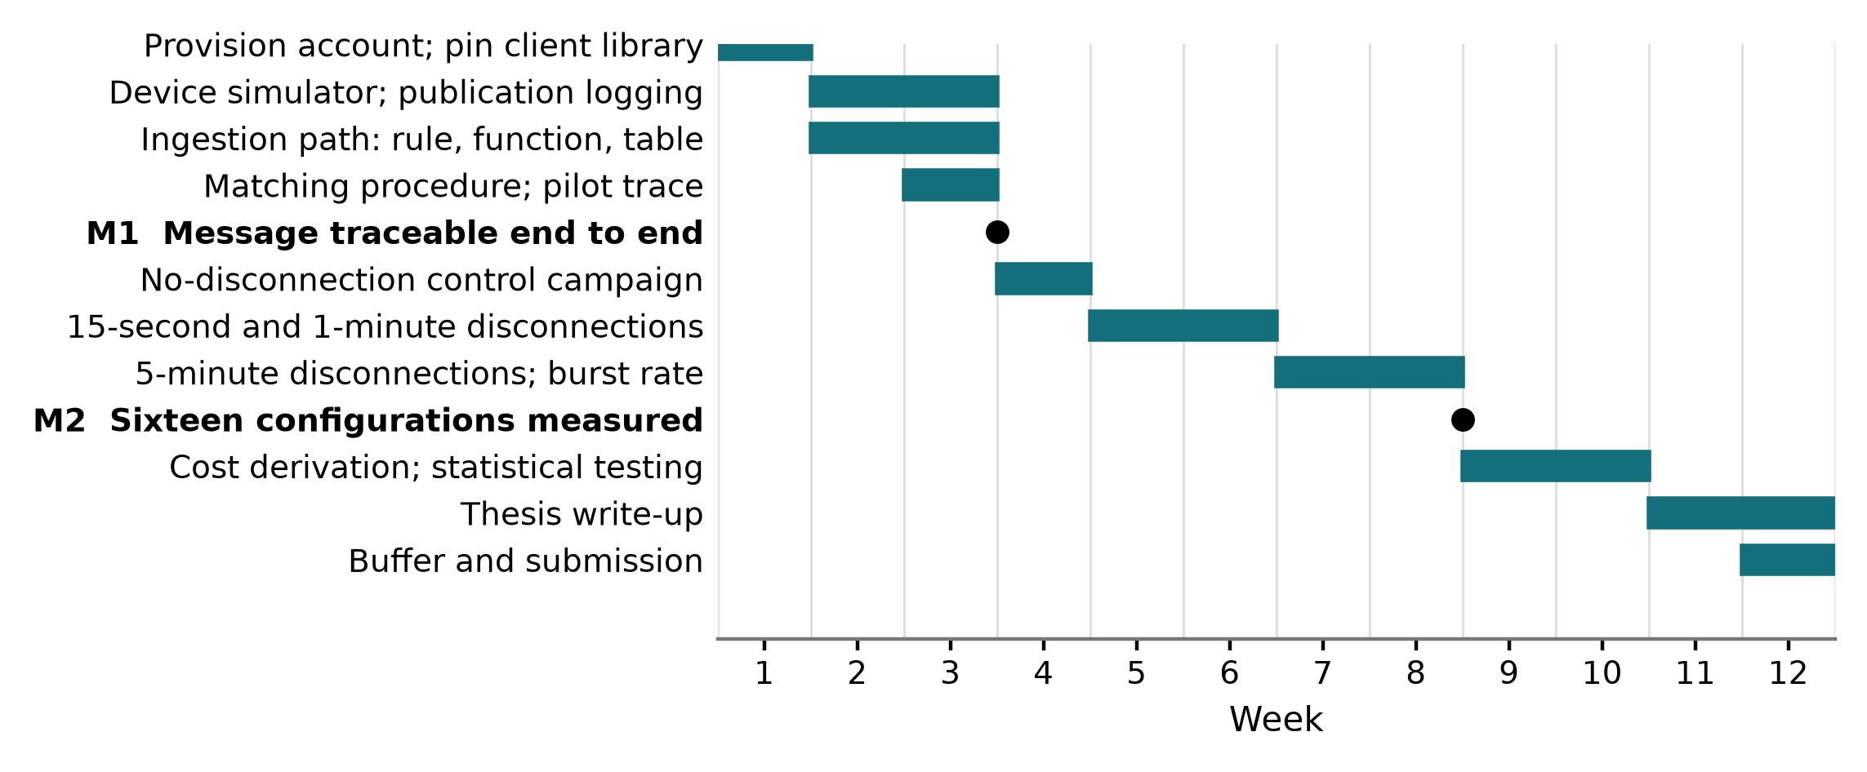
Figure 2 Twelve-week project plan
Measurement then proceeds by disconnection duration from week four, with the steady and bursty publication rates run against each. Weeks nine to eleven cover cost derivation and statistical testing, the write-up begins in week eleven, and week twelve stays free as contingency. The principal risk is that platform-side throttling proves hard to separate from loss, which the pilot is designed to expose.

References
Amazon Web Services (2026) AWS IoT Core developer guide: MQTT. Available at: https://docs.aws.amazon.com/iot/latest/developerguide/mqtt.html (Accessed: 2 August 2026). [Vendor documentation - cited for the supported service levels only]
Dizdarevic, J., Michalke, M., Jukan, A., Masip-Bruin, X. and D'Andria, F. (2024) 'Benchmarking performance of various MQTT broker implementations in a compute continuum', in Proceedings of the 2024 IEEE 24th International Symposium on Cluster, Cloud and Internet Computing. Philadelphia: IEEE, pp. 357-366. doi: 10.1109/CCGrid59990.2024.00048. [Conference - CORE Ranking B (ICORE2026)]
Gruener, S., Koziolek, H. and Ruckert, J. (2021) 'Towards resilient IoT messaging: an experience report analyzing MQTT brokers', in Proceedings of the 2021 IEEE 18th International Conference on Software Architecture. Stuttgart: IEEE, pp. 69-79. doi: 10.1109/ICSA51549.2021.00015. [Conference - CORE Ranking A (ICORE2026)]
Innamorati, C., Boiano, A., Redondi, A.E.C. and Cesana, M. (2026) 'The pulse of MQTT in the wild: a large-scale traffic analysis', Computer Networks, 274, 111845. doi: 10.1016/j.comnet.2025.111845. [Journal - JCR Impact Factor 4.7 (2025), Q2]
Jeddou, S., Fernandez, F., Diez, L., Baina, A., Abdallah, N. and Aguero, R. (2022) 'Delay and energy consumption of MQTT over QUIC: an empirical characterization using commercial-off-the-shelf devices', Sensors, 22(10), 3694. doi: 10.3390/s22103694. [Journal - JCR Impact Factor 3.5 (2024), Q2]
Ko, K.I. and Lee, M.H. (2025) 'MQTT-based architecture for real-time data collection and anomaly detection in smart livestock housing', Sensors, 25(23), 7186. doi: 10.3390/s25237186. [Journal - JCR Impact Factor 3.5 (2024), Q2]
Lima, K., Oyetoyan, T.D., Heldal, R. and Hasselbring, W. (2025) 'Evaluation of MQTT bridge architectures in a cross-organizational context', in Proceedings of the 2025 IEEE 22nd International Conference on Software Architecture. Odense: IEEE, pp. 243-254. doi: 10.1109/ICSA65012.2025.00032. [Conference - CORE Ranking A (ICORE2026)]
Panagou, I.C., Katsoulis, S., Nannos, E., Zantalis, F. and Koulouras, G. (2025) 'A comprehensive evaluation of IoT cloud platforms: a feature-driven comparative analysis', IoT, 6(2), 27. doi: 10.3390/iot6020027. [Journal - JCR Impact Factor 4.3 (2025), Q2; ESCI-indexed]
Shvaika, A., Shvaika, D., Landiak, D. and Artemchuk, V. (2025) 'A distributed architecture for MQTT messaging: the case of TBMQ', Journal of Big Data, 12(1), 224. doi: 10.1186/s40537-025-01271-x. [Journal - JCR Impact Factor 10.8 (2025), Q1]
Shvaika, D., Shvaika, A. and Artemchuk, V. (2025) 'MQTT broker architectural enhancements for high-performance P2P messaging: TBMQ scalability and reliability in distributed IoT systems', IoT, 6(3), 34. doi: 10.3390/iot6030034. [Journal - JCR Impact Factor 4.3 (2025), Q2; ESCI-indexed]

