Source-Free Log Anomaly Detection for AWS Serverless Applications: Measuring the Accuracy Forfeited When No Labelled Source Exists
Kasireddy Vadicharla
25104047
MSc in Cloud Computing
National College of Ireland

Abstract
Learned log anomaly detectors need labelled failures, and a newly deployed serverless application has none. Transfer learning answers this by borrowing labels from another system, but that requires a labelled source, and its authors concede the method degrades when the target is structurally divergent and report results only on public benchmarks. What a detector forfeits when no source exists at all has never been measured on cloud telemetry. This proposal specifies a controlled comparison in which a one-class detector trained solely on an application's own unlabelled logs is measured against a transfer-based detector supplied with a labelled public corpus, both evaluated on the same workload under faults drawn from a published serverless fault distribution. The operational alarms teams already run form a third reference line, and the false alarms caused by ordinary elasticity are reported for all three.
Keywords: log anomaly detection, serverless computing, source-free learning, AWS Lambda, observability

Introduction
Serverless applications are operated through their logs. On Amazon Web Services (AWS) a function, its gateway and its data store emit records to CloudWatch, and that stream is the primary evidence an operator has that anything is wrong. The default control over it is a threshold alarm, which fires when a counter crosses a fixed value.
Threshold alarms catch the obvious and miss the rest. A function returning errors at scale trips an alarm; a function whose latency has drifted upward, whose retries have quietly doubled, or whose invocation sequence has changed shape does not. Those subtler patterns are the ones that precede an outage rather than accompany it, and detecting them is the province of learned models rather than fixed thresholds.
Learned models require labelled examples of failure, and this is where the difficulty begins. A supervised detector must be shown what an anomaly looks like before it can recognise one, and an application deployed last month has produced no such history. The barrier is the availability of labels rather than the cost of computing them, and no amount of engineering effort removes it.
Transfer learning offers a way round. Zhao et al. (2025) train a detector on a labelled source system and carry its knowledge to an unlabelled target through pseudo-labelling and feature alignment, reporting strong accuracy on public log benchmarks. The approach removes the need for target labels, but it does not remove the need for labels: it relocates the requirement to a source system that must exist, must be labelled, and must resemble the target closely enough for alignment to work.
Whether an application can do without that source, and at what price, is what this study measures: how much detection accuracy does a source-free one-class detector forfeit, relative to a transfer-based detector given a labelled source, on the same serverless application?
For a serverless application, none of the three conditions transfer requires is safe. Its telemetry is short, highly repetitive and dominated by platform events rather than application ones, making it precisely the structurally divergent target Zhao et al. warn about, and their own evaluation never left public benchmark corpora.
The alternative is to abandon the source entirely and learn only from what the application itself produces: a one-class model trained on its own unlabelled traffic, treating departures as anomalous. Whether that is a reasonable substitute or a serious concession is unmeasured, and published estimates of the cost of dropping labels disagree by tens of points of accuracy.
This breaks into four objectives. The first builds a labelled evaluation workload by injecting faults drawn from a published distribution of real serverless failures. The second measures the accuracy of a source-free detector trained only on the application's own logs. The third measures a transfer-based detector given a labelled public source on the identical workload. The fourth reports the false alarms each produces on ordinary elastic behaviour.
The proposed solution is a controlled comparison on common inputs. One serverless application is instrumented, its logs reduced to event templates by an established parser, and three detectors run over identical traffic: the source-free model, the transfer-based model, and the threshold alarms an operator would otherwise rely on. Faults are injected on a schedule, so every anomaly is known in advance and recall is computable rather than estimated.
The contribution is a price rather than an endorsement. It states, as a number, how much accuracy is forfeited when the labelled source that transfer learning assumes does not exist, measured in the deployment setting whose absence the transfer literature itself acknowledges. Practitioners gain evidence for whether learned detection is worth attempting on a new service.
Section 2 reviews what dropping labels has been measured to cost and why those measurements conflict, what serverless telemetry offers and withholds, and why neither body of work answers the question. Section 3 specifies the application, the fault injection, the detectors, the metrics and statistical treatment, the ethical position and the schedule.

Literature Review

Detecting Anomalies without Labels
The cost of learning without labels has been measured, and the measurements disagree. Ali et al. (2025) find the strongest semi-supervised detector trailing supervised methods by 18.6 points of F1 on one benchmark, with a one-class support vector machine trailing by 44.7. Their most useful result is negative: differences between semi-supervised families are not statistically significant, which locates the deficit in the absent labels rather than the choice of model.
Albert (2024) reaches an almost opposite conclusion, showing unsupervised threshold heuristics recovering most of that ground on a different benchmark. The reconciliation is a condition rather than a contradiction, and it is decisive for any source-free design: accuracy above 0.99 collapses to 0.03 once anomalies contaminate the supposedly normal training window. Source-free detection is viable exactly to the degree the training period can be certified clean.
Both figures rest on evaluation protocols that two further studies show to be generous. Le and Zhang (2022) re-evaluate deep detectors under chronological rather than random splitting and watch F-measure fall from 0.927 to 0.426 on the same data, so much published accuracy reflects records the model has effectively already seen. Yu et al. (2024) show the comparison is often insufficiently discriminating: a k-nearest-neighbour classifier beats a deep model outright while training roughly a thousand times faster.
Khan et al. (2024) remove a further assumption. Across a factorial of thirteen parsers and seven detectors they find the correlation between parsing accuracy and downstream detection accuracy weak or negative, with one detector's F1 wandering between 0.2 and 0.66 as the parser changed. A better parser does not imply a better detector, so the parser must be fixed and reported rather than tuned.
Sun et al. (2026) push the other way, reducing dependence on both labels and parsers through hybrid language modelling. Their work and Khan et al.'s bracket the design space this study occupies: the parser matters unpredictably, so it is held constant, and the label requirement is what is being removed.

What Serverless Telemetry Actually Offers
What none of the above uses is cloud telemetry. Every corpus above is a public benchmark drawn from supercomputers or distributed file systems, and serverless logs differ in a way that matters. Wen et al. (2023) survey 164 serverless studies and find only 1.22% address testing and debugging at all. Serverless observability is not a solved problem that has been transferred; it is one that has barely been examined.
Nguyen et al. (2025) explain why it resists examination. Measuring a stateless serverless platform, they record a thirty-seven-fold latency swing between warm and cold invocations produced by entirely benign elasticity, and state that ground-truth labels are unobtainable in that setting. Any detector trained on such traffic must distinguish a fault from a scale-up event that looks identical in the logs, and no published study reports how well any does so.
Xie et al. (2025) supply what the benchmarks cannot. From 546 real serverless faults mined from issue trackers and developer forums, they find permission errors the most frequent symptom at 10.81% and incorrect code logic the leading root cause at 17.63%. That measured distribution is the basis on which faults are injected here. Its limitation is equally clear: the faults were mined from human reports rather than telemetry, so whether each is visible in a log at all remains unknown.
The baseline for this study is Zhao et al. (2025), whose cross-system method aligns an unlabelled target to a labelled source. Read against Nguyen et al. (2025), the mismatch is structural: alignment presumes source and target share feature structure, while a serverless target's dominant signal is platform elasticity that no supercomputer corpus contains. The authors' own caveats, degradation on divergent targets and evaluation confined to benchmarks, describe this case precisely.
Table 1 sets the reviewed studies against this proposal. The columns that matter are cloud telemetry, no labelled source, and injected ground truth, and no reviewed row carries all three.
Table 1 Reviewed studies contrasted with the proposed experiment
Study | Telemetry | Labels required | Ground truth | Detector evaluated | What it leaves open
Zhao et al. (2025) | Public benchmarks | Labelled source system | Benchmark labels | Yes, transfer-based | Behaviour on divergent cloud targets
Ali et al. (2025) | Public benchmarks | None, semi-supervised | Benchmark labels | Yes, many | Whether the deficit holds on cloud telemetry
Albert (2024) | Public benchmark | None, unsupervised | Benchmark labels | Yes | Requires a certifiably clean training window
Le and Zhang (2022) | Public benchmarks | Supervised | Benchmark labels | Yes, re-evaluated | Protocol sensitivity, not a new setting
Nguyen et al. (2025) | Serverless | n/a | States labels unobtainable | No | No detector measured
Xie et al. (2025) | Issue trackers | n/a | 546 catalogued faults | No | Whether the faults are visible in logs
This proposal | Serverless CloudWatch | None at all | Injected, known in advance | Three, on common inputs | Answers the above

Why This Research Is Necessary
Three things are settled. That dropping labels costs accuracy is settled, though the amount is disputed between 18.6 points and near-parity depending on corpus and protocol (Ali et al., 2025; Albert, 2024). That published accuracy is protocol-sensitive is settled, with F-measure halving under chronological splitting (Le and Zhang, 2022) and simple classifiers matching deep ones (Yu et al., 2024). And serverless observability is under-studied, at 1.22% of the field (Wen et al., 2023).
What is not settled is the quantity this study measures. No published work reports how much accuracy a detector forfeits when trained only on a serverless application's own unlabelled logs, relative to a transfer-based detector given a labelled source, on common inputs. The transfer literature never uses cloud telemetry; the serverless literature evaluates no detector; and the label-cost literature measures the deficit only on benchmarks whose structure the target does not share.
The practical consequence is that a team standing up a new serverless service cannot tell whether learned detection is worth attempting, or whether the threshold alarms already running are as good as anything available without labels. This proposal answers that.

Research Niche
No existing study evaluates a detector trained without any labelled source, on serverless cloud telemetry, against injected faults whose ground truth is known, with a transfer-based method as comparator. Not one reviewed study satisfies more than two of those four at once: Zhao et al. (2025) provide the comparator but use benchmark corpora and require a labelled source; Ali et al. (2025) drop labels and measure the cost but on those same corpora; Nguyen et al. (2025) work on serverless telemetry but evaluate no detector.
Zhao et al. (2025) are the baseline. Their method removes the need for target labels while still requiring a labelled source, and they state that transfer degrades on structurally divergent targets and that their evaluation never left public benchmarks. That absence is the problem taken up here. This study removes the source as well, in the setting they excluded, and retains their precision, recall and F1 measures.
Three expectations are recorded as thresholds so a measurement can contradict them: that the source-free detector forfeits under twenty points of F1 relative to the transfer-based one; that both exceed the threshold alarms by a margin large enough to justify the effort; and that benign elasticity is the dominant source of false alarms for every approach.
Practitioners gain grounds for deciding whether to attempt learned detection on a service with no failure history. Section 3 specifies the evaluation. Deferred to future work are multi-service topologies, online adaptation, and hybrid designs combining a source-free model with transfer where a source does exist.

Research Method & Specification
A controlled comparison on common inputs answers this question. One serverless application is instrumented, faults are injected on a schedule, and three detectors are run over identical traffic. Figure 1 shows the arrangement.
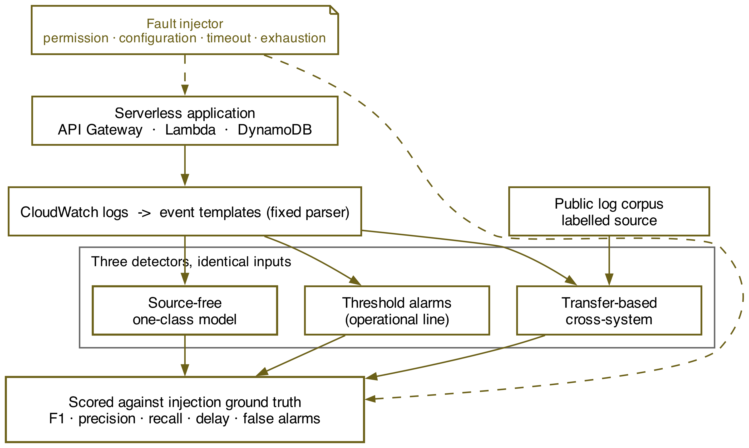
Figure 1 Experimental setup: shared log stream, three detectors, common ground truth

Research Method
The independent variable is the detection approach, at three levels: a source-free one-class detector trained only on the application's own unlabelled logs, a transfer-based detector aligned from a labelled public corpus in the manner of Zhao et al. (2025), and the CloudWatch threshold alarms an operator would otherwise configure. The third is a fixed operational reference line rather than a research comparator. Fault category is a conditioning factor at four levels drawn from the distribution Xie et al. (2025) measured: permission denial, configuration error, dependency timeout and resource exhaustion.
The dependent variable is the F1 score of each detector against the injected ground truth. Secondary measures are precision, recall, detection delay, and the false-alarm rate attributable to benign elasticity, measured separately during a fault-free control period containing genuine cold starts and scale-up bursts. Precision, recall and F1 are recorded on the same terms as Zhao et al. (2025), which allows the source-free result to be read against their transfer-based one.
Ground truth comes from injection rather than annotation. A scheduled script introduces each fault at a recorded time, so every anomalous interval is known in advance and recall is computable rather than estimated. Permission denial is injected by removing an action from the execution role, configuration error by misdirecting an environment variable, dependency timeout by throttling the downstream table, and resource exhaustion by lowering the memory limit below the working set. This is how the study escapes the constraint Nguyen et al. (2025) identify: labels are unobtainable by observation in a serverless setting, but available by construction.
Held constant are the application, the region, the account, the log parser and its configuration, the invocation workload and the evaluation window. Two confounds require handling. Khan et al. (2024) show parsing accuracy does not predict detection accuracy, so the parser is fixed at one implementation, its version recorded, and never tuned between arms. Separately, Albert (2024) shows training-window contamination collapses unsupervised accuracy from above 0.99 to 0.03, so the source-free detector trains on a period during which no fault is injected, verified clean before use.
Internally, the injected faults are synthetic instances of real fault categories, so they may be more clearly separable than the originals Xie et al. (2025) catalogued from human reports. External validity is bounded by one application on one platform. In construct terms, evaluation follows the chronological protocol Le and Zhang (2022) show to be the honest one, training strictly preceding evaluation, which is expected to yield lower figures than the random splits much of the literature reports.

Research Resources
The experiment requires an AWS serverless application comprising a Lambda function, an API Gateway endpoint and a DynamoDB table, with CloudWatch as the telemetry source, and a fault-injection script under the researcher's control. The application and its instrumentation are defined as code so every configuration is provisioned and destroyed reproducibly.
Two data sources support the study. The first is generated on the researcher's own infrastructure: CloudWatch logs from synthetic traffic against the application, with faults injected under the controlled script. Request and account identifiers are stripped before analysis, and no personal data is present at any stage. The second is a public log benchmark corpus carrying its own anomaly labels, used under its published terms to supply the labelled source the comparator requires and aligned to the target by the pseudo-labelling and feature-alignment procedure of Zhao et al. (2025).
The detectors are implemented with standard open-source libraries and the log parser is pinned to a single version. Training runs on a modest instance whose specification is recorded, since the practical claim concerns what a small team can afford.

Evaluation
The question is settled by comparing F1 between the source-free and transfer-based detectors on identical injected traffic, which answers objectives two and three. Objective one is satisfied by the injection schedule itself, and objective four by the fault-free control period, in which every alert raised is by definition a false alarm.
Each comparison is stated as a null and an alternative before any data exists. For the primary comparison, H0 holds that F1 does not differ between the source-free and transfer-based detectors, and H1 that it does. For categorical coverage, H0 holds that F1 does not differ across the four fault categories within an approach, and H1 that at least one differs. For false alarms, H0 holds that the elasticity-induced rate does not differ between approaches, and H1 that it does. None is one-sided, because the reviewed evidence points both ways.
The choice of test follows a normality assessment rather than preceding it. Detectors are evaluated on the same injected intervals, so the observations are paired: where the distributions are normal a paired t-test is applied with Cohen's d, and where they are not the Wilcoxon signed-rank test is substituted with rank-biserial correlation. Category-level detection is compared with McNemar's test. Every reported difference carries a 95% confidence interval.
Tests are conducted at an alpha of 0.05 with Holm-Bonferroni adjustment, since every hypothesis draws on one campaign. Replication is fixed in advance: each fault category is injected sixty times, giving 240 labelled anomalous intervals, a count set by a power calculation for a paired comparison at that alpha which resolves a ten-point difference in F1 at eighty per cent power. Ten points is also the smallest difference treated as practically meaningful, and the decision rule is recorded before collection: the source-free detector is a viable substitute if it falls within ten points of the transfer-based one while exceeding the threshold alarms.

Ethical Considerations of the Research
No people are involved in this study and nothing personal is recorded by it. Every request is synthetic traffic generated for the experiment, and request and account identifiers are stripped from the logs before analysis, which puts consent and data-protection duties outside the study's scope. The public benchmark corpus is used under its stated licence.
Injecting faults into a commercial platform, and driving traffic through it, has to stay within the platform's published terms of acceptable use. Faults are induced only in the researcher's own function, inside the researcher's own account, at invocation rates held below free-tier-safe thresholds. Compute and log ingestion are both billed, so the power calculation rather than the budget determines how many runs occur.
Reporting integrity requires particular care where a comparison flatters the proposed method. The source-free detector's training window is fixed before evaluation and never revised once results are seen; the chronological protocol is used even though it produces lower figures than random splitting; false alarms from the fault-free control are reported alongside detections; and the single-application scope accompanies every summary. Where the source-free detector performs poorly, that is the finding. The application definition, the injection scripts and the collected measurements are released.

Project Plan
Figure 2 sets out the twelve-week schedule. Weeks one to four deploy the instrumented application and build the fault injector, ending in a fixed fault taxonomy aligned to the published distribution.
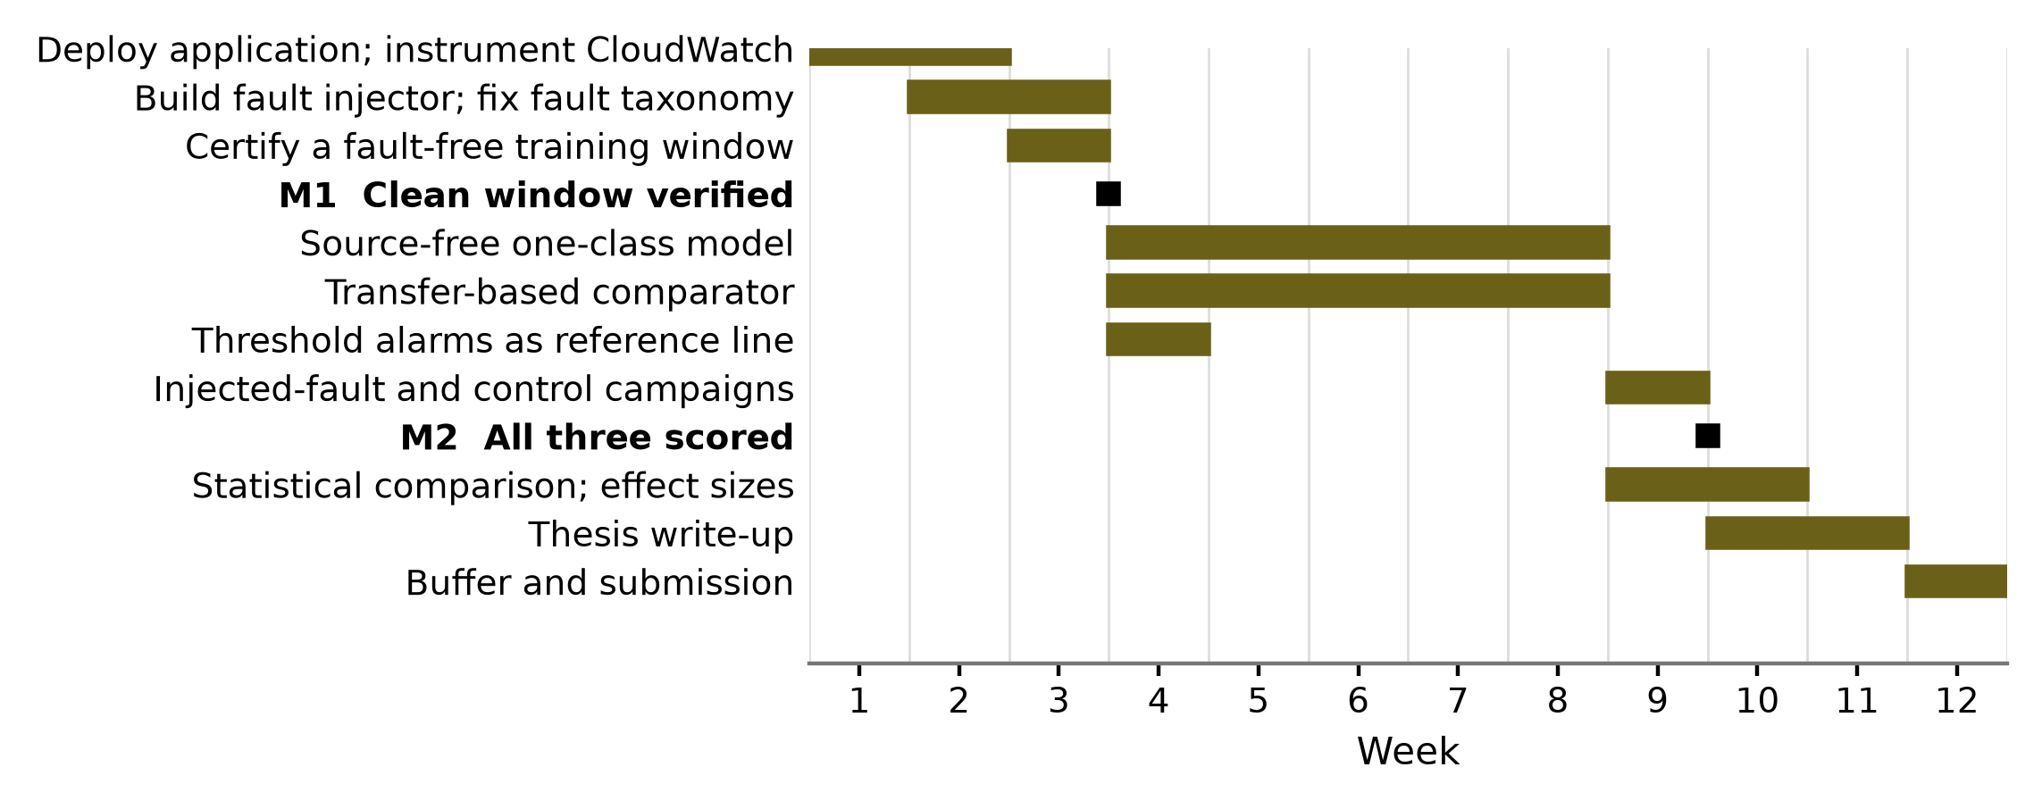
Figure 2 Twelve-week project plan
Detector development then proceeds in parallel from week four: the source-free model trains on the certified-clean window while the transfer-based comparator is aligned from the public corpus, both converging in week nine on identical injected traffic. Weeks nine to eleven cover statistical comparison, the write-up runs from week ten, and week twelve is contingency. The principal risk is certifying the window clean running long, which the early control period exposes.

References
Albert, R.-G. (2024) 'System logs anomaly detection. Are we on the right path?', Applied Artificial Intelligence, 39(1), 2440692. doi: 10.1080/08839514.2024.2440692. [Journal - JCR Impact Factor 2.9 (2024), Q3]
Ali, S., Boufaied, C., Bianculli, D., Branco, P. and Briand, L. (2025) 'A comprehensive study of machine learning techniques for log-based anomaly detection', Empirical Software Engineering, 30(5), 129. doi: 10.1007/s10664-025-10669-3. [Journal - JCR Impact Factor 3.4 (2024), Q2]
Khan, Z.A., Shin, D., Bianculli, D. and Briand, L.C. (2024) 'Impact of log parsing on deep learning-based anomaly detection', Empirical Software Engineering, 29(6), 139. doi: 10.1007/s10664-024-10533-w. [Journal - JCR Impact Factor 3.4 (2024), Q2]
Le, V.-H. and Zhang, H. (2022) 'Log-based anomaly detection with deep learning: how far are we?', in Proceedings of the 44th International Conference on Software Engineering. New York: ACM, pp. 1356-1367. doi: 10.1145/3510003.3510155. [Conference - CORE Ranking A* (ICORE2026)]
Nguyen, C., Elmroth, E. and Bhuyan, M. (2025) 'Silent failures in stateless systems: rethinking anomaly detection for serverless computing', in Proceedings of the 2025 IEEE International Conference on Service-Oriented System Engineering. Piscataway: IEEE, pp. 8-19. doi: 10.1109/SOSE67019.2025.00006. [Conference - CORE Ranking C (ICORE2026)]
Sun, Y., Keung, J., Yang, Z., Liu, S. and Yu, H.K. (2026) 'Improving anomaly detection in software logs through hybrid language modeling and reduced reliance on parser', Automated Software Engineering, 33(1), 12. doi: 10.1007/s10515-025-00548-y. [Journal - JCR Impact Factor 2.0 (2024), Q2]
Wen, J., Chen, Z., Jin, X. and Liu, X. (2023) 'Rise of the planet of serverless computing: a systematic review', ACM Transactions on Software Engineering and Methodology, 32(5), pp. 1-61. doi: 10.1145/3579643. [Journal - JCR Impact Factor 6.9 (2024), Q1]
Xie, C., Zhang, Y., Mao, X., Yang, K. and Zhang, T. (2025) 'Understanding the faults in serverless computing based applications: an empirical study', in Proceedings of the 2025 IEEE International Conference on Software Maintenance and Evolution. Piscataway: IEEE, pp. 161-173. doi: 10.1109/ICSME64153.2025.00024. [Conference - CORE Ranking A (ICORE2026)]
Yu, B., Yao, J., Fu, Q., Zhong, Z., Xie, H., Wu, Y., Ma, Y. and He, P. (2024) 'Deep learning or classical machine learning? An empirical study on log-based anomaly detection', in Proceedings of the IEEE/ACM 46th International Conference on Software Engineering. New York: ACM, pp. 1-13. doi: 10.1145/3597503.3623308. [Conference - CORE Ranking A* (ICORE2026)]
Zhao, X., Guo, K., Huang, M., Qiu, S. and Lu, L. (2025) 'ELFA-Log: cross-system log anomaly detection via enhanced pseudo-labeling and feature alignment', Computers, 14(7), 272. doi: 10.3390/computers14070272. [Journal - JCR Impact Factor 5.2 (2024), Q2]

